*A****computer****is a*[*machine*](https://en.wikipedia.org/wiki/Machine)*that can be programmed to*[*carry out*](https://en.wikipedia.org/wiki/Execution_(computing))*sequences of*[*arithmetic*](https://en.wikipedia.org/wiki/Arithmetic)*or*[*logical operations*](https://en.wikipedia.org/wiki/Logical_operations)*(*[*computation*](https://en.wikipedia.org/wiki/Computation)*) automatically. Modern*[*digital electronic*](https://en.wikipedia.org/wiki/Digital_electronic)*computers can perform generic sets of operations known as*[*programs*](https://en.wikipedia.org/wiki/Computer_program)*. These programs enable computers to perform a wide range of tasks. A****computer system****is a nominally complete computer that includes the*[*hardware*](https://en.wikipedia.org/wiki/Computer_hardware)*,*[*operating system*](https://en.wikipedia.org/wiki/Operating_system)*(main*[*software*](https://en.wikipedia.org/wiki/Software)*), and*[*peripheral*](https://en.wikipedia.org/wiki/Peripheral)*equipment needed and used for full operation. This term may also refer to a group of computers that are linked and function together, such as a*[*computer network*](https://en.wikipedia.org/wiki/Computer_network)*or*[*computer cluster*](https://en.wikipedia.org/wiki/Computer_cluster)*.*

*A broad range of*[*industrial*](https://en.wikipedia.org/wiki/Programmable_logic_controller)*and*[*consumer products*](https://en.wikipedia.org/wiki/Consumer_electronics)*use computers as*[*control*](https://en.wikipedia.org/wiki/Control_system)*system*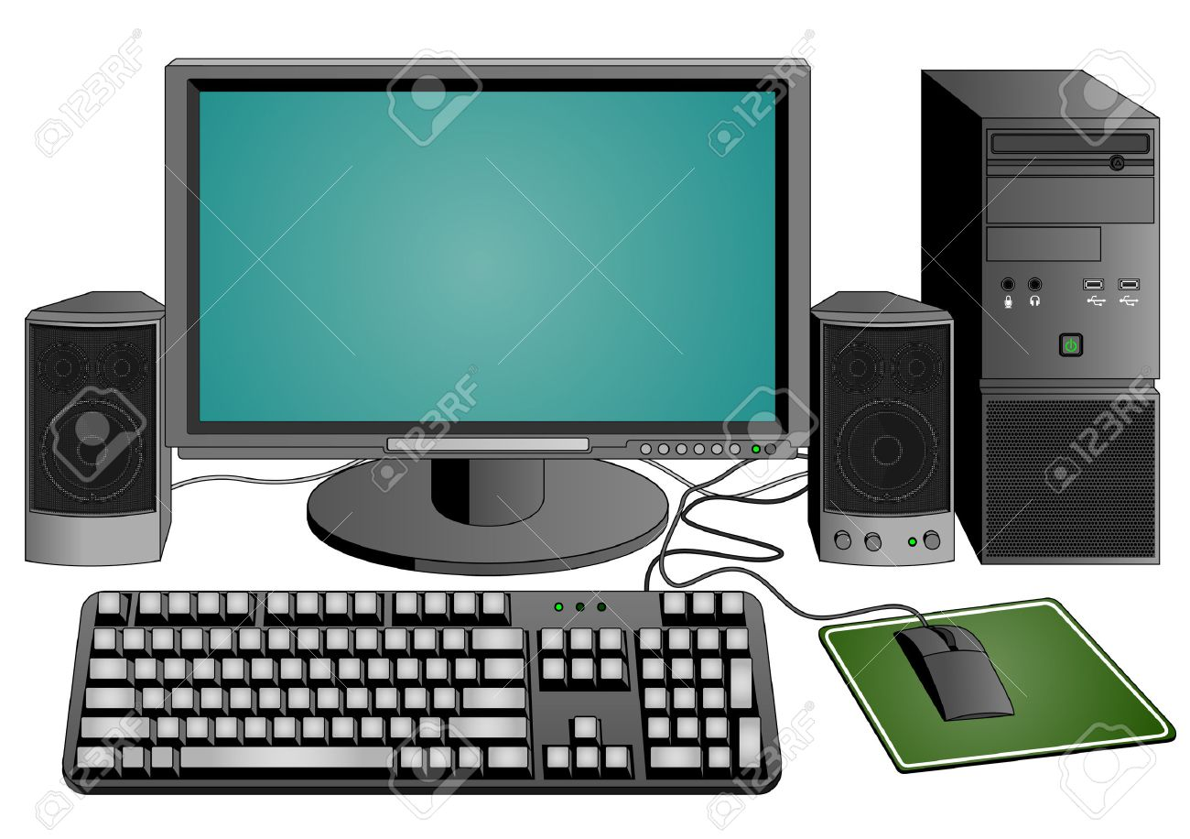

Types of computer

*Mainframe computer*

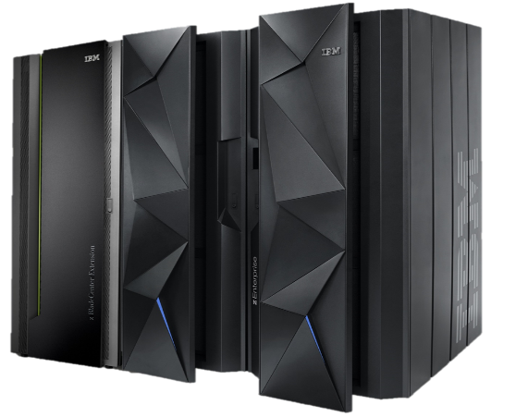[***Mainframe computers***](https://www.geeksforgeeks.org/difference-between-supercomputer-and-mainframe-computer/)***are designed in such a way that they can support hundreds or thousands of users at the same time. It also supports multiple programs simultaneously. So, they can execute different processes simultaneously. All these features make the mainframe computer ideal for big organizations like banking, telecom sectors, etc., which process a high volume of data in general*.**

***Super computer***

***A supercomputer is a computer that performs at or near the highest operational rate for computers.***

***Traditionally, supercomputers have been used for scientific and engineering applications that must handle massive databases, do a great amount of computation or both. Advances like***[***multicore processors***](https://www.techtarget.com/searchdatacenter/definition/multi-core-processor)***and***[***general-purpose graphics processing units***](https://www.techtarget.com/searchvirtualdesktop/definition/GPU-graphics-processing-unit)***have that could be called*desktop supercomputers*or*supercomputers *enabled powerful machines that could be called*desktop supercomputers*or***[***GPU supercomputers***](https://www.techtarget.com/whatis/definition/GPU-supercomputer)***.***

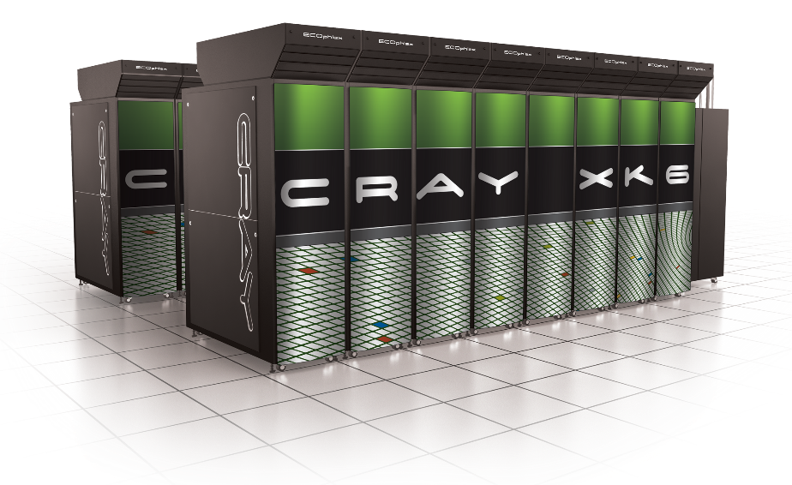

*Leave application for college*

To

The principal

Bhatia Jain Sanghatna College

Wagholi

2-9-2023

Sir,

With due regards, I want to notify you that I am (your name), studying in (mention about your batch) of your college. I need leave for three days because I will have to attend my sister’s marriage ceremony. I need to do all the preparation for her marriage and be a part of this ceremony

This is a very important event for me so I have to take leave. Hope you will consider my problem. Kindly grant me leave from (starting date) so that I can enjoy this ceremony.

Thanking you

You’re sincerely

0Mrudula shitole

Fy bca Roll number-4066