**Othello**

Othello is a strategy board game. It is a two-player game. One player plays with X and the other plays with O.

Rules of the game:

* The game starts with X
* Then the game alternates between white(Os) and black(Xs) until:
  + one player cannot make a valid move to outflank the opponent
  + both players have no valid moves
* Game ends when both players cannot make a valid move
* What is a valid move?
* Assuming the board looks as below, and it is X’s turn:

|  |  |  |  |  |  |  |  |
| --- | --- | --- | --- | --- | --- | --- | --- |
| ‘a1’ | ‘a2’ | ‘a3’ | ‘a4’ | ‘a5’ | ‘a6’ | ‘a7’ | ‘a8’ |
| ‘b1’ | ‘b2’ | b3’ | ‘b4’ | **X** | ‘b6’ | ‘b7’ | ‘b8’ |
| ‘c1’ | ‘c2’ | c3’ | ‘c4’ | **X** | ‘c6’ | ‘c7’ | ‘c8’ |
| ‘d1’ | ‘d2 | ‘d3’ | **O** | **O** | **O** | **X** | ‘d8 |
| ‘e1’ | ‘e2’ | ‘e3’ | **X** | **O** | ‘e6’ | ‘e7’ | ‘e8’ |
| ‘f1’ | ‘f2’ | ‘f3’ | ‘f4’ | ‘f5’ | ‘f6’ | ‘f7’ | ‘f8’ |
| ‘g1’ | ‘g2’ | g3’ | ‘g4’ | ‘g5’ | ‘g6’ | ‘g7’ | ‘g8’ |
| ‘h1’ | ‘h2’ | h3’ | ‘h4’ | ‘h5’ | ‘h6’ | ‘h7’ | ‘h8’ |

Boxes marked green are the possible moves for X

**OR**

Criteria #2: X is in the same row after Os, represented by Orange arrow (d3)

Criteria #2: X is in the same column after Os, represented by Yellow arrow (f5)

Criteria #1: X is placed next to O highlighted by blue arrows

|  |  |  |  |  |  |  |  |
| --- | --- | --- | --- | --- | --- | --- | --- |
| ‘a1’ | ‘a2’ | ‘a3’ | ‘a4’ | ‘a5’ | ‘a6’ | ‘a7’ | ‘a8’ |
| ‘b1’ | ‘b2’ | b3’ | ‘b4’ | **X** | ‘b6’ | ‘b7’ | ‘b8’ |
| ‘c1’ | ‘c2’ | c3’ | ‘c4’ | **X** | ‘c6’ | ‘c7’ | ‘c8’ |
| ‘d1’ | ‘d2 | **X(d3)** | **O** | **O** | **O** | **X** | ‘d8 |
| ‘e1’ | ‘e2’ | ‘e3’ | **X** | **O** | ‘e6’ | ‘e7’ | ‘e8’ |
| ‘f1’ | ‘f2’ | ‘f3’ | ‘f4’ | **X(f5)** | ‘f6’ | ‘f7’ | ‘f8’ |
| ‘g1’ | ‘g2’ | g3’ | ‘g4’ | ‘g5’ | ‘g6’ | ‘g7’ | ‘g8’ |
| ‘h1’ | ‘h2’ | h3’ | ‘h4’ | ‘h5’ | ‘h6’ | ‘h7’ | ‘h8’ |

* The 2 basic criteria for a valid move

1. Chip(X in the example above) can be only placed adjacent to opponent’s chip(O in the example above)
2. Players chip has to be in the same row or column where the chip is placed

* Once a valid move is made all the opponent’s chip in the same row or column are flipped until the Player’s (X in our example) is found
* Here is what the board will look like if f5 is selected

|  |  |  |  |  |  |  |  |
| --- | --- | --- | --- | --- | --- | --- | --- |
| ‘a1’ | ‘a2’ | ‘a3’ | ‘a4’ | ‘a5’ | ‘a6’ | ‘a7’ | ‘a8’ |
| ‘b1’ | ‘b2’ | b3’ | ‘b4’ | **X** | ‘b6’ | ‘b7’ | ‘b8’ |
| ‘c1’ | ‘c2’ | c3’ | ‘c4’ | **X** | ‘c6’ | ‘c7’ | ‘c8’ |
| ‘d1’ | ‘d2’ | ‘d3’ | **O** | **X** | **O** | **X** | ‘d8’ |
| ‘e1’ | ‘e2’ | ‘e3’ | **X** | **X** | ‘e6’ | ‘e7’ | ‘e8’ |
| ‘f1’ | ‘f2’ | ‘f3’ | ‘f4’ | **X** | ‘f6’ | ‘f7’ | ‘f8’ |
| ‘g1’ | ‘g2’ | g3’ | ‘g4’ | ‘g5’ | ‘g6’ | ‘g7’ | ‘g8’ |
| ‘h1’ | ‘h2’ | h3’ | ‘h4’ | ‘h5’ | ‘h6’ | ‘h7’ | ‘h8’ |

* Here is what board will look like if d3 is selected

|  |  |  |  |  |  |  |  |
| --- | --- | --- | --- | --- | --- | --- | --- |
| ‘a1’ | ‘a2’ | ‘a3’ | ‘a4’ | ‘a5’ | ‘a6’ | ‘a7’ | ‘a8’ |
| ‘b1’ | ‘b2’ | b3’ | ‘b4’ | **X** | ‘b6’ | ‘b7’ | ‘b8’ |
| ‘c1’ | ‘c2’ |  |  | **O** | ‘c6’ | ‘c7’ | ‘c8’ |
| ‘d1’ | ‘d2’ | **X** | **X** | **X** | **X** | **X** | ‘d8’ |
| ‘e1’ | ‘e2’ | ‘e3’ | **X** | **O** | ‘e6’ | ‘e7’ | ‘e8’ |
| ‘f1’ | ‘f2’ | ‘f3’ | ‘f4’ | ‘f5’ | ‘f6’ | ‘f7’ | ‘f8’ |
| ‘g1’ | ‘g2’ | g3’ | ‘g4’ | ‘g5’ | ‘g6’ | ‘g7’ | ‘g8’ |
| ‘h1’ | ‘h2’ | h3’ | ‘h4’ | ‘h5’ | ‘h6’ | ‘h7’ | ‘h8’ |

* The total number of chips are calculated for either of the players and the player with maximum chip wins.
* Scores are displayed after every move
* A player can press “P” to pass a turn

Some snippets from the game:

Begin game:

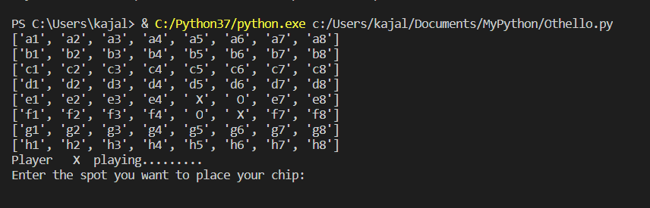

After player X plays

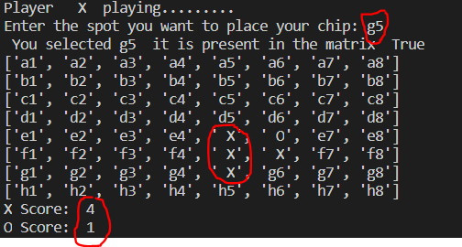

Player O selected a wrong value

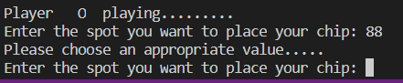

Player O chose a wrong spot

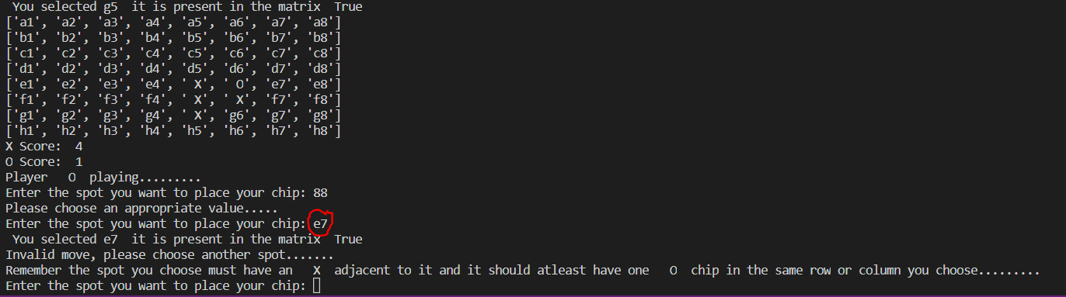

A player can Pass move by pressing “P”

