Q1. What is a variable in C/C++?
Answer: A variable is a named memory location used to store data in a program.
Q2. Why do we use variables in programs?
Answer: Variables are used to store and manage data efficiently in programs.
Q3. What is the difference between a variable name and its value?
Answer: A variable name identifies the data, while its value is the actual stored content.
Q4. Which of the following is a valid variable name?
a) 2num b) total_marks c) for d) my marks
Answer: b) total_marks is a valid variable name according to programming rules.
Q5. Why is Age different from age?
Answer: C/C++ is case-sensitive, so Age and age are different variables in programming.
Q6. Can a variable name contain spaces? Why?
Answer: No, variable names cannot contain spaces because they must be a single identifier.
Q7. Can a variable name start with an underscore (_)?
Answer: Yes, a variable name can start with an underscore (_) in C/C++.
Q8. What happens if two variables have the same name in the same scope?
Answer: It causes an error because variable names must be unique within one scope.
Q9. Write three meaningful variable names for storing student information.
Answer: studentName, studentAge, and studentMarks for storing student information.
Q10. Which naming convention is better and why: studentMarks or sm?
Answer: studentMarks is better because it is meaningful and easy to understand.
Q11. What is a data type?
Answer: A data type specifies the kind of data a variable stores.
Q12. Which data type is used to store whole numbers?
Answer: int is used to store whole numbers without decimals.
Q13. Which data type is used to store decimal values?
Answer: float or double is used to store decimal values accurately.
Q14. What is the difference between float and double?
Answer: double provides more precision than float for decimal calculations.
Q15. Which data type stores a single character?
Answer: char stores a single character in memory.
Q16. Which data type stores True/False values?
Answer: bool stores True/False values for logical operations.
Q17. What data type is suitable for storing a person's name?
Answer: string is suitable for storing a person's name as text data.
Q18. Predict the output: int age=18; cout<<age;
Answer: Output: 18 will be displayed on the screen.
Q19. Identify the data type: 25, 3.14, 'A', true.
Answer: 25 → int,
3.14 → float/double,
'A' → char, true → bool.
Q20. What happens if you store a decimal number in an int variable?
Answer: The decimal part is removed automatically when stored in an int variable.
Q21. What is the purpose of cin?
Answer: cin is used to take input from the user.
Q22. What is the purpose of cout?
Answer: cout is used to display output on the screen.
Q23. Which symbol is used with cin?
Answer: The >> symbol is used with cin for input operations.
Q24. Which symbol is used with cout?
Answer: The << symbol is used with cout for output operations.
Q25. Explain: cin >> age;
Answer: This statement takes the value of age from the keyboard.
Q26. Explain: cout << age;
Answer: This statement displays the value of age on the screen.
Q27. What is the purpose of endl?
Answer: endl moves the cursor to the next line after output.
Q28. Write a statement to input a student's marks.
Answer: cin >> marks;
Q29. Write a statement to display "Welcome to C++".
Answer: cout << "Welcome to C++";
Q30. Predict the output: cout << "Programming";
Answer: Output: Programming will be displayed on the screen.
Q31. What is an operator?
Answer: An operator is a symbol used to perform operations on data values.
Q32. Which operator is used for addition?
Answer: The + operator is used for addition of numbers.
Q33. What is the result of 10 % 3?
Answer: The result of 10 % 3 is 1 as the remainder.
Q34. What is the result of 8 % 2?
Answer: The result of 8 % 2 is 0 as the remainder.
Q35. Which operator checks equality?
Answer: The == operator checks equality between values.
Q36. What is the difference between = and == ?
Answer: = assigns a value, while == compares two values for equality.
Q37. What is the result of 5 > 3?
Answer: The result of 5 > 3 is true.
Q38. What does && represent?
Answer: && represents the logical AND operator in conditions.
Q39. What does || represent?
Answer: || represents the logical OR operator in conditions.
Q40. What does ! represent?
Answer: ! represents the logical NOT operator for negation.
Q41. Write a program to print "Hello World".
Answer:
Problem Statement
Write a C++ program to display the message "Hello World" on the screen.
Algorithm / Steps
- Start the program.
- Display "Hello World".
- End the program.
- Dry Run with Sample Input
Input: No input required.
Execution:
- Display "Hello World".
Program Code
#include <iostream>
using namespace std;
int main()
{
cout << "Hello World";
return 0;
}
Output
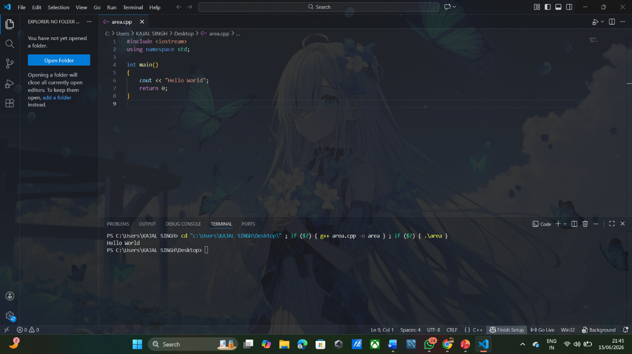
Explanation of the Logic
The program uses the cout statement to print the text "Hello World" on the screen.

Q42. Write a program to input two numbers and display their sum.
Answer:
Problem Statement
Write a C++ program to input two numbers and display their sum.
Algorithm / Steps
- Start the program.
- Declare two variables.
- Input two numbers from the user.
- Calculate their sum.
- Display the sum.
- End the program.
Dry Run with Sample Input
Input:
7
9
Execution:
- a = 7
- b = 9
- sum = 7 + 9 = 16
Output:
16
Program Code
#include <iostream>
using namespace std;
int main()
{
int a, b, sum;
cin >> a >> b;
sum = a + b;
cout << sum;
return 0;
}
Output Screenshot
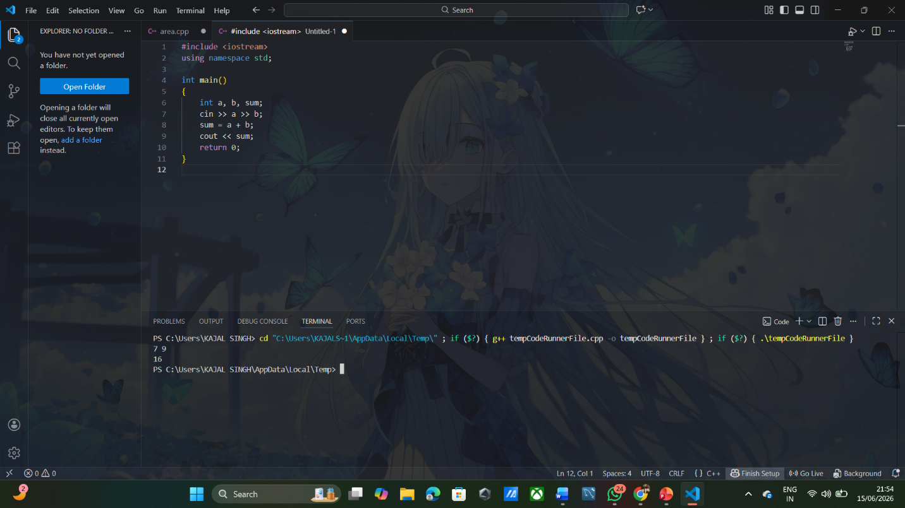
Explanation of the Logic
The program takes two numbers as input, adds them using the + operator, and displays the result.

Q43. Write a program to calculate the area of a rectangle.
Answer:
. Problem Statement
Write a C++ program to calculate the area of a rectangle using its length and width.
Algorithm / Steps
- Start the program.
- Declare variables for length and width.
- Input length and width.
- Calculate area = length × width.
- Display the area.
- End the program.
Dry Run with Sample Input
Input:
Length = 5
Width = 4
Execution:
- area = 5 × 4
- area = 20
Output:
20
Program Code
#include <iostream>
using namespace std;
int main()
{
int length, width, area;
cin >> length >> width;
area = length * width;
cout << area;
return 0;
}
Output Screenshot
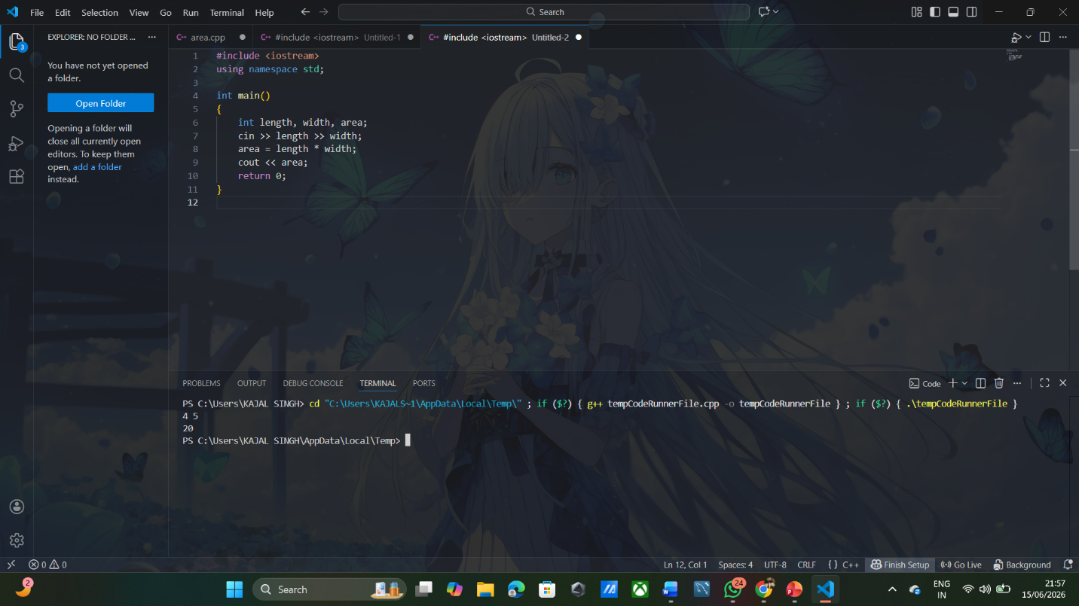
Explanation of the Logic
The program multiplies the length and width of the rectangle to find its area and then displays the result.

Q44. What formula is used to calculate Simple Interest?
Answer: Simple Interest = (P × R × T) / 100.
Q45. Write a program to calculate Simple Interest.
Answer:
Problem Statement
Write a C++ program to calculate Simple Interest using Principal, Rate, and Time.
Algorithm / Steps
- Start the program.
- Declare variables for Principal (P), Rate (R), and Time (T).
- Input the values of P, R, and T.
- Calculate SI = (P × R × T) / 100.
- Display the Simple Interest.
- End the program.
Dry Run with Sample Input
Input:
P = 1000
R = 5
T = 2
Execution:
- SI = (1000 × 5 × 2) / 100
- SI = 100
Output:
100
Program Code
#include <iostream>
using namespace std;
int main()
{
float P, R, T, SI;
cin >> P >> R >> T;
SI = (P * R * T) / 100;
cout << SI;
return 0;
}
Output Screenshot
Input:
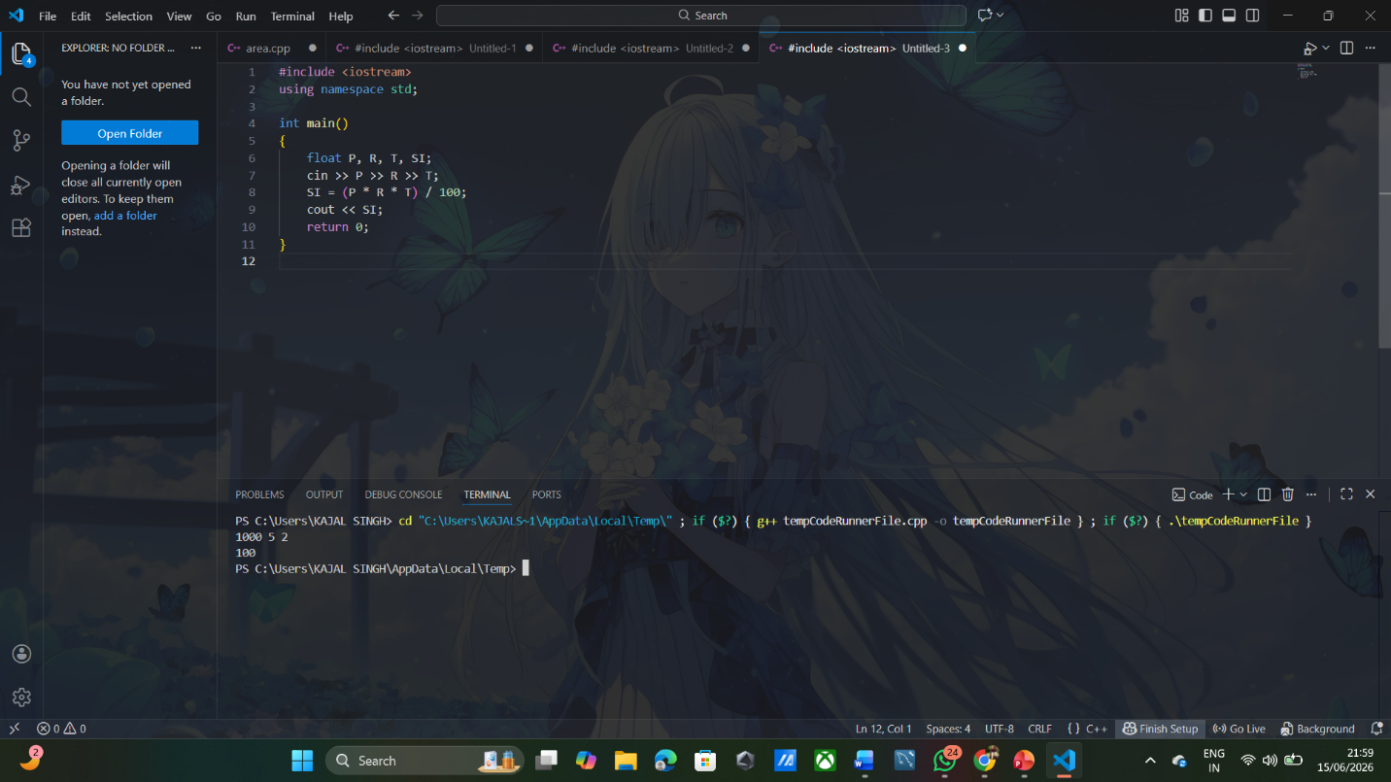
Explanation of the Logic
The program takes the principal amount, rate of interest, and time as input. It then applies the Simple Interest formula (P × R × T) / 100 and displays the calculated interest.

Q46. Why is a temporary variable used while swapping two numbers?
Answer: A temporary variable is used to safely store a value during swapping.
Q47. Swap the values: a = 10, b = 20.
Answer: After swapping, a = 20 and b = 10 successfully exchanged.
Q48. What formula is used to convert Celsius into Fahrenheit?
Answer: The conversion formula is Fahrenheit = (C × 9/5) + 32.
Q49. What is the Fahrenheit value of 0°C?
Answer: The Fahrenheit value of 0°C is 32°F.
Q50. Why can integer division give incorrect results in the Celsius-to-Fahrenheit program?
Answer: Integer division may remove decimal values, causing inaccurate results in calculations.

