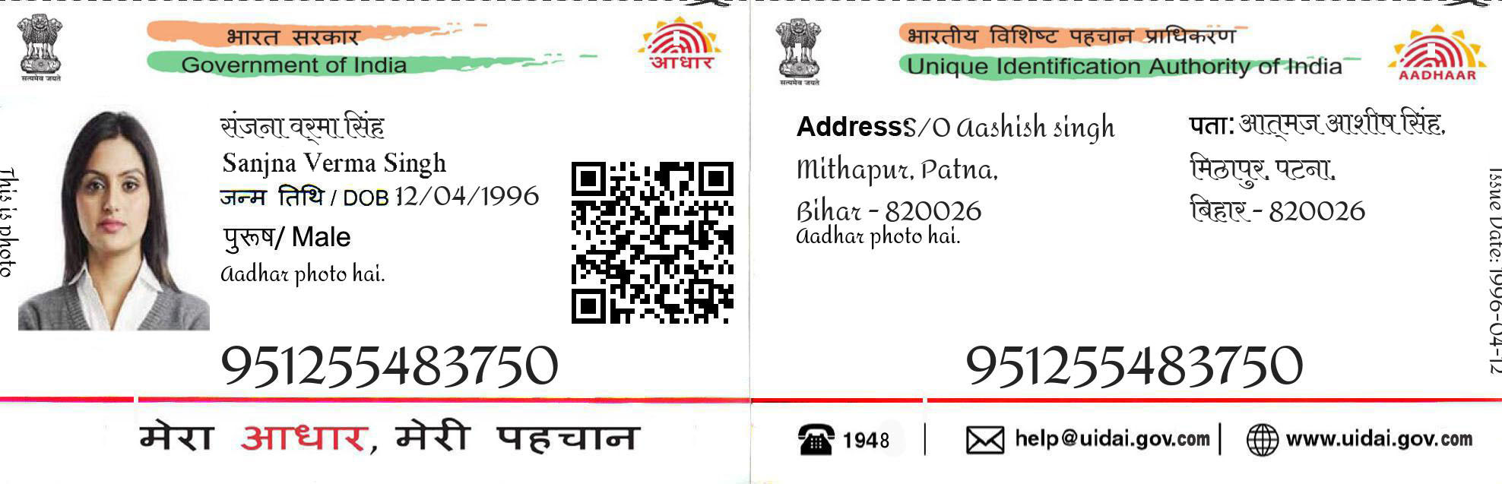

9512 5548 3750

Address /S/0:Palak Srivastav

T-60,Shukkar Bazar, Dk .Mohan Garden,

West-Delhi, 110059.

Date Of Birth/DOB/12/04/1996

Palak

9512 5548 3750

Gender/Female