# 1.)data analysis

1.Analyse data source « tv viewers » and « killed characters »

2.Analyse for a second time the data source according to the feedback of teacher

# 2.)story concept

1.Written a story concept

2.Get a feedback from teacher that the content for project was not enough

3.Rewritten the story concept with additional information

# 3.)data acquisition

1. Create an excel file for tv viewers

2. Downloaded picture of each characters

3. Analyse the file data.json

4. Analyse killed character from season 1-5

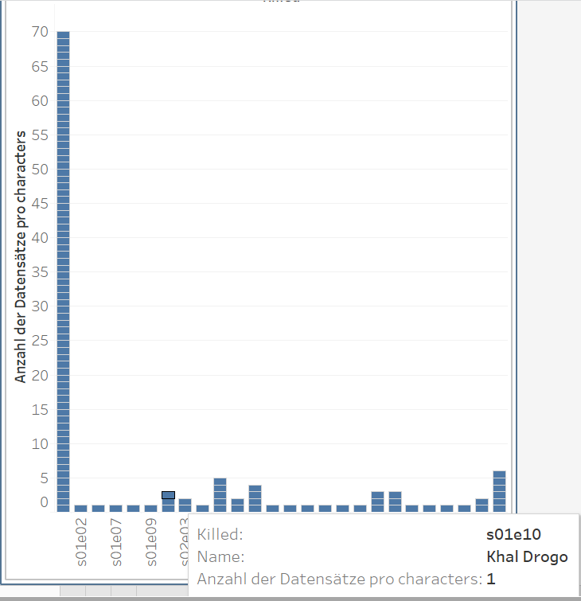

# 4.)data integration

# 5.)chart sketching

1.Create a paper prototyp

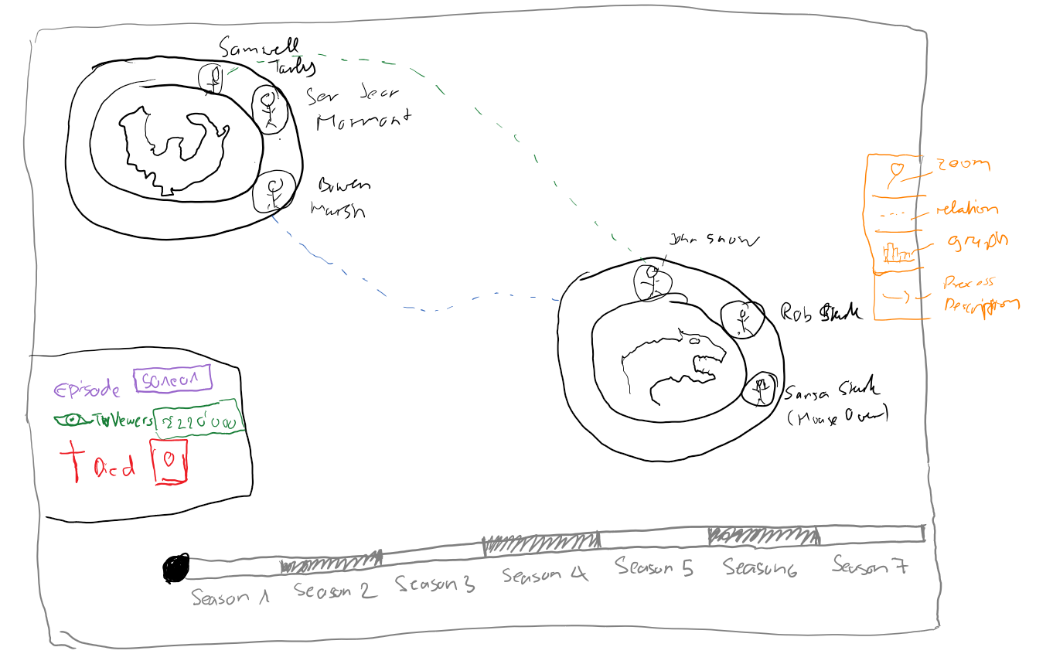

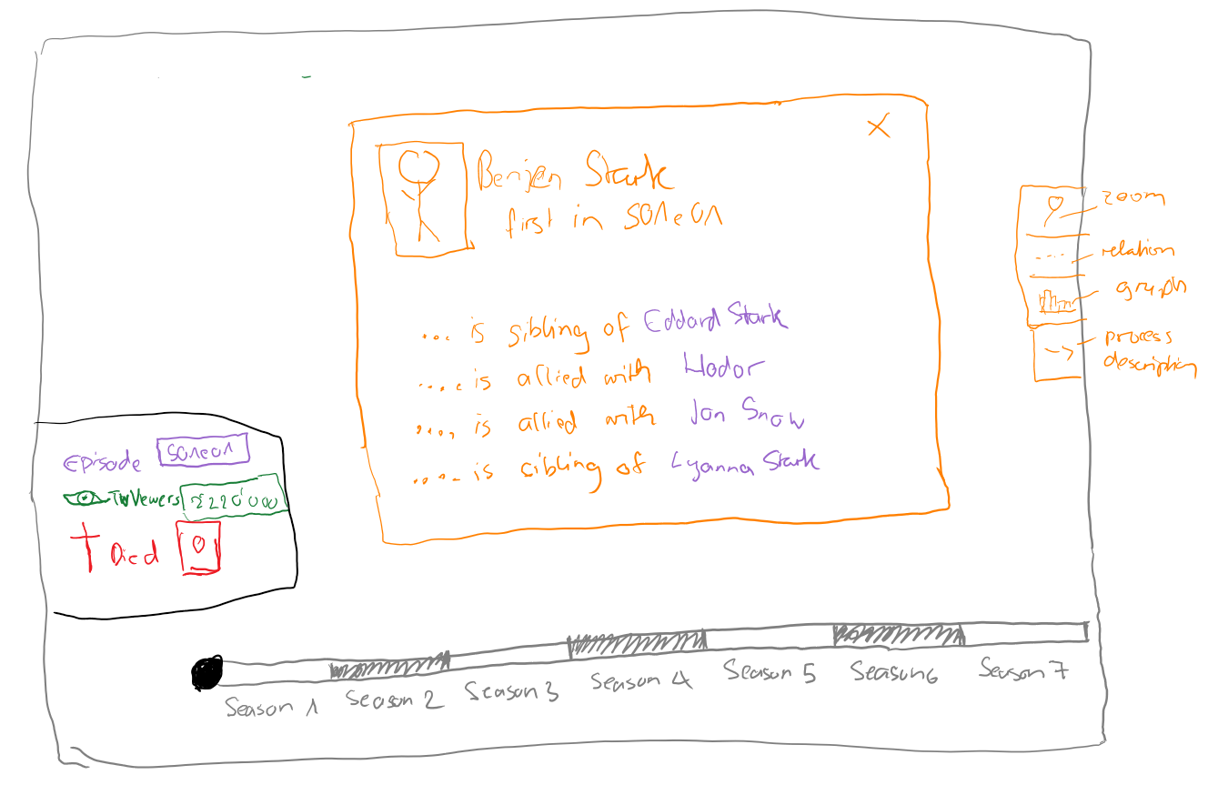

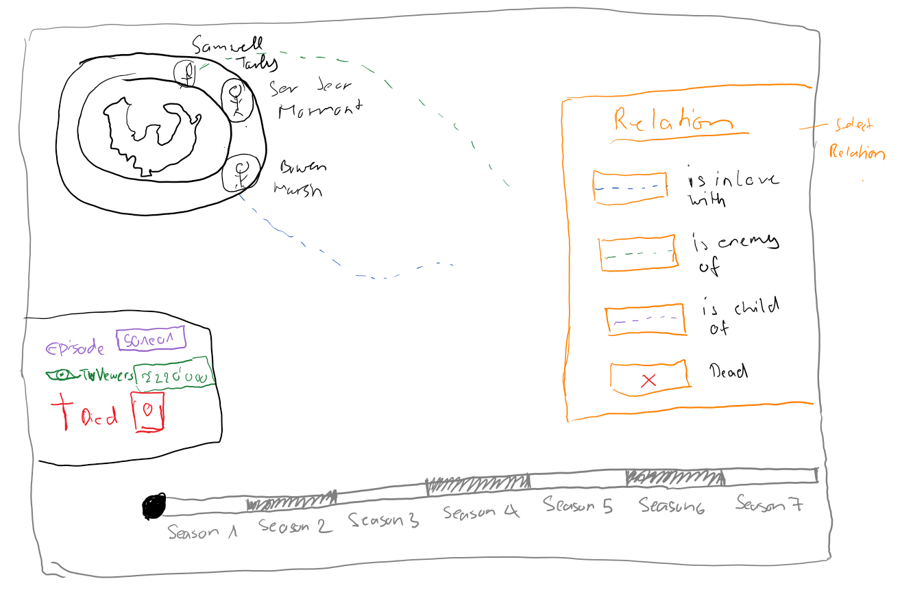

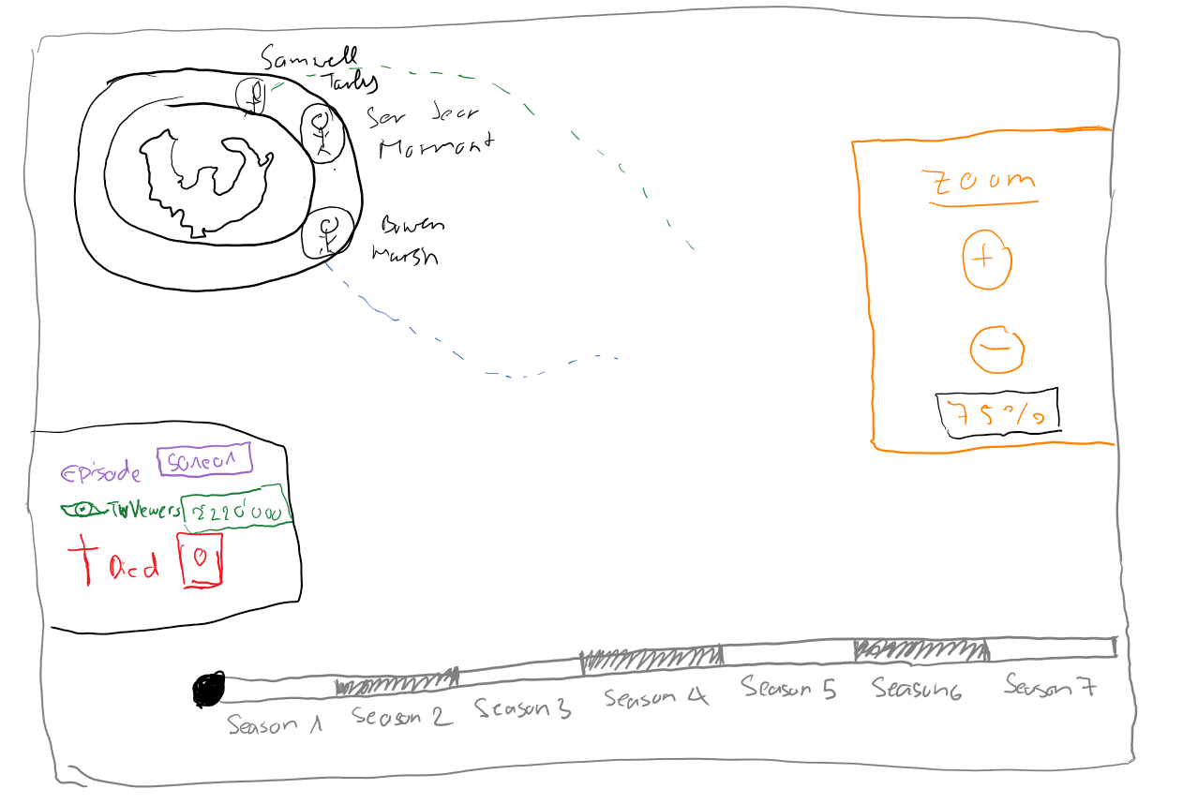

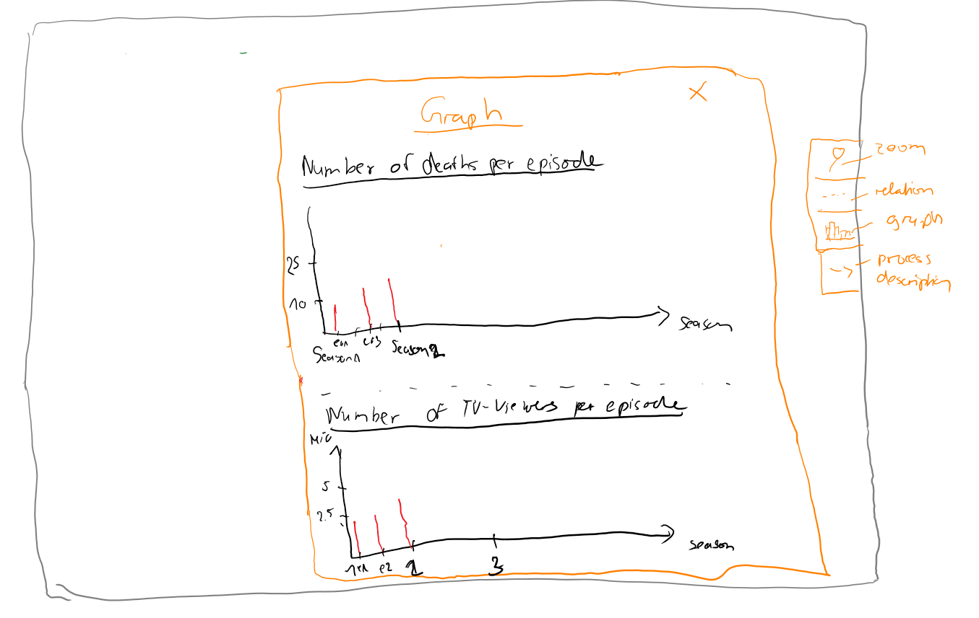

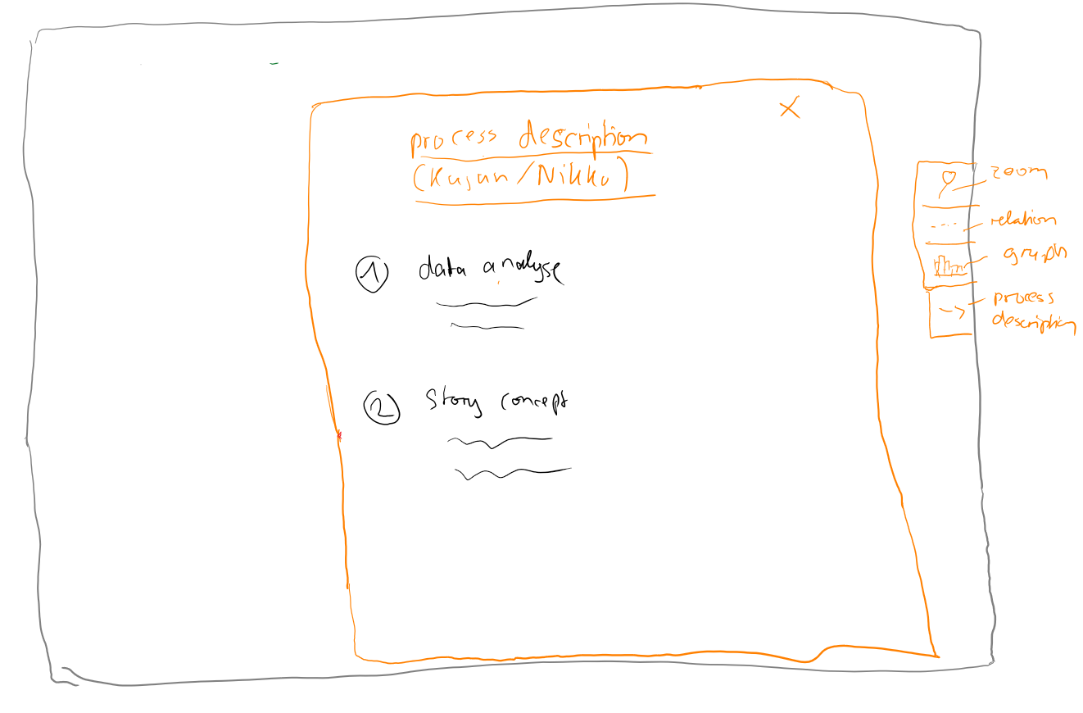

# 6.)implementation

# 7.)design

# 8.)documentation

# 9.)presentation