# Technical Design Document: KajaAiken_ProgrammingExercise_7

# Name: Kaja Aiken
# Date: June 26, 2026
# Program Description: This program will use regular expressions to count the number of sentences in a paragraph from user input. It will be able to support capital letters and numbers. The program will then display the amount of sentences counted at the end.

## Function: extract_sentences
Validates user input using regular expressions.

Parameters:
Paragraph (str): The user’s input.

Variables:
Pattern (str): The regular expression pattern that matches the user's input.
Sentences (list of strings): Stores the output from the re.findall() method.

Logic:
- Define the regular expression pattern to include A-Z and 0-9 entries.
- Set matches using re.DOTALL and re.MULTILINE.
- Use re.findall() to scan the user’s input whilst extracting substrings and placing them into the sentences list.
- Return the sentence list.

Return:
List: All the extracted sentences.

## Function: main
Manages the presentation, user interaction, and function execution.

Parameters:
None

Variables:
Lines (list): Collects lines of text entered by the user.
Line (str): Captures text from the input.
Paragraph (str): The user’s input.
Sentence_list (list): Holds output and returned by extract_sentences.
Index (int): Tracks and displays the position of each sentence.
Sentence (str): Holds the individual sentences during final presentation.

Logic:
- Print a greeting and prompt the user for input.
- Execute an infinite while True loop to accept multiple lines. The user is asked to enter twice to break this loop.
- Join the lines together using .join()
- Verify the user’s input is not blank and is valid.
- Pass the paragraph string as an argument to extract_sentences().
- Goes through the list and uses .strip() to eliminate white spaces.
- Call the len(sentence_list) to tally up the total amount of sentences.

Return:
None

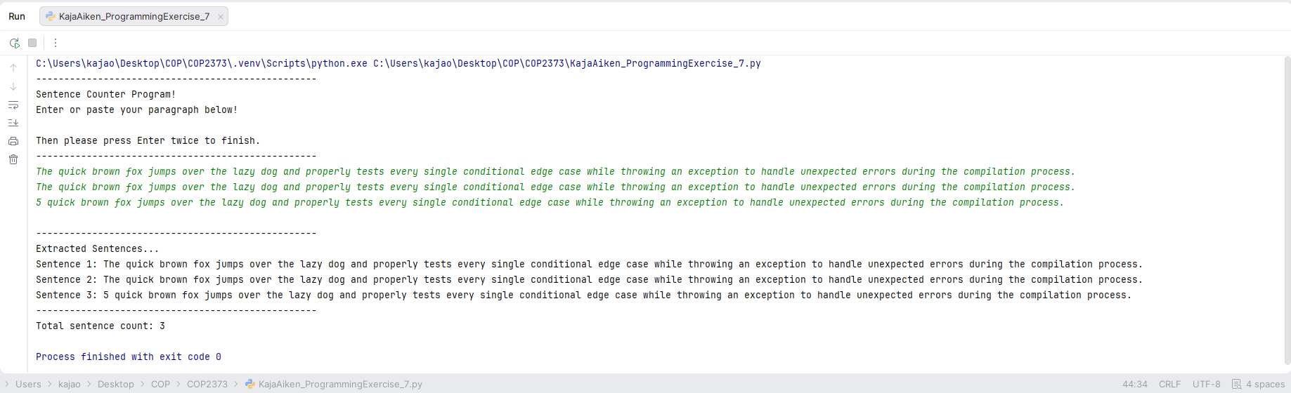
https://github.com/kajaoe/COP2373

