# Technical Design Document: KajaAiken_ProgrammingExercise_6

# Name: Kaja Aiken
# Date: June 26, 2026
# Program Description: This program will use regular expressions to validate a phone number, social security number, and ZIP code based off of the user’s input. It will test the validity of the information using functions.

## Function: validate_phone
Validates phone number from user using regular expressions.

Parameters:
Phone (str): The phone number entered by the user.

Variables:
Pattern (str): The regex pattern allows options like a leading "+1", parentheses around the area code, standard dashes, dots, spaces, or an unformatted 10-digit string.

Logic:
- Define the regex string pattern.
- Use re.match() to check if the input matches the pattern.
- Convert the match to the boolean value.
- Return the boolean outcome.

Return:
Bool: True if the phone number matches the pattern. False, if otherwise.

## Function: validate_ssn
Validates social security number from user using regular expressions.

Parameters:
Ssn (str): The social security number entered by the user.

Variables:
Pattern (str): The regex pattern enforces AAA-GG-SSSS structure.

Logic:
- Define the regex string pattern.
- Use re.match() to check if the input matches the pattern.
- Convert the match to the boolean value.
- Return the boolean outcome.

Return:
Bool: True if the social security number matches the pattern. False, if otherwise.

## Function: validate_zip
Validates ZIP code from the user using regular expressions.

Parameters:
Zip (str): The ZIP code entered by the user.

Variables:
Pattern (str): The regex pattern enforces five digit or extended ZIP formats.

Logic:
- Define the regex string pattern.
- Use re.match() to check if the input matches the pattern.
- Convert the match to the boolean value.
- Return the boolean outcome.

Return:
Bool: True if the ZIP code matches the pattern. False, if otherwise.

## Function: run_test
Executes automated test cases to verify the correctness of the validation logic.

Parameters:
None

Variables:
Phone_test (list of tuples): Contains test pairs consisting of a string and its validity boolean.
Ssn_test (list of tuples): Contains test pairs consisting of a string and its validity boolean.
Zip_test (list of tuples): Contains test pairs consisting of a string and its validity boolean.

Logic:
- Print visual headers indicating the verification sequence.
- Populate test scenario lists with pre-determined valid and invalid cases for all data categories.
- Utilize the all() function combined with list comprehensions to loop through each test case tuple, passing the test inputs to their corresponding validation functions, and evaluating them against the boolean results.
- Display "Verified." for each test category if every test scenario succeeds; otherwise display "Failed to verify."

Return: None

## Function: main
Manages the presentation, user interaction, and function execution.

Parameters:
None

Variables:
User_phone (str): Stores the phone number from user input.
User_ssn (str): Stores the social security number from user input.
User_zip (str): Stores the ZIP code from user input.

Logic:
- Print a greeting and title.
- Prompt the user to enter a phone number, social security number, and ZIP code back to back. Use .strip() to eliminate white spaces.
- Print confirmation of results.
- Evaluate user_phone using validate_phone(). Print a success message if True, or an invalid error message if False.
- Evaluate user_ssn using validate_ssn(). Print a success message if True, or an invalid error message if False.
- Evaluate user_zip using validate_zip(). Print a success message if True, or an invalid error message if False.
- Call run_test().

Return:
None

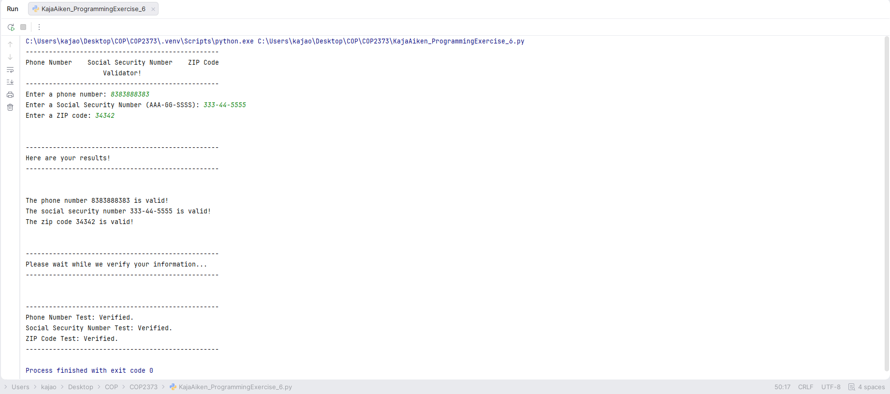
https://github.com/kajaoe/COP2373

