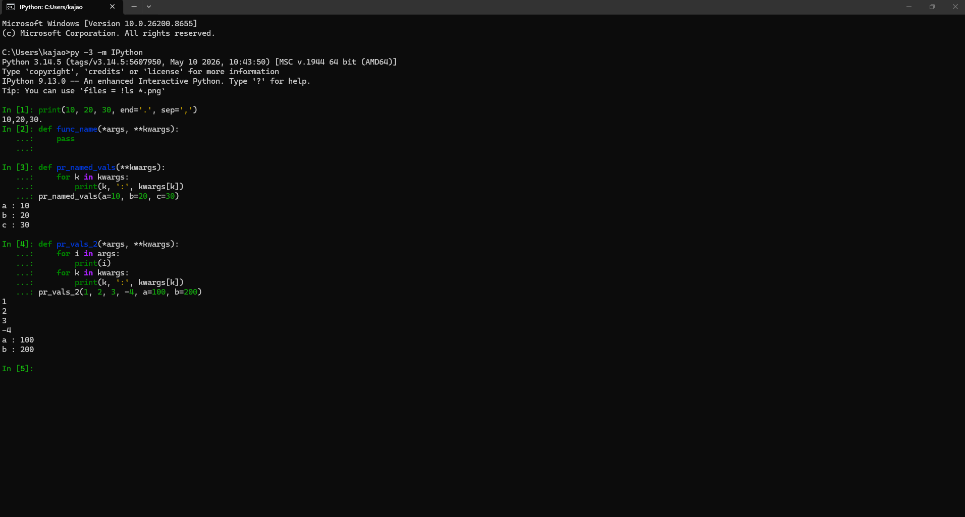
Advantages of kwargs
- It is flexible with complex and dynamic arguments. This allows for a function to accept any arguments without defining them. This is perfect for spontaneous coding when the user’s data is unpredictable.
- The arguments can be seamless, making dictionary arguments digestible.
- It is good with expanding on code that has already been defined, making new changes easy to put in without breaking the code.

Disadvantages of kwargs
- Inability to be written out in the def line makes it harder to read. This makes reading the logic harder as well.
- It cannot suggest arguments or find missing arguments like PyCharm. This makes debugging harder, ultimately slowing development.
- Typos become detrimental because the functions won’t catch them. More work has to be put in to correct the code.

