4190.308: Computer Architecture

Midterm Exam

November 4th, 2016

Professor Jae W. Lee

SOLUTIONS

Student ID #: ___________________

Name: ___________________

This is a closed book, closed notes exam.

120 Minutes

14 Pages  
(+ 2 Appendix Pages)

Total Score: 200 points

Notes:

* Please turn off all of your electronic devices (phones, tablets, notebooks, netbooks, and so on). A clock is available on the lecture screen.
* Please stay in the classroom until the end of the examination.
* You must not discuss the exam's contents with other students during the exam.
* You must not use any notes on papers, electronic devices, desks, or part of your body.

*(This page is intentionally left blank. Feel free to use as you like.)*

**Part A: Short Answers (20 points)**

|  |  |
| --- | --- |
| **Question 1 (20 points)** |  |

Please indicate whether each of the following statements is true or false. You don’t have to justify your answer—Just write down true or false.

1. According to the technology trends, the capacity of DRAM devices has been scaling up much faster than the speed (latency) of them.

**ANSWER: TRUE**

1. To compare two IEEE 754 floating-point numbers (except for ±Infinity, and NaN), you can simply interpret them as two sign-magnitude integers and perform an integer comparison to obtain the correct result.

**ANSWER: TRUE**

1. When performing multiple floating-point additions, the order of additions does not affect the final result since addition is commutative.

**ANSWER: FALSE**

1. Unlike integers, the difference between a pair of two adjacent floating-point numbers is non-uniform.

**ANSWER: TRUE**

1. CISC architectures (e.g., x86-64) generally have an advantage in code size over RISC architectures (e.g., MIPS, ARM).

**ANSWER: TRUE**

**Part B: Floating-Point Numbers (20 points)**

|  |  |
| --- | --- |
| **Question 2 (20 points)** |  |

Consider the following 6-bit floating-point representation based on the IEEE 754 floating point format. The most significant bit represents a sign bit. The next three bits are the exponent, with an exponent bias of 3. The last two bits are the fraction. The rules are like those in the IEEE standard (normalized, denormalized, representation of zero, infinity, and NaN).

|  |  |  |
| --- | --- | --- |
| Sign  (1 bit) | Exponent  (3 bits) | Fraction  (2 bit) |

1. Fill in the empty boxes in the following table. (1 pt / blank) (Last 2 rows are 3 pts)

|  |  |  |
| --- | --- | --- |
| **Number** | **Decimal Representation** | **Binary Representation** |
| Positive Zero | +0.0 | 000000 |
| Negative Zero | -0.0 | 100000 |
| 0.7510 | 0.75 (3/4) | 001010 |
| 0.12510 | 0.125 (1/8) | 000010 |
| One | 1.0 | 001100 |
| Positive Infinity | + ∞ | 011100 |
| Negative Infinity | – ∞ | 111100 |
| Not-a-Number | NaN | 011101 / 011110 / 011111 / 111101/ 111110 / 111111 |
| The largest number | 14 | 011011 |
| The smallest positive number | 1/16 | 000001 |

1. Show all the possible non-zero values that are represented in the *denormalized* form.

(1 pt / answer)

(+) 000001, 000010, 000011 (-) 100001, 100010, 100011

**Part C: Human x86-64 CPU (26 points)**

|  |  |
| --- | --- |
| **Question 3 (12 points)** |  |

Ben Bitdiddle wrote the following C code, compiled it to x86-64 binary using gcc, and ran it. What is the program output? (*Hint*: Think about what the generated assembly code will look like.)

|  |
| --- |
| #include <stdio.h>  int main()  {  int x = 1, y;  if (x == 0 && x--) y = 1;  else y = 0;  printf("x = %d, y = %d\n", x, y); // 1st printf  if (x == 1 && x--) y = 1;  else y = 0;  printf("x = %d, y = %d\n", x, y); // 2nd printf  if (x == -1 && x--) y = 1;  else y = 0;  printf("x = %d, y = %d\n", x, y); // 3rd printf  } |

**(2 points per each correct answer.)**

**x = 1, y = 0**

**x = 0, y = 1**

**x = 0, y = 0**

|  |  |
| --- | --- |
| **Question 4 (14 points)** |  |

Alice Hacker wrote the following C code to run it on x86-64/Linux system. What will be the program output? Fill in each blank with a correct value.

|  |
| --- |
| #include <stdio.h>  union {  int i;  short s[2];  unsigned char c[4];  } u;  int main()  {  int s0, s1;  u.i = 0xbadbabe;  s0 = (int) u.s[0];  s1 = (int) u.s[1];  printf("sizeof(int)=%d, sizeof(short)=%d, sizeof(char)=%d\n",  sizeof(int), sizeof(short), sizeof(char));  printf("sizeof(u.i)=%d\n", sizeof(u.i));  printf("sizeof(u.s)=%d, sizeof(u.s[0])=%d\n", sizeof(u.s), sizeof(u.s[0]));  printf("sizeof(u.c)=%d, sizeof(u.c[0])=%d\n", sizeof(u.c), sizeof(u.c[0]));  printf("sizeof(u)=%d\n", sizeof(u));  printf("s0=0x%x, s1=0x%x\n", s0, s1);  printf("u.c=0x%x 0x%x 0x%x 0x%x\n", u.c[0],u.c[1],u.c[2],u.c[3]);  } |

sizeof(int)=4, sizeof(short)=2, sizeof(char)=1

sizeof(u.i)=____(4)

sizeof(u.s)=____(4), sizeof(u.s[0])=____(2)

sizeof(u.c)=____(4), sizeof(u.c[0])=____(1)

sizeof(u)=____(4) (1pt each)

s0=0x_________, s1=0x_____ (s0=0xffffbabe, s1=0xbad) (2pts each)

u.c=0x____(be) 0x____(ba) 0x____(ad) 0x____(b) (1pts each)

**Part D: Human x86-64 Compiler (38 points)**

|  |  |
| --- | --- |
| **Question 5 (18 points)** |  |

The following code shows an array of a simple structure. Assume an x86-64/Linux system.

|  |
| --- |
| struct {  int i;  double d[2];  char c;  short s;  } st[2]; |

1. If the address of st[0] is 0x1000, what is each element’s address (in hexadecimal format)? Fill in the table below. (2 pts / blank)

|  |  |
| --- | --- |
| **Element** | **Address** |
| int i | 0x1000 |
| double d[0] | 0x1008 |
| double d[1] | 0x1010 |
| char c | 0x1018 |
| short s | 0x101a |
| st[1] | 0x1020 |

1. Redefine the structure to have the smallest size. How many bytes are saved for this array by this optimization? (3pts for redefinition / 3pts for saved bytes)

|  |  |
| --- | --- |
| struct {  double d[2];  int i;  short s;  char c; OR  } st[2]; | struct {  double d[2];  int i;  char c;  short s;  } st[2]; |

8 bytes are saved per element (or 16 bytes in total)

|  |  |
| --- | --- |
| **Question 6 (20 points)** |  |

Consider the following assembly code for a for loop in C:

|  |
| --- |
| loop:  push %ebp  mov %esp,%ebp  mov %edi,%ecx  mov %esi,%edx  xor %eax,%eax  cmp %edx,%ecx  jle .L4  .L6:  dec %ecx  inc %edx  inc %eax  cmp %edx,%ecx  jg .L6  .L4:  inc %eax  mov %ebp,%esp  pop %ebp  ret |

Please de-compile this code. In other words, fill in the original C code below using the assembly code. (Note: you may only use the symbolic variable names x, y, and result in your code — *do not use register names!*) (4pts / blank)

int loop(int x, int y)

{

int result;

for ( result = 0; x > y ; result++ )

{

x--;

y++;

}

result++;

return result;

}

**Part E: Procedure Calls (32 points)**

|  |  |
| --- | --- |
| **Question 7 (32 points)** |  |

Here is a C program which prints the *n*-th term of the Fibonacci sequence. C function fibonacci() in the left is compiled to x86-64 assembly in the right with an x86-64/Linux GCC compiler. Answer the following questions.

|  |  |
| --- | --- |
| #include <stdio.h>  int fibonacci(int n)  {  if (n == 0)  return 0;  else if (n == 1)  return 1;  return fibonacci(n-1) + fibonacci(n-2);  }  int main()  {  int n;  printf(“n: ”);  scanf(“%d”, &n);  printf(“%d\n”, fibonacci(n)); ➁  return 0;  } | fibonacci:  0x400614 pushq %rbp  0x400615 movq %rsp, %rbp  0x400618 pushq %rbx  0x400619 subq $24, %rsp  0x40061d movl %edi, -20(%rbp)  0x400620 cmpl $0, -20(%rbp)  0x400624 jne 0x40062d  0x400626 movl $0, %eax  0x40062b jmp 0x400658  0x40062d cmpl $1, -20(%rbp)  0x400631 jne 0x40063a  0x400633 movl $1, %eax  0x400638 jmp 0x400658  0x40063a movl -20(%rbp), %eax  0x40063d subl $1, %eax  0x400640 movl %eax, %edi  0x400642 call 0x400614  0x400647 movl %eax, %ebx  0x400649 movl -20(%rbp), %eax  0x40064c subl $2, %eax  0x40064f movl %eax, %edi  0x400651 call 0x400614 ➀  0x400656 addl %ebx, %eax  0x400658 addq $24, %rsp  0x40065c popq %rbx  0x40065d popq %rbp  0x40065f retq |

1. What is the total number of instructions executed if n = 2? (8 pts)

(Using GDB, need to validate via hand-counting)

51 is the answer when n = 2,

(cf. 89 when n =3; 15 when n = 1)

1. Assuming n = 5, what are the values of %ebx, %eax, and %rip just before ➀ is executed for the first time? (8 pts)

%ebx = 1, %eax = 0, %rip = 0x400651

1. What will the stack snapshot look like at the program execution point in Question (2)? Fill in the empty table below. Use “???” for an unknown value. (1pts / row)

**Hints:**

* 1. %rsp and %rbp hold 0x7fffffffe360 and 0x7fffffffe380, respectively.
  2. The return address to main is 0x4005f2 (i.e. after all fibonacci() is done).
  3. Right before ➁,both %rbp and %rbx hold 0x0.

|  |  |  |
| --- | --- | --- |
| Stack Address | Value | |
| Bytes 7~4 | Bytes 3~0 |
| 0x7fffffffe418 | 0x00000000 | 0x004005f2 |
| 0x7fffffffe410 | 0x00000000 | 0x00000000 |
| 0x7fffffffe408 | 0x00000000 | 0x00000000 |
| 0x7fffffffe400 | ??? | ??? |
| 0x7fffffffe3f8 | 0x00000005 | ??? |
| 0x7fffffffe3f0 | ??? | ??? |
| 0x7fffffffe3e8 | 0x00000000 | 0x00400647 |
| 0x7fffffffe3e0 | 0x00007fff | 0xffffe410 |
| 0x7fffffffe3d8 | 0x00000000 | 0x00000000 |
| 0x7fffffffe3d0 | ??? | ??? |
| 0x7fffffffe3c8 | 0x00000004 | ??? |
| 0x7fffffffe3c0 | ??? | ??? |
| 0x7fffffffe3b8 | 0x00000000 | 0x00400647 |
| 0x7fffffffe3b0 | 0x00007fff | 0xffffe3e0 |
| 0x7fffffffe3a8 | 0x00000000 | 0x00000000 |
| 0x7fffffffe3a0 | ??? | ??? |
| 0x7fffffffe398 | 0x00000003 | ??? |
| 0x7fffffffe390 | ??? | ??? |
| 0x7fffffffe388 | 0x00000000 | 0x00400647 |
| 0x7fffffffe380 | 0x00007fff | 0xffffe3b0 |
| 0x7fffffffe378 | 0x00000000 | 0x00000000 |
| 0x7fffffffe370 | ??? | ??? |
| 0x7fffffffe368 | 0x00000002 | ??? |
| 0x7fffffffe360 | ??? | ??? |

**Part F: Y86-64 SEQ implementation (64 points)**

Here is an overall structure of Y86-64 sequential implementation.

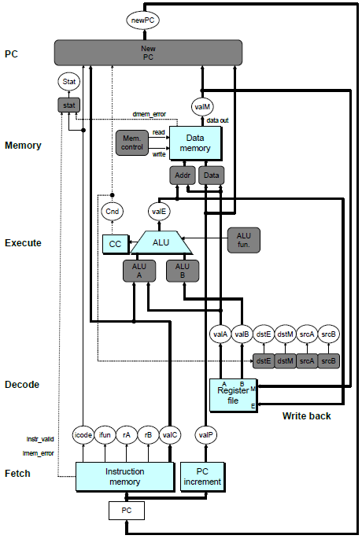

|  |  |
| --- | --- |
| **Question 8 (10 points)** |  |

Using Y86-64 instruction encoding (in Appendix), fill in the boxes below.

(*Note*: You may or may not need all 10 bytes (boxes) for Question (2).)

|  |  |  |  |  |  |  |  |
| --- | --- | --- | --- | --- | --- | --- | --- |
| byte | | | 0 | 1 |  |  | |
| (1) |  |  | 62 | 63 | → | andq %rsi, %rbx | | | | | | | | | | | |
|  |  |  |  |  | Disassemble |  | | | | | | | | | | | |
|  |  |  |  |  | byte | | 0 | | 1 | 2 | 3 | 4 | 5 | 6 | 7 | 8 | 9 |
| (2) | jne 0x277 | | | | → | | 74 | | 77 | 02 | 00 | 00 | 00 | 00 | 00 | 00 | - |
|  |  | | | | Assemble | |  | |  |  |  |  |  |  |  |  |  |

|  |  |
| --- | --- |
| **Question 9 (20 points)** |  |

Please fill the following computation table of the Y86-64 SEQ implementation for pushq instruction. We already filled the fetch stage for you as an example. Use the following variables ONLY: valA, valB, valC, valE, valM, valP, PC, Register value, and Memory value.

|  |  |  |  |  |
| --- | --- | --- | --- | --- |
| pushq rA | A | 0 | rA | F |

(*Notes* – Use the following notations: Concatenation: “:”

Assignment: “←”

Register value: “R[*registerName*]”

Memory value: “M*size*[*memoryAddress*]”)

|  |  |
| --- | --- |
| Fetch | icode:ifun ← M1[PC]  rA:rB ← M1[PC+1]  valP ← PC+2 |
| Decode | valA ← R[rA]  valB ← R[%rsp] |
| Execute | valE ← valB + (-8) |
| Memory | M8[valE] ← valA |
| Write back | R[%rsp] ← valE |
| PC update | PC ← valP |

|  |  |
| --- | --- |
| **Question 10 (14 points)** |  |

The following figure shows the memory stage of the Y86-64 SEQ implementation.

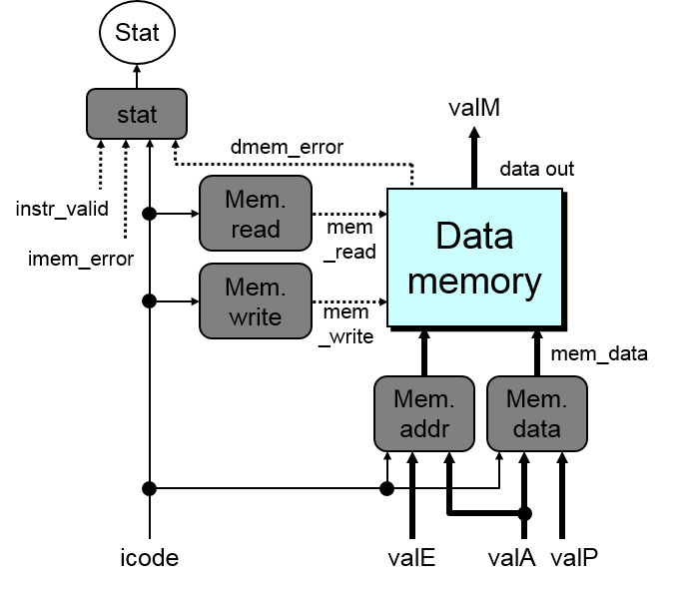

1. Write down an HCL code for the signal mem_write.

|  |  |  |
| --- | --- | --- |
| bool mem_write = | icode in {IRMMOVQ, IPUSHQ, ICALL} | ; |

1. Write down an HCL code for the signal mem_data.

|  |  |  |
| --- | --- | --- |
| word mem_data = | [  icode in {IRMMOVQ, IPUSHQ} : valA;  icode == ICALL : valP;  # Default: Don’t write anything  ] | ; |

|  |  |
| --- | --- |
| **Question 11 (20 points)** |  |

We’d like to add test instruction to the Y86-64 sequential implementation;

|  |  |  |  |  |
| --- | --- | --- | --- | --- |
|  | icode:fn | | rA:rB | |
| test rA, rB | C = ITEST | 0 | rA | rB |

How should the control signals be modified in the Execute stage? Write down your code for the following four signals: SetCC, ALUA, ALUB, ALUfunc. We provide you with the original code for your reference.

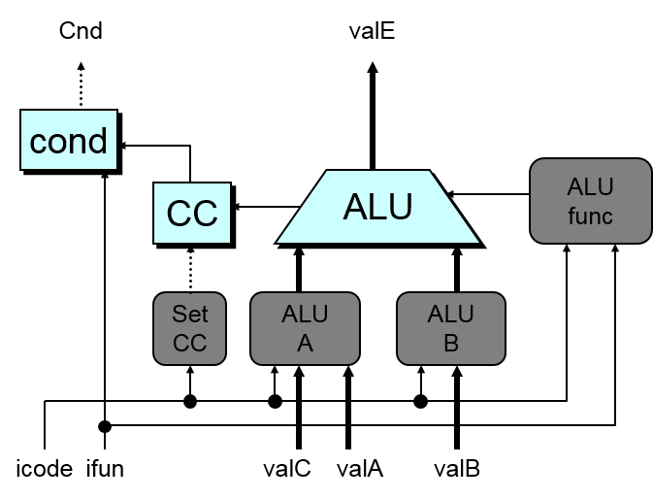

|  |  |  |
| --- | --- | --- |
|  | Original code | Your code |
| **ALU A** | word aluA = [  icode in {IRRMOVQ, IOPQ} : valA;  icode in {IIRMOVQ, IRMMOVQ,  IMRMOVQ} : valC;  icode in {ICALL, IPUSHQ} : -8;  icode in {IRET, IPOPQ} : 8;  ]; | word aluA = [  icode in {IRRMOVQ, IOPQ, **ITEST**} : valA;  icode in {IIRMOVQ, IRMMOVQ,  IMRMOVQ} : valC;  icode in {ICALL, IPUSHQ} : -8;  icode in {IRET, IPOPQ} : 8;  ]; |
| **ALU B** | word aluB = [  icode in {IRMMOVQ, IMRMOVQ,  IOPQ, ICALL, IPUSHQ,  IRET, IPOPQ} : valB;  icode in {IRRMOVQ, IIRMOVQ} : 0;  ]; | word aluB = [  icode in {IRMMOVQ, IMRMOVQ,  IOPQ, ICALL, IPUSHQ,  IRET, IPOPQ, **ITEST**} : valB;  icode in {IRRMOVQ, IIRMOVQ} : 0;  ]; |
| **ALU func** | word alufun = [  icode == IOPQ : ifun;  1 : ALUADD;  ]; | word alufun = [  icode == IOPQ : ifun;  **icode == ITEST : 2;** (=ALUAND)  1 : ALUADD;  ]; |
| **Set CC** | bool set_cc = icode in {IOPQ}; | bool set_cc = icode in {IOPQ, **ITEST**}; |

Appendix A: Y86-64 (Instruction Set)

|  |  |  |  |  |  |  |  |  |  |  |  |  |  |  |  |
| --- | --- | --- | --- | --- | --- | --- | --- | --- | --- | --- | --- | --- | --- | --- | --- |
| Instruction | icode:fn | | rA:rB | |  | | | | | | | | | | |
| byte | 0 |  | 1 |  | | 2 | 3 | 4 | 5 | | 6 | 7 | 8 | | 9 |
| halt | 0 = IHALT | 0 |  |  | | | | | | | | | | | |
|  |  |  |  |  |  | | | | |
| nop | 1 = INOP | 0 |  |  |  | | | | | | | | | | |
|  |  |  |  |  |  | | | | | | | | | | |
| cmovXX rA, rB | 2 = IRRMOVQ | fn |  |  |  | | | | | | | | | | |
|  |  |  |  |  |  | | | | | | | | | | |
| rrmovq |  | 0 |  |  |  | | | | | | | | | | |
| cmovle |  | 1 |  |  |  | | | | | | | | | | |
| cmovl |  | 2 |  |  |  | | | | | | | | | | |
| cmove |  | 3 |  |  |  | | | | | | | | | | |
| cmovne |  | 4 |  |  |  | | | | | | | | | | |
| cmovge |  | 5 |  |  |  | | | | | | | | | | |
| cmovg |  | 6 |  |  |  | | | | | | | | | | |
|  |  |  |  |  | 9 | | | | | | | | | | |
| irmovq V, rB | 3 = IIRMOVQ | 0 | F | rB | V | | | | | | | | | | |
|  |  |  |  |  |  | | | | | | | | | | |
| rmmovq rA, D(rB) | 4 = IRMMOVQ | 0 | rA | rB | D | | | | | | | | | | |
|  |  |  |  |  |  | | | | | | | | | | |
| mrmovq D(rB), rA | 5 = IMRMOVQ | 0 | rA | rB | D | | | | | | | | | | |
|  |  |  |  |  |  | | | | | | | | | | |
| OPq rA, rB | 6 = IOPQ | fn | rA | rB |  | | | | | | | | | | |
|  |  |  |  |  |  | | | | | | | | | | |
| addq |  | 0 |  |  |  | | | | | | | | | | |
| subq |  | 1 |  |  |  | | | | | | | | | | |
| andq |  | 2 |  |  |  | | | | | | | | | | |
| xorq |  | 3 |  |  |  | | | | | | | | | | |
|  |  |  |  |  | 8 | | | | | | | | |  | |
| jXX Dest | 7 = IJXX | fn | Dest | | | | | | | | | | |  | |
|  |  |  |  |  |  | | | | | | | | | | |
| jmp |  | 0 |  |  |  | | | | | | | | | | |
| jle |  | 1 |  |  |  | | | | | | | | | | |
| jl |  | 2 |  |  |  | | | | | | | | | | |
| je |  | 3 |  |  |  | | | | | | | | | | |
| jne |  | 4 |  |  |  | | | | | | | | | | |
| jge |  | 5 |  |  |  | | | | | | | | | | |
| jg |  | 6 |  |  |  | | | | | | | | | | |
|  |  |  |  |  | 8 | | | | | | | | |  | |
| call Dest | 8 = ICALL | 0 | Dest | | | | | | | | | | |  | |
|  |  |  |  |  |  | | | | | | | | | | |
| ret | 9 = IRET | 0 |  |  |  | | | | | | | | | | |
|  |  |  |  |  |  | | | | | | | | | | |
| pushq rA | A = IPUSHQ | 0 | rA | F |  | | | | | | | | | | |
|  |  |  |  |  |  | | | | | | | | | | |
| popq rA | B = IPOPQ | 0 | rA | F |  | | | | | | | | | | |

|  |  |  |  |  |  |  |  |
| --- | --- | --- | --- | --- | --- | --- | --- |
| Register encoding | | | | | | | |
| 0 | 1 | 2 | 3 | 4 | 5 | 6 | 7 |
| %rax | %rcx | %rdx | %rbx | %rsp | %rbp | %rsi | %rdi |
| 8 | 9 | A | B | C | D | E | F |
| %r8 | %r9 | %r10 | %r11 | %r12 | %r13 | %r14 | No register |

Appendix B: X86-64 assembly

**Common instructions**

**mov** src, dst dst = src

**movsbl** src, dst byte to int, sign-extend

**movzbl** src, dst byte to int, zero-fill

**lea** addr, dst dst = addr

**add** src, dst dst += src

**sub** src, dst dst -= src

**imul** src, dst dst *= src

**neg** src, dst dst = -dst(arith inverse)

**sal** count, dst dst <<= count

**sar** count, dst dst >>= count(arith shift)

**shr** count, dst dst >>= count(logical shift)

**and** src, dst dst &= src

**or**  src, dst dst |= src

**xor** src, dst dst ^= src

**not** dst dst = ~dst(bitwise inverse)

**cmp** a, b b - a, set flag

**test** a, b a & b, set flag

**jmp** label jump to label(unconditional)

**je**  label ZF equal/zero

**jne** label ~ZF not equal/zero

**js**  label SF negative

**jns** label ~SF nonnegative

**jg**  label ~(SF^OF)&~ZF greater(signed)

**jge** label ~(SF^OF) greater or equal(signed)

**jl**  label (SF^OF) less(signed)

**jle** label (SF^OF)|ZF less or equal(signed)

**ja**  label ~CF&~ZF above(unsigned)

**jb**  label CF below(unsigned)

**push** src add to top of stack

Mem[--%rsp] = src

**pop**  dst remove top from stack

dst = Mem[%rsp++]

**call** fn push %rip, jump to fn

**ret**  pop %rip



**Instruction suffixes**

**b** byte

**w** word; 2 bytes

**l** double word; 4 bytes

**q** quad word; 8 bytes

Suffix is elided when can be inferred from operands. e.g. %rax implies q, %eax implies l.

**Condition codes / flags**

**ZF** Zero flag

**SF** Sign flag

**CF** Carry flag

**OF** Overflow flag

**Registers**

**%rip** Instruction pointer

**%rsp** Stack pointer

**%rax** Return value

**%rdi** 1st argument

**%rsi** 2nd argument

**%rdx** 3rd argument

**%rcx** 4th argument

**%r8**  5th argument

**%r9**  6th argument

**%r10, %r11**

Caller-saved registers

**%rbx, %rbp, %r12-15**

Callee-saved registers

**Addressing modes**

Example source operands to **mov**

**Immediate:** mov $0x5, dst

$val

source is constant value

**Register:** mov %rax, dst

%R, R is register

source in %R

**Direct:** mov (%rax), dst

source read from Mem[%R]

**Indirect displacement:**

mov 8(%rax), dst

D(%R), D is displacement

source read from Mem[%R+D]

**Indirect scaled-index:**

mov 8(%rsp,%rcx,4), dst

D(%RB, %RI, S)

source read from Mem[%RB+D+%RI*S]