<Proof>
D(n): the average IPL of a binary tree with n nodes.
Clearly D(0) = 0, D(1)=1.
D(n) =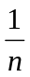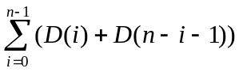 + n
= 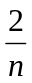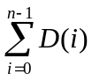+ n
Assume that c>0 s.t. 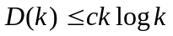 for all k<n.
Then, we verify that 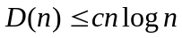. (i.e., 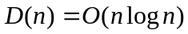)

D(n) = + n
≤ 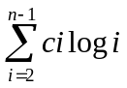 + n + 1 <- D(0), D(1) 분리
≤ 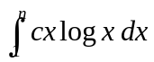 + n + 1
= 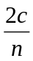(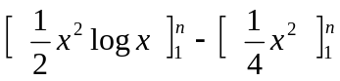) + n + 1
= (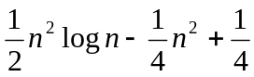) + n + 1
= 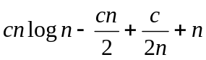 + 1
= 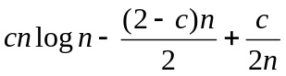+ 1
≤ 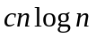 ← We can choose such a c>0 for n≥2.

