**University of Westminster**

School of Electronics and Computer Science

|  |  |
| --- | --- |
| **4COSC003W.Y Computer Science Practice** | |
| Module leader | Maria Chondrogianni |
| Unit | Coursework 2 |
| Weighting: | 60% |
| Qualifying mark | 30% |
| Description | **Data storage and manipulation** |
| Learning Outcomes Covered in this Assignment: | LO3, LO4, LO5, LO6 |
| Handed Out: | 18th June 2017 |
| Due Date | 17th July 2017, 9.00am |
| Expected deliverables | A single document detailing design, implementation and testing of a database |
| Method of Submission: | **online via Blackboard. No hard copies or emails accepted.** |
| Type of Feedback and Due Date: | Generic and written feedback to all students three weeks after submission.  All marks will remain provisional until formally agreed by an Assessment Board. |

**Assessment regulations**

Refer to section 4 of the *How you study* guide for undergraduate students for a clarification of how you are assessed, penalties and late submissions, what constitutes plagiarism etc.

**Penalty for Late Submission**

If you submit your coursework late but within 24 hours or one working day of the specified deadline, 10 marks will be deducted from the final mark, as a penalty for late submission, except for work which obtains a mark in the range 40-49%, in which case the mark will be capped at the pass mark (40%). If you submit your coursework more than 24 hours or more than one working day after the specified deadline you will be given a mark of zero for the work in question unless a claim of Mitigating Circumstances has been submitted and accepted as valid.

It is recognised that on occasion, illness or a personal crisis can mean that you fail to submit a piece of work on time. In such cases you must inform the Campus Office in writing on a mitigating circumstances form, giving the reason for your late or non-submission. You must provide relevant documentary evidence with the form. This information will be reported to the relevant Assessment Board that will decide whether the mark of zero shall stand. For more detailed information, please refer to the [University Assessment Regulations](http://www.westminster.ac.uk/study/current-students/resources/academic-regulations).

**Task details:**

**You are required to produce an ERD (Entity Relationship Diagram) for the case study given below using UML notation. The ERD should represent client software training system.**

**For each of the entities in your model, you should clearly identify appropriate attributes and relevant keys.**

**Relationships between entities should be clearly identified and labelled with any assumptions fully documented.**

**You are also required to implement your design as a relational database using MySQL database by creating appropriate SQL scripts and executing them.**

**You should populate your tables with sufficient data to demonstrate execution of four relevant and useful queries.**

**Submission details:**

**You must submit a single pdf document with the following elements:**

1. ***ER diagram for* software training system *– a sample diagram is given at the end of case study. You are advised to use the entity table shown after the sample ERM to ensure that for each and every entity, a primary key is identified and a foreign key where necessary*.**
2. ***SQL table creation scripts.***
3. ***SQL scripts showing the sample data you have inserted into your database - a sample script file is shown on the last page.***
4. ***Four SQL query scripts that demonstrate some useful functionality of the system, with an explanation of their rationale/use. The SQL should be provided, together with a screen print of the output it produces. Use the table on the last page to document your queries.***

**Coursework Case study**

Software Training House (STH) is a specialist company in providing software training. The clients are small and large companies as well as local and central government departments who seek these courses for their employees.

The training packages can be in areas such as office software like Microsoft Office to more specialised software like 3D Animation (Maya, 3DMax), motion capture and many more.

Each package cost is based on the level at which it is offered – Basic, Intermediate, Advance or Customised.

Clients book the training packages at least three months in advance and the training can be delivered either at Client’s premises or in STH’s specialist IT labs.

Training carried on STH’s premises can include employees from more than one company attending the same software training.

STH employs a number of experts for the delivery of the training packages and each of them can deliver at least two or more training packages. Experts receive a nominal salary, supplemented by expertise level payment at which each training package is delivered.

Each basic package is worth £200, intermediate is worth £500, advance £1000 and customised in the range £1000 to £3000.

You are tasked with designing a database to record client details, bookings for each client as well as training packages including the experts who delivered it.

**Sample ERM:**

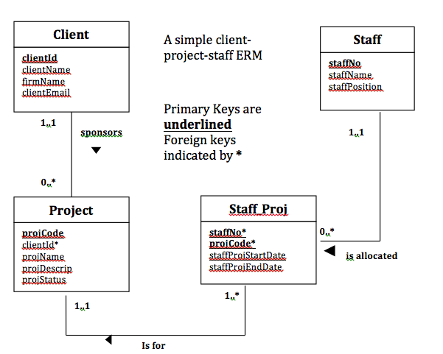

|  |  |  |  |
| --- | --- | --- | --- |
| **Entity** | **Primary Key (PK)** | **Foreign Key (FK)** | **Rationale for PK** |
| Client | clientID | N/A | Client name as alternative possibility but may not scale up and clientID would be unique |
| Staff | staffNO | N/A | StaffNO is unique to each staff |
| Project | projCode | N/A | projCode aunique identifier for each project |
| Staff_Proj | staffNO, projCode | staffNO, projCode | Staff_Proj is a link entity and a minimum PK is a composite key made up of parent PKs as well as being FKs. |

**Sample SQL script file:**

DROP TABLE dept;

CREATE TABLE dept

**(**DEPTNO INT(2),

DNAME VARCHAR(14),

LOC VARCHAR(13),

*CONSTRAINT pk_dept_deptno PRIMARY KEY (DEPTNO)*

**)** ;

Insert into dept (DEPTNO,DNAME,LOC) values (10,'ACCOUNTING','NEW YORK');

Insert into dept (DEPTNO,DNAME,LOC) values (20,'RESEARCH','DALLAS');

Insert into dept (DEPTNO,DNAME,LOC) values (30,'SALES','CHICAGO');

Insert into dept (DEPTNO,DNAME,LOC) values (40,'OPERATIONS','BOSTON');

DROP TABLE emp;

CREATE TABLE emp

**(**EMPNO INT(4),

ENAME VARCHAR(10),

JOB VARCHAR(9),

MGR INT(4),

HIREDATE DATE,

SAL FLOAT(7,2),

COMM FLOAT(7,2),

DEPTNO INT(2),

*CONSTRAINT pk_emp_empno PRIMARY KEY (EMPNO),*

*CONSTRAINT fk_emp_deptno FOREIGN KEY (DEPTNO) REFERENCES dept (DEPTNO)*

**)**;

Insert into emp (EMPNO,ENAME,JOB,MGR,HIREDATE,SAL,COMM,DEPTNO) values (7369,'SMITH','CLERK',7902,STR_TO_DATE('17-12-80','%d-%m-%Y'),800,null,20);

Insert into emp (EMPNO,ENAME,JOB,MGR,HIREDATE,SAL,COMM,DEPTNO) values (7499,'ALLEN','SALESMAN',7698,STR_TO_DATE('20-02-81','%d-%m-%Y'),1600,300,30);

Insert into emp (EMPNO,ENAME,JOB,MGR,HIREDATE,SAL,COMM,DEPTNO) values (7521,'WARD','SALESMAN',7698,STR_TO_DATE('22-02-81','%d-%m-%Y'),1250,500,30);

|  |  |  |  |  |
| --- | --- | --- | --- | --- |
| **Query No** | **Purpose** | **Tables involved** | **SQL** | **Correct Execution** |
| 1 | Show how many projects each member of staff is working on | 1 table – Staff_proj | Select count(*) -------- | Yes/No |
| 2 | To reward long term staff –who have been with the company over 10 years | 1 table - Staff | Date operations – current date (System Date), Date Staff joined, etc, ordered by | Yes/No |
| 3 | Staff who have worked on projects sponsored by a specific client | All 4 tables | 3 joins, etc | Yes/No |
| 4 |  |  |  |  |