Comparative Genomics 2018
Practical 2: Gene prediction
Group number: 6
Group members: Kyle Kimler, Kajetan Juszczak

Summary

- tigr-glimmer long-orfs -n -t 1.15 01.fa 01.long-orf-coords
long-orfs – in order to execute glimmer we need to build a probability model for coding sequence. To build the model program called build-icm is trained on some training sequences. In this case, these sequences are gathered by program long-orfs. This program takes genom as input and outputs long non-overlapping orfs.
-n output file will not have header with program settings
-t we specify the cut-off value for entropy distance score. All the genes with scores bellow cut-off values will not be taken into consideration.
01.fa input file name
01.long-orf-coords output file name
- tigr-glimmer extract -t 01.fa 01.long-orf-coords > 01.longorf
extract – program takes genome and output of long orfs as input and outputs multi fasta file listing parts of genome between coordinates
- t in this case it specify that output will be text file
01.fa input file name – genome
01.long-orf-coords coordinates input file
01.longorf output filename
- tigr-glimmer build-icm -r 01.icm < 01.longorf
build-icm – a program taking the output of extract as input and based on it outputs intrapolated context model(ICM)
-r it means that program is using not only 5’ → 3’ orfs but also 3’ → 5’ orfs for building model
01.icm output filename(model)
01.longorf input filename
- tigr-glimmer glimmer3 -o50 -g110 -t30 01.fa 01.icm 01.glimmer
glimmer3 – program that predicts genes. Takes two files as input – model and sequence to be predicted and output to files name.predict and name.detail
-o50 maximum overlap between genes set to 50
-g110 minimum length of gene set to 110
-t30 sets threshold score for region. If its above the threshold the region is considered potential gene.
01.fa 01.icm inputs (sequence for which genes will be predicted and model respectively)
01.glimmer name of the output file. Two files will be generated each time one with .predict and one with .detail ending.
- Can be taken from some already known genes in the genome found by homology based search or genes can be taken from very similar organisms.
- It is designed for identification of genes in microbial DNA. It does not take into consideration that some stop codons might be within introns so they would not terminate orf.
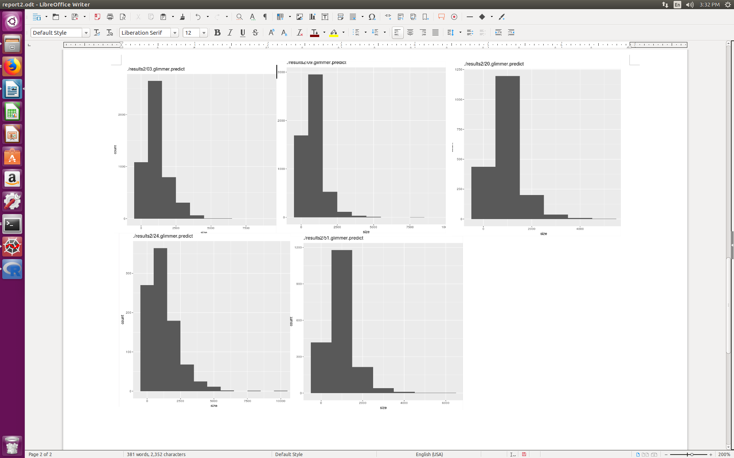
- Histograms
- the graphs are similar in distribution. The difference can be seen in number of genes, it is significantly lower for eukaryotic organism(4th plot - 24).
- Attachment

ex.2
- Attachments
- Attachments
- Protein COS7, alpha-glucoside permease

