Chairable: Powered Spherical Wheel Attachment for Office Chairs

Kaj Grant-Mathiasen | Divyam Sharma | Amrit Mangat | Colin Buchko | Kate Wang

divyams@sfu.ca – August 8th, 2023

Introduction

* An innovative mobile chair concept that eliminates the need for constant standing and sitting
* Offers an engaging and dynamic element to combat tedious deskwork
* Reduce frustration and physical strain caused by repetitive interruptions and standing up to retrieve items
* 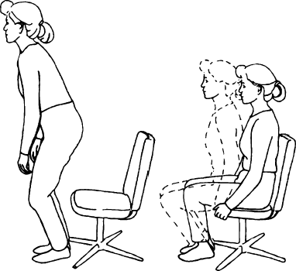A simple alternative for individuals with limited mobility, addressing the challenges faced in the office environment

The Problem

* 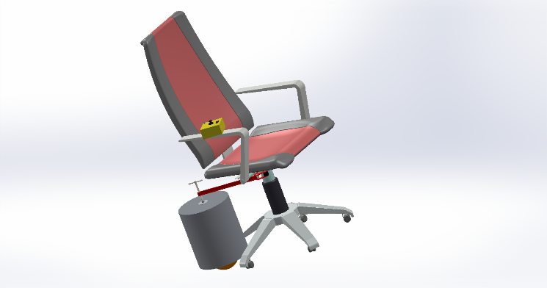Non-intrusive operation of day-to-day movements
* Able to navigate in tight spaces
* Intuitive operation and lightweight design
* Maximum weight capacity of 125kg
* Exploration of spherical wheel design

Solution Design

Chairable consists of 3 main subsystems:

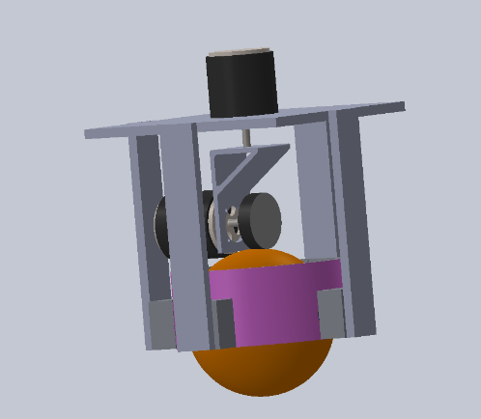1. Mechanical:

* Main driver motor
* Rotational motor
* L bracket mounting system

2. Structural

* Ball bearing system
* Clamp attachment
* Casing and support bars

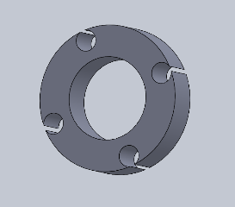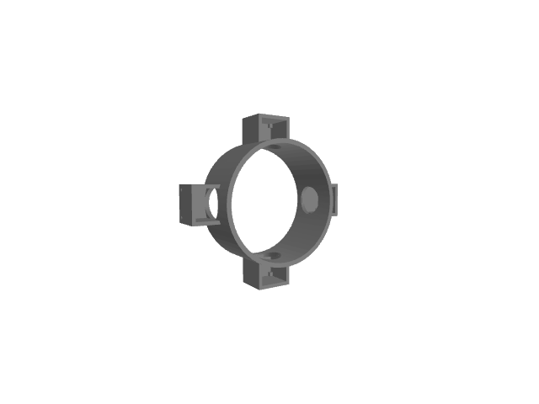

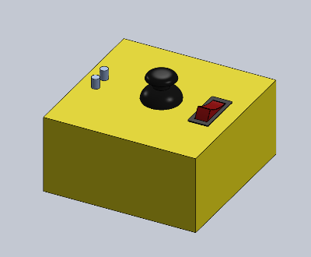3. Electrical

* RF control circuit
* LiPo battery system
* Remote user controller

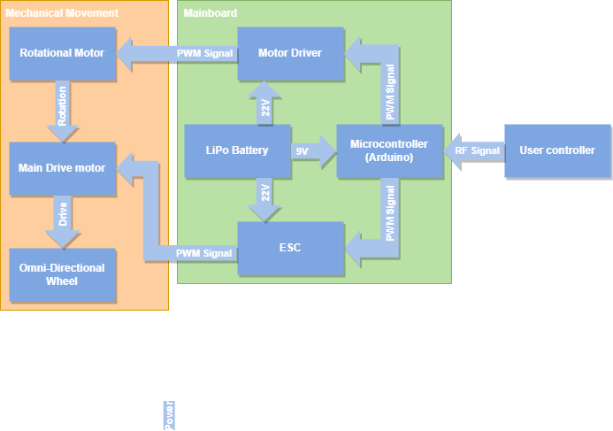

## Research/Results

* Initial testing demonstrates the system’s ability to navigate in all directions
* Brushless RC motor provides an efficient balance between cost and performance
* 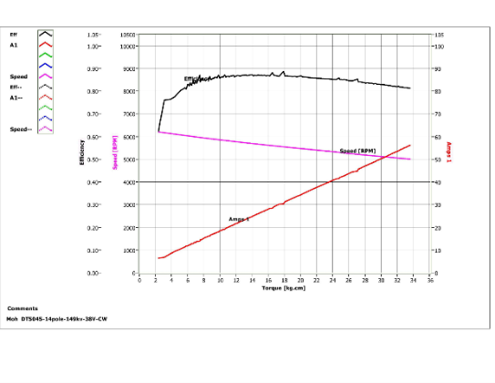Spherical wheel size was chosen to maximize traction
* Calculated gear ratio of a 1 to 4 reduction to limit required torque to 16 kg.cm for a 125kg load

## Conclusion

Chairable’s PoC demonstrates the core principles of the design. Future iterations would see the following improvements:

1. Improve structural attachment to ensure consistent stabilization and downward force
2. Refine mechanical implementation using alternative materials and mounting system
3. Incorporate the use of gearing to ensure compatibility with full weight capacity

## References

[1] Stand to sit / sit to stand, https://iris.hattiesburgclinic.com/patadv/exkit/Body%20Mechanics/English/0040000025mov006_English.html (accessed Aug. 6, 2023).

[2] S. Balsara, “Burnout in the Tech Sector: Why is it happening and what are the solutions?”, IT World Canada, https://www.itworldcanada.com/article/burnout-in-the-tech-sector-why-is-it-happening-and-what-are-the-solutions/485039 (accessed Aug. 6, 2023).

[3] wmj259, “Torque Curves for SK3’s || 6354 260KV || 6374 149KV || 6374 192KV ||,” Electric Skateboard Builders Forum | Learn How to Build your own E-board, Mar. 26, 2017. Available: https://electric-skateboard.builders/t/torque-curves-for-sk3s-6354-260kv-6374-149kv-6374-192k v/19721. [Accessed: Jul. 13, 2023]