**Linux VM 1**

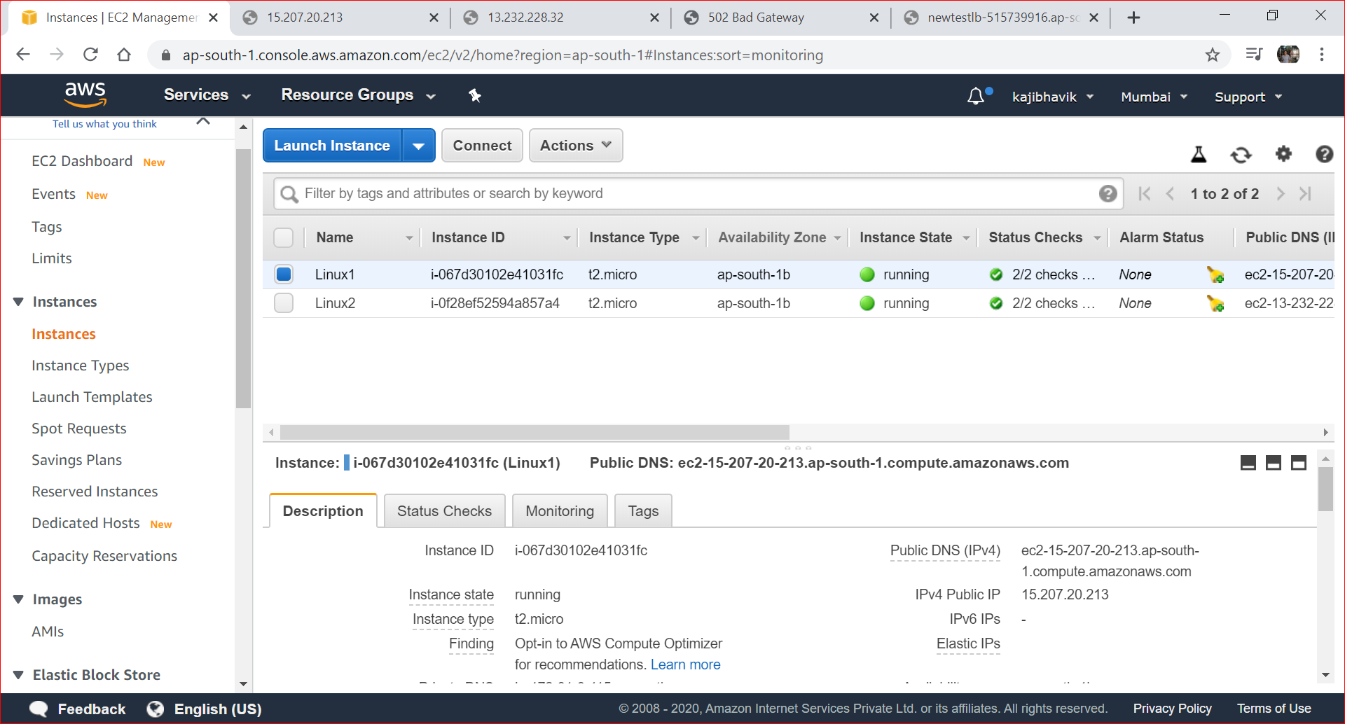

**Linux VM 2**

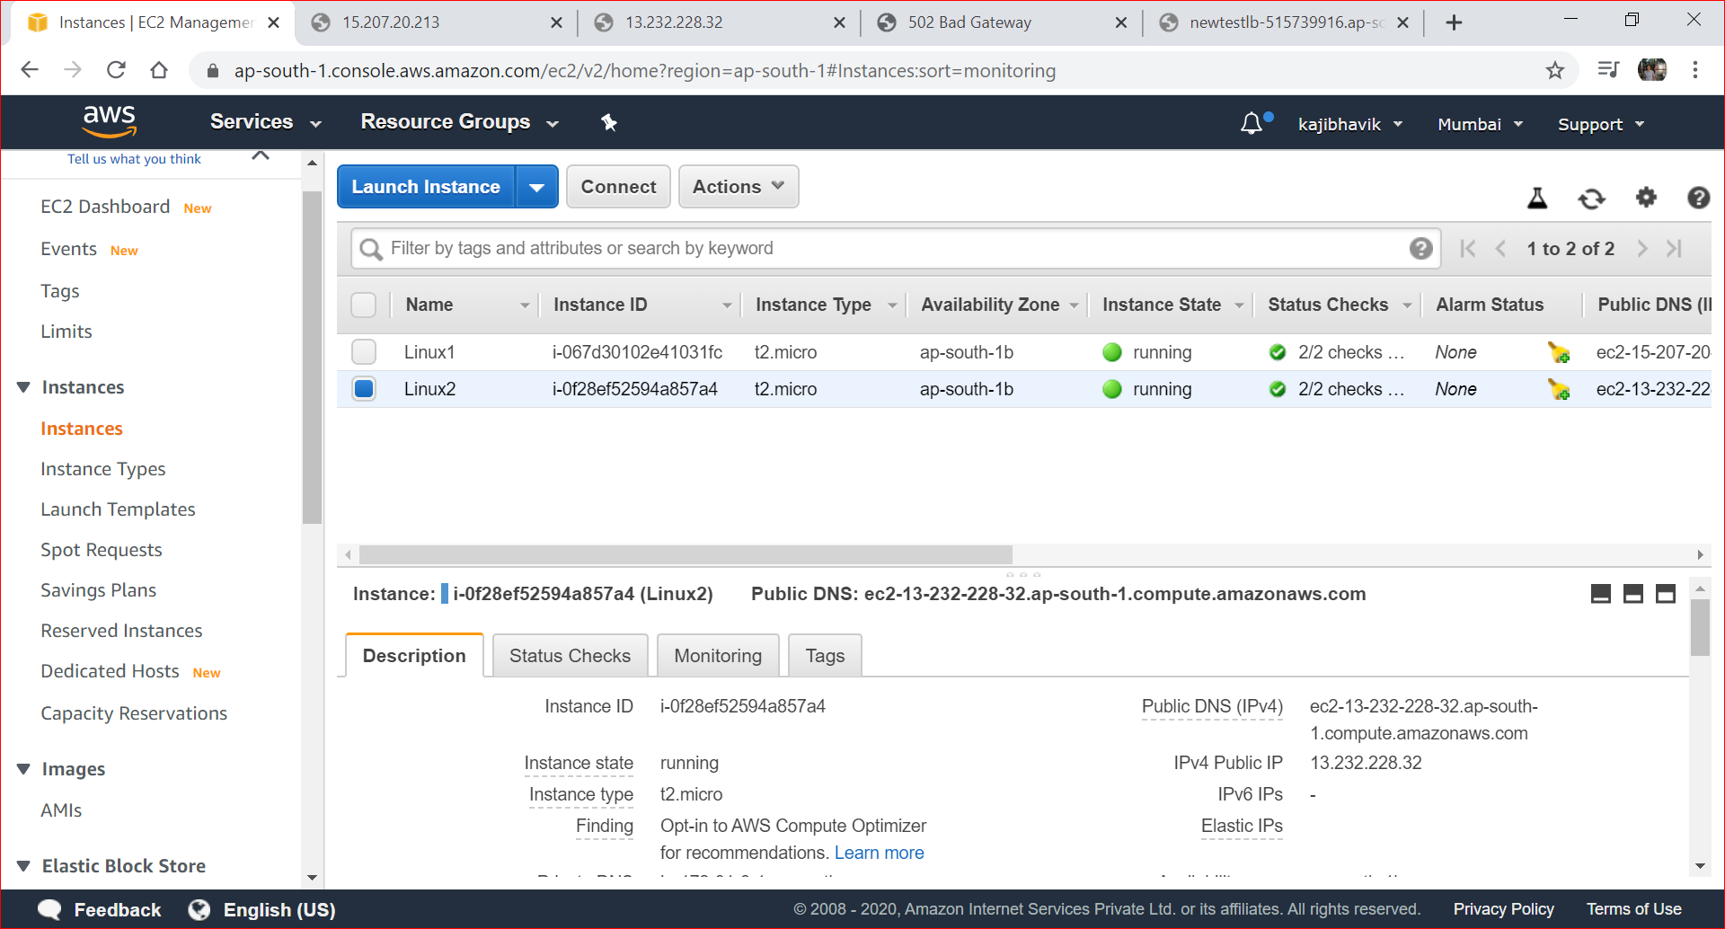

**Load balancer Instance - TestLB**

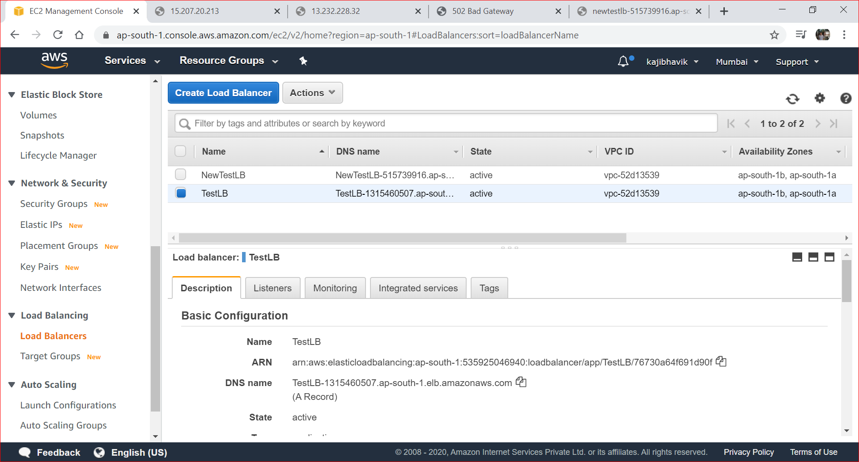

**Website hosted on Linux 1**

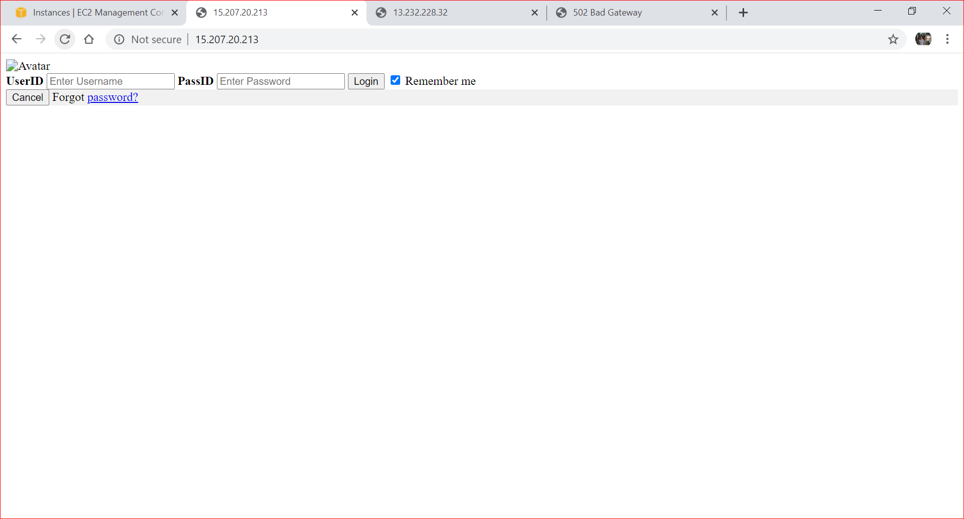

**Website hosted on Linux 2**

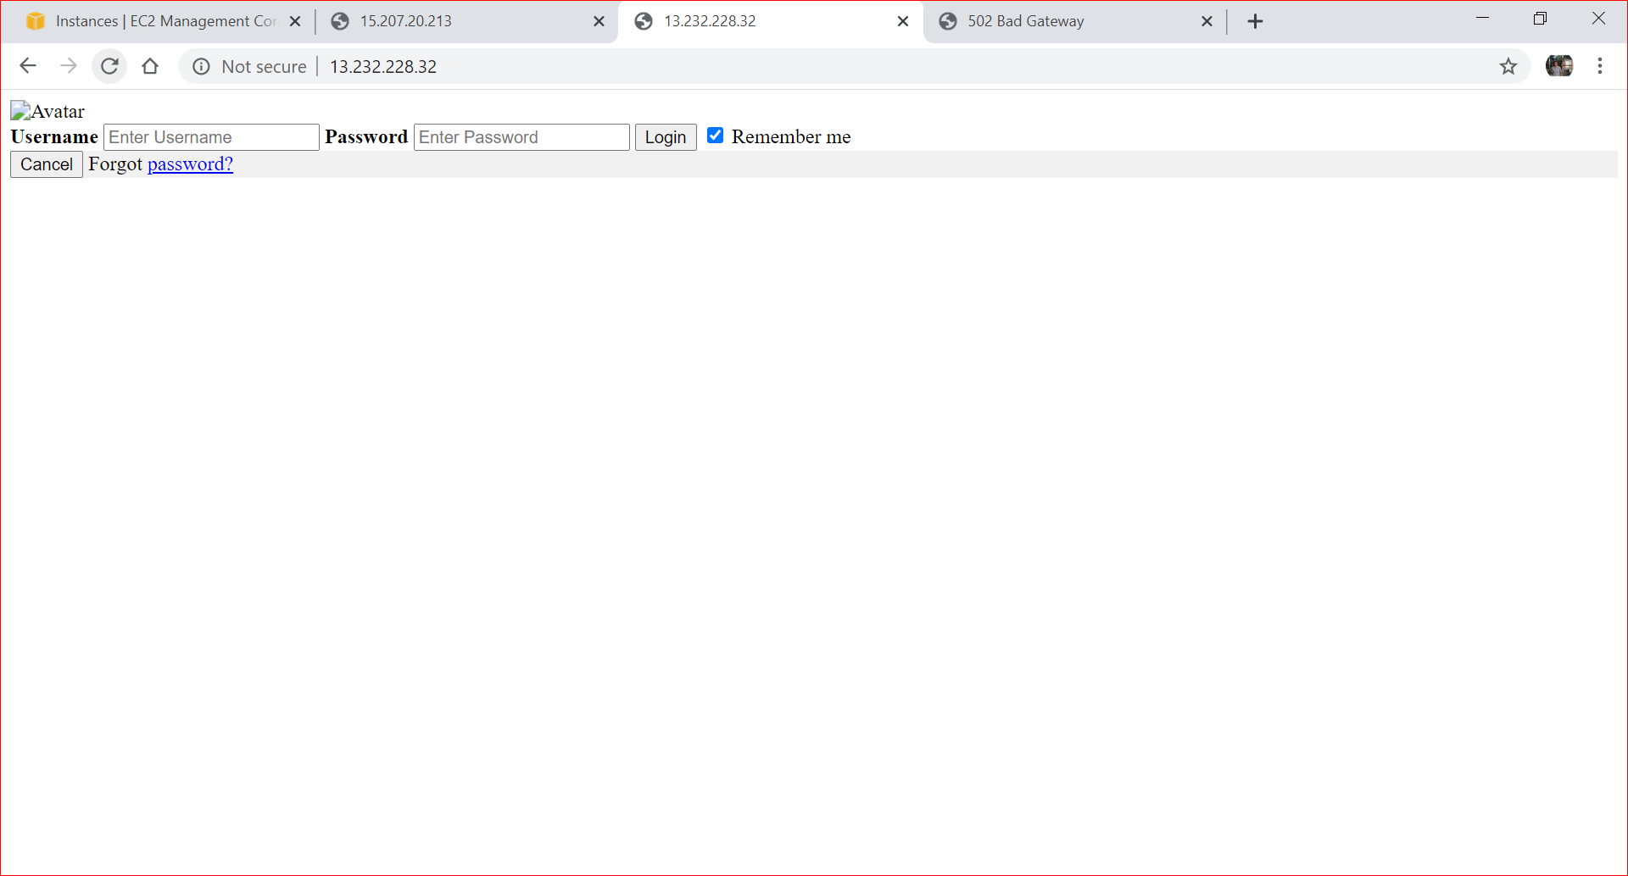

**Website hosted on Linux2 Instance of Load balancer - TestLB**

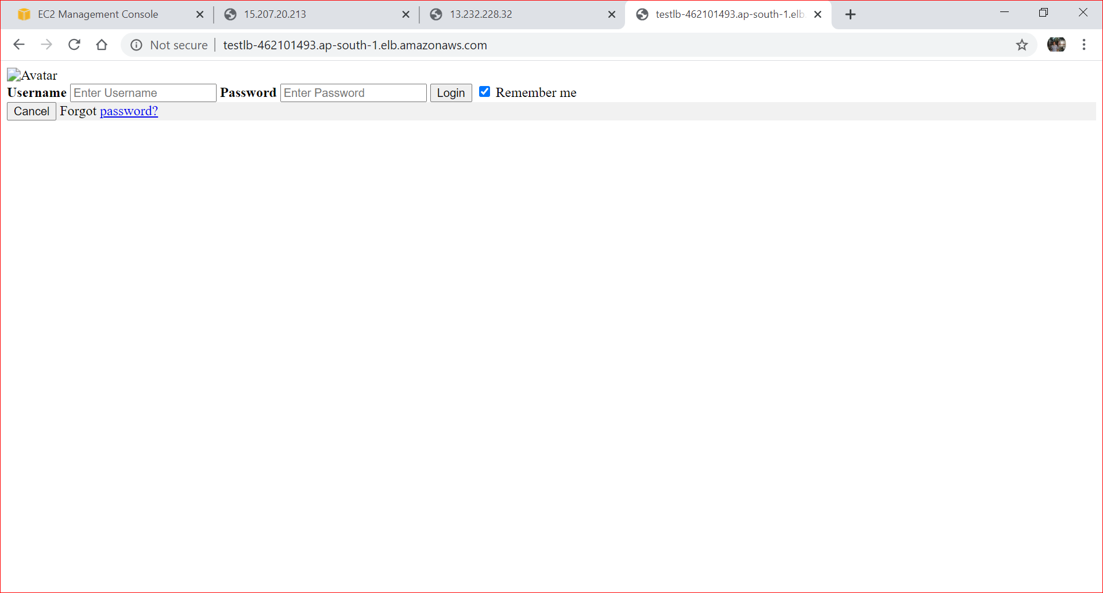

**Website hosted on Linux1 Instance of Load balancer - TestLB**

