**"Schatte ~The Witch and the Fake Shadow~" released on Steam from November 8**

**~It was not likely! 3D action game using light and shadow!!~**

Indie game circle DiceyCraft (representative: Daisuke Kajino) will release the Windows game "Schatte ~ The Witch and the Fake Shadow ~" on Steam from November 8, 2017 .

**■ Landing page**

<http://store.steampowered.com/app/732290/Schatte_The_Witch_and_the_Fake_Shadow/>

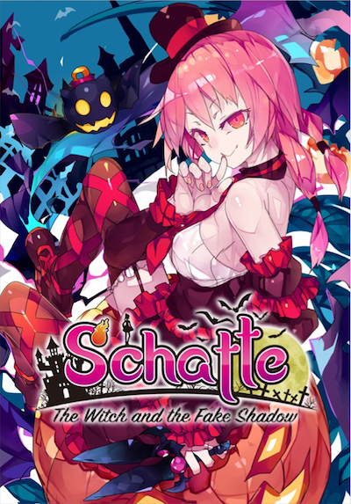

**■ Description**

This is a 3D "Step-on-Shadow" action game of which character you control is "Schatte, The shadow witch" and her fairy servant "Ranta".

You can’t miss the unique system of this game with every action using shadows, which we all once have dreamed of. You will capture the stages by binding shadow to stop the motion, moving in the shadows, even controlling the enemy diving into the shadows, and by using other variety of actions. We believe that our original gimmicks prepared on each stage will offer you a new experience you have never known.

This product is Steam version of "Schatte ~ The Witch and the Fake Shadow ~" distributed by ComicMarket 92.

Currently we are selling on DLSite.com, MelonbooksDL, Melonbooks, Toranoana etc.

**■ Features**

・"Various action using light and shadow" and "Unique gimmick"

・Graphic and sound that produces a little eerie and pretty fantasy

・Switchable between Japanese and English

・This product was made by one person

■ **Price**: $14,99(USD)

■ **Genre**: Action

■ **Platform** : Windows 10

■ **Press Kit**

You can download materials such as screenshots and logos from the URL below.

<http://press.diceycraft.info/steam201711/index.html>

**■ After that**

We are planning to expand to consumer games in 2018 and preparing for it.