Inventory Management

System

Tables’s snap and other outputs

Dbms.mini.project

# TABLE SNAPS

1. **EMPLOYEE TABLE**

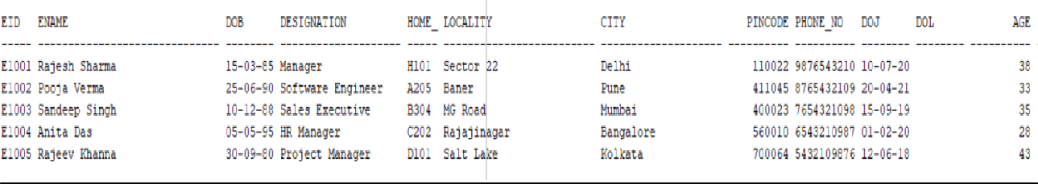

1. **SUPPLIER TABLE**

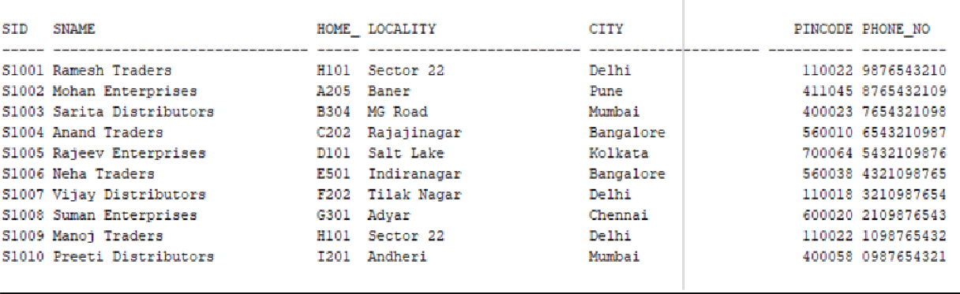

1. **CUSTOMER TABLE**

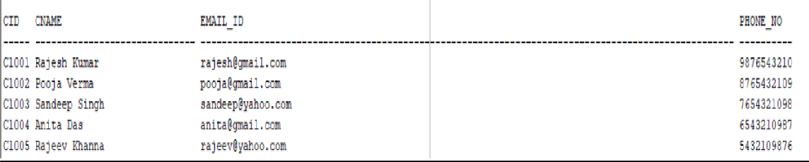

1. **STOCK TABLE**

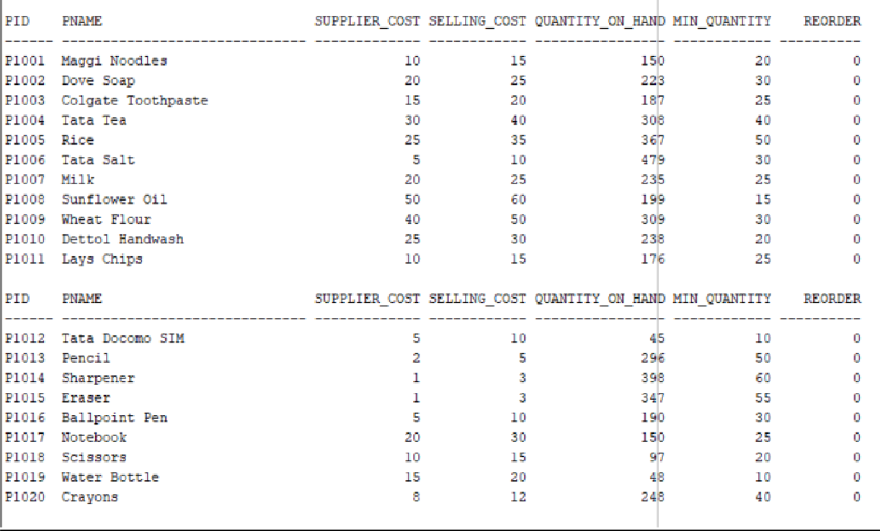

1. **BILL ITEMS TABLE**

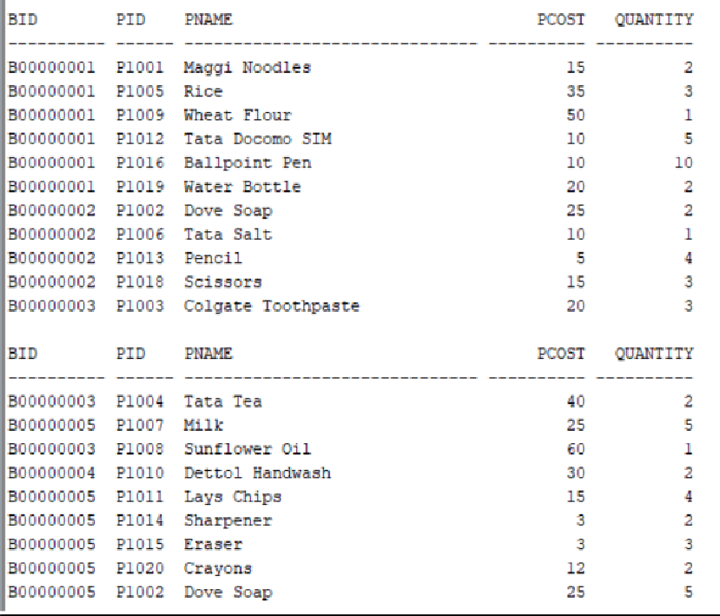

1. **BILL TABLE**

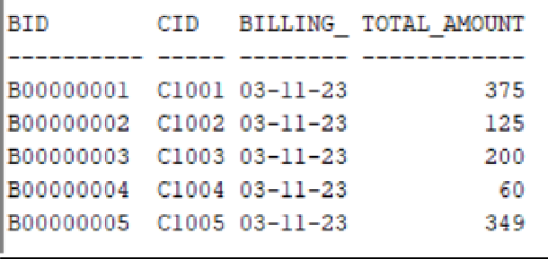

1. **SUPPLIED TABLE**

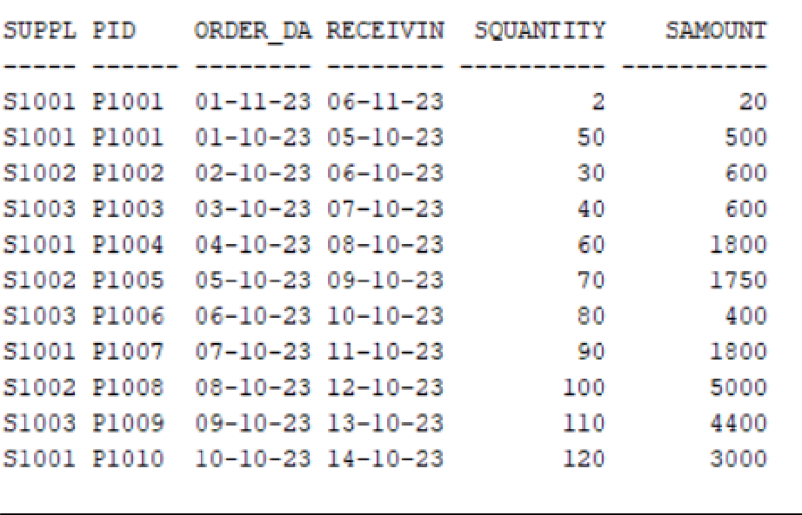

1. **EMP SALARY TABLE**

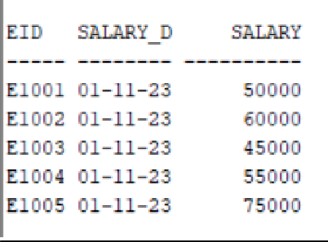

# OTHER OUTPUTS:

EXECUTING PROCEDURE TO GET TOTAL PROFIT OF PARTICULAR MONTH AND YEAR

SET SERVEROUTPUT ON;

BEGIN DECLARE

result NUMBER; BEGIN

CalculateTotalProfit(10, 2023, result); DBMS_OUTPUT.PUT_LINE('Total Profit: ' || result); EXCEPTION

WHEN OTHERS THEN

DBMS_OUTPUT.PUT_LINE('An error occurred: '); END;

END;

/

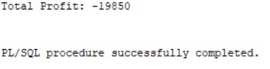

(AS NO SELL IN OCT)

REDUCE QUANTITY OF PRODUCT IN STOCK WHEN PRODUCT IS PURCHASED AND IF QUANTITY ON HAND IS MIN THAN REQUIRED MIN QUANTITY THAN REORDER WILL BE 1 FROM 0

BEFORE:



AFTER INSERTING A TUPLE IN BILL ITEMS:

INSERT INTO Bill_Items (bid, pid, quantity) VALUES ('B00000006', 'P1001', 5);

SELECT * FROM STOCK;



INCREASE QUANTITY OF PRODUCT IN STOCK WHEN PRODUCT IS SUPPLIED AND IF QUANTITY ON HAND IS MAX THAN REQUIRED MIN QUANTITY THAN REORDER WILL BE 0 FROM 1

BEFORE :



AFTER :

INSERT INTO supplied (supplier_id, pid, order_date, squantity) VALUES ('S1001', 'P1001', TO_DATE('2023-11-02', 'YYYY-MM-DD'), 5);

UPDATE supplied

SET receiving_date= TO_DATE('07-11-23', 'DD-MM-YY')

WHERE supplier_id = 'S1001' AND pid = 'P1001' and order_date=TO_DATE('01-11-23', 'DD-MM-YY');

select * from stock;



CALCULATING AGE FROM DATE OF BIRTH

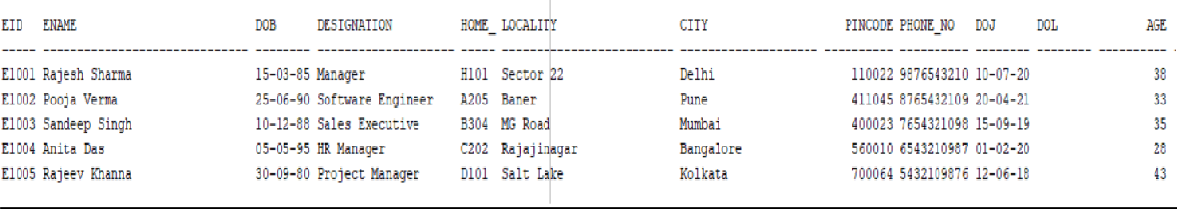

GENERATE COST AND NAME OF THE PRODUCT IN BILL ITEMS FROM BID

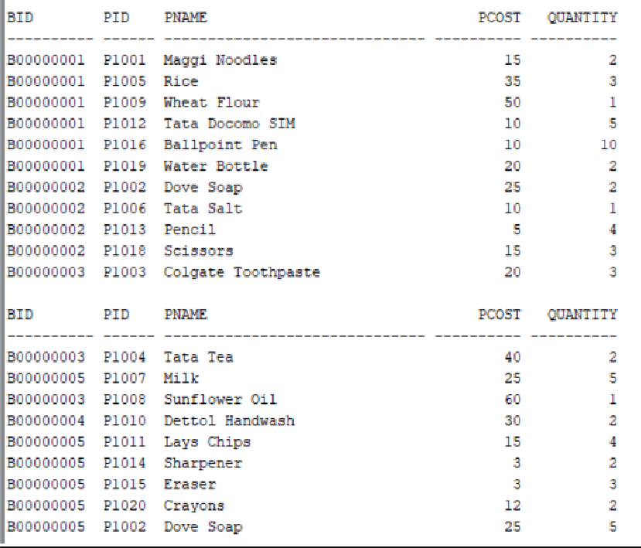

CALCULATE TOTAL AMOUNT OF BILL AND FILL THE BILLING DATE AS CURRENT DATE IN BILL TABLE

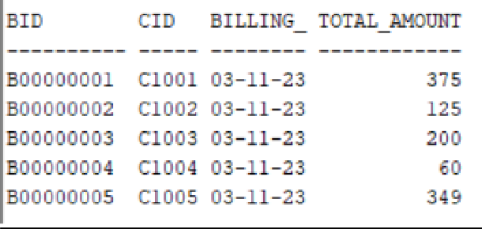

FILL SALARY AUTOMATECALLY IN EMP SALARY

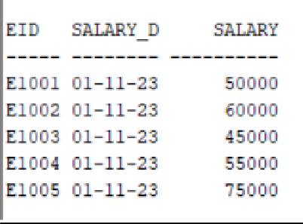

FILL AMOUNT THAT IS GIVEN TO SUPPLIER BASED ON

PRODUCT’S QUNATITY AND BUYING COST FROM SUPPLIER

