Website Pages

* Home
* About – The Witch

The Drawer

Disclaimer

* Services
* Shamanic Energy Healing
* Ceremonial Clearings & Healings
* House and Space Clearings
* Weddings, Funerals and Events
* Events
* Shop –

Home Deco:

* Dream Catchers
* Activated Dream Catchers
* Channeled Art
* Crystals (coming soon)

Women’s Self-Care

* Crystal Yoni Egg
* Crystal Dearmouring Wand
* Blog
* Join the tribe – Newsletter, emails
* Subcribe private fb group $9.95 pm
* Connect

**Home –**

Are you ready to unlock the Magic within?

(sign up to newlsetter option link to ‘Join the Tribe’ )

– latest blgo post and shop items

Links to instagram and facebook

Instagram: thewitchesdrawer

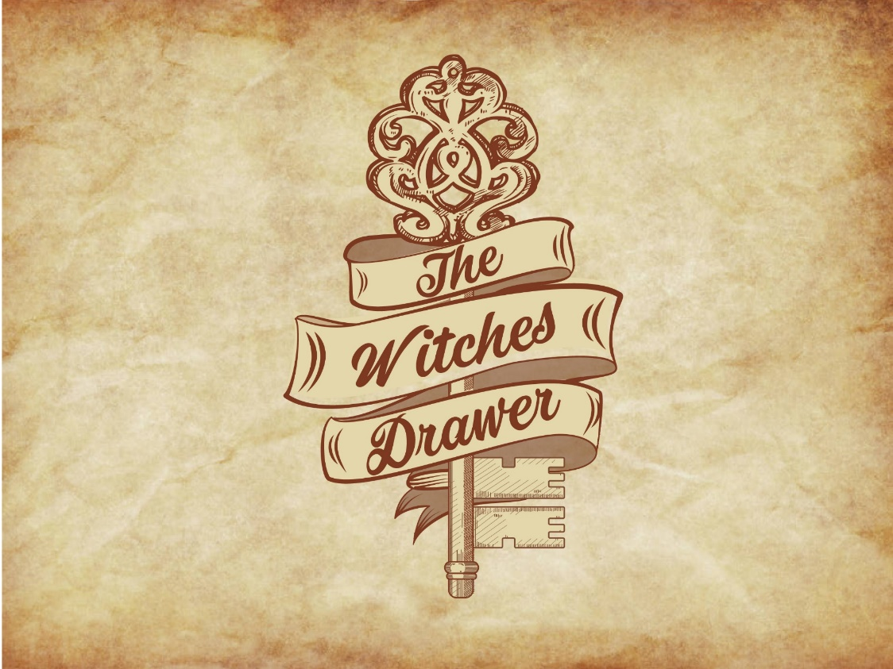

**The Drawer –**

The Witches Drawer is a space intentionally dedicated to the health of the soul on all levels

With an array of unique Home Décor, Art and Products that are here to support and inspire your heart and all your magical and self love needs

The Witches Drawer has also been birthed as a portal for energy healing and holistic health hosting events, programs and services both off and online, with the intention to create space for education, connection. community and healing as we remember the power of who we are and discuss the various alternative paths of healing that are available to us

So whether it is through one of our soulful sound healing journeys in person or perhaps through one of the unique crystal activated dreamcatchers or products we have specially put together, the witches drawer is here to support you on your journey of unlocking the magic that lies within your being

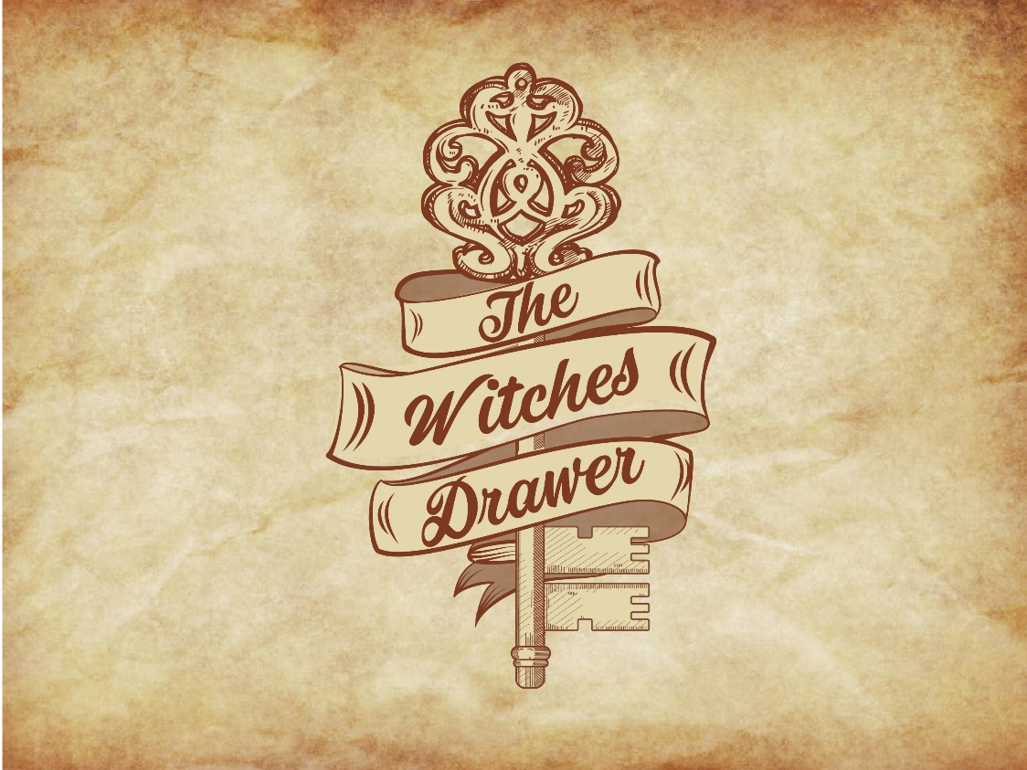

**The Witch –**



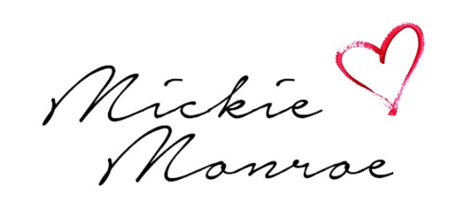

Mickie Monroe is a Tantra and Yoga Practitioner, Shamanic and Intuitive Healer and all round Galactic Goddess here to bring you transmissions of love and truth.

As a trained Yin Yoga Teacher, Tantra Practitioner, Shamanic Energy and Sound Healer, Spiritual Channel and Card Reader, Mickie speaks directly to your soul, moving into whatever is needed for your empowerment as well as human potential.

With a mystical depth and a unique ability to tune into the Magic that is available to all of us, weaving ancient wisdom with a modern day approach so we can integrate all things to do with love, sex and the universe.

Whether it's facilitating workshops, classes and events or working one on one with clients, Mickie has the intuitive ability to see exactly what is needed and to move from that space in each moment, leaving you feeling inspired, empowered, connected and lighter as your vibrational frequency shifts into higher states.

Her intention is to bring you on the path of your soul and life purpose, so that you may be the potential you came here to be, as you integrate your being mentally, physically, emotionally and spiritually.

Whether you are seeking healing on your path or wanting to learn more about the practices, Mickie Monroe is here to walk with you on your journey to remembering who you truly are on all levels

For more information you can go to

[www.mickiemonroe.com](http://www.mickiemonroe.com)

Social Media:

Facebook Page: Mickie Monroe

Instagram: @thesensualjedi

**Disclaimer:**

The information contained in this website is for general information purposes only. This is not medical advice and for serious medical conditions, we advise you to see your local GP or professional health practitioner. This website is not connected to or affiliated with any religious groups or endorses any beliefs that wrong or condemn and is used for entertainment purposes. The information is provided by The Witches Drawer and while we endeavour to keep the information up to date and correct, we make no representations or warranties of any kind, express or implied, about the completeness, accuracy, reliability, suitability or availability with respect to the website or the information, products, services, or related graphics contained on the website for any purpose. Any reliance you place on such information is therefore strictly at your own risk.  
In no event will we be liable for any loss or damage or issues including without limitation, indirect or consequential loss or damage or issues in connection with information provided on this website. It is the reader’s discretion on how they use the information provided.  
Through this website you are able to link to other websites which are not under the control of The Witches Drawer We have no control over the nature, content and availability of those sites. The inclusion of any links does not necessarily imply a recommendation or endorse the views expressed within them.  
Every effort is made to keep the website up and running smoothly. However, The Witches Drawer takes no responsibility for, and will not be liable for, the website being temporarily unavailable due to technical issues beyond our control

**Services –**

* 1 hr Energy Clearing: $110
* 1.5 hr Reading and Energy Clearing:  $150
* 1 hr Group Clearings/ Journeys available: $90
* Online Distance Reading and Clearing: $90

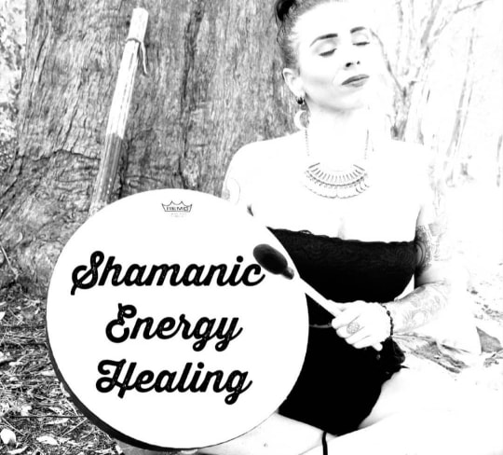

Shamanic Healing -

Shamanism is one of the oldest forms of spirituality that exists within our societies that offers an ancient approach to our health and wellbeing that encompasses all levels of our being and was an integral part of our way of life, with Shamans being honoured and respected within the tribe and community.  
A shaman is commonly known as an individual who travels between this realm and the spirit world to retrieve wisdom, power and energy that can be utilised for the betterment of our lives. Offering deep healing and ceremonial approaches, the Shaman guides the soul along its journey through this life.

If you are ready for overall well being and a deeper sense of peace within yourself, then perhaps this is exactly what you need

A session may include healing modalities such as:  
-soul retrieval and past life clearing  
-ancestral line clearing  
-meeting your spirit guides and animals  
-Balancing of all your energy centres  
– releasing anything that may be in your energy field that may be effecting your health on all levels of mind, body and soul.

Other techniques such as  
-energy clearing  
– sounding healing  
-card reading saging and light language may be used as your higher self guides you to  
exactly what you need in each and every moment.

This is why it is not simply ‘Reiki’  
A shaman speaks directly to the soul and is guided into what is needed in each and every moment, on every layer of your being

This is a truly profound session that will raise your vibrational frequency to bring you into overall wellbeing, leaving you feeling uplifted and connected at the heart.

Who is this for?

– Sufferers of depression and anxiety  
– Lacking energy and passion in life  
– Curious of spiritual ourneying  
– Ready for change in life/ feeling stuck or stagnant  
– Stuck in patterns or behaviours  
– Looking for guidance on a deeper level  
– Suffering physical ailments, mental and emotional issues

In Person Session located in Surfers Paradise, Gold Coast, Queensland, Australia at Chameleon New Age Salon

* Ceremonial Clearings & Healings
* House and Space Clearings
* Weddings, Funerals & Events

**Events**

* Workshops, Classes and Events
* Classes – Yin Yoga
* Events – Monthly Shamanic Sound Healing and Energy Clearing
* Workshop – Tempe of the Yoni

**Shop –**

Dream Catchers – Crystal Activated

* **The Archangel**

This special dreamcatcher has been divinely crystal gridded and activated offering healing vibrations for your beautiful home

It is called ‘Archangel’ as it offers healing from the realms of the archangels who want to support and guide you.

Let the Archangels offer their energy of love and support for you and your home space

Some Archangels you can work with intentionally include: Michaela, Raphael, **(name more)**

**(Picture of dreamcatcher)**

Want to know more on what a Crystal Activated Dream Catcher is and the benefits of having one in your home? - Link to blog post **(write blog post)**

* **The Angel**

Similar to the ‘Archangel’ version, this dream catcher is activated through the power of crystal gridding to offer your space and being the healing vibrations of the angels.

Some Angels that you can intentionally work with include

Let the Angels offer healing and guidance for your being and your surroundings

* **OM**

Healing Dream Catchers –

* **The Owl**

This is a unique dreamcatcher specially made by a Shamanic Healer, with loving intention and healing energy to offer your home not on a unique decoration, but the wisdom of the higher realms as the owl represents higher knowledge and guidance.

Connect with this dreamcatcher in meditation to be guided by your spirit team in attaining the knowledge you seek on your journey

* **Raven**

Colour Options: Black or Beige

* **Zen**

Colour Options: Black or White

* **Moon Child**

This beautiful dreamcatcher tunes into the healing energies offered by nature

* **Tree of Life**
* **Soul Compass**

Let this dream catcher be your guide

Self- Care –

* **Crystal Yoni Egg**
* **Crystal Wand**

* **Connect**

For inquiries and bookings

Email: [thewitchesdrawer@gmail.com](mailto:thewitchesdrawer@gmail.com)

Ph: +61414745784