01-healthy-mesh.png

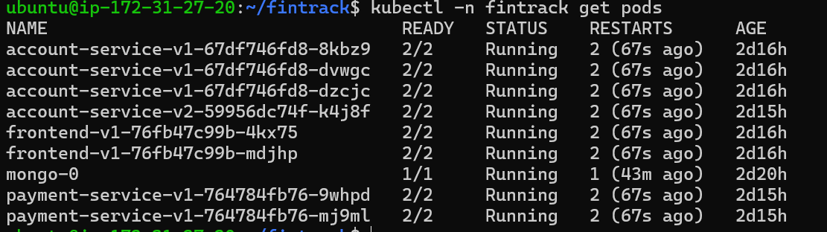
STRICT mTLS rejects a plain-HTTP client from outside the mesh.

02-canary-split.png

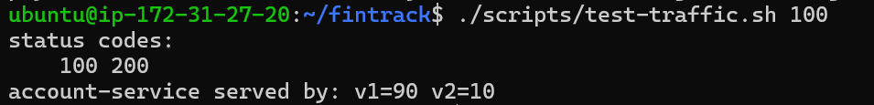

03-phase1-simulation.png

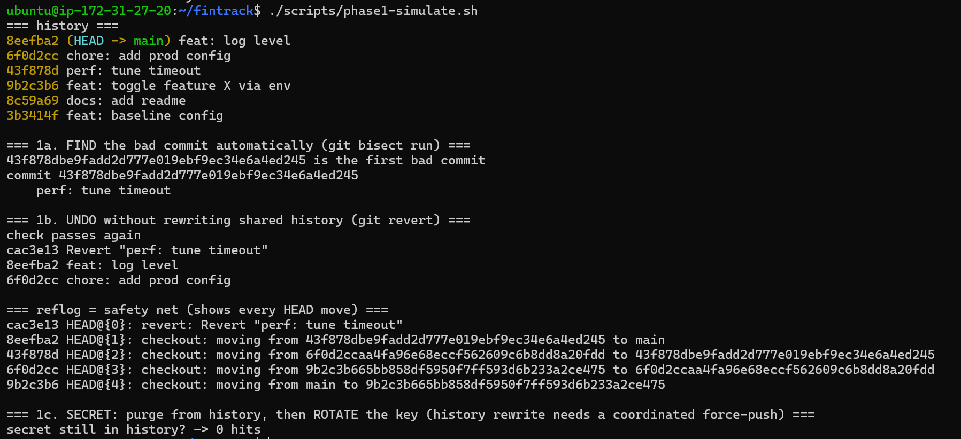

04-mtls-enforced.png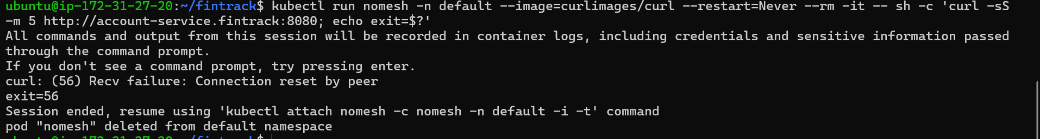

05-namespace-quota.png.