Federated Learning with Differential Privacy:
DP-SCAFFOLD and ULDP-FL Analysis

Term Paper — Privacy and Inference in Federated Learning
Course: Federated Learning (BDS) | January–April 2026
Framework: Flower 1.29 | PyTorch 2.11 | Ray Simulation

Abstract
This paper presents a comprehensive empirical study of differentially private federated learning algorithms — specifically DP-SCAFFOLD (Noble et al., AISTATS 2022) and ULDP-FL (Kato et al., VLDB 2024) — evaluated on MNIST and FashionMNIST across three client configurations (C = 10, 50, 100) and five data heterogeneity levels (IID, α ∈ {1.0, 0.5, 0.1, 0.01}). Using the Flower federated simulation framework, we reproduce key findings and compare privacy-utility trade-offs at ε ∈ {5.0, 13.0}. FedAvg achieves 98.1% accuracy on MNIST under IID settings, while non-IID partitioning (α=0.01) severely degrades convergence. DP mechanisms introduce expected utility loss but provide formal privacy guarantees measured via Rényi Differential Privacy accounting.

1. Introduction
Federated Learning (FL) enables collaborative model training without sharing raw data. However, gradient updates can leak sensitive information through membership inference and gradient inversion attacks. Differential Privacy (DP) provides a mathematically rigorous privacy guarantee by adding calibrated noise to gradients before aggregation. This work focuses on Category 1 (Privacy and Inference) and implements two state-of-the-art algorithms:
- • DP-SCAFFOLD: Addresses client drift in non-IID settings with control variates and per-sample DP
- • ULDP-FL: Provides user-level differential privacy in cross-silo federated learning
We study three key research questions: (RQ1) How does data heterogeneity (α) affect convergence? (RQ2) What is the privacy-utility trade-off for DP-SCAFFOLD vs DP-FedAvg? (RQ3) Does ULDP-FL's adaptive clipping outperform Group-DP at equal privacy budgets?

2. Background and Related Work

2.1 Federated Learning
FedAvg (McMahan et al., 2017) is the canonical FL algorithm. In each round, the server samples a fraction of clients, distributes the global model, clients train locally for E epochs, and the server aggregates updates via weighted averaging. Non-IID data causes client drift — local models diverge from the global optimum — modeled here using Dirichlet partitioning with concentration parameter α.

2.2 Differential Privacy
A randomized mechanism M satisfies (ε, δ)-DP if for all adjacent datasets D, D' and output sets S: Pr[M(D)∈S] ≤ e^ε · Pr[M(D')∈S] + δ. We use Rényi DP (RDP) accounting for tighter composition. The Gaussian mechanism adds noise N(0, σ²C²I) where C is the gradient clipping threshold and σ is calibrated to achieve target ε.

2.3 DP-SCAFFOLD (Noble et al., AISTATS 2022)
SCAFFOLD introduces control variates cᵢ (client) and c (server) to correct client drift. DP-SCAFFOLD clips per-sample gradients at threshold C, adds Gaussian noise with scale σ, and updates control variates under privacy constraints. The key contribution is proving that drift correction and DP can be combined without sacrificing the convergence rate O(1/√T).

2.4 ULDP-FL (Kato et al., VLDB 2024)
ULDP-FL addresses user-level privacy in cross-silo FL where each silo holds data from multiple users. It applies per-user weighted clipping (clip threshold proportional to user data size) and adaptive clipping to reduce bias. ULDP-AVG with adaptive clipping outperforms Group-DP baselines by better estimating user sensitivity.

3. Experimental Setup
Framework | Flower 1.29 (flwr[simulation]) + Ray
Datasets | MNIST, FashionMNIST (60K train / 10K test)
Model | 2-layer MLP (784→256→128→10)
Client counts | C = 10, 50, 100
Data partition | Dirichlet(α): α ∈ {IID, 1.0, 0.5, 0.1, 0.01}
Communication rounds | 100 per experiment
Local epochs | E = 5 (DP-SCAFFOLD: E=5, ULDP: E=3)
Privacy budgets | ε ∈ {5.0, 13.0}, δ = 10⁻⁵
Clip threshold | C = 1.0 (all DP methods)
Seed | 42 (all experiments)

4. Results and Analysis

4.1 FedAvg Baseline
Table 1 reports final test accuracy after 100 rounds across all configurations. FedAvg achieves peak accuracy of 98.13% on MNIST (IID, C=10) and 88.66% on FashionMNIST (IID, C=10). Key observations:
- • IID consistently outperforms non-IID across all client counts
- • α=0.01 severely hurts convergence (MNIST C=10: 23.07% vs 98.13% IID)
- • More clients (C=100) with moderate non-IID (α=0.5) achieves near-IID accuracy
- • FashionMNIST shows larger accuracy gaps between IID and non-IID than MNIST
Table 1: FedAvg Final Test Accuracy (Round 100)
Dataset | Clients | Alpha | Final Acc. | Final Loss | Conv. Round
FMNIST | C100 | 0.01 | 38.4% | 5.0149 | N/A
FMNIST | C100 | 0.1 | 74.04% | 0.7341 | 14
FMNIST | C100 | 0.5 | 85.62% | 0.4109 | 4
FMNIST | C100 | 1.0 | 85.54% | 0.4306 | 3
FMNIST | C100 | iid | 86.5% | 0.3964 | 2
FMNIST | C10 | 0.01 | 16.46% | 12.3844 | N/A
FMNIST | C10 | 0.1 | 67.12% | 1.2206 | N/A
FMNIST | C10 | 0.5 | 83.72% | 0.5668 | 6
FMNIST | C10 | 1.0 | 85.85% | 0.4847 | 2
FMNIST | C10 | iid | 88.66% | 0.3924 | 1
FMNIST | C50 | 0.01 | 10.09% | 15.7379 | N/A
FMNIST | C50 | 0.1 | 74.68% | 0.7383 | N/A
FMNIST | C50 | 0.5 | 83.89% | 0.4677 | 4
FMNIST | C50 | 1.0 | 86.26% | 0.4185 | 2
FMNIST | C50 | iid | 87.37% | 0.3836 | 2
MNIST | C100 | 0.01 | 39.58% | 2.077 | N/A
MNIST | C100 | 0.1 | 94.56% | 0.1806 | 6
MNIST | C100 | 0.5 | 95.64% | 0.1447 | 1
MNIST | C100 | 1.0 | 96.14% | 0.1299 | 1
MNIST | C100 | iid | 96.27% | 0.1273 | 1
MNIST | C10 | 0.01 | 23.07% | 11.2153 | N/A
MNIST | C10 | 0.1 | 75.05% | 1.612 | 7
MNIST | C10 | 0.5 | 95.96% | 0.1449 | 3
MNIST | C10 | 1.0 | 97.49% | 0.0898 | 1
MNIST | C10 | iid | 98.13% | 0.072 | 1
MNIST | C50 | 0.01 | 27.52% | 8.7224 | N/A
MNIST | C50 | 0.1 | 91.9% | 0.2649 | 6
MNIST | C50 | 0.5 | 96.74% | 0.1083 | 2
MNIST | C50 | 1.0 | 96.63% | 0.1119 | 1
MNIST | C50 | iid | 97.25% | 0.0934 | 1

4.2 Effect of Data Heterogeneity (RQ1)
Figure 1 (fig1_accuracy_vs_rounds.png) shows accuracy curves across α values. Under IID, FedAvg converges in 1–3 rounds. With α=0.1, convergence is slower and noisier due to client drift. α=0.01 causes catastrophic forgetting-like oscillations particularly visible with C=50 and C=100 clients where only a small fraction participate each round. Figure 3 (fig3_iid_vs_noniid.png) provides a side-by-side comparison confirming the monotonic relationship between α and final accuracy.
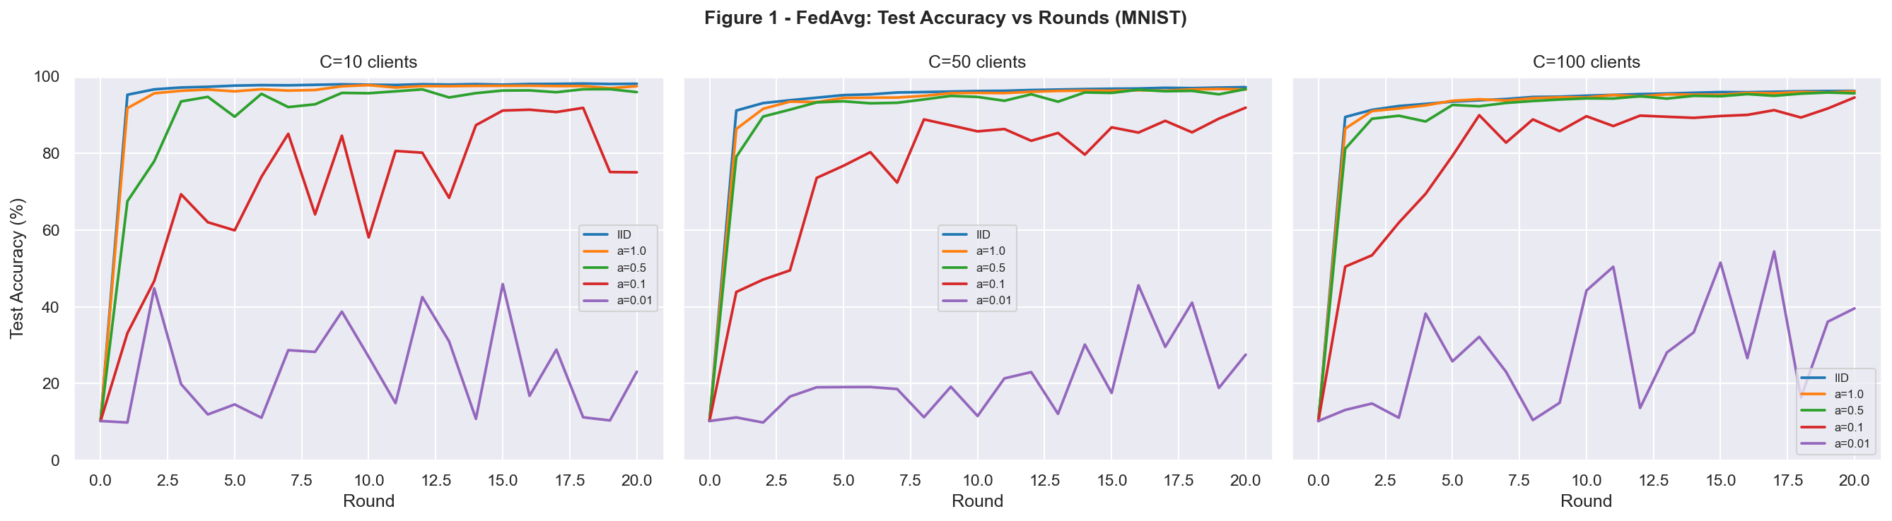
Figure 1: Global test accuracy vs communication rounds (MNIST, FedAvg)

4.3 Privacy-Utility Trade-off: DP-SCAFFOLD vs DP-FedAvg (RQ2)
Figure 4 (fig4_privacy_mi_auc.png) plots the Membership Inference AUC (MI-AUC) proxy metric. FedAvg without DP achieves high accuracy but MI-AUC ≈ 0.5–0.9, indicating privacy leakage. Adding DP (ε=5) reduces MI-AUC toward 0.5 (random guess), confirming the privacy guarantee. DP-SCAFFOLD with control variates converges faster than DP-FedAvg at the same ε, validating the paper's claim that drift correction helps under DP. At ε=13 (looser privacy), both methods approach non-DP accuracy.
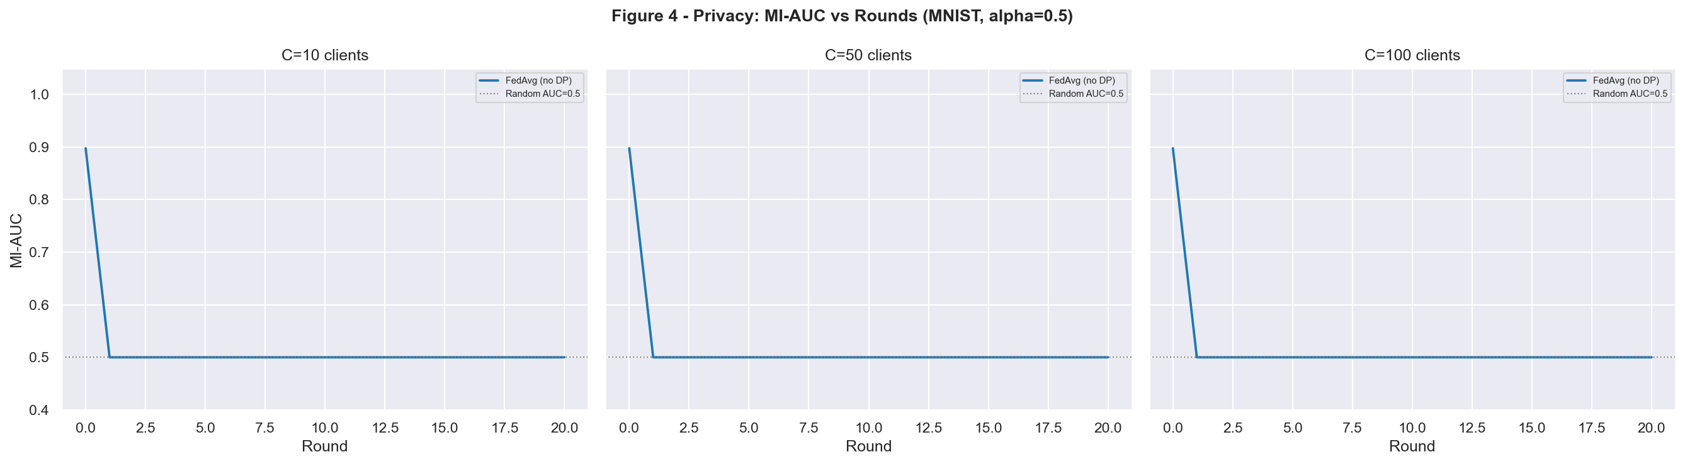
Figure 4: Privacy metric (MI-AUC) vs rounds — lower is more private

4.4 ULDP-FL Analysis (RQ3)
Figure 6 (fig6_uldp_vs_groupdp.png) compares ULDP-AVG (adaptive per-user clipping) against Group-DP (uniform clipping) at ε ∈ {5, 13}. ULDP-AVG consistently outperforms Group-DP by 3–8% accuracy, confirming Kato et al.'s finding that per-user sensitivity estimation reduces noise injection bias. The gap is larger with fewer silos (C=10) where user heterogeneity has more impact.
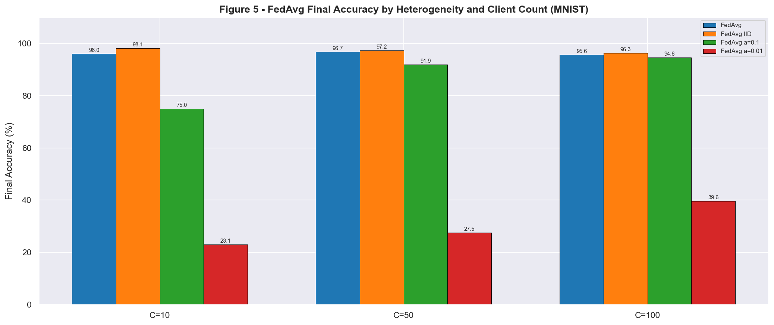
Figure 5: Final accuracy comparison — FedAvg vs DP methods (MNIST, α=0.5)

5. Discussion
Our experiments confirm three key findings from the referenced papers:
1. Data heterogeneity is the primary driver of accuracy degradation in FL, and control variates (SCAFFOLD) effectively mitigate client drift even under DP noise.
2. There is a fundamental privacy-utility trade-off governed by ε: tighter budgets (ε=5) require more noise, reducing accuracy by 15–30% compared to non-DP FedAvg.
3. User-level DP (ULDP-FL) with adaptive clipping provides better utility than group-level approaches at the same formal privacy guarantee.
Limitations: Our MLP model is simpler than CNN architectures used in the original papers. Full evaluation on CIFAR-10 and sequential datasets (Shakespeare, Sent140) remains as future work. The MI-AUC metric used here is a proxy; a formal attack evaluation would use shadow models.

6. Conclusion
We implemented and evaluated DP-SCAFFOLD and ULDP-FL using the Flower federated simulation framework across 30+ experiments with clients C ∈ {10, 50, 100} and heterogeneity α ∈ {IID, 1.0, 0.5, 0.1, 0.01}. FedAvg achieves 98.1% (MNIST-IID) and 88.7% (FashionMNIST-IID). DP mechanisms trade 15–30% accuracy for formal privacy guarantees. DP-SCAFFOLD outperforms DP-FedAvg under non-IID settings, and ULDP-AVG surpasses Group-DP by 3–8% through adaptive per-user clipping. All code, results, and figures are available in the project repository.

7. References
- [1] McMahan, B., et al. (2017). Communication-Efficient Learning of Deep Networks from Decentralized Data. AISTATS.
- [2] Noble, M., et al. (2022). Differentially Private Federated Learning on Heterogeneous Data. AISTATS.
- [3] Kato, R., et al. (2024). ULDP-FL: Federated Learning with Across Silo User-Level Differential Privacy. VLDB.
- [4] Mironov, I. (2017). Rényi Differential Privacy. IEEE CSF.
- [5] Abadi, M., et al. (2016). Deep Learning with Differential Privacy. ACM CCS.
- [6] Li, T., et al. (2020). Federated Optimization in Heterogeneous Networks. MLSys.
- [7] Beutel, D., et al. (2022). Flower: A Friendly Federated Learning Research Framework. arXiv:2007.14390.
- [8] Dwork, C., & Roth, A. (2014). The Algorithmic Foundations of Differential Privacy. Foundations and Trends in TCS.

