Skill Week-9
Task 1: To Connect Modules, Validate Interfaces, Test End-to-End Execution, Handle Errors, Improve Reliability, Refactor Components.
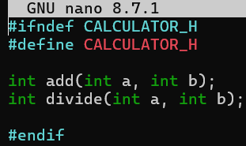
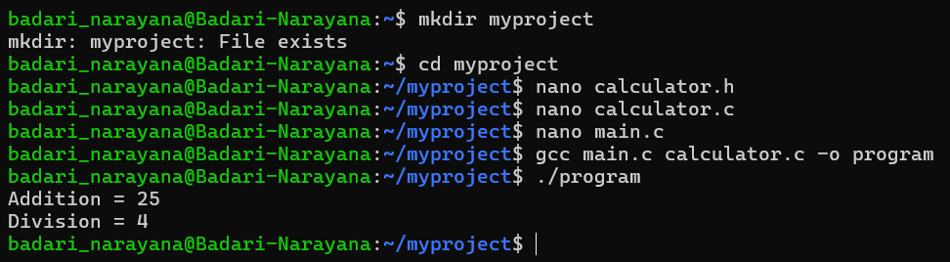
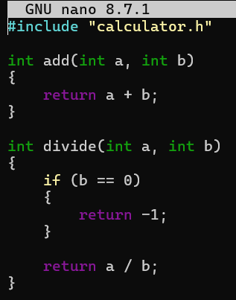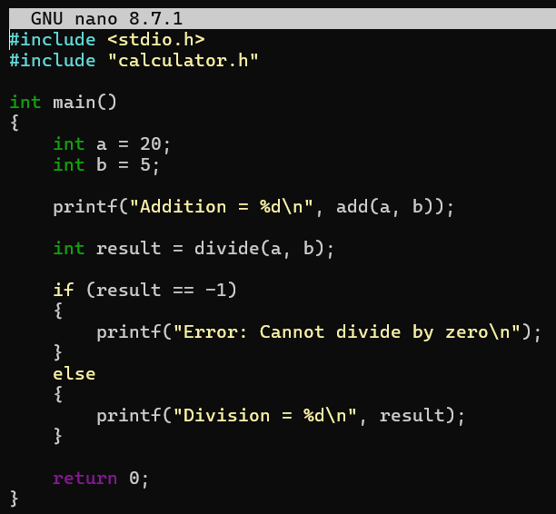

Task 2: To Detect Runtime Errors, Generate Messages, Log Failures, Handle Invalid Syntax, Recover Gracefully, Test Error Scenarios.
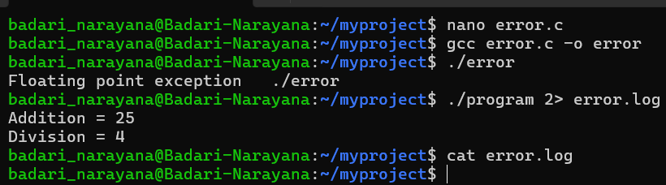
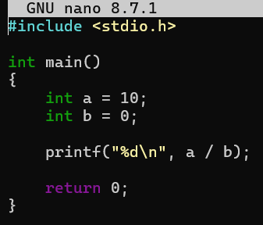

Task 3: To Run Valgrind, Identify Leaks, Fix Memory Errors, Release Resources, Verify Cleanup, Document Findings.
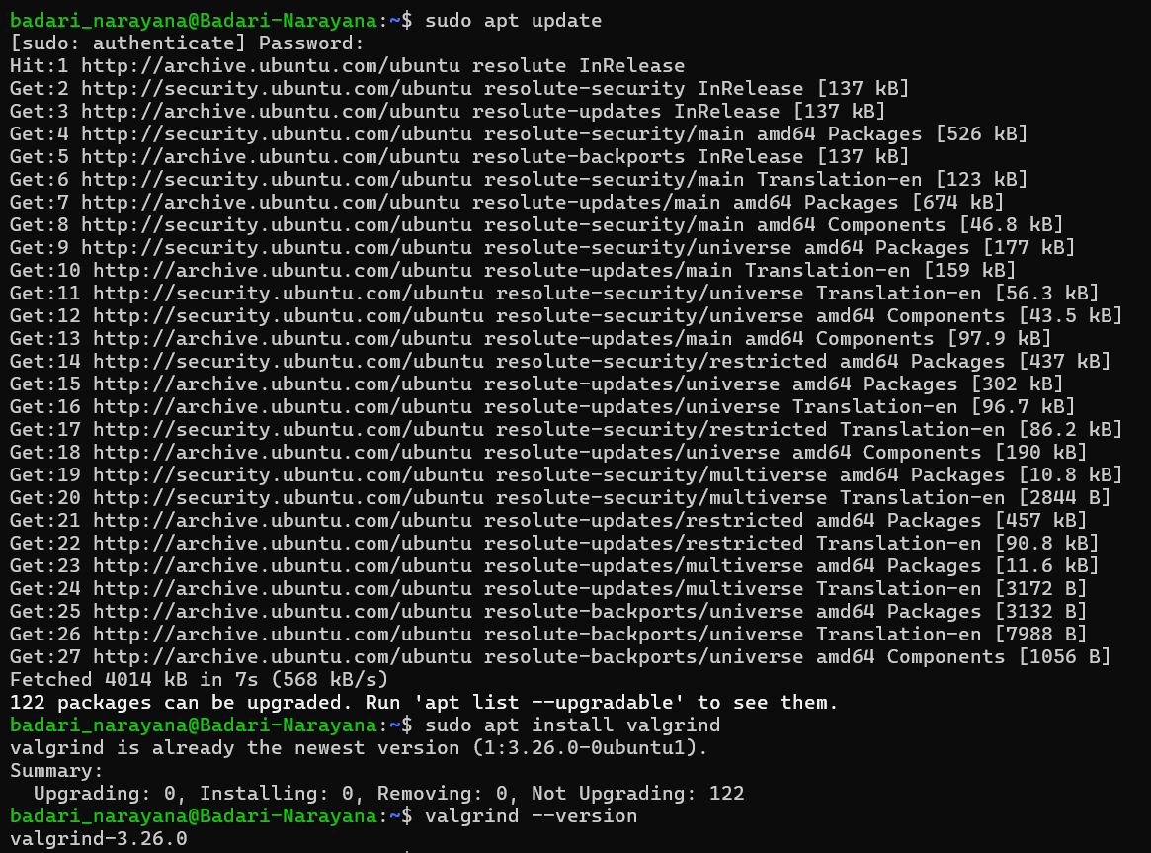
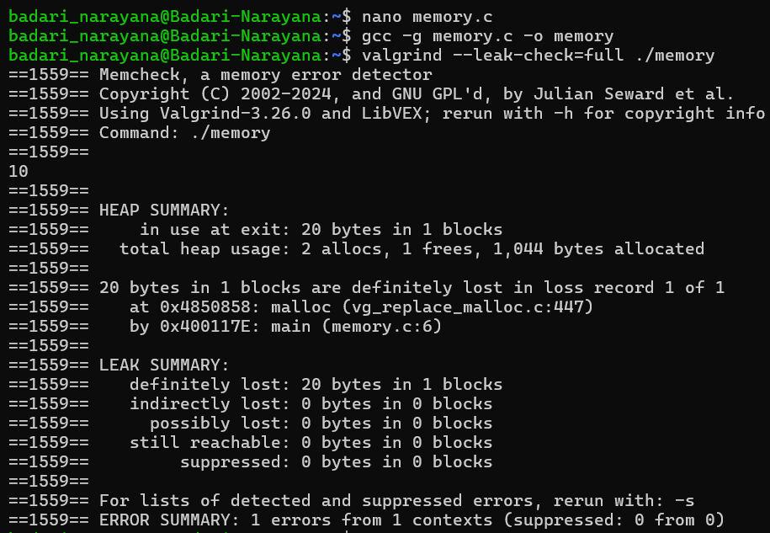
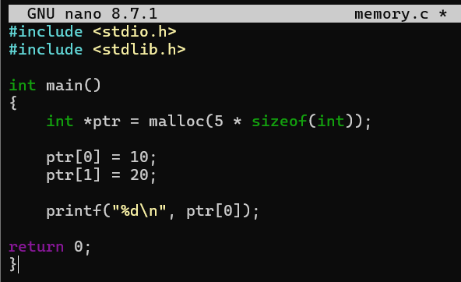
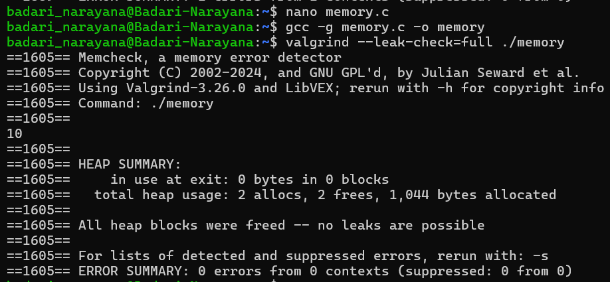
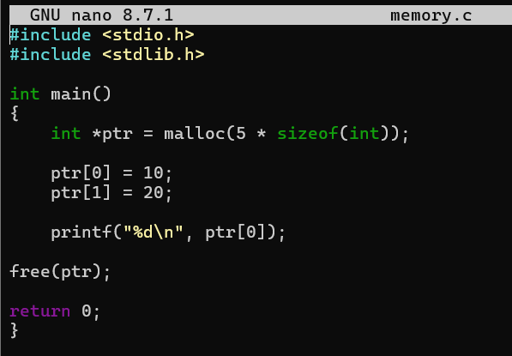
Task 4: To Design Test Cases, Create Test Scripts, Automate Execution, Verify Outputs, Compare Results, Generate Reports.
