Practical Week 3
Task 1: Develop a C program using fork() that creates a parent and child process. Display the Process ID (PID), Parent Process ID (PPID), and process states at different stages of execution.
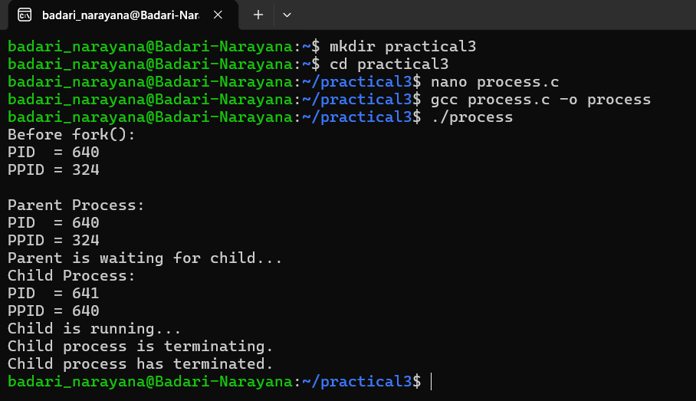
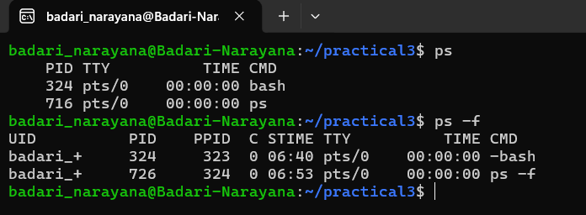
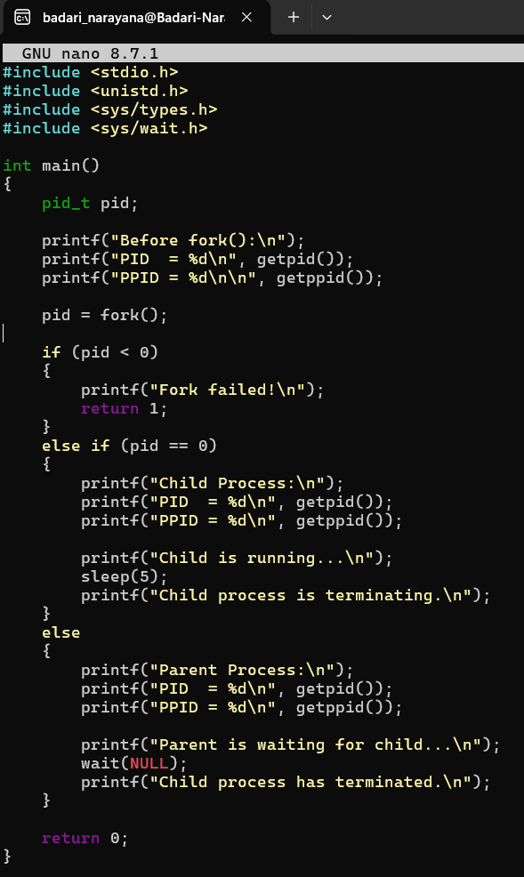
Task 2: Design an experiment to observe process state transitions (Ready, Running, Waiting, Terminated) using Linux monitoring tools such as ps, top, and /proc. Document the observations.

