Practical Week-9
Task 1: Implement a file copy utility using low-level Linux file I/O system calls (open, read, write, lseek, close). Compare its performance with standard library functions (fopen, fread, fwrite).
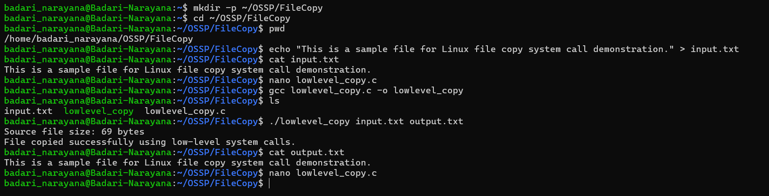
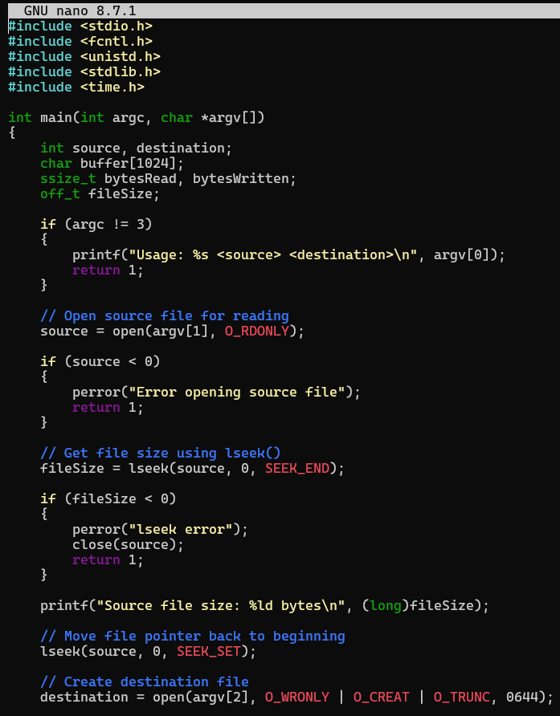
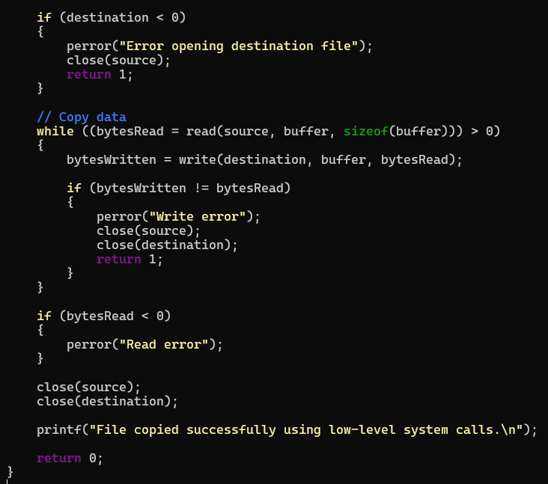

Task 2: Develop a program that redirects standard input and output using file descriptors and dup2(). Demonstrate how shells implement I/O redirection.
