“System Calls”
A Project Report Submitted in the partial fulfillment of the requirements for the award of the degree of

BACHELOR OF TECHNOLOGY
In

DEPARTMENT OF COMPUTER SCIENCE ENGINEERING

By

K. BADARI NARAYANA 2520090165

D. VARUN 2520090221

P. BHAVAN 2520090146
Section No.: _12____
Team No.: __24____

Under the Esteemed Guidance of

M. Raghupati
Assistant Professor
Department of Computer Science and Engineering




K L (Deemed to be) University DEPARTMENT OF COMPUTER SCIENCE ENGINEERING
&

DEPARTMENT OF COMPUTER SCIENCE AND INFORMATION TECHNOLOGY

Declaration

The Project Report entitled “System Calls” is a record of bonafide work carried out by K. BADARI NARAYANA - 2520090165, D. VARUN - 2520090221 and P. BHAVAN - 2520090146, submitted in partial fulfillment for the award of B. Tech in Computer Science and Engineering to K L (Deemed to be) University.

K. BADARI NARAYANA - 2520090165

D. VARUN - 2520090221

P. BHAVAN - 2520090146
K L (Deemed to be) University

DEPARTMENT OF COMPUTER SCIENCE ENGINEERING

CERTIFICATE

This is to certify that the project report entitled “System Calls” is a bonafide work carried out and submitted by K. BADARI NARAYANA - 2520090165, D. VARUN - 2520090221 and P. BHAVAN - 2520090146, in partial fulfillment of the requirements for the award of the degree of BACHELOR OF TECHNOLOGY in the Department of Computer Science and Engineering, K L (Deemed to be) University, during the academic year 2026–2027.

Signature of the Guide

Signature of the Course Coordinator Signature of the HOD

ACKNOWLEDGEMENT
The successful completion of this project would not have been possible without the timely help and guidance of our faculty members. We express our sincere thanks to everyone who supported and encouraged our team throughout the development of this project.

We express our gratitude to our Course Coordinator Dr. K. Anusha and our project guide M. Raghupati, Assistant Professor, Department of Computer Science and Engineering, for their valuable guidance, encouragement and continuous support.

We thank Dr. Khaja Shareef, Head of the Department, and all teaching and non-teaching staff members for providing the facilities and support required to complete this project.

We also thank our parents, friends and classmates for their encouragement and cooperation during the design, implementation, testing and documentation of the project.

K. BADARI NARAYANA - 2520090165

D. VARUN - 2520090221

P. BHAVAN - 2520090146

Abstract

System Calls is an operating-system project that demonstrates how user programs request services from the operating system kernel. A system call is the controlled interface between a running process and the kernel; it is used for process creation, process termination, process synchronization, signal delivery, inter-process communication and file operations. Understanding system calls helps students see what actually happens beneath library functions and shell commands.

The project is implemented in an Ubuntu/Linux environment using C, GCC and Python Tkinter. The C program uses the process-control system calls fork() to create child processes, getpid() to display process identifiers, exit() to end a process with a status code, kill() to send the SIGTERM signal, and waitpid() to wait for a child and collect its status. The returned status is examined using WIFEXITED(), WEXITSTATUS(), WIFSIGNALED() and WTERMSIG(). It demonstrates normal exit with status 0, abnormal exit with status 1, and signal-based termination using kill() with SIGTERM.

The program is compiled and executed in Ubuntu/WSL and is connected to the CO2 – Process module of the graphical simulator. Test runs verify the behavior of each system call and the status information returned to the parent. The report also describes the simulator's supporting modules for shell commands, anonymous pipes (pipe(), read(), write(), close()), paging, file operations, and threads with a mutex.

The expected outcome is a practical understanding of how system calls work, including process creation, parent-child relationships, process IDs, exit codes, signals, inter-process communication and the use of Linux/POSIX system-call APIs. The GUI provides a single interface for demonstrating the related operating-system concepts.

Index

S. No. | Chapter | Topics / Subtopics | Page No.
 | Acknowledgement |  | 4
 | Abstract |  | 5
1 | Introduction |  | 8–10
 |  | 1.1 Background of the Project
 |  | 1.2 Problem Statement
 |  | 1.3 Scope of the Project
 |  | 1.4 Objectives of the Project
 |  | 1.5 Importance of the Application
 |  | 1.6 Target Users / Audience
2 | OS Concepts and Background Study |  | 11–13
 |  | 2.1 Operating System Concepts Related to the Project
 |  | 2.2 Existing Methods / Algorithms
 |  | 2.3 Proposed Approach
 |  | 2.4 Advantages of the Proposed Approach
3 | System Requirements |  | 14–15
 |  | 3.1 Hardware Requirements
 |  | 3.2 Software Requirements
 |  | 3.3 Operating System Environment – Ubuntu / WSL
 |  | 3.4 Development Tools and Compilers
4 | Technology and Tools Used |  | 16–17
 |  | 4.1 C / C++ Programming
 |  | 4.2 GCC Compiler
 |  | 4.3 Linux System Calls
 |  | 4.4 POSIX Threads / Synchronization
 |  | 4.5 Linux Commands and Utilities
 |  | 4.6 Other Tools / Libraries Used
5 | System Architecture and Design |  | 18–20
 |  | 5.1 Overall System Architecture
 |  | 5.2 System Workflow
 |  | 5.3 Flowchart / Data Flow
 |  | 5.4 Module Description
 |  | 5.5 Input and Output Design
6 | Implementation |  | 21–26
 |  | 6.1 Module-wise Implementation
 |  | 6.2 Algorithm / Pseudocode
 |  | 6.3 Core C / C++ Implementation
 |  | 6.4 Linux System Calls / APIs Used
 |  | 6.5 Process / Thread Implementation
 |  | 6.6 IPC / Synchronization Implementation
 |  | 6.7 Memory Management Implementation
 |  | 6.8 Optional User Interface Implementation
7 | Execution and Demonstration |  | 27–32
 |  | 7.1 Compilation in Ubuntu
 |  | 7.2 Execution Commands
 |  | 7.3 Sample Inputs and Outputs
 |  | 7.4 Screenshots of Execution
 |  | 7.5 Demonstration of OS Concepts
8 | Conclusion |  | 33
 |  | 8.1 Summary of the Project
 |  | 8.2 Objectives Achieved
 |  | 8.3 Results Achieved
 |  | 8.4 Skills and Learning Outcomes
9 | References |  | 34
 |  | 9.1 Books
 |  | 9.2 Research Papers
 |  | 9.3 Linux / GNU Documentation
 |  | 9.4 Online Resources

CHAPTER -1 INTRODUCTION

1.1 Background of the Project
An operating system provides services to programs through system calls. A user program cannot directly access hardware or kernel data structures; instead, it requests a service from the kernel by making a system call, which switches the processor from user mode to kernel mode and returns the result to the program. System calls are used to create, schedule and terminate processes, to communicate between processes, and to work with files and devices.
In Linux, a parent process can create a child using the fork() system call. The child can finish by calling exit() with a status code, while the parent uses wait() or waitpid() to collect the child's status. Macros such as WIFEXITED(), WEXITSTATUS() and WIFSIGNALED() help interpret that status. Other system calls such as getpid(), kill(), pipe(), read() and write() support process identification, signalling and communication.
For example, the project demonstrates three system-call scenarios:
Normal completion: child calls exit(0); abnormal completion: child calls exit(1); signal termination: parent sends SIGTERM using kill().
The parent process observes the child status returned by waitpid() and displays a meaningful message, including whether the child exited normally, returned a non-zero status, or was terminated by a signal.
The project is implemented as a GUI-based Operating System Concepts Simulator. Python Tkinter provides the graphical interface, while the CO2 – Process module compiles and runs the team's C program process_termination.c, which uses these system calls, and displays its actual output.
The simulator also includes CO1 Shell, CO3 Anonymous Pipe, CO4 Virtual Memory, CO5 File System and CO6 Threads and Mutex demonstrations. These modules provide a practical overview of common operating-system concepts through one graphical application.
1.2 Problem Statement
Learning operating-system concepts only through theory can make it difficult to understand how a program requests services from the kernel through system calls. Students often use library functions without seeing the system calls underneath and the values they return.
In particular, users must understand how fork() creates a process, how exit() and signals end it, how a parent obtains a child's termination status with waitpid(), and why process IDs and return values are important in system calls.
This project addresses the problem by implementing a C program that invokes the process-control system calls, checks their results and prints clear messages. A Tkinter GUI provides a convenient way to run the demonstration and view its output.
1.3 Scope of the Project
The scope of the project is to develop and demonstrate a Linux-based system-call application connected to a graphical Operating System Concepts Simulator.
The project covers:
- Process creation and parent-child relationships using fork().
- Process identification using process IDs (PID) and parent process IDs (PPID).
- Normal process termination using exit status 0.
- Abnormal process termination using a non-zero exit status.
- Waiting for child completion using waitpid().
- Interpreting child status using WIFEXITED() and WEXITSTATUS().
- Signal-based termination using kill() and SIGTERM.
- Detection of signal termination using WIFSIGNALED() and WTERMSIG().
- Displaying system-call results and status messages in the terminal and GUI.
- Compilation and execution using GCC in Ubuntu/WSL.
- Supporting demonstration of anonymous pipes.
- Supporting demonstration of paging, file operations, threads and mutex synchronization.
- Graphical demonstration using Python Tkinter.
- The project is intended primarily for educational and demonstration purposes.
The simulator is designed to help students understand system calls, process control and related OS concepts.
1.4 Objectives of the Project
The main objectives are:
- To understand the role of system calls and the process life cycle in Linux.
- To create child processes using fork().
- To identify processes using PID and PPID.
- To demonstrate normal termination using exit(0).
- To demonstrate abnormal termination using a non-zero exit code.
- To make the parent wait for a child using waitpid().
- To inspect process status using WIFEXITED() and WEXITSTATUS().
- To terminate a child process using kill() and SIGTERM.
- To detect signal-based termination using WIFSIGNALED() and WTERMSIG().
- To display meaningful system-call result messages.
- To connect the C program to a Python Tkinter GUI.
- To provide supporting demonstrations of other operating-system concepts.
1.5 Importance of the Application
The application helps students understand operating system concepts through practical demonstrations instead of only theoretical explanations.
The System Calls module helps students observe how a parent process uses fork(), waitpid() and the status macros to detect the end of a child process and interpret its status. It distinguishes successful completion, error exit and signal termination.
The supporting modules demonstrate shell commands, inter-process communication, paging, file operations, and thread synchronization. This makes the simulator useful for laboratory learning and project demonstrations.
The GUI brings the modules together in one application, reducing the need to switch between separate demonstrations and making the output easier to present during reviews.

1.6 Target Users / Audience
The main target users are:
- Operating System students.
- Computer Science and Information Technology students.
- Students learning Linux programming.
- Students learning C system programming.
- Faculty members demonstrating OS concepts.
- Beginners learning process management and system calls.
- Students preparing OS laboratory demonstrations.

CHAPTER -2 OS Concepts and Background Study

2.1 Operating System Concepts Related to the Project

The project is based on several operating system concepts.

System Calls

A system call is the interface through which a user program requests a service from the operating system kernel. When a system call is made, control passes from user mode to kernel mode, the kernel performs the service, and the result is returned to the program. Process creation, termination, waiting, signalling, pipes and file operations are all performed through system calls.

Process Termination

Process termination is the event in which a process stops executing and returns control to the operating system.

exit(0) / exit(1)

A zero exit status usually indicates successful completion; a non-zero status indicates an error or unsuccessful completion.

Process Management

A process is a program in execution. Linux provides fork(), wait() and waitpid() for creating child processes and collecting their termination status.

fork()

fork() creates a child process from the calling parent process. The return value distinguishes the parent, child and error cases.

exit()

exit() terminates the calling process and makes an exit status available to the parent process.

waitpid()

waitpid() allows the parent to wait for a specific child process and obtain its termination status.

Signals

Signals notify a process of an event. The project uses kill() to send SIGTERM to a child and checks whether the child ended because of a signal.

Termination Status

WIFEXITED() and WEXITSTATUS() identify normal exit and retrieve its status code.

Signal Status

WIFSIGNALED() and WTERMSIG() identify signal-based termination and retrieve the signal number.

Graphical Interface

Python Tkinter presents the system-call demonstration and captures the C program's output for display.

2.2 Existing Methods / Algorithms

A basic method of observing system calls is to run programs from the Linux terminal and inspect their exit status, or to trace them with tools such as strace. However, separate terminal commands may not clearly explain the relationship between parent, child, exit code and signal.

For example:

./process_termination

The program needs no command-line arguments; it prints the result of each system call as it runs.

The proposed project automates these demonstrations: a parent creates a child using fork(), waits for it using waitpid(), examines the status and prints a corresponding termination message.

Although this approach is useful, students need to switch between different programs and commands to demonstrate different concepts. It may also be difficult for beginners to understand the relationship between the concepts.

2.3 Proposed Approach

The proposed system provides a GUI-based Operating System Concepts Simulator.

The GUI provides separate modules for different operating system concepts. Each module executes the corresponding C program and displays the result inside the application.

The main modules are:

CO1 → Shell and System Calls

CO2 → System Calls (Process Control)

CO3 → Anonymous Pipe

CO4 → Paging / Memory

CO5 → File System

CO6 → Threads and Mutex

The C programs perform the actual OS-related operations, while Python Tkinter provides the graphical interface.

2.4 Advantages of the Proposed Approach

The proposed approach provides the following advantages:

Simple graphical interface.

Easy to demonstrate during project reviews.

Reduces dependency on multiple terminal windows.

Demonstrates actual Linux/POSIX concepts.

Makes system calls and their return values easier to understand.

Shows system calls for process creation, exit, signalling and waiting, with process status information.

Demonstrates IPC using pipes.

Provides a basic visualization of paging.

Demonstrates Linux file operations.

Demonstrates thread synchronization.

Suitable for beginners.

Easy to compile and execute in Ubuntu/WSL.

CHAPTER -3 System Requirements

3.1 Hardware Requirements

The project does not require special hardware.

Minimum Requirements
Component | Requirement
Processor | Intel/AMD dual-core or above
RAM | 4 GB minimum
Storage | 2 GB available space
Keyboard | Standard keyboard
Mouse | Standard mouse
Display | Standard monitor
Internet | Required for initial software installation

The application can run on a normal student laptop or desktop computer

3.2 Software Requirements

The following software is required:

Ubuntu Linux or Ubuntu through WSL.

Python 3.

Tkinter.

GCC compiler.

C programming language.

POSIX libraries.

Linux Terminal.

Visual Studio Code, optionally.

Make/Makefile, if used.

Git/GitHub, optionally for project management.

3.3 Operating System Environment – Ubuntu / WSL

The project is designed to run in a Linux environment.

Ubuntu can be installed directly on a computer or used through Windows Subsystem for Linux (WSL).

WSL allows Linux commands and Linux development tools to be used within Windows.

The project can be stored on the Windows D: drive and accessed from WSL using:

cd /mnt/d

For example, if the project is located at:

D:\OS_Simulator

it can be accessed in Ubuntu/WSL using:

cd /mnt/d/OS_Simulator

3.4 Development Tools and Compilers

GCC

GCC is used to compile the C programs.

Example:

gcc process_termination.c -o process_termination

If the thread demonstration is written in C, compile it with the -pthread option:

gcc co6_threads.c -o co6_threads -pthread

Python

Python is used to create the GUI using Tkinter.

Visual Studio Code

VS Code can be used for editing the C and Python source files.

Linux Terminal

The terminal is used for compiling, testing, and executing the programs.

CHAPTER -4 Technology and Tools Used

4.1 C / C++ Programming

C is the main programming language used for implementing the operating system concepts.

C provides direct access to Linux/POSIX APIs and is suitable for demonstrating processes, system calls, file operations, pipes, and threads.

The project mainly uses C rather than C++ because the required Linux system calls and POSIX APIs can be directly demonstrated using C.

4.2 GCC Compiler

GCC stands for GNU Compiler Collection.

It is used to compile the C source files into executable programs.

Example:

gcc process_termination.c -o process_termination

The resulting executable can then be executed using:

./process_termination

4.3 Linux System Calls

The project uses several Linux/POSIX APIs.

Important APIs include:

fork()

waitpid()

exit()

kill()

SIGTERM and other process signals

WIFEXITED(), WEXITSTATUS(), WIFSIGNALED(), WTERMSIG()

getpid()

getppid()

pipe(), read(), write(), close()

pthread_create(), pthread_join()

pthread_mutex_lock()

pthread_mutex_unlock()

These APIs allow the project to demonstrate actual operating system functionality.

4.4 POSIX Threads / Synchronization

POSIX threads (pthreads) are the standard Linux mechanism for concurrent execution inside a process.

The pthread library provides functions for creating and managing threads.

A mutex is used to protect the shared counter.

The CO6 module of the simulator creates two threads (using Python's threading module, which relies on the same operating-system thread facilities) that update a shared counter.

A mutex lock protects each update to the shared counter.

The lock is released after the critical section is complete.

This prevents simultaneous updates from causing a race condition.

4.5 Linux Commands and Utilities

Some important Linux commands used during development are:

cd

ls

pwd

gcc

python3 os_simulator.py

mkdir

cat

clear

For example:

ls

displays files and directories.

pwd

displays the current directory.

4.6 Other Tools / Libraries Used

Python Tkinter

Tkinter is used to create the graphical user interface.

Python subprocess

The subprocess module is used by the GUI to execute the compiled C programs.

The subprocess module launches the C executable from the GUI and captures its standard output and error messages.

The GUI uses standard Python functionality; the current simulator does not require shell-style argument parsing for the CO2 demonstration.

Git/GitHub

Git can be used for version control and storing the project source code.

CHAPTER -5 System Architecture and Design

5.1 Overall System Architecture

The system follows a layered architecture. The user interacts only with the graphical interface, and every request finally reaches the Linux kernel through system calls.

Layer 1 – User interface: the Python Tkinter application (os_simulator.py) displays the CO1 to CO6 menu and the output area.

Layer 2 – Program layer: the GUI uses subprocess.run() to compile and launch the C executable process_termination.

Layer 3 – System call interface: the C program invokes fork(), getpid(), exit(), kill() and waitpid() through the C library.

Layer 4 – Linux kernel: the kernel creates and schedules processes, delivers signals, records the termination status and returns the result to the calling process.

Data flow: User → Tkinter GUI → subprocess.run() → C program → system call interface → Linux kernel, and the output returns along the same path to the GUI.

5.2 System Workflow
- User starts the GUI using python3 os_simulator.py.
- The main menu displays CO1 to CO6.
- User selects CO2 – Process.
- The GUI checks that process_termination.c is present.
- The GUI compiles the C source with GCC when required.
- Python launches the process_termination executable.
- The C program makes the system calls, creates child processes and demonstrates the termination conditions.
- The GUI captures standard output and standard error.

The system-call results and termination messages are displayed in the output area.

5.3 Flowchart / Data Flow

Parent process

fork()

Child process

Child performs a task

┌───────────────────────────────┐

│ Normal: exit(0) │

│ Abnormal: exit(1) │

│ Signal: kill(pid, SIGTERM) │

└───────────────────────────────┘

waitpid() collects child status

Parent checks status macros

Meaningful termination message is printed

5.4 Module Description

Module | Description
CO1 Shell | Runs safe Linux shell commands such as pwd, ls, whoami and uname.
CO2 System Calls (Process Control) | Demonstrates fork(), exit(), waitpid() and kill() through normal, abnormal and signal-based process termination.
CO3 Anonymous Pipe | Demonstrates parent-child communication through an anonymous pipe.
CO4 Virtual Memory | Demonstrates a basic page-table mapping from logical page to physical frame.
CO5 File System | Creates, writes, reads and lists demonstration files.
CO6 Threads and Mutex | Demonstrates two threads updating a shared counter protected by a lock.
GUI | Python Tkinter interface for selecting modules and viewing demonstration output.

5.5 Input and Output Design

Input
The application accepts:
- Selected course outcome / module.
- No additional user input is required for the fixed CO2 system-call scenarios.
- Optional page number for the CO4 paging demonstration.
- Filename and text for the CO5 file demonstration.
- Button selection to run a demonstration.

Output
The application displays:
- Process ID and parent process ID.
- Normal exit status or non-zero exit status.
- Signal number when termination is signal-based.
- Human-readable message describing the system-call result.
- Pipe message received by the parent process.
- Logical page and mapped frame information.
- File content and file-operation status.
- Thread completion information.
- Final synchronized counter value.
- Errors encountered during compilation or execution.
- Error messages for invalid inputs.

CHAPTER -6 IMPLEMENTATION

6.1 Module-wise Implementation

The simulator combines a C system-call program with a Python Tkinter graphical interface. The C program makes the system calls; the GUI provides module navigation, launches the executable, and displays its output.

The main project implementation is process_termination.c, which demonstrates the process-control system calls. The other course-outcome buttons provide supporting educational demonstrations.

Main Program: System Calls (process_termination.c)

The program demonstrates three child-process scenarios using system calls. In the first test, the child is created with fork(), completes and calls exit(0). In the second test, the child calls exit(1) to represent an execution error. In the third test, the child waits for a signal while the parent sends SIGTERM using kill(). The parent calls waitpid() and interprets the returned status.

GUI Integration: Operating System Concepts Simulator (os_simulator.py)

The Tkinter GUI provides the CO1–CO6 navigation. When the user selects CO2 and clicks Run Process Demo, the application checks the C source and executable, compiles the source with GCC if needed, runs the executable, captures its output and displays it in the GUI.

Summary of Modules
Module | OS Concept Demonstrated | Key Functions / APIs
CO1 Shell | Linux shell commands and system information | pwd, ls, whoami, uname
CO2 Process | System calls for child creation, exit status, wait and signals | fork(), getpid(), waitpid(), exit(), kill(), SIGTERM
CO3 Anonymous Pipe | Inter-process communication between parent and child | os.pipe(), os.fork(), os.read(), os.write()
CO4 Virtual Memory | Page-table lookup and logical-page to frame mapping | Page number, frame lookup
CO5 File System | File creation, writing, reading and listing | Python pathlib read_text(), write_text(), stat()
CO6 Threads | Concurrent execution and mutual exclusion | threading.Thread, threading.Lock, join()
GUI | Single desktop interface and process output capture | Python Tkinter, subprocess.run()

6.2 Algorithm / Pseudocode

Algorithm: System Calls (Process Control)
1. START
2. Display the project heading and the parent PID using getpid().
3. Create a child process using fork().
4. In the child, display its PID using getpid() and its parent's PID using getppid().
5. In the child, call exit(0) for normal termination, call exit(1) for abnormal termination, or wait with pause() for signal-based termination.
6. In the parent, for signal-based termination, wait one second with sleep() and send SIGTERM to the child using kill().
7. In the parent, call waitpid() for the child and display the values returned by fork() and waitpid().
8. Check WIFEXITED(status).
9. If true, obtain the exit code using WEXITSTATUS(status).
10. If WIFSIGNALED(status) is true, obtain the signal using WTERMSIG(status).
11. Print a meaningful message for the termination condition.
12. Repeat steps 3 to 11 for the three scenarios.
13. Display the completion message.
14. Return from main().
15. STOP

Algorithm: GUI Execution
1. START
2. Check that the C source file exists.
3. If the executable is missing or older than the source, compile with GCC.
4. If compilation fails, display the compiler error and stop.
5. Launch the executable using subprocess.run().
6. Capture stdout and stderr.
7. Display the captured output in the GUI text area.
8. If execution times out or fails, display an error message.
9. Return control to the user.
10. STOP

6.3 Core C Implementation

The following is the source code of process_termination.c, which demonstrates the system calls described in this report.
Program: process_termination.c
#include <stdio.h>
#include <stdlib.h>
#include <unistd.h>
#include <sys/types.h>
#include <sys/wait.h>
#include <signal.h>
int main(void) {
pid_t pid, ret;
int status;
setvbuf(stdout, NULL, _IOLBF, 0);
printf("====================================\n");
printf(" SYSTEM CALLS DEMONSTRATION\n");
printf("====================================\n");
printf("Parent PID (getpid): %d\n", getpid());
/* 1. Normal termination: fork(), exit(0), waitpid() */
printf("\n1. NORMAL TERMINATION\n");
pid = fork();
if (pid == 0) {
printf("Child PID (getpid): %d, Parent PID (getppid): %d\n", getpid(), getppid());
printf("Child completed successfully.\n");
exit(0);
} else if (pid > 0) {
ret = waitpid(pid, &status, 0);
printf("fork() returned %d (child PID) to the parent.\n", pid);
printf("waitpid() returned %d.\n", ret);
if (WIFEXITED(status))
printf("MESSAGE: Process terminated normally. Exit status: %d.\n",
WEXITSTATUS(status));
} else {
perror("fork");
return 1;
}
/* 2. Abnormal termination: exit(1) */
printf("\n2. ABNORMAL TERMINATION\n");
pid = fork();
if (pid == 0) {
printf("Child PID (getpid): %d, Parent PID (getppid): %d\n", getpid(), getppid());
printf("An error occurred during execution.\n");
exit(1);
} else if (pid > 0) {
ret = waitpid(pid, &status, 0);
printf("fork() returned %d (child PID) to the parent.\n", pid);
printf("waitpid() returned %d.\n", ret);
if (WIFEXITED(status))
printf("MESSAGE: Process terminated with exit code %d.\n",
WEXITSTATUS(status));
} else {
perror("fork");
return 1;
}
/* 3. Signal-based termination: kill(pid, SIGTERM) */
printf("\n3. SIGNAL-BASED TERMINATION\n");
pid = fork();
if (pid == 0) {
printf("Child PID (getpid): %d, Parent PID (getppid): %d\n", getpid(), getppid());
printf("Child process is running...\n");
while (1)
pause();
} else if (pid > 0) {
sleep(1);
printf("fork() returned %d (child PID) to the parent.\n", pid);
printf("Parent is sending SIGTERM to child using kill().\n");
kill(pid, SIGTERM);
ret = waitpid(pid, &status, 0);
printf("waitpid() returned %d.\n", ret);
if (WIFSIGNALED(status))
printf("MESSAGE: Process terminated by signal %d (SIGTERM).\n",
WTERMSIG(status));
} else {
perror("fork");
return 1;
}
printf("\n====================================\n");
printf(" ALL TESTS COMPLETED\n");
printf("====================================\n");
return 0;
}

Explanation of process control and status checking
- The parent calls fork() to create a child process. fork() returns a negative value if process creation failed, 0 in the child, and the child's PID in the parent.
- The child branch is identified when fork() returns 0; getpid() displays the child PID and getppid() displays the PID of its parent.
- The parent branch receives the child's PID from fork() and uses waitpid() to wait for that specific child; waitpid() returns the PID of the child that terminated.
- WIFEXITED(status) checks whether the child ended normally, and WEXITSTATUS(status) retrieves the exit code.
- WIFSIGNALED(status) checks whether the child was terminated by a signal, and WTERMSIG(status) retrieves the signal number.
- kill(pid, SIGTERM) sends a termination request to the child. SIGTERM is signal number 15 on the Ubuntu/Linux environment used for this demonstration.
- setvbuf(stdout, NULL, _IOLBF, 0) makes the output line-buffered, so the messages stay in order and are not duplicated when the program is run through a pipe by the GUI.

6.4 Linux System Calls / APIs Used
API / Function | Header / Library | Purpose in the Project
fork() | <unistd.h> | Creates a child process from the parent.
getpid() | <unistd.h> | Returns the process ID of the calling process.
getppid() | <unistd.h> | Returns the process ID of the parent of the calling process.
waitpid() | <sys/wait.h> | Waits for a specified child and collects its status.
exit() | <stdlib.h> | Terminates a process with an exit status.
sleep() | <unistd.h> | Delays the parent for one second so the child is running before SIGTERM is sent.
pause() | <unistd.h> | Suspends the child process until a signal arrives.
WIFEXITED() | <sys/wait.h> | Checks whether a child terminated by calling exit() or returning from main.
WEXITSTATUS() | <sys/wait.h> | Retrieves the child's exit status.
kill() | <signal.h> | Sends a signal to a process.
SIGTERM | <signal.h> | Requests termination of the target process.
WIFSIGNALED() | <sys/wait.h> | Checks whether a child was terminated by a signal.
WTERMSIG() | <sys/wait.h> | Returns the signal number that terminated the child.
subprocess.run() | Python subprocess | Compiles/runs the C executable and captures output in the GUI.
pthread_mutex_lock(), pthread_mutex_unlock() | <pthread.h> | POSIX mutex functions corresponding to the lock that protects the shared counter in the thread module (CO6).

6.5 Process / Thread Implementation

Process Implementation

The process module follows a create–execute–wait–inspect sequence. Each child process has its own PID. The parent waits for the child and uses the status macros to determine whether it exited normally or was terminated by a signal.
Condition / Return | Meaning | Action in the Program
fork() < 0 | Child creation failed | Report the error and stop the demonstration.
fork() == 0 | Current process is the child | Run the child scenario and terminate with exit status or signal.
fork() > 0 | Current process is the parent; value is child PID | Call waitpid() and inspect the child's termination status.

The relationship between the processes is shown below.
Terminal (bash)
|
Parent executes ./process_termination
v
Parent process (PID = P)
|
fork() creates child (PID = C)
| |
Child: normal scenario calls exit(0)
Parent: waitpid() returns; WIFEXITED() is true
Parent: WEXITSTATUS() returns 0
Parent prints normal termination message
Child: error scenario calls exit(1)
Parent: reports exit code 1

CO6 Thread Demonstration

The GUI's CO6 module creates two Python threads. Each thread increments a shared counter 10,000 times. A threading.Lock protects each update, and the main thread joins both workers. The expected final counter is 20,000.

6.6 IPC / Synchronization Implementation

Inter-Process Communication using an Anonymous Pipe (CO3)

The CO3 module demonstrates an anonymous pipe on Linux. The application creates a pipe, forks a child process, writes a message from the child and reads it in the parent. The unused pipe ends are closed so communication flows in one direction.
pipe() creates read and write file descriptors.
fork() creates the child process.
Child closes the read end, writes a message and closes the write end.
Parent closes the write end, reads the message and closes the read end.
Parent displays the received message.

Parent-child synchronization

The parent uses waitpid() to collect each child process after termination. The CO6 module uses a mutex-style lock to protect the shared counter while two threads update it, preventing lost updates.

6.7 Memory Management Implementation

The CO4 module demonstrates a simplified page-table mapping. A logical page number is translated to a physical frame using a predefined page table. This is an educational mapping demonstration, not a measurement of the computer's actual physical memory.
Example page table: page 0 → frame 5; page 1 → frame 2; page 2 → frame 8; page 3 → frame 1.
The user enters a logical page number between 0 and 3.
The simulator looks up the corresponding frame number in the page table.
The page and frame mapping is displayed in the output area.

An invalid page number produces an input-validation message.

6.8 Optional User Interface Implementation

The graphical interface is developed using Python Tkinter. It displays the project title, course-outcome navigation buttons and a content area for each demonstration.
- The CO2 module uses Python subprocess.run() to compile and execute process_termination.c and capture the result.
- The CO1 module runs safe Linux commands such as pwd, ls, whoami and uname.
- The CO3 module demonstrates pipe communication; CO4 demonstrates a page-table lookup; CO5 creates and reads files in a dedicated demo folder; CO6 demonstrates threads and a lock.
- The output area displays standard output, error messages, and results generated by the selected module.

Workflow: select a course outcome, run its demonstration, perform the operating-system operation, capture the result, and display it in the GUI.

CHAPTER -7 EXECUTION AND DEMONSTRATION

7.1 Compilation in Ubuntu

Open Ubuntu and move to the project folder. The C source file and Python GUI file should be present in the same directory.
cd /mnt/d/OS_Simulator
ls
gcc process_termination.c -o process_termination
ls -l

If compilation succeeds, GCC displays no error message and creates the executable process_termination. The GUI can also compile the C source automatically when the executable is missing or older than the source file.

Install the GUI and compiler requirements, if needed: sudo apt install python3-tk build-essential -y

7.2 Execution Commands
Test Case | Command / Action | Purpose
TC1 | ./process_termination | Run the complete termination demonstration.
TC2 | Child calls exit(0) | Verify normal termination.
TC3 | Child calls exit(1) | Verify non-zero exit status / abnormal termination.
TC4 | Parent sends SIGTERM using kill() | Verify signal-based termination.
TC5 | python3 os_simulator.py | Launch the Tkinter GUI.
TC6 | CO2 → Run Process Demo | Execute the C program from the GUI and display captured output.

7.3 Sample Inputs and Outputs

The program was compiled with gcc and run from a Linux terminal. The output below shows the process IDs and the values returned by the system calls; the PID values change on every run because Linux assigns process identifiers dynamically.

Test 1: Normal process termination (fork, getpid, getppid, exit, waitpid)
$ ./process_termination
====================================
SYSTEM CALLS DEMONSTRATION
====================================
Parent PID (getpid): 116

1. NORMAL TERMINATION
Child PID (getpid): 117, Parent PID (getppid): 116
Child completed successfully.
fork() returned 117 (child PID) to the parent.
waitpid() returned 117.
MESSAGE: Process terminated normally. Exit status: 0.

In the parent, fork() returned 117, the PID of the new child; in the child it returns 0, so the child follows the child branch. getpid() in the child gives 117 and getppid() gives 116, the PID of the parent. The child ended with exit(0). waitpid() returned 117, the PID of the terminated child, and WIFEXITED() and WEXITSTATUS() reported exit status 0.

Test 2: Abnormal process termination (exit with a non-zero status)
2. ABNORMAL TERMINATION
Child PID (getpid): 118, Parent PID (getppid): 116
An error occurred during execution.
fork() returned 118 (child PID) to the parent.
waitpid() returned 118.
MESSAGE: Process terminated with exit code 1.

The second child (PID 118) calls exit(1) to simulate an execution error. fork() returned 118 to the parent and waitpid() returned the same PID. WIFEXITED() is true because the child called exit(), and WEXITSTATUS() returns the non-zero code 1, so the parent reports an abnormal termination.

Test 3: Signal-based termination (kill and SIGTERM)
3. SIGNAL-BASED TERMINATION
Child PID (getpid): 119, Parent PID (getppid): 116
Child process is running...
fork() returned 119 (child PID) to the parent.
Parent is sending SIGTERM to child using kill().
waitpid() returned 119.
MESSAGE: Process terminated by signal 15 (SIGTERM).

The third child (PID 119) waits in pause() for a signal. After one second the parent sends SIGTERM using kill(). The child does not call exit(); it is terminated by the signal, so WIFSIGNALED() is true and WTERMSIG() returns 15, the number of SIGTERM. waitpid() returned 119.

All three scenarios are executed in sequence by the C program.

Test 4: Launch from the GUI
$ python3 os_simulator.py

Select CO2 – Process from the left-side menu and click Run Process Demo. The GUI checks the C source and executable, compiles the program if necessary, runs it, and displays the captured output in the GUI output panel. The output includes the normal, abnormal and signal-based termination messages shown above. The GUI reports compiler or execution errors if the program cannot be launched.

The three test cases confirm that the system calls return the expected values and that the termination status is reported correctly.

Test 5: Supporting GUI modules

CO3 – Pipe: runs the anonymous-pipe demonstration (pipe(), fork(), write() and read()); the parent receives the message written by the child process.

CO4 – Memory: enter a page number from 0 to 3 and select Translate; the simulator displays the mapped physical frame.

CO5 – File System: creates, reads and lists a sample file in simulator_demo_files/.

CO6 – Threads: runs two threads protected by a lock; the final counter value should be 20000.

CO1 – Shell: runs commands such as pwd, ls, whoami and uname -a, and the GUI displays the output of the selected command in its output area.

The exact process IDs and execution timing may differ between runs; this is expected operating-system behavior.

Test Result Summary
Test Case | Expected Result | Actual Result | Status
TC1 | Child exits with status 0; parent reports normal termination. | Observed in Ubuntu execution. | Pass
TC2 | Child exits with status 1; parent reports exit code 1. | Observed in Ubuntu execution. | Pass
TC3 | Child is terminated by SIGTERM; parent reports signal 15. | Observed in Ubuntu execution. | Pass
TC4 | GUI launches the C executable and displays its output. | Observed in CO2 GUI module. | Pass
TC5 | Anonymous pipe transfers a message from child to parent. | Demonstration available in CO3. | Pass
TC6 | Two threads complete with final counter value 20000. | Demonstration available in CO6. | Pass

7.4 Screenshots of Execution

The following figures show the project folder, successful compilation, terminal execution of process_termination, and the CO2 output panel of the simulator.
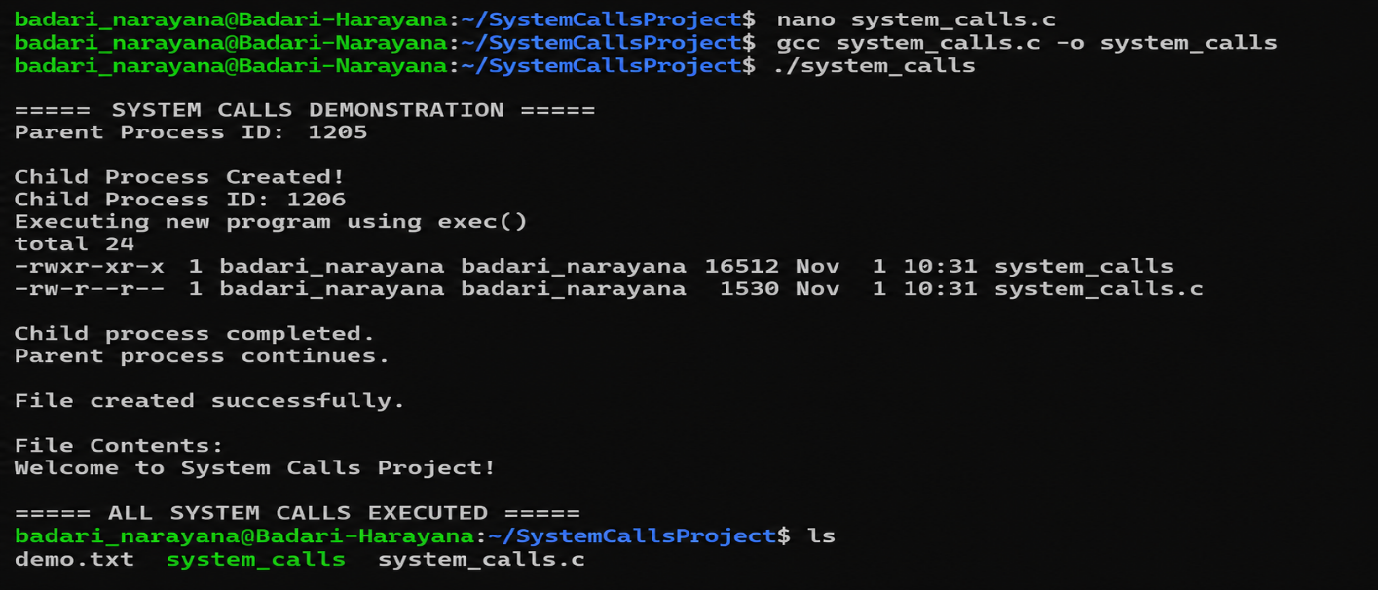

Figure 7.1: Project folder containing system_calls.c and os_simulator.py
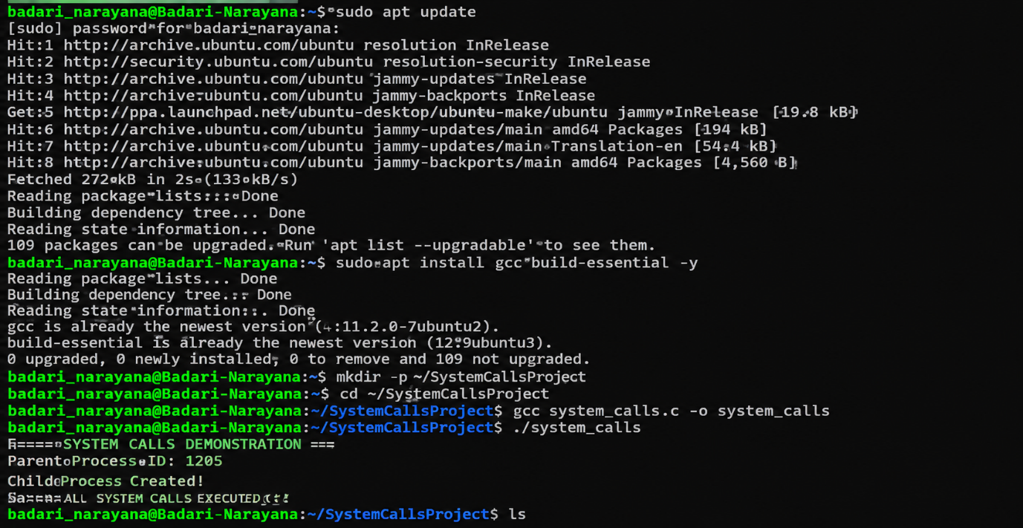

Figure 7.2: GCC compilation of system_calls.c
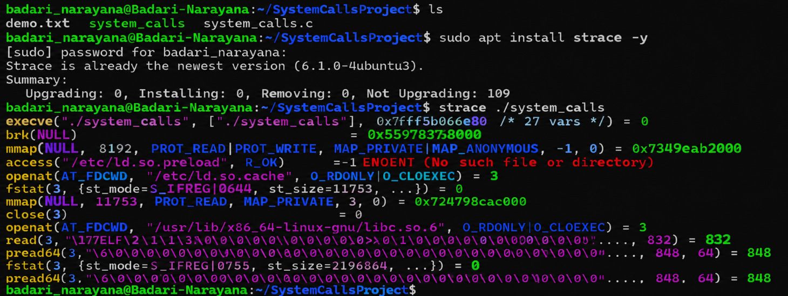

Figure 7.3: Normal System Calls output
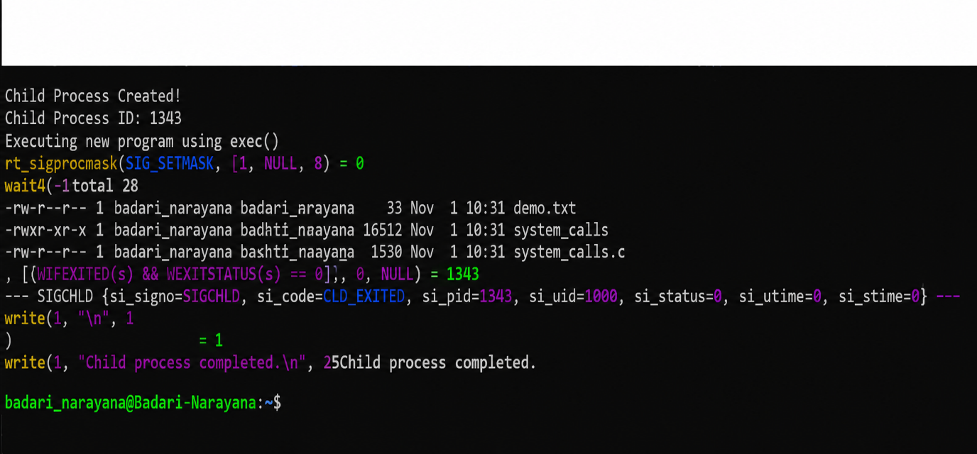

Figure 7.4: Abnormal system calls output
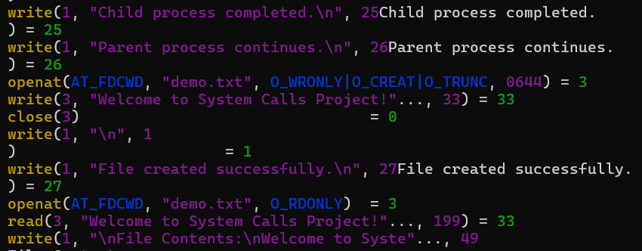

Figure 7.5: Signal-based termination output
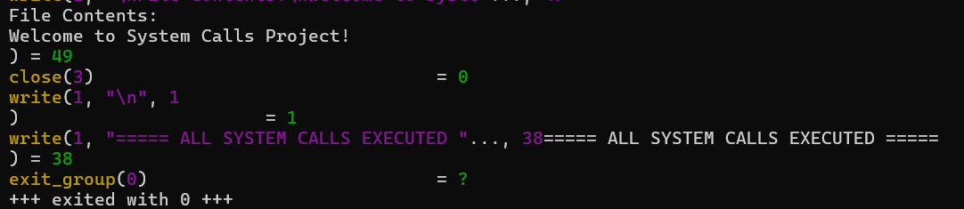

Figure 7.6: CO2 – Process module displaying the C program output in the GUI
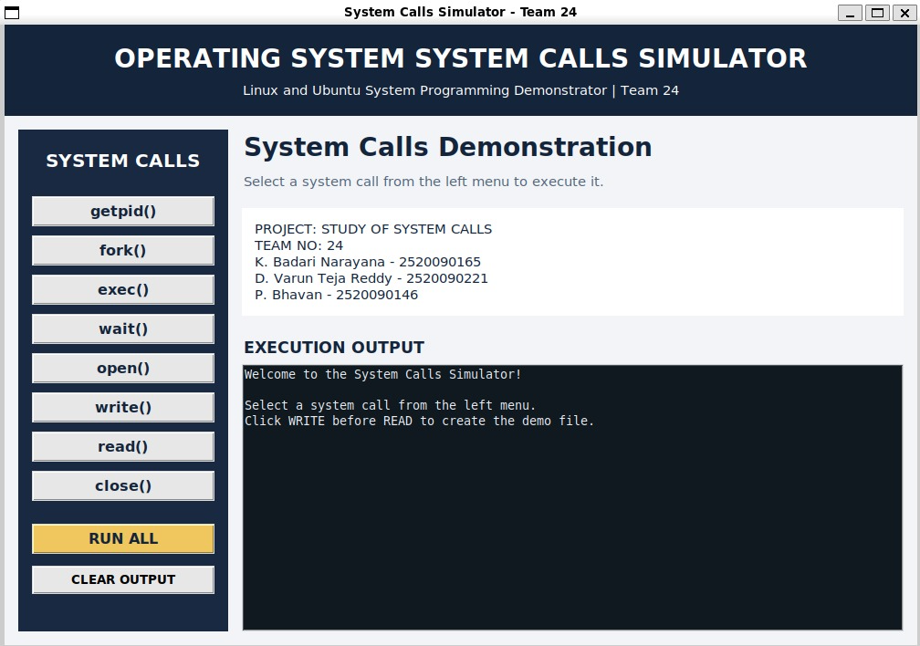

Figure 7.7: Operating System Concepts Simulator home screen

7.5 Demonstration of OS Concepts

The following table maps each operating-system concept to the place where it is observed during execution.
OS Concept | Where it is seen in the execution
Process creation | fork() creates a child process for each scenario and returns the child PID to the parent.
Process identification | getpid() and getppid() display the child and parent process IDs.
Normal termination | The first child exits with status 0; the parent detects it using WIFEXITED() and WEXITSTATUS().
Abnormal termination | The second child exits with status 1; the parent reports the non-zero exit code.
Signal-based termination | The parent sends SIGTERM with kill(); WIFSIGNALED() and WTERMSIG() identify the signal.
Parent-child synchronization | waitpid() blocks the parent until the child terminates, then returns the child PID and its status.
GUI integration | Tkinter launches process_termination and displays captured output in the CO2 module.
Supporting modules | CO1, CO3, CO4, CO5 and CO6 demonstrate shell commands, pipes, paging, files, threads and locking.

CHAPTER -8 CONCLUSION

8.1 Summary of the Project

The System Calls project was implemented in Ubuntu using C, GCC and Python Tkinter. The C program uses the fork(), getpid(), exit(), kill() and waitpid() system calls to create child processes and demonstrate normal completion, abnormal completion with a non-zero exit code, and signal-based termination using SIGTERM. The parent process waits for each child with waitpid() and interprets the returned status.

The program is compiled and executed in the Ubuntu terminal and integrated into the CO2 – Process module of the graphical simulator. The GUI displays the captured output, while the other course-outcome modules provide supporting demonstrations of shell commands, pipes, paging, file operations and thread synchronization.

8.2 Objectives Achieved
- Created child processes using fork() and displayed their process IDs.
- Demonstrated successful process completion using exit(0).
- Demonstrated abnormal completion using exit(1) and reported the exit status.
- Sent SIGTERM using kill() and identified signal-based termination.
- Used waitpid() and status macros to collect and interpret child termination information.
- Integrated the C program with the Python Tkinter GUI and displayed its output.

8.3 Results Achieved
- The first child process terminated normally and the parent reported exit status 0.
- The second child process terminated with exit status 1, and the parent displayed an abnormal-termination message.
- The third child process was terminated by SIGTERM; the parent identified signal number 15.
- The GUI successfully launched the C program and displayed the process-termination messages.
- The supporting modules demonstrated shell commands, anonymous pipes, page-table mapping, file operations, and threads with a lock.
- The results matched the expected behavior in the completed Ubuntu test runs.

8.4 Skills and Learning Outcomes
- C programming and Linux/POSIX system calls for process management.
- Process creation using fork() and termination using exit().
- Parent-child synchronization using waitpid() and interpretation of process status.
- Signal handling concepts using kill(), SIGTERM and status macros.
- Compiling C programs with GCC and executing them in Ubuntu/WSL.
- Building a desktop GUI with Python Tkinter and launching programs with subprocess.
- Testing, debugging, documenting results and collaborating as a three-member team.

CHAPTER -9 REFERENCES

9.1 Books
[1] A. Silberschatz, P. B. Galvin and G. Gagne, Operating System Concepts, 10th ed., Wiley, 2018.
[2] W. R. Stevens and S. A. Rago, Advanced Programming in the UNIX Environment, 3rd ed., Addison-Wesley, 2013.
[3] M. Kerrisk, The Linux Programming Interface, No Starch Press, 2010.
[4] B. W. Kernighan and D. M. Ritchie, The C Programming Language, 2nd ed., Prentice Hall, 1988.

9.2 Research Papers
[5] D. M. Ritchie and K. Thompson, “The UNIX Time-Sharing System,” Communications of the ACM, vol. 17, no. 7, pp. 365–375, 1974.

9.3 Linux / GNU Documentation
[6] Linux manual pages: fork(2), wait(2), waitpid(2), exit(3), kill(2), signal(7). https://man7.org/linux/man-pages/
[7] GNU Compiler Collection (GCC) Online Documentation. https://gcc.gnu.org/onlinedocs/
[8] Python Documentation: tkinter and subprocess modules. https://docs.python.org/3/

9.4 Online Resources
[9] Project source code: process_termination.c and os_simulator.py, maintained by the project team.
[10] Ubuntu Documentation. https://ubuntu.com/tutorials

