Skill Week-3
Task 1: To Apply Single Quotes, Preserve Literal Content, Ignore Variable Expansion, Store Quoted Strings, Validate Parsing Results, Test Edge Cases.
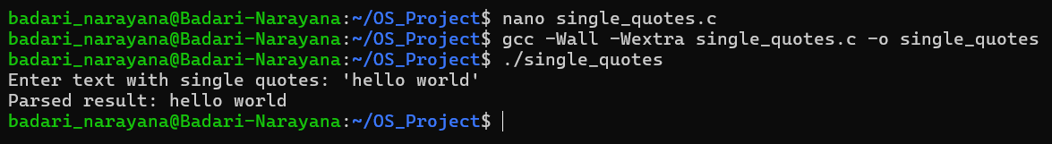
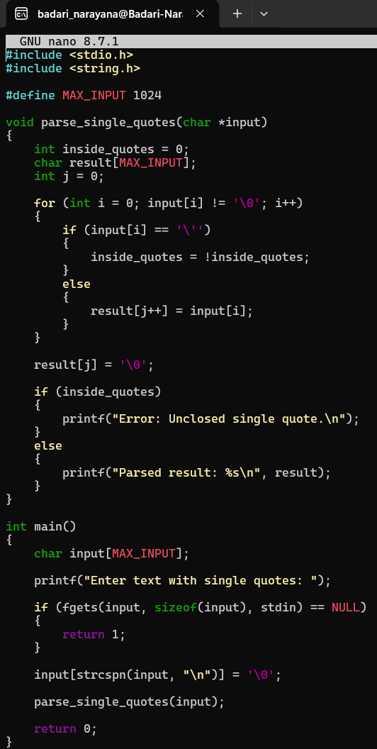

Task 2: To Apply Double Quotes, Preserve Spaces, Allow Variable Expansion, Parse Nested Tokens, Validate Outputs, Test Quoted Commands.
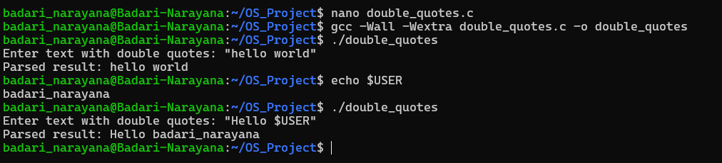
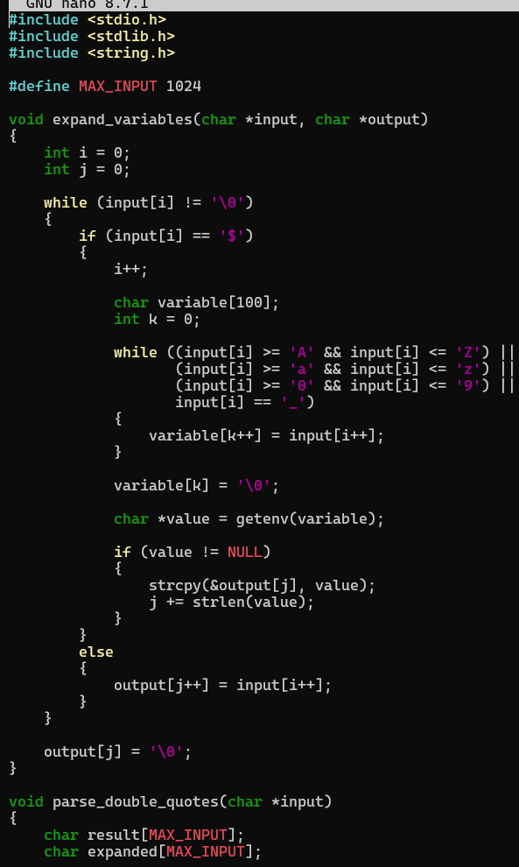
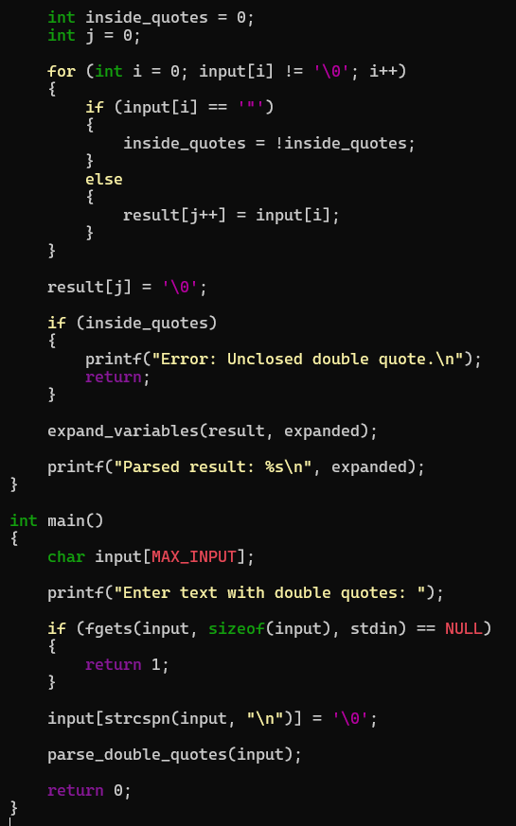

Task 3: To Create Process Escape Sequences, Handle Escaped Spaces, Escape Special Symbols, Preserve Characters, Validate Parser Output, Test Complex Inputs.
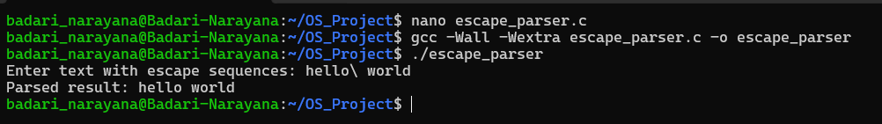
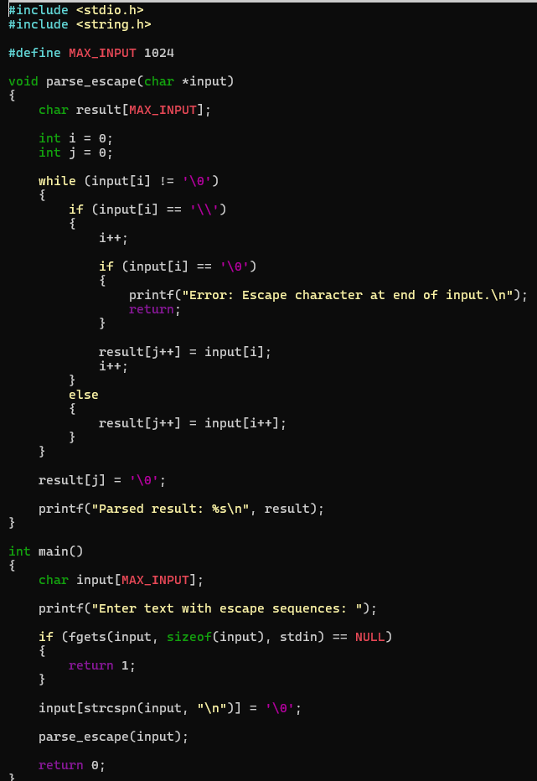

Task 4: To Create Child Processes, Execute Programs, Handle Execution Errors, Pass Arguments, Manage Parent Process, Test Command Launching.
