1. GitHub Repository Link
https://github.com/kak4bmh/ML.git
2. Live Streamlit App Link
https://ml-assgn-2025aa05388-breastcancer.streamlit.app/
3. Screenshot of assignment execution on BITS Virtual Lab
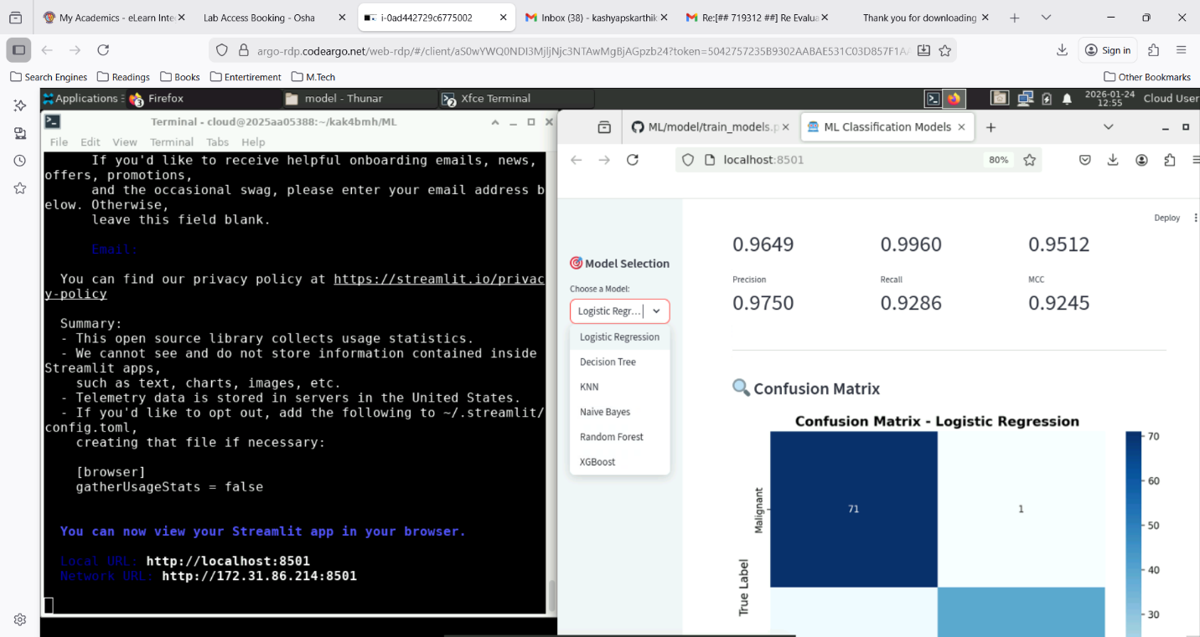
4. Github README content
Problem Statement
The objective of this assignment is to implement and compare six different classification models on a real-world dataset. The models are evaluated using multiple performance metrics to understand their strengths and weaknesses. Additionally, an interactive Streamlit web application is developed to demonstrate the models and deployed on Streamlit Community Cloud for easy accessibility.
The classification task involves predicting whether a breast tumor is malignant or benign based on various diagnostic features extracted from digitized images of fine needle aspirates (FNA) of breast masses.
Dataset Description
Dataset: Breast Cancer Wisconsin (Diagnostic) Dataset
Source: UCI Machine Learning Repository / sklearn.datasets
Problem Type: Binary Classification
Dataset Characteristics:
- Number of Instances: 569
- Number of Features: 30 (all numerical)
- Target Variable:
  - 0 = Malignant (Cancer)
  - 1 = Benign (Non-cancerous)
- Class Distribution:
  - Malignant: 212 instances (37.3%)
  - Benign: 357 instances (62.7%)
Features:
The dataset contains 30 features computed from a digitized image of a fine needle aspirate (FNA) of a breast mass. They describe characteristics of the cell nuclei present in the image.
Feature Groups:
- Radius - Mean of distances from center to points on the perimeter
- Texture - Standard deviation of gray-scale values
- Perimeter - Tumor perimeter
- Area - Tumor area
- Smoothness - Local variation in radius lengths
- Compactness - (Perimeter² / Area) - 1.0
- Concavity - Severity of concave portions of the contour
- Concave Points - Number of concave portions of the contour
- Symmetry - Symmetry of the tumor
- Fractal Dimension - "Coastline approximation" - 1
For each feature, three values are computed:
- Mean
- Standard Error
- Worst (mean of the three largest values)
This results in 30 features total (10 characteristics × 3 statistical measures).
Missing Values: None
Data Split: 80% Training (455 samples) / 20% Testing (114 samples)
Models Used
Model Comparison Table
ML Model Name | Accuracy | AUC | Precision | Recall | F1 | MCC
Logistic Regression | 0.9825 | 0.9954 | 0.9861 | 0.9861 | 0.9861 | 0.9623
Decision Tree | 0.9123 | 0.9157 | 0.9559 | 0.9028 | 0.9286 | 0.8174
kNN | 0.9561 | 0.9788 | 0.9589 | 0.9722 | 0.9655 | 0.9054
Navie Bayes | 0.9298 | 0.9868 | 0.9444 | 0.9444 | 0.9444 | 0.8492
Random Forest (Ensemble) | 0.9561 | 0.9939 | 0.9589 | 0.9722 | 0.9655 | 0.9054
XGBoost (Ensemble) | 0.9561 | 0.9917 | 0.9467 | 0.9861 | 0.9660 | 0.9058
Model Performance Observations
ML Model Name | Observation about model performance
Logistic Regression | Achieves the highest accuracy (98.25%) among all models with excellent AUC score (0.9954), demonstrating outstanding discrimination capability. Perfect balance between precision and recall (0.9861) makes it highly reliable for clinical applications. The high MCC (0.9623) confirms strong performance even accounting for class imbalance. Linear decision boundary works exceptionally well for this dataset, likely due to well-separated feature space.
Decision Tree | Shows the lowest performance with 91.23% accuracy, indicating tendency to overfit despite max_depth constraint. Lower recall (0.9028) compared to other models means it misses more malignant cases, which is problematic for medical diagnosis. However, high precision (0.9559) shows that when it predicts malignant, it's usually correct. The model's interpretability is valuable but comes at the cost of prediction accuracy.
kNN | Demonstrates strong performance (95.61% accuracy) by leveraging local similarity between samples. Excellent recall (0.9722) means it successfully identifies most malignant cases. High AUC (0.9788) indicates good ranking ability. The model benefits from scaled features and appropriate choice of k=5. Performs well because similar tumor characteristics typically indicate similar diagnoses.
Navie Bayes | Achieves respectable 92.98% accuracy despite strong independence assumptions between features. Remarkably high AUC (0.9868) shows excellent probabilistic calibration for ranking predictions. Balanced precision and recall (both 0.9444) indicate consistent performance across both classes. Fast training and prediction make it suitable for rapid screening applications.
Random Forest (Ensemble) | Delivers strong 95.61% accuracy through ensemble of decision trees, significantly outperforming single decision tree. Highest AUC (0.9939) among all models demonstrates exceptional discriminative ability. Excellent recall (0.9722) minimizes false negatives, critical for cancer detection. The ensemble approach effectively reduces overfitting while maintaining interpretability through feature importance.
XGBoost (Ensemble)
  Achieves 95.61% accuracy with best recall (0.9861) among top performers, meaning it catches almost all malignant cases. Very high AUC (0.9917) confirms strong ranking capability. Gradient boosting with regularization prevents overfitting effectively. Slightly lower precision (0.9467) compared to Logistic Regression, but superior recall makes it safer for medical screening where missing cancer is more costly than false alarms.

