Sporządź tabele stanów przedstawionych układów. Rozwiązanie prześlij w formie pliku: AK-lab2-bramki-imie-nazwisko.pdf na Moodle.

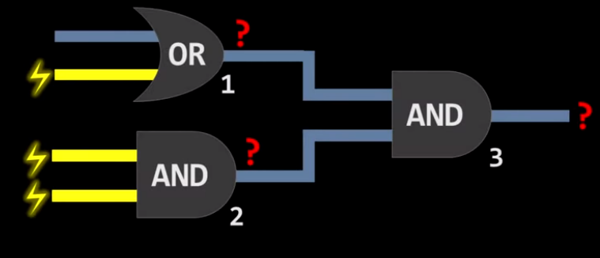

1. Tabelki…
2. OR

|  |  |  |
| --- | --- | --- |
| 0 | 0 | 0 |
| 0 | 1 | 1 |
| 1 | 0 | 1 |
| 1 | 1 | 1 |

1. AND

|  |  |  |
| --- | --- | --- |
| 0 | 0 | 0 |
| 0 | 1 | 0 |
| 1 | 0 | 0 |
| 1 | 1 | 1 |

1. AND

|  |  |  |
| --- | --- | --- |
| 0 | 0 | 0 |
| 0 | 1 | 0 |
| 1 | 0 | 0 |
| 1 | 1 | 1 |

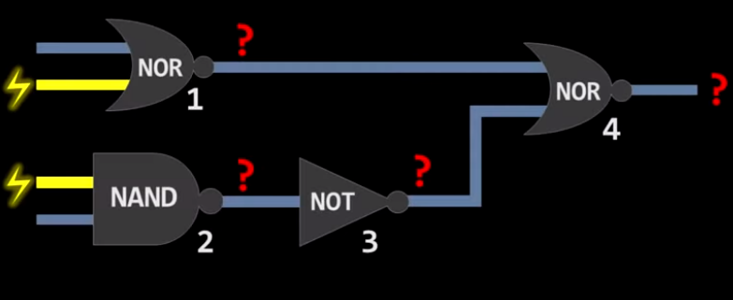

1. Tabelki…
2. NOR

|  |  |  |
| --- | --- | --- |
| 0 | 0 | 1 |
| 0 | 1 | 0 |
| 1 | 0 | 0 |
| 1 | 1 | 0 |

1. NAND

|  |  |  |
| --- | --- | --- |
| 0 | 0 | 1 |
| 0 | 1 | 1 |
| 1 | 0 | 1 |
| 1 | 1 | 0 |

1. NOT

|  |  |
| --- | --- |
| 0 | 1 |
| 1 | 0 |

1. NOR

|  |  |  |
| --- | --- | --- |
| 0 | 0 | 1 |
| 0 | 1 | 0 |
| 1 | 0 | 0 |
| 1 | 1 | 0 |

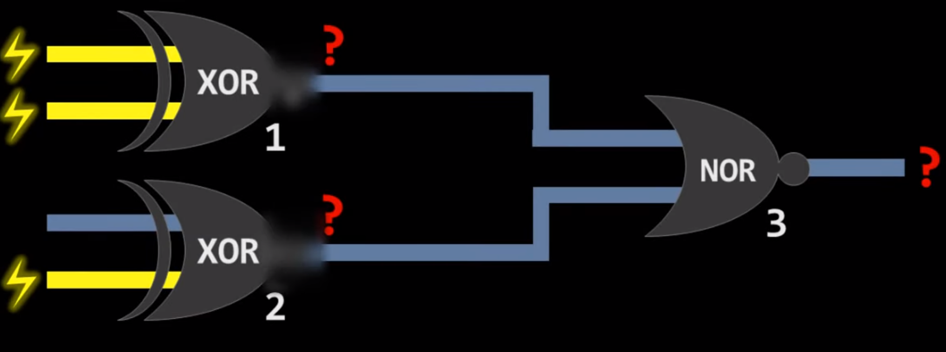

1. Tabelki…
2. XOR

|  |  |  |
| --- | --- | --- |
| 0 | 0 | 0 |
| 0 | 1 | 1 |
| 1 | 0 | 1 |
| 1 | 1 | 0 |

1. XOR

|  |  |  |
| --- | --- | --- |
| 0 | 0 | 0 |
| 0 | 1 | 1 |
| 1 | 0 | 1 |
| 1 | 1 | 0 |

1. NOR

|  |  |  |
| --- | --- | --- |
| 0 | 0 | 1 |
| 0 | 1 | 0 |
| 1 | 0 | 0 |
| 1 | 1 | 0 |

1. Zbuduj bramkę OR: korzystając z bramek AND i NOT (w dowolnej ilości)
2. Zbuduj bramkę AND z bramek NAND
3. Zbuduj bramkę OR z bramek NAND
4. Zbuduj bramkę NOR z bramek NAND
5. Zbuduj bramkę XOR z bramek NAND

Sporządź tabele stanów przedstawionych układów:

1. 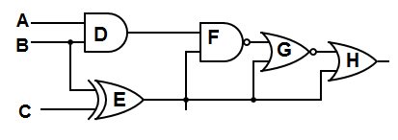
2. 