Thalia Mills
7/21/08 and 7/22/08
integrate_annulus tests
This word file is saved as ThaliaAnnulusTest.doc in:
C:\Documents and Settings\Thalia Mills\My Documents\MATLAB\ThaliaAnnulusTest

Tested the new integrate_annulus_basic function Gil sent against the old integrate_annulus (uses cartesian_to_polar and unwrap). The old integrate_annulus function used the small angle limit. It also used "c-code" cartesian_to_polar. The new "integrate_annulus_basic" function does not make the small angle approx. and therefore is "correct." Also, it is self-contained and does not use unwrap or cartesian_to_polar or any C-code.
Note that there was an intermediate version of the cartesian_to_polar which fixed a problem with integrating near phi=90 deg. This version was used for DPPC/Chol I vs. phi plots (need to re-do these) and also for analyzing some CMU dhpc and dppc data for Stephanie Tristram-Nagle. However, all published data were analyzed using the old cartesian_to_polar.c code, and so "old" in this document refers to the code used for thesis/published papers/etc.

MATLAB workspace saved as: ThaliaAnnulusTest.mat in:
C:\Documents and Settings\Thalia Mills\My Documents\MATLAB\ThaliaAnnulusTest\NewCalcs

General conclusions:
1. Differences are neglible, but if comapring data, should use the same analysis.
2. The new function tends to give slightly higher S-values (e.g. for DOPC, new S=0.28 compared with old S=0.25). This would tend to decrease the area, which would be good for comparison to LAXS because the WAXS areas are usually a bit high.
3. new vs. old has no effect on whether the data require a double order parameter fit. Again, the two S values are very similar when comparing the old vs. new function.
4. Bottom line: from now on should use the new function ("integrate_annulus_basic") because it is "correct" and because it is self-contained and does not rely on C-code.

7/21/08
EDU>> load do_5c.mat; load dodpch15_15_3c.mat; load dodpch15_20_3c.mat; load dodpch15_25c.mat; load dodpch15_30c.mat;load dodpch15_35c.mat;load dodpch15_40c.mat;load dodpch15_45c.mat;load dp_45_2c.mat;load dpch40_45_2c.mat;load mdo_3c.mat; load mdodpch15_15_2c.mat;load mdp_45_2new.mat; load mdodp_45_2.mat;
Work on CHESS October 2006 dopc data
EDU>> Spec_to_Phos=2174;X_Lambda=1.274;
EDU>> X_cen=933;Y_cen=92;MaskI=mdo_3c;
EDU>> new_do_5a1=integrate_annulus_basic(do_5c,[0.8,1.8]);
EDU>> NewFitPhi_MSG(new_do_5a1,[10,80],[100,1,1],0,'new-do-5a1');
Optimization terminated: relative function value
changing by less than OPTIONS.TolFun.

df=68 SSE=395.375 RMSE=2.41129 adjR2=0.999239 R2=0.99926
Iback=485.834 A=2411.45 m=1.87222
errIback=10.5479 errA=83.1517 errm=0.0681501
S=0.277534 errS=0.0103681
Fchains_030=0.312854 Fchains_6090=0.267049
Fscatt_030=0.500832 Fscatt_6090=0.193909

EDU>> old_do_5a1=integrate_annulus(do_5c,[0.8,1.8]);
EDU>> NewFitPhi_MSG(old_do_5a1,[10,80],[100,1,1],0,'old-do-5a1');
Optimization terminated: relative function value
changing by less than OPTIONS.TolFun.

df=68 SSE=777.321 RMSE=3.381 adjR2=0.998643 R2=0.998682
Iback=441.625 A=2745.81 m=1.70561
errIback=17.9663 errA=142.13 errm=0.0911456
S=0.252083 errS=0.0139729
Fchains_030=0.294079 Fchains_6090=0.286221
Fscatt_030=0.483379 Fscatt_6090=0.206366
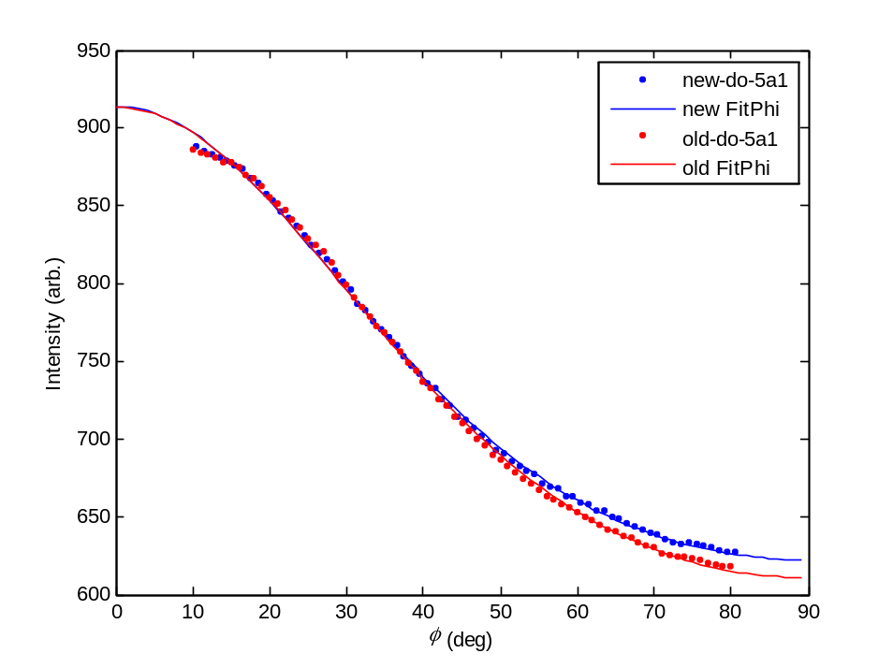
7/22/08
Work on CHESS February 2006 dppc and dppc+40% chol data
DPPC
EDU>> Spec_to_Phos=2462;X_Lambda=1.18018;
EDU>> X_cen=972;Y_cen=95.5;MaskI=mdp_45_2new;
EDU>> new_dp_45_2a1=integrate_annulus_basic(dp_45_2c,[0.8,1.8]);
EDU>> old_dp_45_2a1=integrate_annulus(dp_45_2c,[0.8,1.8]);
EDU>> NewFitPhi_MSG(new_dp_45_2a1,[8,80],[100,1,1],0,'new-dp-45-2a1');
Optimization terminated: relative function value
changing by less than OPTIONS.TolFun.

df=70 SSE=837.95 RMSE=3.45987 adjR2=0.998617 R2=0.998655
Iback=561.347 A=1598.36 m=3.086
errIback=5.16313 errA=40.4879 errm=0.0936108
S=0.450489 errS=0.0120978
Fchains_030=0.454311 Fchains_6090=0.149193
Fscatt_030=0.630958 Fscatt_6090=0.112598

EDU>> NewFitPhi_MSG(old_dp_45_2a1,[8,80],[100,1,1],0,'old-dp-45-2a1');
Optimization terminated: relative function value
changing by less than OPTIONS.TolFun.

df=70 SSE=1154.57 RMSE=4.06126 adjR2=0.998198 R2=0.998248
Iback=549.718 A=1653.38 m=3.02326
errIback=6.33001 errA=49.8048 errm=0.106771
S=0.442329 errS=0.0139739
Fchains_030=0.447046 Fchains_6090=0.154232
Fscatt_030=0.624376 Fscatt_6090=0.116249
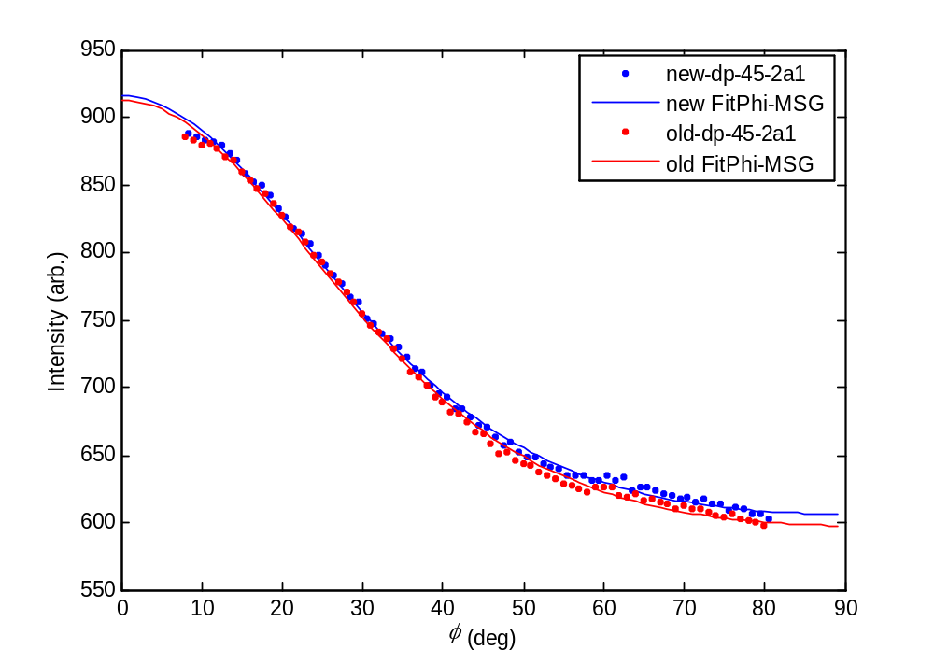
DPPC + 40% Chol (Note fit not great for either new or old I vs. phi plots)
EDU>> Spec_to_Phos=2462;X_Lambda=1.18018;
EDU>> X_cen=911;Y_cen=86.5;MaskI=mdodp_45_2;
EDU>> new_dpch40_45_2a1=integrate_annulus_basic(dpch40_45_2c,[0.8,1.8]);
EDU>> old_dpch40_45_2a1=integrate_annulus(dpch40_45_2c,[0.8,1.8]);

EDU>> NewFitPhi_MSG(new_dpch40_45_2a1,[4,80],[100,1,1],0,'new-dpch40-45-2a1');
Optimization terminated: relative function value
changing by less than OPTIONS.TolFun.

df=74 SSE=641.634 RMSE=2.94461 adjR2=0.995357 R2=0.995479
Iback=86.474 A=351.007 m=11.4024
errIback=0.881751 errA=6.29528 errm=0.417257
S=0.8606 errS=0.00552094
Fchains_030=0.93176 Fchains_6090=0.000466673
Fscatt_030=0.974994 Fscatt_6090=0.00026536

EDU>> NewFitPhi_MSG(old_dpch40_45_2a1,[4,80],[100,1,1],0,'old-dpch40-45-2a1');
Optimization terminated: relative function value
changing by less than OPTIONS.TolFun.

df=74 SSE=528.09 RMSE=2.6714 adjR2=0.996373 R2=0.996469
Iback=84.171 A=351.722 m=11.2617
errIback=0.806289 errA=5.72951 errm=0.366707
S=0.858713 errS=0.00498821
Fchains_030=0.929288 Fchains_6090=0.000518844
Fscatt_030=0.973921 Fscatt_6090=0.000297261

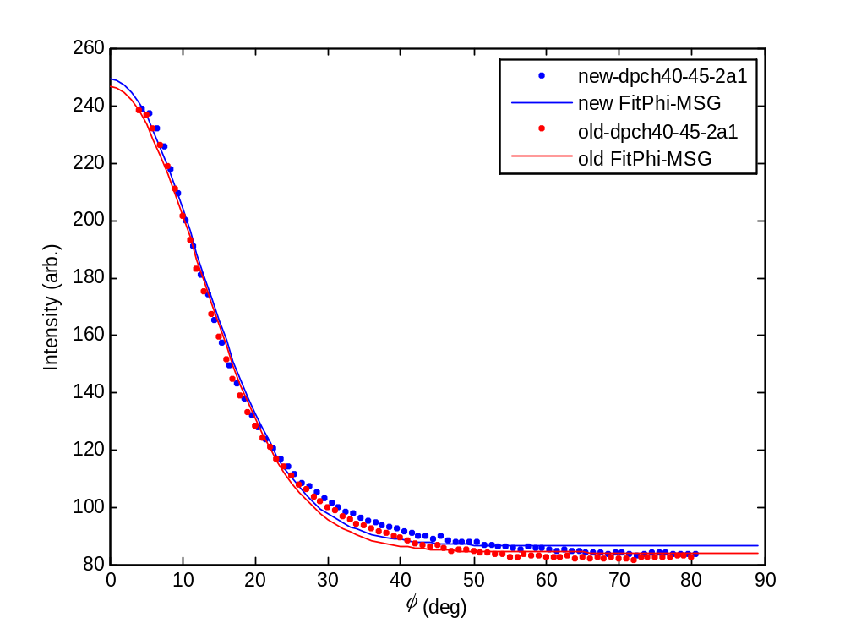
7/22/08
Work on CHESS October 2006 dodpch15 data
EDU>> Spec_to_Phos=2174;X_Lambda=1.274;

EDU>> X_cen=936;Y_cen=69.5;MaskI=mdodpch15_15_2c;
EDU>> new_dodpch15_15_3a1=integrate_annulus_basic(dodpch15_15_3c,[0.8,1.8]);
EDU>> old_dodpch15_15_3a1=integrate_annulus(dodpch15_15_3c,[0.8,1.8]);
EDU>> X_cen=938;Y_cen=69.5;MaskI=mdodpch15_15_2c;
EDU>> new_dodpch15_20_3a1=integrate_annulus_basic(dodpch15_20_3c,[0.8,1.8]);
EDU>> new_dodpch15_25a1=integrate_annulus_basic(dodpch15_25c,[0.8,1.8]);
EDU>> new_dodpch15_30a1=integrate_annulus_basic(dodpch15_30c,[0.8,1.8]);
EDU>> new_dodpch15_35a1=integrate_annulus_basic(dodpch15_35c,[0.8,1.8]);
EDU>> new_dodpch15_40a1=integrate_annulus_basic(dodpch15_40c,[0.8,1.8]);
EDU>> new_dodpch15_45a1=integrate_annulus_basic(dodpch15_45c,[0.8,1.8]);
EDU>> old_dodpch15_20_3a1=integrate_annulus(dodpch15_20_3c,[0.8,1.8]);
EDU>> old_dodpch15_25a1=integrate_annulus(dodpch15_25c,[0.8,1.8]);
EDU>> old_dodpch15_30a1=integrate_annulus(dodpch15_30c,[0.8,1.8]);
EDU>> old_dodpch15_35a1=integrate_annulus(dodpch15_35c,[0.8,1.8]);
EDU>> old_dodpch15_40a1=integrate_annulus(dodpch15_40c,[0.8,1.8]);
EDU>> old_dodpch15_45a1=integrate_annulus(dodpch15_45c,[0.8,1.8]);

dodpch15_15_3a1 (1:1 DOPC/DPPC + 15% Chol at 15˚C)
EDU>> NewFitPhi_MSG(new_dodpch15_15_3a1,[3,80],[100,1,1],0,'new-dodpch15-15-3a1');
Optimization terminated: relative function value
changing by less than OPTIONS.TolFun.

df=75 SSE=346566 RMSE=67.977 adjR2=0.969345 R2=0.970141
Iback=819.697 A=2911.47 m=12.0929
errIback=19.9802 errA=139.957 errm=1.1648
S=0.869161 errS=0.0135305
Fchains_030=0.942685 Fchains_6090=0.000277122
Fscatt_030=0.97962 Fscatt_6090=0.000151839

EDU>> NewFitPhi_MSG(old_dodpch15_15_3a1,[3,80],[100,1,1],0,'new-dodpch15-15-3a1');
Optimization terminated: relative function value
changing by less than OPTIONS.TolFun.

df=75 SSE=355944 RMSE=68.8907 adjR2=0.969462 R2=0.970255
Iback=809.692 A=2917.17 m=11.5626
errIback=20.5821 errA=144.771 errm=1.1187
S=0.862687 errS=0.0143499
Fchains_030=0.934469 Fchains_6090=0.000413572
Fscatt_030=0.976159 Fscatt_6090=0.000233151

EDU>> NewFitPhi_MSG2(new_dodpch15_15_3a1,[3,80],[100,1,1,1,10],0,'new-dodpch15-15-3a1');
Optimization terminated: relative function value
changing by less than OPTIONS.TolFun.

df=73 SSE=5756 RMSE=8.87972 adjR2=0.999477 R2=0.999504
Iback=698.1 A1=2599.55 m1=3.60633 A2=1448.98 m2=30.0054
errIback=13.6808 errA1=80.2114 errm1=0.245565 errA2=52.675 errm2=1.24821
S1=0.514016 S2=0.949096 errS1=0.0281745 errS2=0.00215936
P1=0.642098 P2=0.357902 errP1=0.0109579 errP2=0.0109579
AreaF1=0.675939 AreaF2=0.324061
Fchains_030=0.687173 Fchains_6090=0.0718809
Fscatt_030=0.78608 Fscatt_6090=0.0575451

EDU>> NewFitPhi_MSG2(old_dodpch15_15_3a1,[3,80],[100,1,1,1,10],0,'old-dodpch15-15-3a1');
Optimization terminated: relative function value
changing by less than OPTIONS.TolFun.

df=73 SSE=5350.04 RMSE=8.56085 adjR2=0.999528 R2=0.999553
Iback=690.077 A1=1338.78 m1=30.6183 A2=2677.67 m2=3.69999
errIback=12.5158 errA1=50.1772 errm1=1.27319 errA2=73.3677 errm2=0.22608
S1=0.950135 S2=0.524635 errS1=0.00211348 errS2=0.025327
P1=0.333325 P2=0.666675 errP1=0.010317 errP2=0.010317
AreaF1=0.301797 AreaF2=0.698203
Fchains_030=0.682094 Fchains_6090=0.0707235
Fscatt_030=0.785348 Fscatt_6090=0.056369
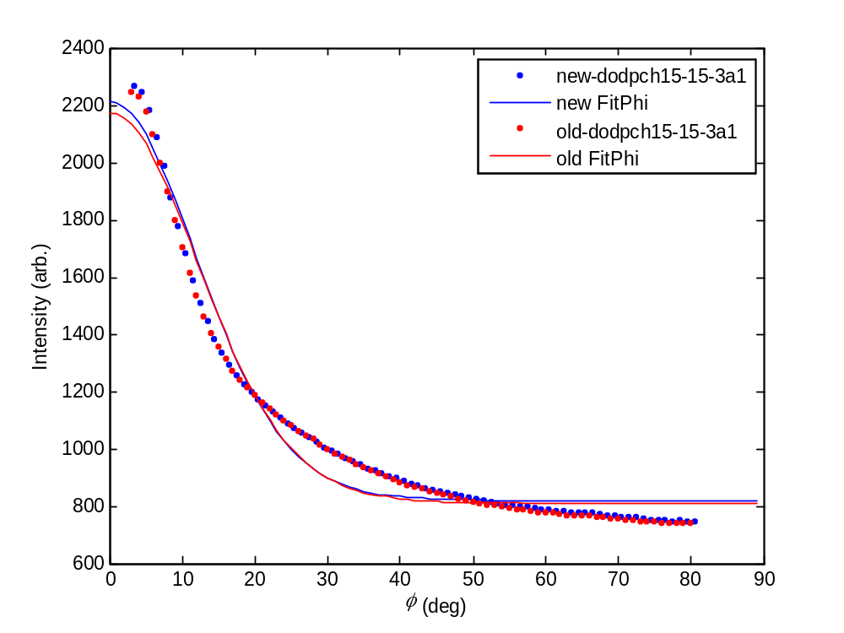
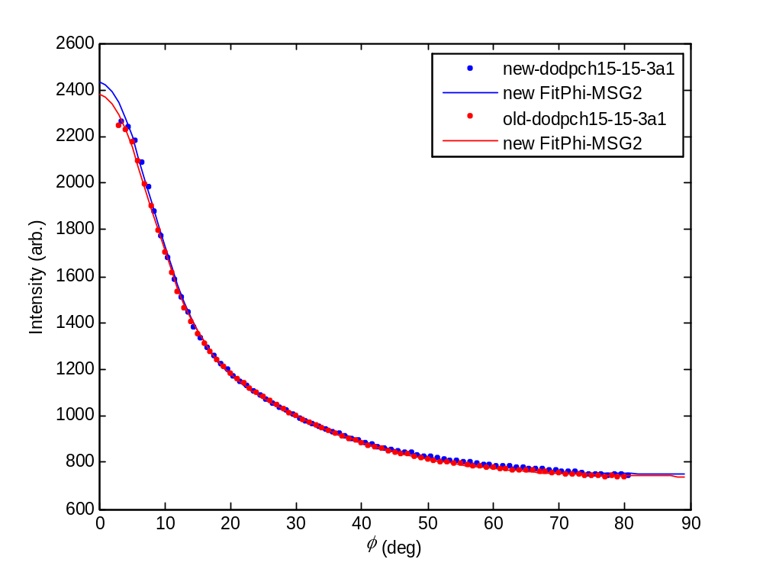
dodpch15_20_3a1 (1:1 DOPC/DPPC + 15% Chol at 20˚C)
EDU>> NewFitPhi_MSG(new_dodpch15_20_3a1,[4,80],[100,1,1],0,'new-dodpch15-20-3a1');
Optimization terminated: relative function value
changing by less than OPTIONS.TolFun.

df=74 SSE=527607 RMSE=84.4382 adjR2=0.968135 R2=0.968973
Iback=1149.65 A=3996.25 m=9.34253
errIback=27.1403 errA=201.101 errm=0.904929
S=0.826454 errS=0.0188
Fchains_030=0.884903 Fchains_6090=0.00218372
Fscatt_030=0.953079 Fscatt_6090=0.00138452

EDU>> NewFitPhi_MSG(old_dodpch15_20_3a1,[4,80],[100,1,1],0,'old-dodpch15-20-3a1');
Optimization terminated: relative function value
changing by less than OPTIONS.TolFun.

df=74 SSE=529140 RMSE=84.5609 adjR2=0.969309 R2=0.970117
Iback=1134.01 A=4037.03 m=8.96047
errIback=27.8429 errA=207.141 errm=0.857756
S=0.818126 errS=0.0196131
Fchains_030=0.873124 Fchains_6090=0.00289887
Fscatt_030=0.947059 Fscatt_6090=0.00187408

EDU>> NewFitPhi_MSG2(new_dodpch15_20_3a1,[4,80],[100,1,1,1,10],0,'new-dodpch15-20-3a1');
Optimization terminated: relative function value
changing by less than OPTIONS.TolFun.

df=72 SSE=3846.51 RMSE=7.30915 adjR2=0.999761 R2=0.999774
Iback=972.144 A1=1722.08 m1=28.937 A2=3956.49 m2=3.36533
errIback=13.301 errA1=43.8596 errm1=0.911677 errA2=79.095 errm2=0.140183
S1=0.947178 S2=0.485533 errS1=0.00169849 errS2=0.0170467
P1=0.30326 P2=0.69674 errP1=0.00684119 errP2=0.00684119
AreaF1=0.269604 AreaF2=0.730396
Fchains_030=0.6418 Fchains_6090=0.0893211
Fscatt_030=0.751391 Fscatt_6090=0.0710098

EDU>> NewFitPhi_MSG2(old_dodpch15_20_3a1,[4,80],[100,1,1,1,10],0,'old-dodpch15-20-3a1');
Optimization terminated: relative function value
changing by less than OPTIONS.TolFun.

df=72 SSE=3053.06 RMSE=6.5118 adjR2=0.999818 R2=0.999828
Iback=963.286 A1=4053.28 m1=3.48336 A2=1574.16 m2=29.7436
errIback=10.9877 errA1=65.0857 errm1=0.118679 errA2=38.4309 errm2=0.867711
S1=0.49969 S2=0.948639 errS1=0.0140351 errS2=0.00152823
P1=0.720271 P2=0.279729 errP1=0.00588748 errP2=0.00588748
AreaF1=0.750943 AreaF2=0.249057
Fchains_030=0.639328 Fchains_6090=0.0864518
Fscatt_030=0.753288 Fscatt_6090=0.0684581
dodpch15_25a1 (1:1 DOPC/DPPC + 15% Chol at 25˚C)
EDU>> NewFitPhi_MSG(new_dodpch15_25a1,[4,80],[100,1,1],0,'new-dodpch15-25a1');
Optimization terminated: relative function value
changing by less than OPTIONS.TolFun.

df=74 SSE=665470 RMSE=94.8306 adjR2=0.976175 R2=0.976802
Iback=1615.38 A=5640.31 m=7.36524
errIback=35.1092 errA=271.238 errm=0.621124
S=0.772431 errS=0.0221933
Fchains_030=0.809118 Fchains_6090=0.0092998
Fscatt_030=0.910902 Fscatt_6090=0.0064867

EDU>> NewFitPhi_MSG(old_dodpch15_25a1,[4,80],[100,1,1],0,'old-dodpch15-25a1');
Optimization terminated: relative function value
changing by less than OPTIONS.TolFun.

df=74 SSE=635360 RMSE=92.6604 adjR2=0.978183 R2=0.978757
Iback=1587.88 A=5743.74 m=7.08976
errIback=35.5669 errA=276.122 errm=0.577639
S=0.762163 errS=0.0224546
Fchains_030=0.795132 Fchains_6090=0.0113303
Fscatt_030=0.902253 Fscatt_6090=0.00799717

EDU>> NewFitPhi_MSG2(new_dodpch15_25a1,[4,80],[100,1,1,1,10],0,'new-dodpch15-25a1');
Optimization terminated: relative function value
changing by less than OPTIONS.TolFun.

df=72 SSE=7912.7 RMSE=10.4833 adjR2=0.999709 R2=0.999724
Iback=1361.01 A1=1984.4 m1=24.6254 A2=5959.67 m2=3.1414
errIback=23.7417 errA1=77.1197 errm1=1.06145 errA2=137.602 errm2=0.153073
S1=0.937701 S2=0.457607 errS1=0.0027528 errS2=0.0195568
P1=0.249796 P2=0.750204 errP1=0.0084712 errP2=0.0084712
AreaF1=0.218019 AreaF2=0.781981
Fchains_030=0.594799 Fchains_6090=0.108661
Fscatt_030=0.715797 Fscatt_6090=0.0855755

EDU>> NewFitPhi_MSG2(old_dodpch15_25a1,[4,80],[100,1,1,1,10],0,'old-dodpch15-25a1');
Optimization terminated: relative function value
changing by less than OPTIONS.TolFun.

df=72 SSE=6988.55 RMSE=9.85207 adjR2=0.999753 R2=0.999766
Iback=1359.25 A1=6033.79 m1=3.34233 A2=1763.73 m2=25.7396
errIback=19.3199 errA1=109.951 errm1=0.13501 errA2=70.4919 errm2=1.1147
S1=0.48273 S2=0.940462 errS1=0.0165047 errS2=0.00263971
P1=0.773809 P2=0.226191 errP1=0.00768825 errP2=0.00768825
AreaF1=0.801386 AreaF2=0.198614
Fchains_030=0.600026 Fchains_6090=0.10047
Fscatt_030=0.72533 Fscatt_6090=0.0788818

dodpch15_30a1 (1:1 DOPC/DPPC + 15% Chol at 30˚C)

EDU>> NewFitPhi_MSG(new_dodpch15_30a1,[4,80],[100,1,1],0,'new-dodpch15-30a1');
Optimization terminated: relative function value
changing by less than OPTIONS.TolFun.

df=74 SSE=650353 RMSE=93.7473 adjR2=0.989125 R2=0.989411
Iback=2487.14 A=9670.57 m=5.30931
errIback=49.7672 errA=398.608 errm=0.322734
S=0.668868 errS=0.0222888
Fchains_030=0.677298 Fchains_6090=0.0388347
Fscatt_030=0.819869 Fscatt_6090=0.0291188

EDU>> NewFitPhi_MSG(old_dodpch15_30a1,[4,80],[100,1,1],0,'old-dodpch15-30a1');
Optimization terminated: relative function value
changing by less than OPTIONS.TolFun.

df=74 SSE=563083 RMSE=87.2309 adjR2=0.990986 R2=0.991223
Iback=2436.58 A=9920.52 m=5.14802
errIback=48.6825 errA=391.044 errm=0.289728
S=0.657432 errS=0.0210846
Fchains_030=0.663963 Fchains_6090=0.0431985
Fscatt_030=0.809593 Fscatt_6090=0.0325071

EDU>> NewFitPhi_MSG2(new_dodpch15_30a1,[4,80],[100,1,1,1,10],0,'new-dodpch15-30a1');
Optimization terminated: relative function value
changing by less than OPTIONS.TolFun.

df=72 SSE=14923.8 RMSE=14.3971 adjR2=0.999744 R2=0.999757
Iback=2107.28 A1=2239.37 m1=18.653 A2=10694.2 m2=2.91762
errIback=45.0909 errA1=164.997 errm1=1.2331 errA2=238.22 errm2=0.154134
S1=0.91706 S2=0.428361 errS1=0.00568186 errS2=0.0205867
P1=0.173144 P2=0.826856 errP1=0.01102 errP2=0.01102
AreaF1=0.147716 AreaF2=0.852284
Fchains_030=0.530717 Fchains_6090=0.134767
Fscatt_030=0.669873 Fscatt_6090=0.104451

EDU>> NewFitPhi_MSG2(old_dodpch15_30a1,[4,80],[100,1,1,1,10],0,'old-dodpch15-30a1');
Optimization terminated: relative function value
changing by less than OPTIONS.TolFun.

df=72 SSE=15172.3 RMSE=14.5164 adjR2=0.99975 R2=0.999764
Iback=2122.43 A1=1832.77 m1=20.2059 A2=10783.5 m2=3.16574
errIback=36.5524 errA1=151.866 errm1=1.51953 errA2=188.587 errm2=0.139105
S1=0.923644 S2=0.460709 errS1=0.00592875 errS2=0.0176811
P1=0.14527 P2=0.85473 errP1=0.0105153 errP2=0.0105153
AreaF1=0.125043 AreaF2=0.874957
Fchains_030=0.540353 Fchains_6090=0.122192
Fscatt_030=0.68411 Fscatt_6090=0.0945493
dodpch15_35a1 (1:1 DOPC/DPPC + 15% Chol at 35˚C)

Had to do 2 iterations with new integrate_annulus_basic I vs. phi file
EDU>> NewFitPhi_MSG(new_dodpch15_35a1,[6,80],[100,1,1],0,'new-dodpch15-35a1');
Maximum number of function evaluations exceeded;
increase options.MaxFunEvals

df=72 SSE=1.82451e+007 RMSE=503.393 adjR2=0.786049 R2=0.791831
Iback=4502.75 A=6546.21 m=7.28373
errIback=190.305 errA=1461.96 errm=3.03132
S=0.769483 errS=0.111025
Fchains_030=0.805082 Fchains_6090=0.00986083
Fscatt_030=0.908433 Fscatt_6090=0.00690253

EDU>> NewFitPhi_MSG(new_dodpch15_35a1,[6,80],[4502.75,6546.21,7.28373],0,'new-dodpch15-35a1');
Optimization terminated: relative function value
changing by less than OPTIONS.TolFun.

df=72 SSE=147029 RMSE=45.1893 adjR2=0.998276 R2=0.998322
Iback=3546.18 A=16095.7 m=3.53844
errIback=49.6858 errA=394.659 errm=0.106671
S=0.50616 errS=0.012447
Fchains_030=0.505655 Fchains_6090=0.116354
Fscatt_030=0.676956 Fscatt_6090=0.0884266

EDU>> NewFitPhi_MSG(old_dodpch15_35a1,[6,80],[100,1,1],0,'old-dodpch15-35a1');
Optimization terminated: relative function value
changing by less than OPTIONS.TolFun.

df=72 SSE=66947.2 RMSE=30.493 adjR2=0.99926 R2=0.99928
Iback=3440.45 A=16663 m=3.46877
errIback=34.9716 errA=278.478 errm=0.0697292
S=0.497961 errS=0.00827525
Fchains_030=0.49789 Fchains_6090=0.121015
Fscatt_030=0.670066 Fscatt_6090=0.0918977

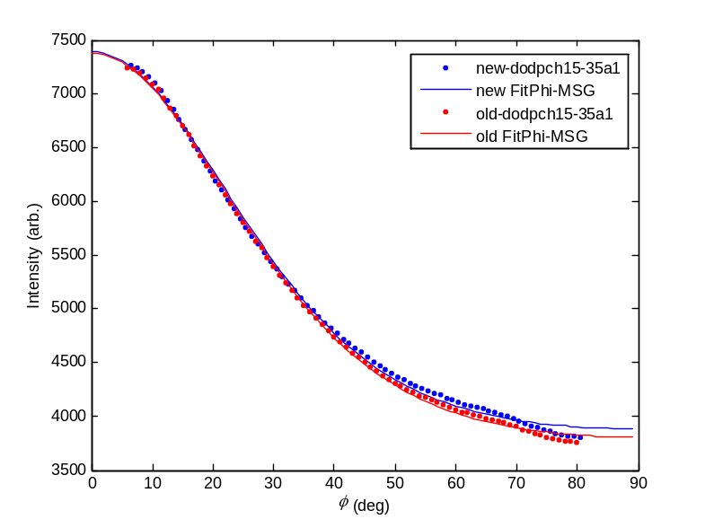
After 2 iterations, no convergence on fitting double order param fit to new integrate_annulus_basic I vs. phi file
EDU>> NewFitPhi_MSG2(new_dodpch15_35a1,[6,80],[100,1,1,1,10],0,'new-dodpch15-35a1');
Maximum number of function evaluations exceeded;
increase options.MaxFunEvals
df=70 SSE=66688.3 RMSE=30.8657 adjR2=0.999196 R2=0.999239
Iback=2966.24 A1=8373.27 m1=4.86645 A2=12404.8 m2=1.5621
errIback=2309.68 errA1=16920.4 errm1=3.14225 errA2=3579.96 errm2=4.72631
S1=0.635986 S2=0.230037 errS1=0.250265 errS2=0.727103
P1=0.402986 P2=0.597014 errP1=0.491105 errP2=0.491105
AreaF1=0.353155 AreaF2=0.646845
Fchains_030=0.423822 Fchains_6090=0.201916
Fscatt_030=0.582235 Fscatt_6090=0.154371

EDU>> NewFitPhi_MSG2(new_dodpch15_35a1,[6,80],[2966.24,8373.27,4.86645,12404.8,1.5621],0,'new-dodpch15-35a1');
Maximum number of function evaluations exceeded;
increase options.MaxFunEvals
df=70 SSE=56399.9 RMSE=28.3851 adjR2=0.99932 R2=0.999357
Iback=2923.44 A1=7350.48 m1=5.20126 A2=13779.3 m2=1.63518
errIback=1708.41 errA1=12048 errm1=2.8365 errA2=2960.4 errm2=3.24227
S1=0.661273 S2=0.241274 errS1=0.202896 errS2=0.498084
P1=0.347873 P2=0.652127 errP1=0.375017 errP2=0.375017
AreaF1=0.300486 AreaF2=0.699514
Fchains_030=0.419198 Fchains_6090=0.20656
Fscatt_030=0.577346 Fscatt_6090=0.157496

Needed 2 iterations to get convergence on fitting double order param fit to old integrate_annulus I vs. phi
(Also needed 2 iterations for thesis)
EDU>> NewFitPhi_MSG2(old_dodpch15_35a1,[6,80],[100,1,1,1,10],0,'old-dodpch15-35a1');
Maximum number of function evaluations exceeded;
increase options.MaxFunEvals
df=70 SSE=29268.6 RMSE=20.4481 adjR2=0.999667 R2=0.999685
Iback=2817.33 A1=9258.89 m1=4.5789 A2=12420.2 m2=1.45523
errIback=1993.67 errA1=13648.4 errm1=2.10073 errA2=3424.34 errm2=3.73633
S1=0.612017 S2=0.213589 errS1=0.183055 errS2=0.575233
P1=0.427088 P2=0.572912 errP1=0.366939 errP2=0.366939
AreaF1=0.376439 AreaF2=0.623561
Fchains_030=0.414591 Fchains_6090=0.207693
Fscatt_030=0.574927 Fscatt_6090=0.158344

EDU>> NewFitPhi_MSG2(old_dodpch15_35a1,[6,80],[2817.33,9258.89,4.5789,12420.2,1.45523],0,'old-dodpch15-35a1');
Optimization terminated: relative function value
changing by less than OPTIONS.TolFun.
df=70 SSE=28003.8 RMSE=20.0014 adjR2=0.999682 R2=0.999699
Iback=2770.46 A1=9065.23 m1=4.64063 A2=12990.9 m2=1.43008
errIback=1969.87 errA1=12226.7 errm1=1.98409 errA2=4271 errm2=3.37332
S1=0.617345 S2=0.209716 errS1=0.169625 errS2=0.519317
P1=0.411007 P2=0.588993 errP1=0.336065 errP2=0.336065
AreaF1=0.359991 AreaF2=0.640009
Fchains_030=0.409812 Fchains_6090=0.212594
Fscatt_030=0.569907 Fscatt_6090=0.161837
Note: more different than other files compared with papers/thesis but maybe because difficult time converging. Difference now: using student version of matlab and dawson's integral function which I stole from the web.
dodpch15_40a1 (1:1 DOPC/DPPC + 15% Chol at 40˚C)
EDU>> NewFitPhi_MSG(new_dodpch15_40a1,[6,80],[100,1,1],0,'new-dodpch15-40a1');
Optimization terminated: relative function value
changing by less than OPTIONS.TolFun.

df=72 SSE=1079.6 RMSE=3.87227 adjR2=0.999842 R2=0.999846
Iback=895.532 A=4727.39 m=3.36991
errIback=4.68632 errA=37.2386 errm=0.0318846
S=0.48609 errS=0.00387317
Fchains_030=0.486776 Fchains_6090=0.127873
Fscatt_030=0.66016 Fscatt_6090=0.0969808

EDU>> NewFitPhi_MSG(old_dodpch15_40a1,[6,80],[100,1,1],0,'old-dodpch15-40a1');
Optimization terminated: relative function value
changing by less than OPTIONS.TolFun.

df=72 SSE=1531.85 RMSE=4.61255 adjR2=0.999787 R2=0.999793
Iback=863.485 A=4952.89 m=3.24858
errIback=6.02337 errA=47.9779 errm=0.0367584
S=0.471146 errS=0.00458926
Fchains_030=0.472993 Fchains_6090=0.136688
Fscatt_030=0.647808 Fscatt_6090=0.103472

EDU>> NewFitPhi_MSG2(new_dodpch15_40a1,[6,80],[100,1,1,1,10],0,'new-dodpch15-40a1');
Optimization terminated: relative function value
changing by less than OPTIONS.TolFun.

df=70 SSE=1079.63 RMSE=3.92725 adjR2=0.999837 R2=0.999846
Iback=895.602 A1=2385.36 m1=3.3723 A2=2341.46 m2=3.36839
errIback=21.8573 errA1=2.57374e+008 errm1=245.887 errA2=2.57374e+008 errm2=241.846
S1=0.486381 S2=0.485906 errS1=29.8525 errS2=29.3884
P1=0.504644 P2=0.495356 errP1=38503.4 errP2=38503.4
AreaF1=0.504583 AreaF2=0.495417
Fchains_030=0.486827 Fchains_6090=0.127841
Fscatt_030=0.660206 Fscatt_6090=0.096957

EDU>> NewFitPhi_MSG2(old_dodpch15_40a1,[6,80],[100,1,1,1,10],0,'old-dodpch15-40a1');
Optimization terminated: relative function value
changing by less than OPTIONS.TolFun.

df=70 SSE=1531.9 RMSE=4.67806 adjR2=0.999781 R2=0.999793
Iback=863.625 A1=2509.28 m1=3.24944 A2=2442.46 m2=3.24936
errIback=29.4523 errA1=3.41953e+008 errm1=6534.77 errA2=3.41953e+008 errm2=6712.12
S1=0.471254 S2=0.471243 errS1=815.706 errS2=837.859
P1=0.506747 P2=0.493253 errP1=48835.1 errP2=48835.1
AreaF1=0.506746 AreaF2=0.493254
Fchains_030=0.473086 Fchains_6090=0.136627
Fscatt_030=0.647892 Fscatt_6090=0.103427
dodpch15_45a1 (1:1 DOPC/DPPC + 15% Chol at 45˚C)
EDU>> NewFitPhi_MSG(new_dodpch15_45a1,[6,80],[100,1,1],0,'new-dodpch15-45a1');
Optimization terminated: relative function value
changing by less than OPTIONS.TolFun.

df=72 SSE=556.885 RMSE=2.7811 adjR2=0.999773 R2=0.999779
Iback=577.434 A=3059.24 m=3.06409
errIback=4.07162 errA=32.3742 errm=0.0373861
S=0.447651 errS=0.00485317
Fchains_030=0.451777 Fchains_6090=0.150939
Fscatt_030=0.628664 Fscatt_6090=0.113865

EDU>> NewFitPhi_MSG(old_dodpch15_45a1,[6,80],[100,1,1],0,'old-dodpch15-45a1');
Optimization terminated: relative function value
changing by less than OPTIONS.TolFun.

df=72 SSE=1222.9 RMSE=4.12125 adjR2=0.999531 R2=0.999543
Iback=555.319 A=3211.1 m=2.96337
errIback=6.47583 errA=51.596 errm=0.0536397
S=0.434445 errS=0.00710258
Fchains_030=0.440087 Fchains_6090=0.159154
Fscatt_030=0.618056 Fscatt_6090=0.119799

EDU>> NewFitPhi_MSG2(new_dodpch15_45a1,[6,80],[100,1,1,1,10],0,'new-dodpch15-45a1');
Optimization terminated: relative function value
changing by less than OPTIONS.TolFun.

df=70 SSE=556.755 RMSE=2.82022 adjR2=0.999767 R2=0.999779
Iback=577.201 A1=1513.18 m1=3.05616 A2=1547.96 m2=3.0678
errIback=21.1108 errA1=2.04478e+008 errm1=781.008 errA2=2.04478e+008 errm2=777.389
S1=0.446621 S2=0.448133 errS1=101.547 errS2=100.839
P1=0.494318 P2=0.505682 errP1=47236.4 errP2=47236.4
AreaF1=0.494517 AreaF2=0.505483
Fchains_030=0.45154 Fchains_6090=0.151103
Fscatt_030=0.62845 Fscatt_6090=0.113984

EDU>> NewFitPhi_MSG2(old_dodpch15_45a1,[6,80],[100,1,1,1,10],0,'old-dodpch15-45a1');
Optimization terminated: relative function value
changing by less than OPTIONS.TolFun.

df=70 SSE=1222.79 RMSE=4.17952 adjR2=0.999517 R2=0.999543
Iback=555.069 A1=1448.86 m1=2.9626 A2=1764.25 m2=2.96037
errIback=35.6177 errA1=3.07956e+008 errm1=523.044 errA2=3.07956e+008 errm2=336.093
S1=0.434344 S2=0.434048 errS1=69.2677 errS2=44.5285
P1=0.450921 P2=0.549079 errP1=68097.3 errP2=68097.3
AreaF1=0.450882 AreaF2=0.549118
Fchains_030=0.439856 Fchains_6090=0.159319
Fscatt_030=0.617846 Fscatt_6090=0.119918

