Let x denote the mole fraction of Tat in a sample, defined as the number of Tat divided by the total number of Tat and lipids. x = Tat / (Tat + lipid).

Zeros are qz values at which an x-ray form factor changes its sign, which is manifested by a cusp in the absolute form factor.

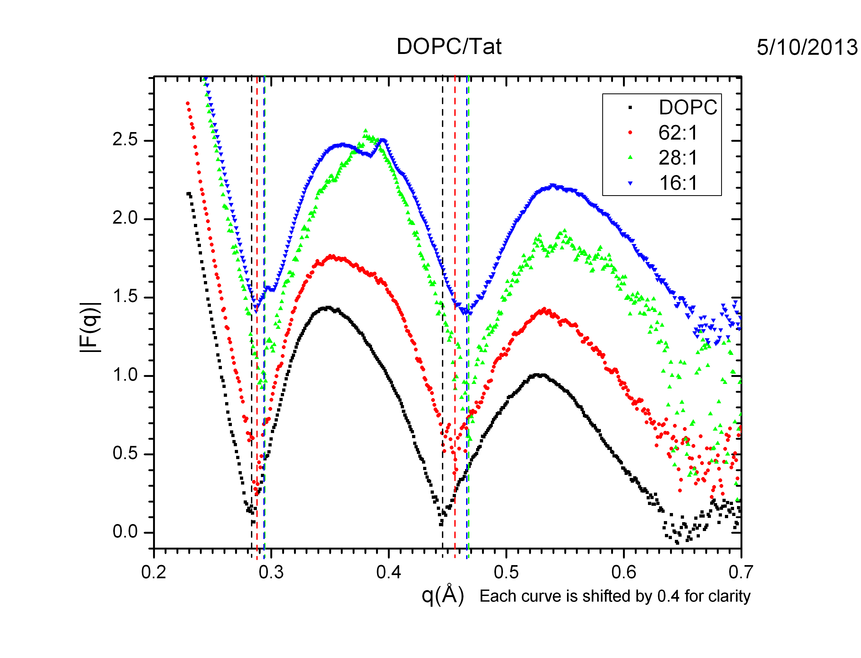

Figure Form factors for DOPC/Tat at various Tat concentrations. x = 0 (black), 0.0159 (red), 0.0345 (green), and 0.0588 (blue). T = 37°. The dotted lines indicate the estimated positions of the zeros. Each curve is shifted for visual clarity.

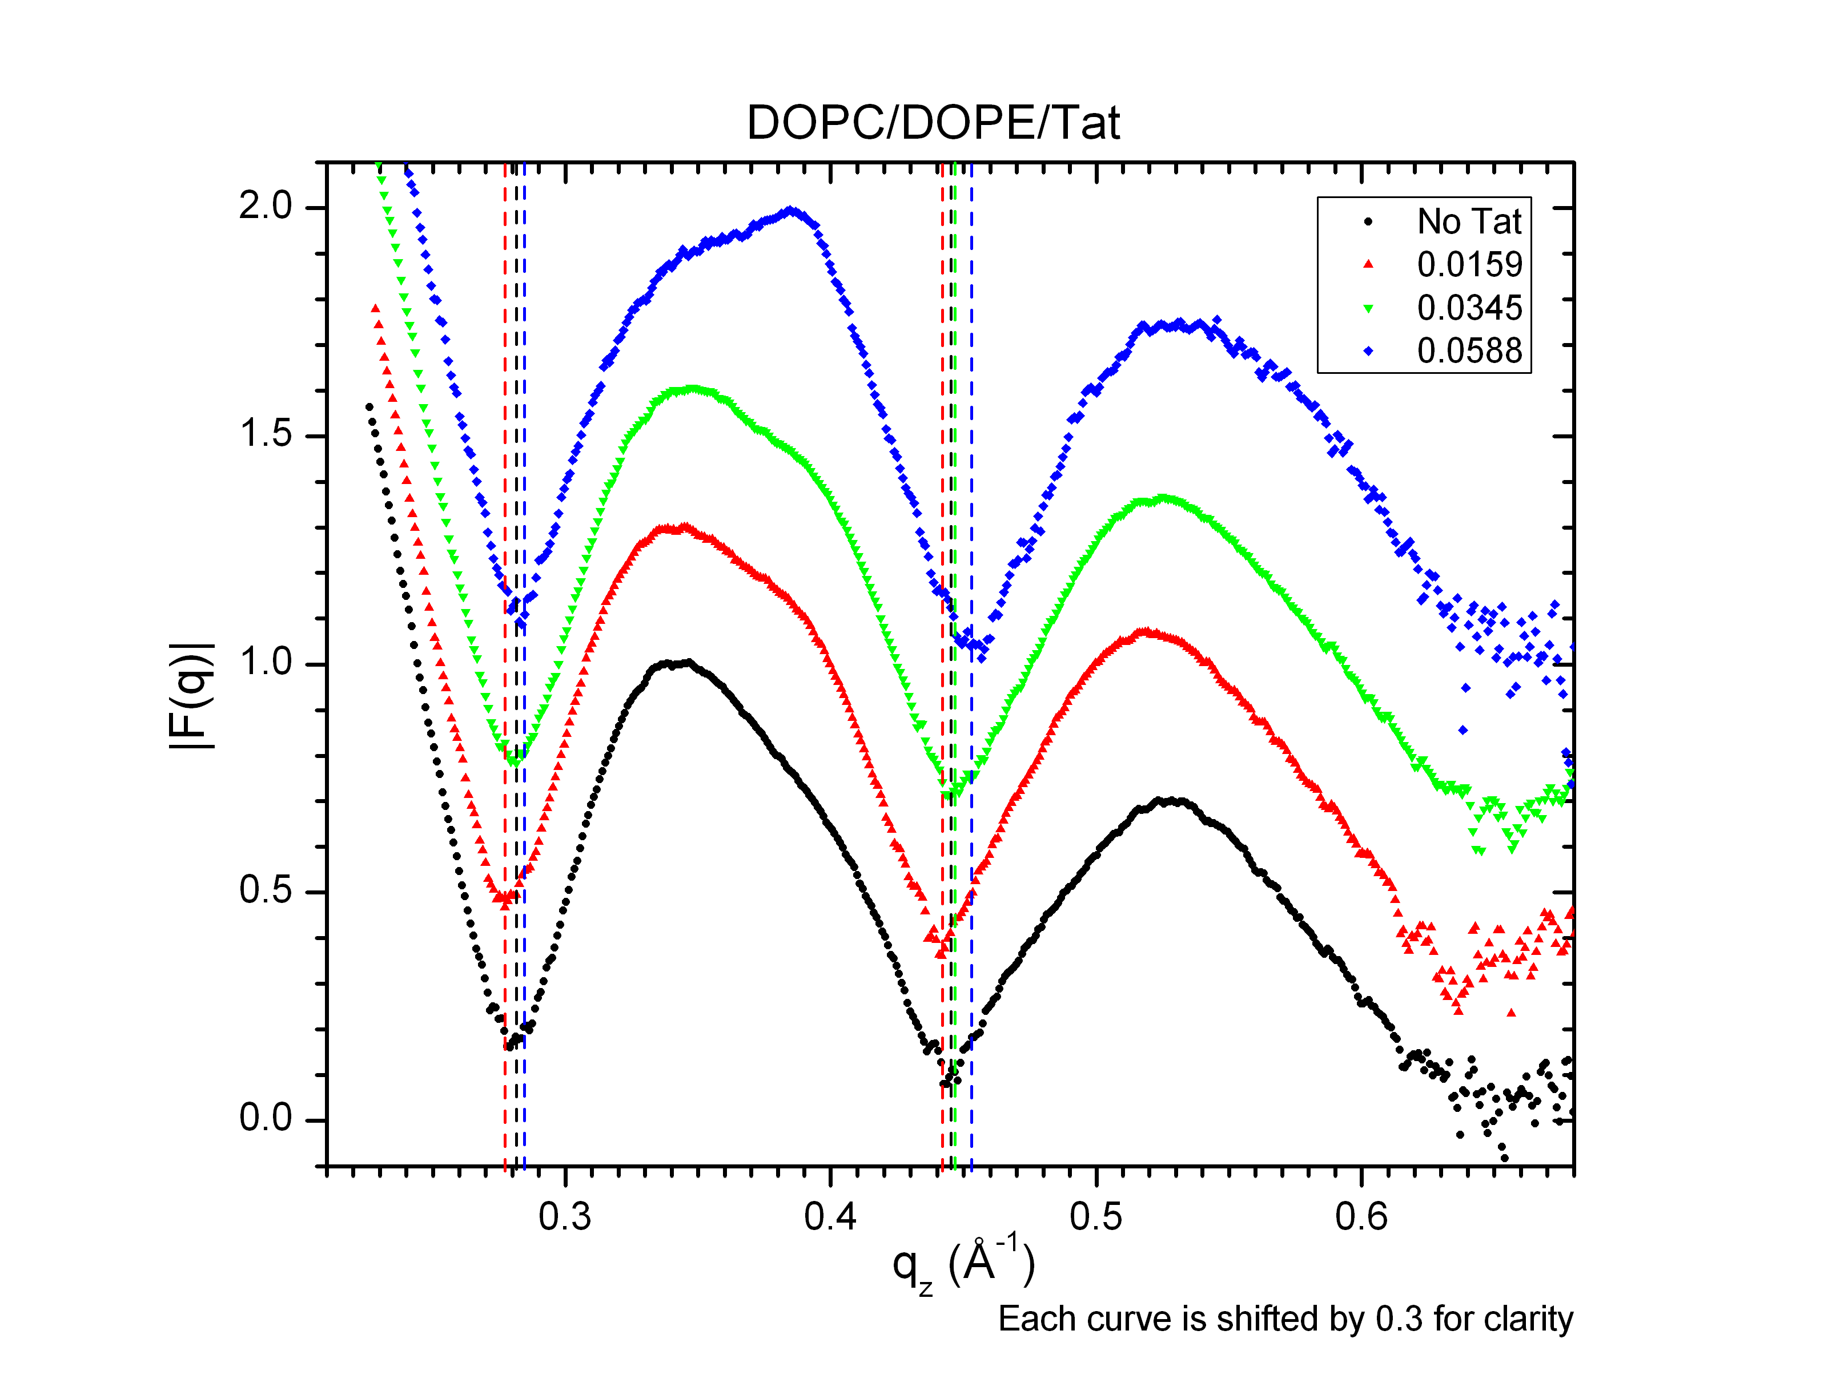

Figure Form factors for DOPC/DOPE/Tat at various Tat concentrations. x = 0 (black), 0.0159 (red), 0.0345 (green), and 0.0588 (blue). T = 37°. The dotted lines indicate the estimated positions of the zeros. Each curve is shifted for visual clarity.

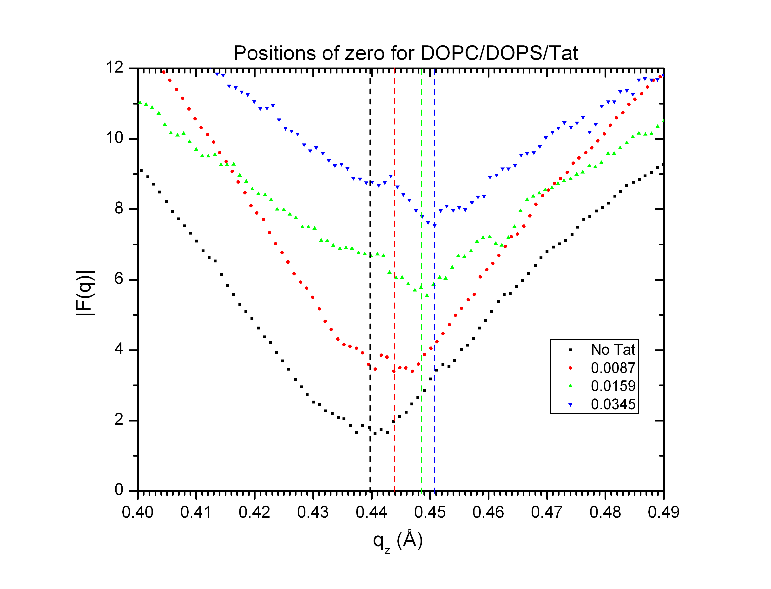

Figure Form factors in the proximity of the second zero for DOPC/DOPS/Tat at various Tat concentrations. x = 0 (black), 0.0087 (red), 0.0159 (green), and 0.0345 (blue). T = 37°. The dotted lines indicate the estimated positions of the zeros. Each curve is shifted for visual clarity.

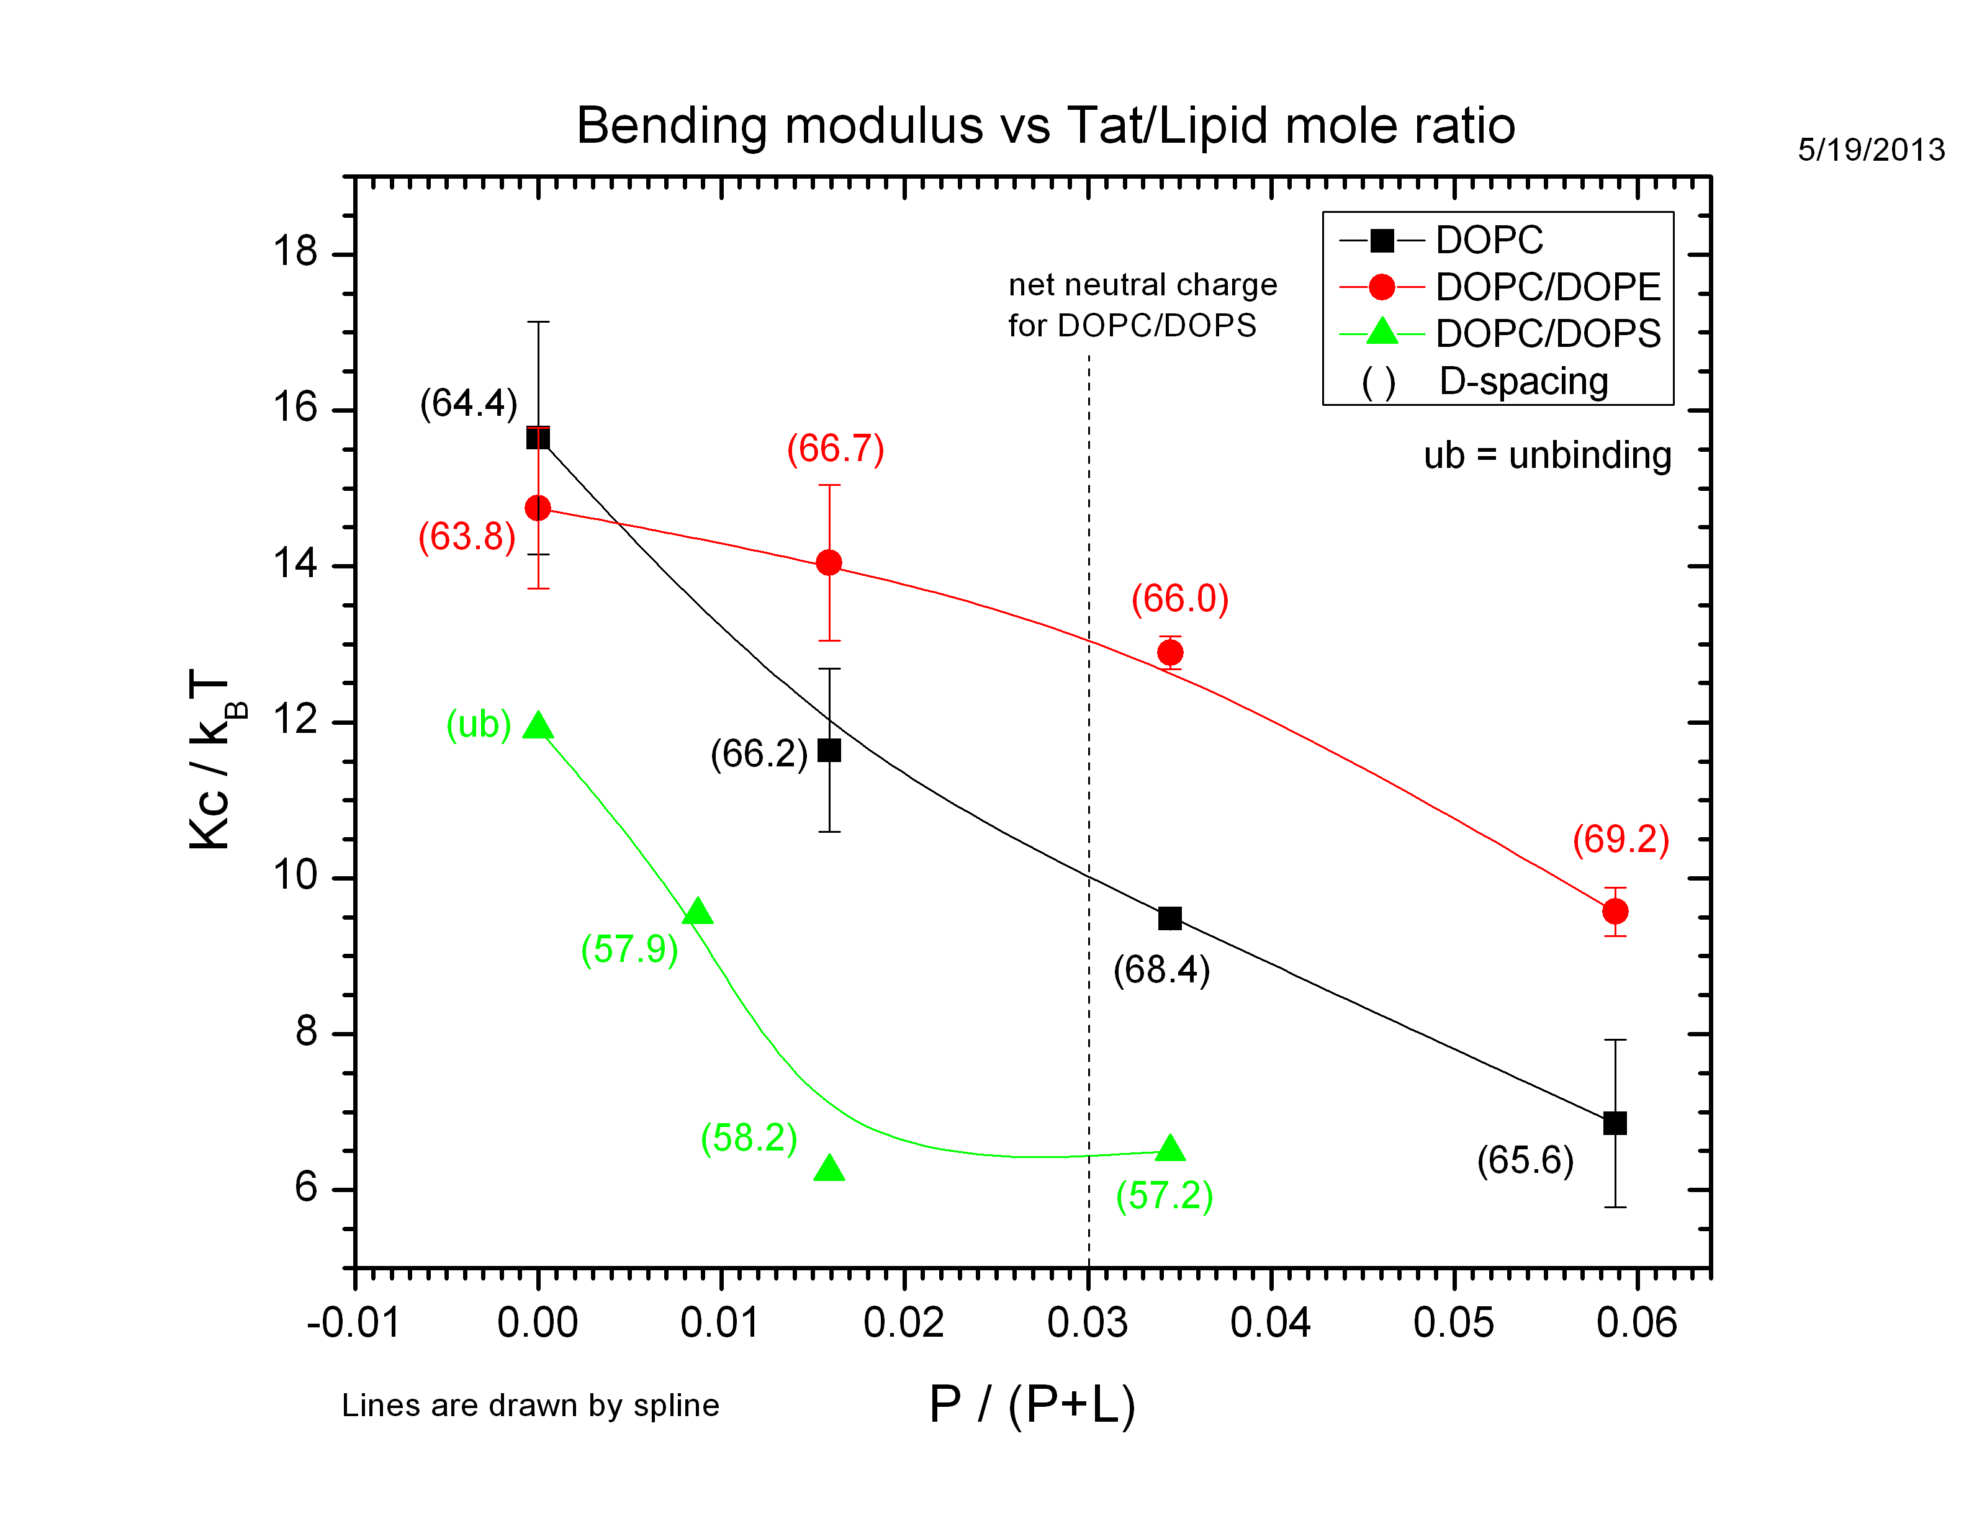

Figure Effect on bending modulus Kc, in units of thermal energy kT, of adding Tat to membranes composed of DOPC, DOPE and DOPS with differing ratio.

Table 1: D-spacing

Figure 5 shows DPP as a function of Tat concentration. Looking at zero Tat data points (x = 0), the bilayer thickness for DOPC/DOPE is lower than DOPC. Does this make an intuitive sense? The only difference between DOPC and DOPE is the size of the head-groups; DOPE has a smaller head group. Figure 5 suggests that including a smaller head group lipid increases the thickness. This seems to suggest that the order parameter for DOPC/DOPE is higher than that for DOPC since DOPC/DOPE chains have less room to fluctuate. Unfortunately, this observation is not consistent with experimentally measured SXray. See Fig. ?.

* Should work on DOPC/DOPS (3:1) data from May 2013. We watched unbind of the sample. Can do some good study on charged lipid membranes.
* Any way to distinguish pore from micropinocytosis model?
* Can I do a better job at analyzing DOPC/DOPS (3:1)/Tat data sets? Mosaic spread issue must be overcome.
* Work on fixed angle data sets from December 2013.
* Analyze DOPC/DOPE (3:1)/Tat (72:1) from May 2013.
* Analyze DOPC/DOPE (1:1)/Tat (72:1) from May 2013.