**Supplementary Information for HIV-1 Tat membrane translocation probed using X-ray and neutron scattering, CD, and MD simulations**

Kiyotaka Akabori1, Bradley Treece1, Michael S. Jablin1, John F. Nagle1, Brian Maranville2, Kun Huang3, Angel Garcia3 and Stephanie Tristram-Nagle1

1Biological Physics Group, Physics Department, Carnegie Mellon University, 5000 Forbes Avenu, Pittsburgh, Pennsylvania, 2NIST Center for Neutron Research, 100 Bureau Drive, Stop 6102, Gaithersburg, MD 20899, 3Physics Department, Rensselaer Polytechnic Institute, 110 Eighth Street, Troy, NY 12180

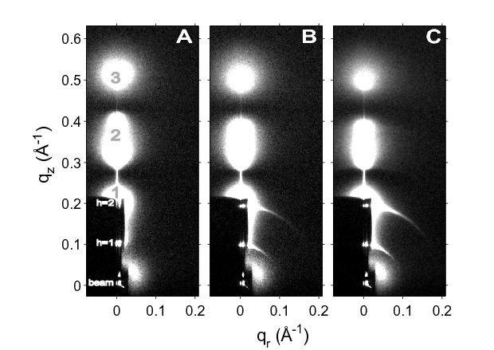

**Supplementary Information Figure 1.** Hydration of DOPC/DOPE (1:1), x=0.034 Tat. **A.** Lamellar D-spacing = 60.6 Å, **B.** 65.4 Å, **C.** 65.3 Å. Mosaic spread increases with hydration, shown by visible lengthening of thin arcs near h=1 and h=2 in **B** and **C**.

As hydration proceeded, the mosaic spread, or degree of misorientation, increased. This was apparent by the increasing lengths of the arcs emanating out from the h=1 and h=2 lamellar orders, shown in **S.I. Fig. 1.** The mosaic spread of these samples was quantitated as described in Materials and Methods. These results are included in **S.I. Fig. 2**, as a function of time after stopping the helium flow and beginning the hydration. The cooling Peltier was at first set to 200 mAmps, which caused the lamellar D-spacing to increase. It was then decreased to 100 mAmps, which caused less water to condense into the sample, and the lamellar D-spacing decreased, as did the mosaic spread. Thus, Tat’s ability to disrupt the bilayers appears to be a reversible effect, dependent on the hydration of the sample.

hydrating.tif

**Supplementary Information Figure 2.** Mosaic spread as a function of time of hydration of DOPC/DOPE (1:1) x=0.034 Tat, as a function of time. Cooling Peltier setting was changed from 200 mAmps (black circles) to 100 mAmps (red squares). Numbers are the lamellar D-spacing (Å).

Supplementary Information Figure 3. Effect of hydration on WAXS data. A. WAXS of a fairly dry sample, lamellar D-spacing = 59.7 Å. B. After 15 minutes hydrating with a cooling Peltier setting of 300 mAmps, D = 66.1 Å. C. WAXS of water condensed from the vapor onto a silicon wafer. D. Sample in B. with water removed by subtracting a fraction of condensed water from C.

Water condenses from the vapor during sample hydration due to the well-insulated hydration chamber and a Peltier cooler located under the sample. As the lamellar D-spacing swells, condensed water appears as a broad, isotropic, diffuse band centered at q=2 Å-1. This band is close to the chain correlation WAXS, which is used to obtain the order parameter, Sxray, so it is necessary to remove the water scattering prior to analyzing chain WAXS. This is done by quantitatively matching the water scattering in S.I.Fig. 3.B with a fraction of that in S.I.Fig. 3.C, and subtracting the water out. We found that hydrated samples are less ordered than dry samples, which suggests that a hydrated sample with the water subtracted out, as in S.I. Fig. 3.D, is the appropriate one to use for our analysis.

Chisquare.tif

Supplementary Information Figure 4. Chi-square as a function of Tat position Z across the bilayer. A. DOPC, B. DOPC:DOPE (3:1, C. DOPC:DOPE (1:1).

In addition to letting the Tat position move freely during the SDP fit to the form factor data, we can also fix Tat’s position In order to determine the location of Tat in these membrane mimics, the Tat position Z is fixed in 1 Å steps and the resulting chi-square from the SDP model fit is plotted as shown in Supplementary Information Fig. 4.

TatinWater.TIFTatCDThinFilm.TIF

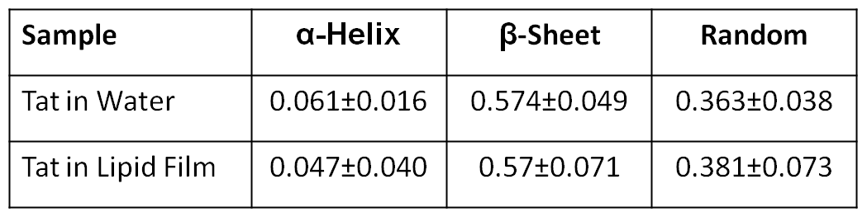

Supplementary Information Figure 5. CD spectroscopy of A. Tat solubilized in water and B. DOPC:DOPE (3:1)/Tat, x = 0.108.

CD spectroscopy was used to determine the secondary structure of Tat in a fully hydrated lipid environment compared to that solubilized in water. **S.I. Fig. 5.A** shows the mean residue ellipticity vs. wavelength of Tat solubilized in water. Two algorithms in DichroWEB were used to fit the data, CDSSTR and Contin, and several protein basis sets were used, two of which are shown in **S.I.Fig.5.A**.MRE for DOPC:DOPE (3:1)/Tat, x=0.108 is shown in **S.I.Fig.5.B.** Results of the fits to protein data sets are summarized in the table, where the errors represent the standard deviations obtained by averaging over all algorithms and basis sets. As shown, there was little difference between the secondary structure of Tat solubilized in water and in an unoriented lipid film. The main 2o structure in each case is β-sheet (includes strands and turns), followed by random coil and <10% α-helix. These results suggest that the membrane has little effect on the 2o structure of Tat.