Dear Kun,
Prof. Nagle emphasized that there is something in the simulations that reviewers would be likely to ask and that is important for understanding what Tat does to the lipid bilayer. The simulation and the xray data show that Tat makes the bilayer thinner in the sense that the average D_{PP} is smaller. However, an average is not as informative as one would like. Tat could make the bilayer thinner where the tat is located and not make it thinner where tat is not located. If that is what happens, then the effect of Tat would be larger, and more important, than would be revealed by the average.
So, the presence of Tat may result in compression of lipid bilayer along z-direction. If so, the phosphorus-phosphorus distance of the bilayer near Tat (denoted by D_{PP}’ in the figure below) may be different from that away from Tat (D_{PP}). For small Tat concentration, D_{PP} would be the same as that of pure DOPC if the distance from all Tats is large enough. Of course, for our concentrations, the thinning effect may extend throughout the bilayer because the lateral effect of Tat might have a larger lateral decay length than the distance between Tats. Whether that is the case or not, one would expect that the thickness near the Tats is smaller than the average thickness.
So, we want to measure D_{PP}’. First, let us define what we mean by lipids close to Tat. As in the figure below, we imagine a cylinder around Tat and pick up all the phosphorus atoms within it. Approximating Tat as a cylinder with its height given by the FWHM of its electron density distribution, its radius R_{Tat} ≈ 9 Å comes from the volume of Tat = 1876 A³ and h_{Tat} = 7.6 Å measured from one of the simulations. Let us define the lateral center of the cylinder in some way - a crude approximation would put it at the arginine in the middle of the amino acid sequence. Then let us define D_{PP}’ using only those lipids whose phosphorus atoms lie within these 9 Å cylinders around the tats. Then D_{PP}’ = Z_{phos} (>0) - Z_{phos} (<0) where Z_{phos}(>0) (Z_{phos}(>0)) is the average Z of the n1 (n2) lipids in the upper (lower) monolayer, respectively. To be more precise, assume that the arginine in the middle of the amino acid sequence is at the center of the cylinder.
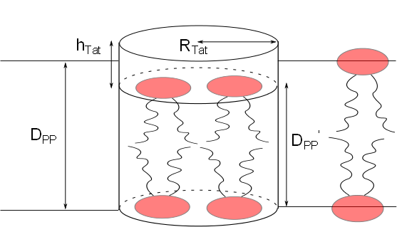
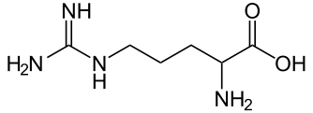
Use this carbon atom as the center

Wouldn’t the backbone be better? Or, average over all atoms in tat?
The algorithm for doing this looks straightforward. For each time frame (snapshot), the positions (Xi_{Tat} ,Yi_{Tat}, Zi_{Tat}) of each Tat, i, would be listed. All phosphorus atoms j would be chosen if its (X,Y) lateral position lies within 9 Å of any one of the (Xi_{Tat} ,Yi_{Tat}) and its Zi position would be placed in a list. (No need to keep a record of which cylinder each phosphorus falls into.) Then, Z_{phos}(>0) and Z_{phos}(<0) would be calculated from the list. Before going to the next snapshot, the number of selected phosphates in each monolayer should be recorded as local lateral depletion is also an interesting quantity to consider, although this could be misleading if the Tat cylinders overlap. While doing this, it would also be good to record the difference between Z_{phos}(>0) and the >0 Tats and also for <0. After averaging over many snapshots, there will hopefully be decent statistics for local thinning and local difference between Tat and phosphorus Z positions, and maybe local lateral depletion if overlaps are taken into account.

