11/13/2013, KA
This document is a short summary of what I found by modeling and fitting to the experimental form factors. For main results, see Fig. 5, Fig. 6, and Fig. 7.

Notations:
CG = Gaussian representing the Carbonyl-Glycerol backbone
PC = Gaussian representing the Phosphate-Choline combined head group
Tat = Gaussian representing the Tat peptide
CH2+CH = function representing the combined methylene (CH₂) and methine (CH) groups
CH3 = Gaussian representing the terminal methyl group (CH₃)
water = function representing the water
total = sum of all the above functions

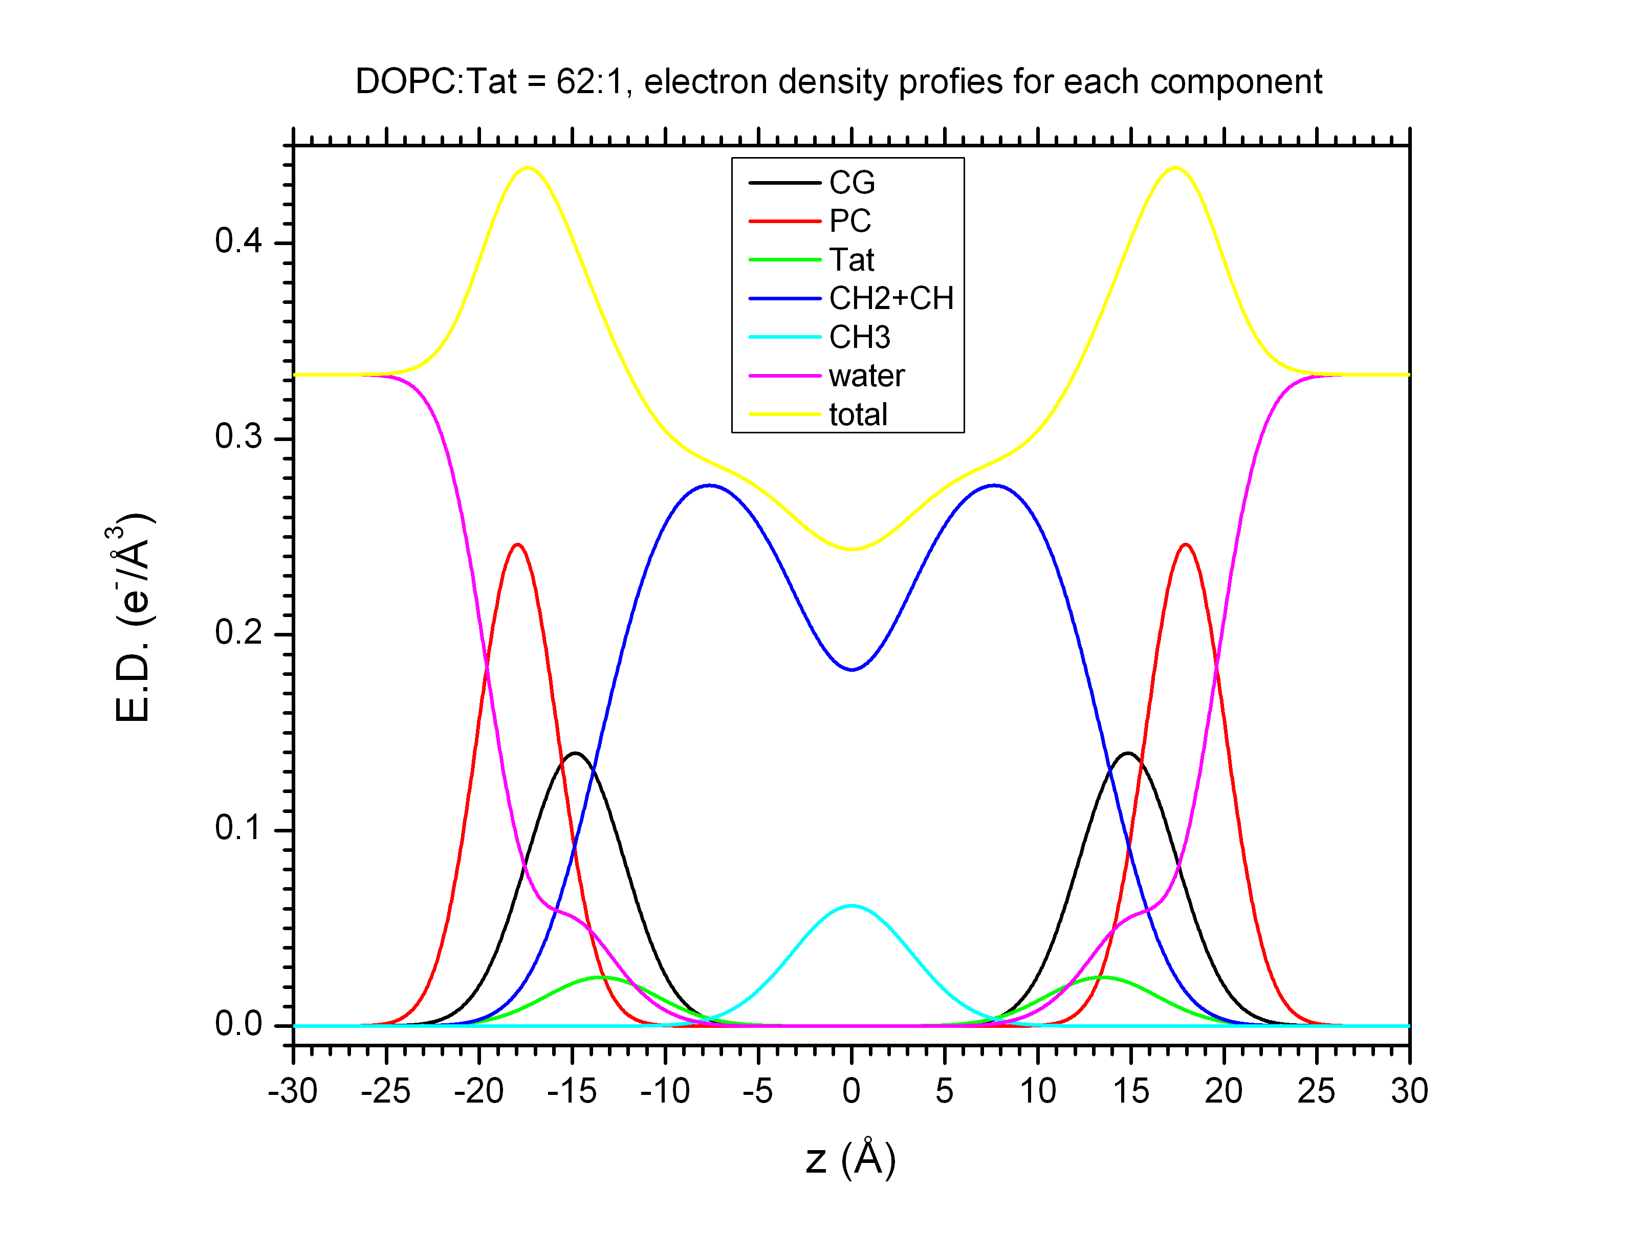
Fig. 1 The electron density profiles for DOPC/Tat (62:1). The Tat is located close to the CG group, but slightly more toward the center.

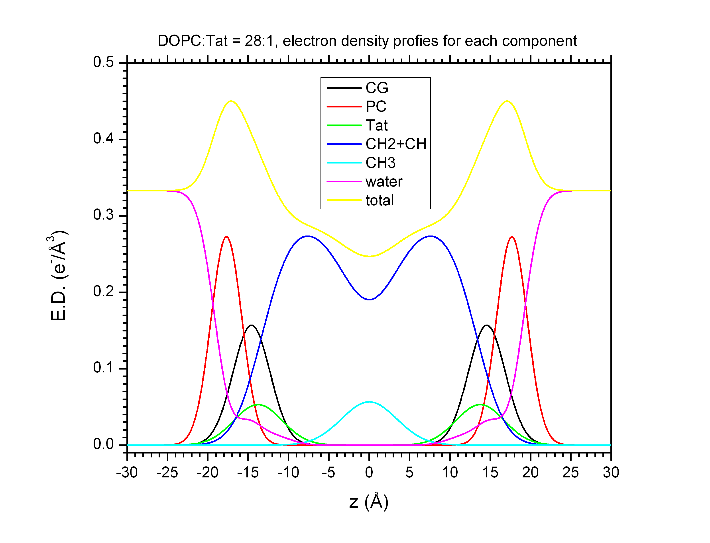
Fig. 2 The electron density profiles for DOPC/Tat (28:1). The Tat is located close to the CG group. It is slightly further from the center compared to 62:1 mole ratio.

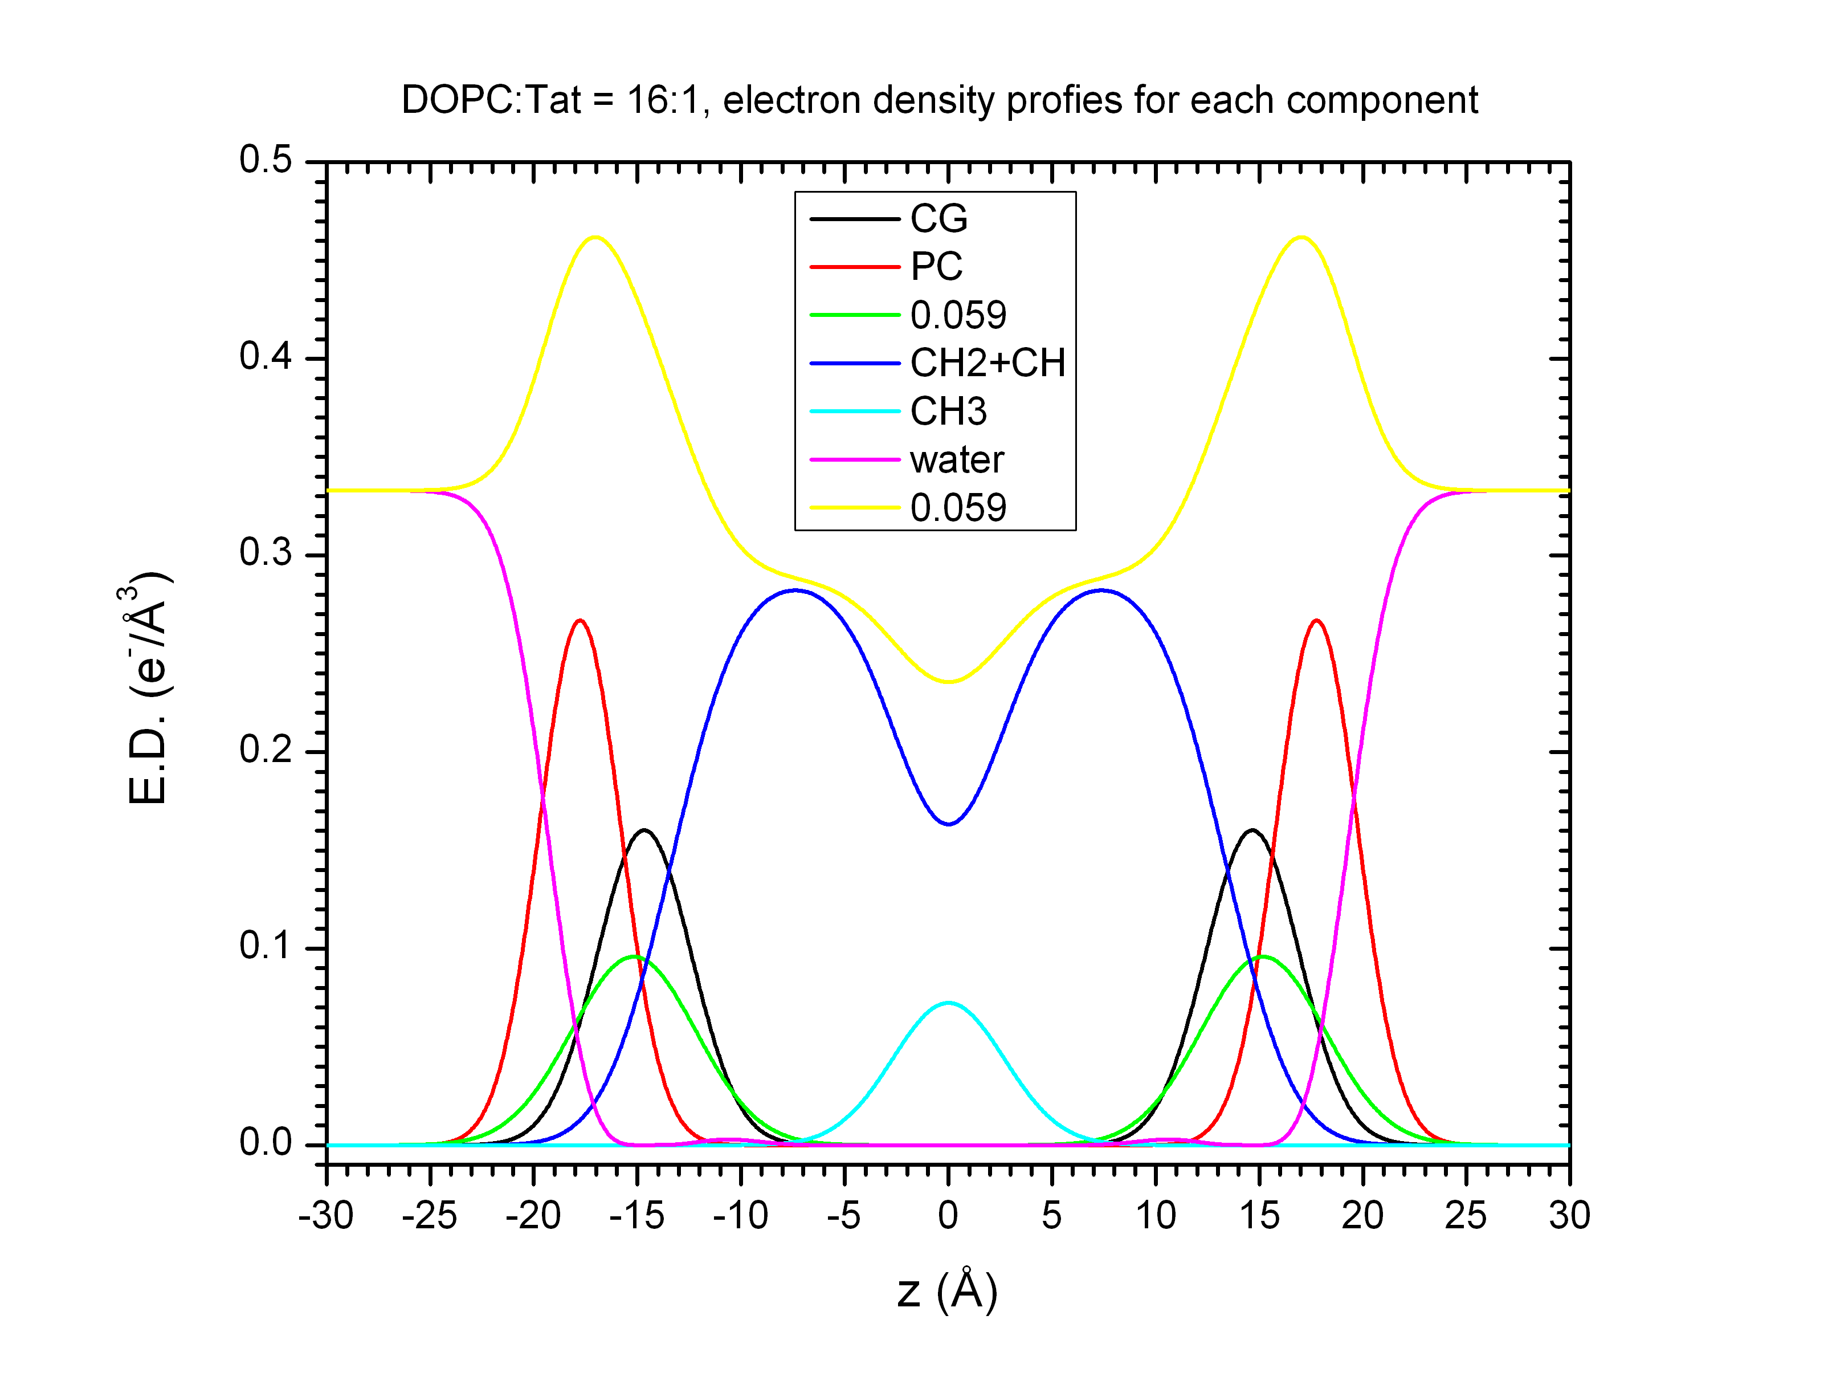
Fig. 3 The electron density profiles for DOPC/Tat (16:1). The Tat is located close to the CG group. It is even further from the center compared to 28:1 mole ratio.

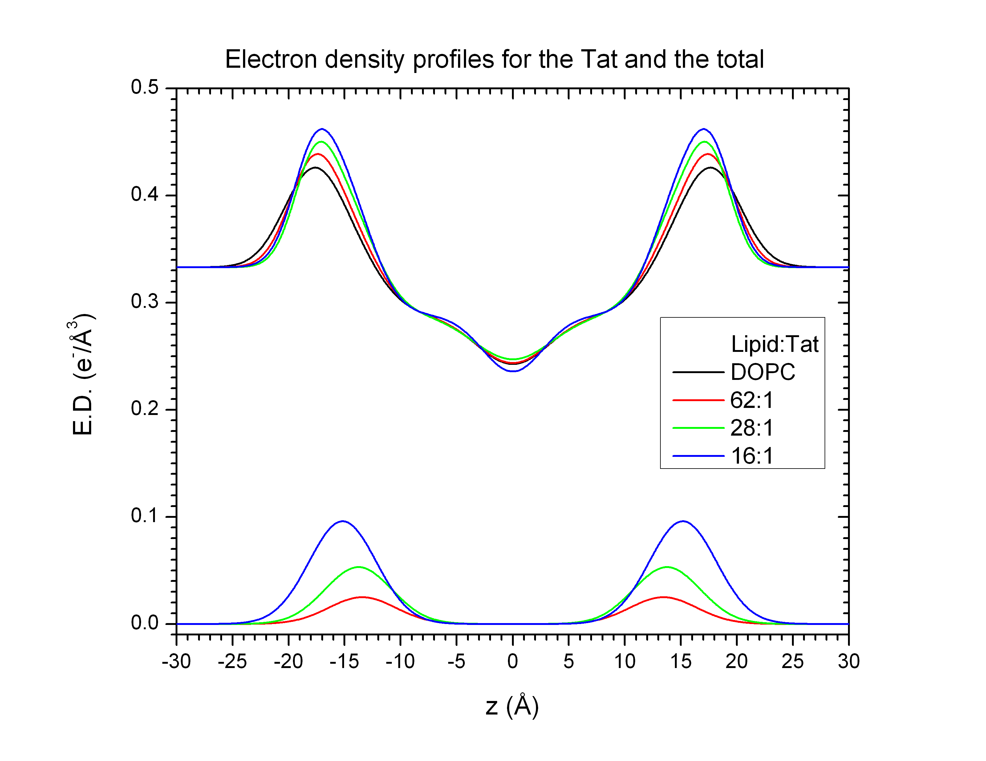
Fig. 4 Selected electron density profiles for all concentrations. The upper four curves represent the total electron density and the lower three the Tat density. As shown, Tat moves out as the concentration increases.

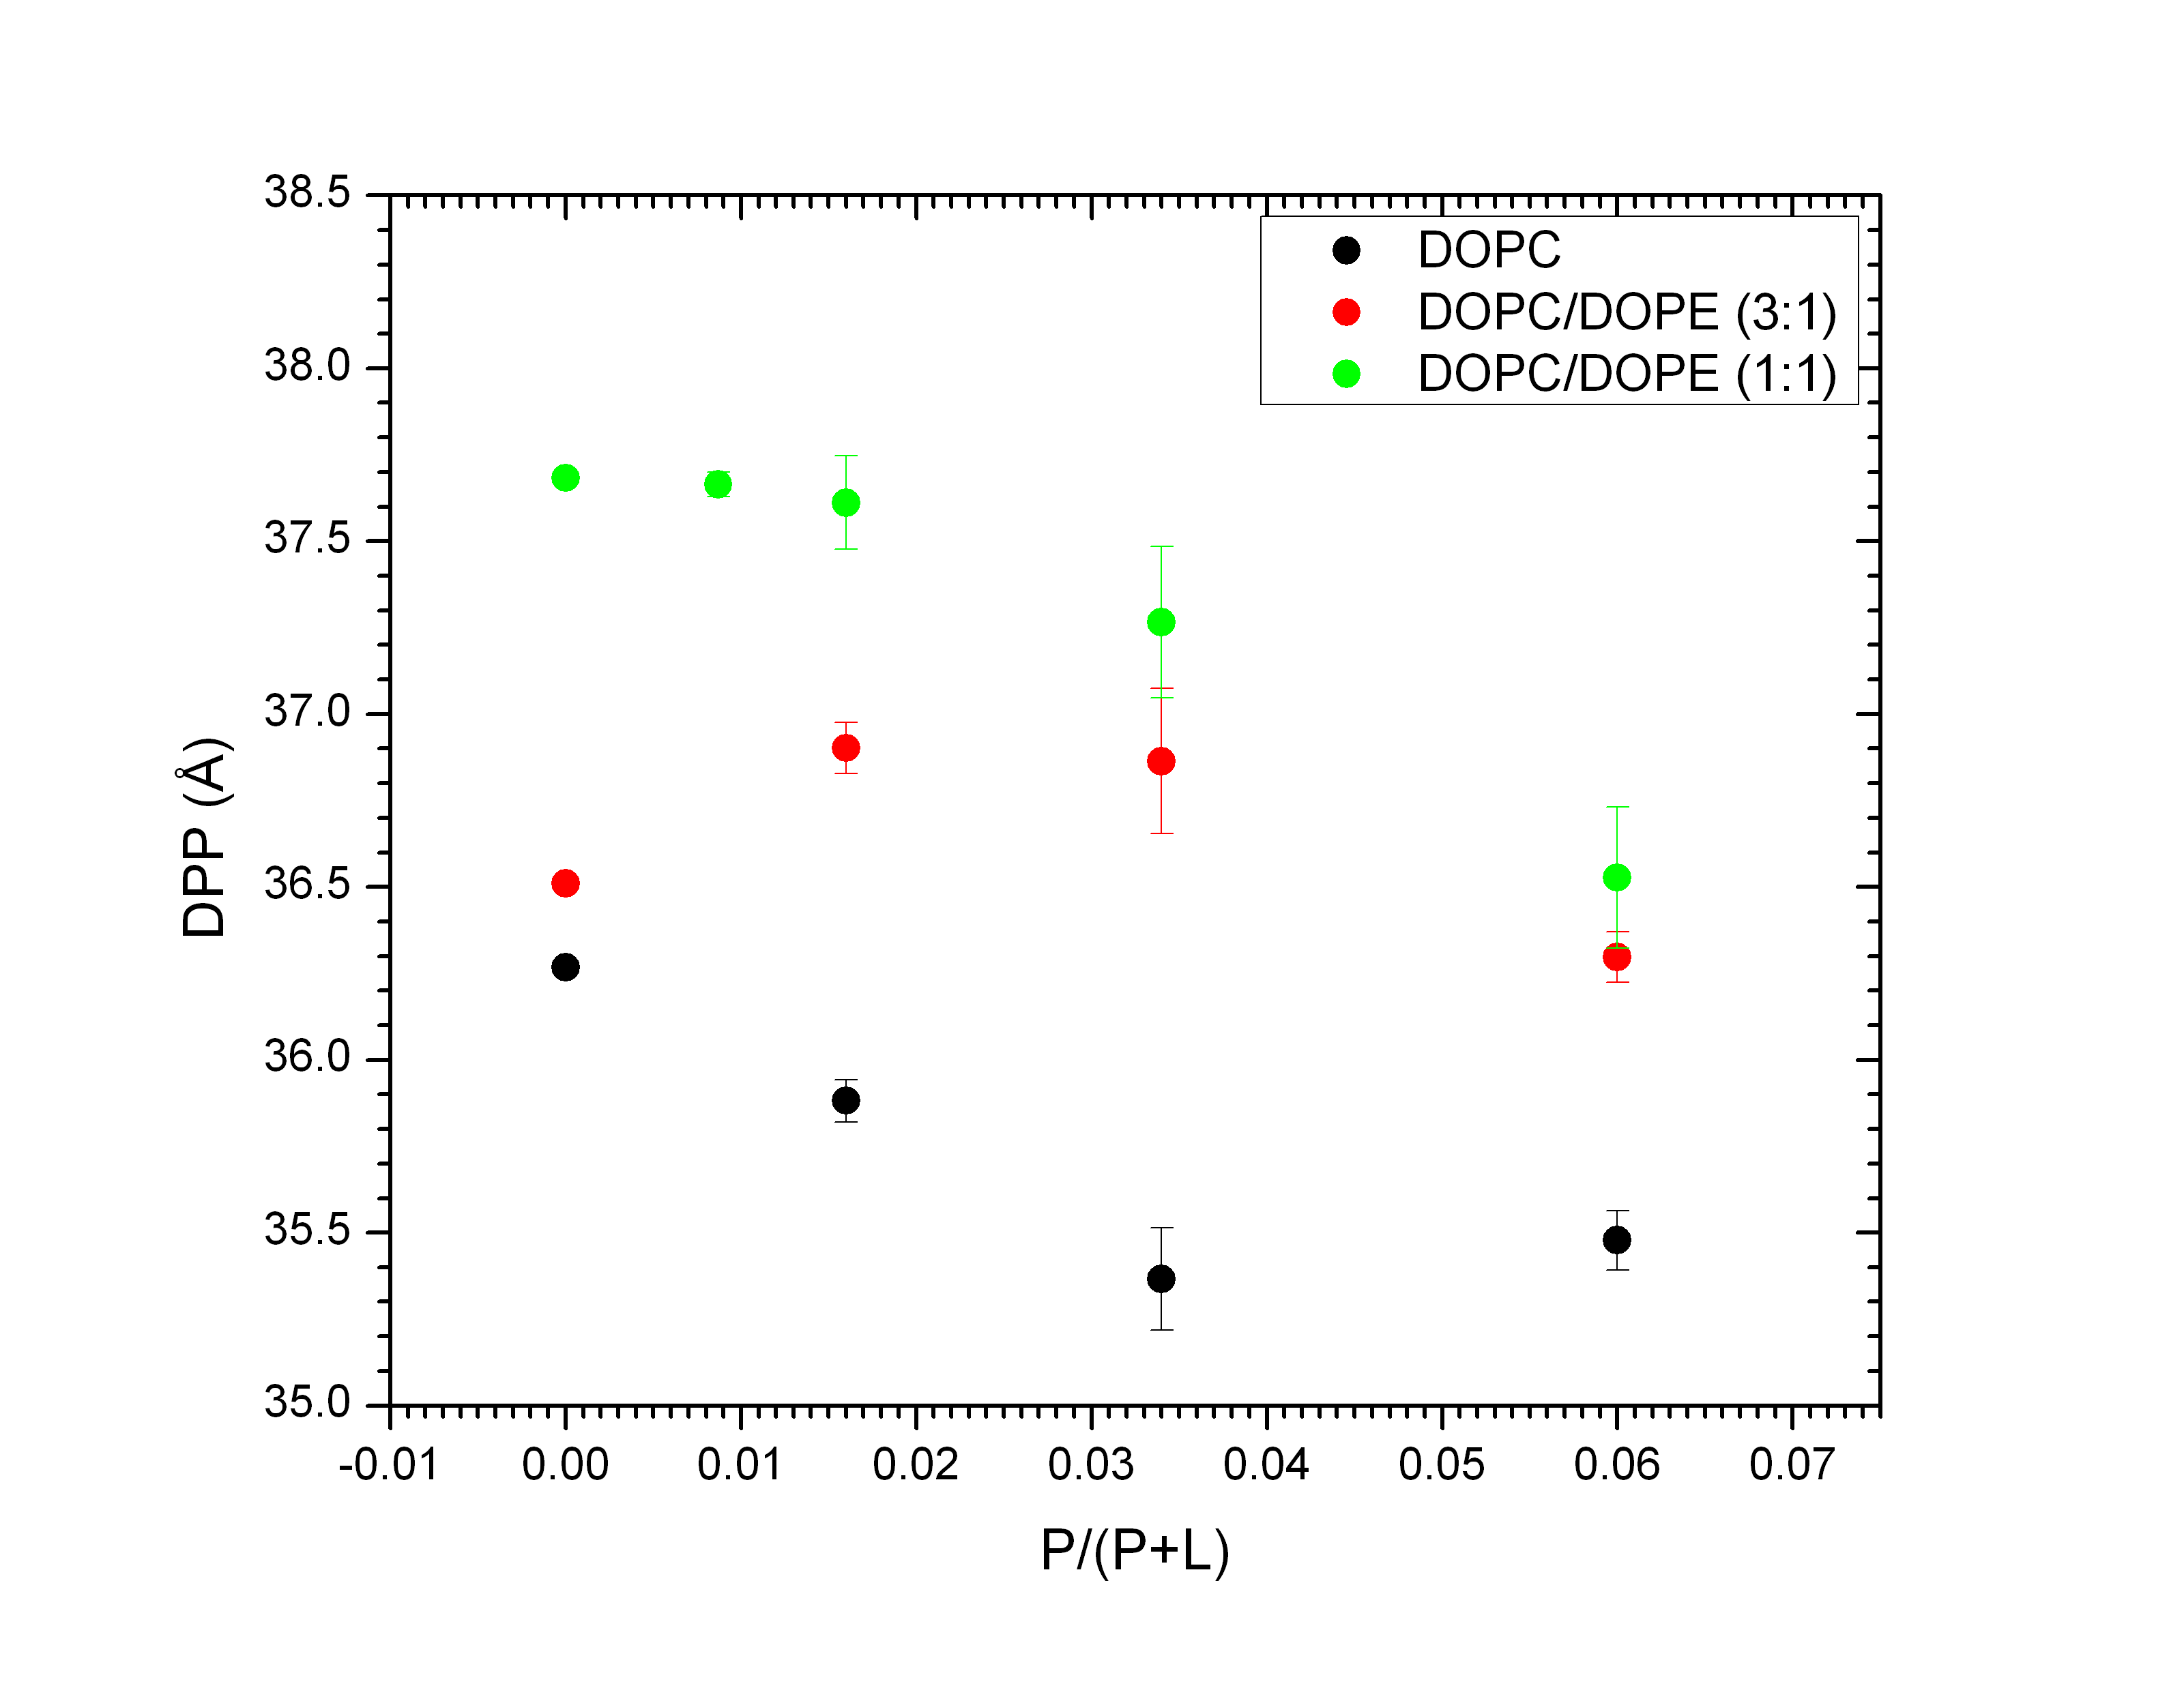
Fig. 5 Phosphate-phosphate distance (DPP) as a function of increasing concentration. Only DOPC data (black points) are of interest. The thickness as measured by DPP, in fact, decreases but not by much. This is very different from the 2007 PNAS result.

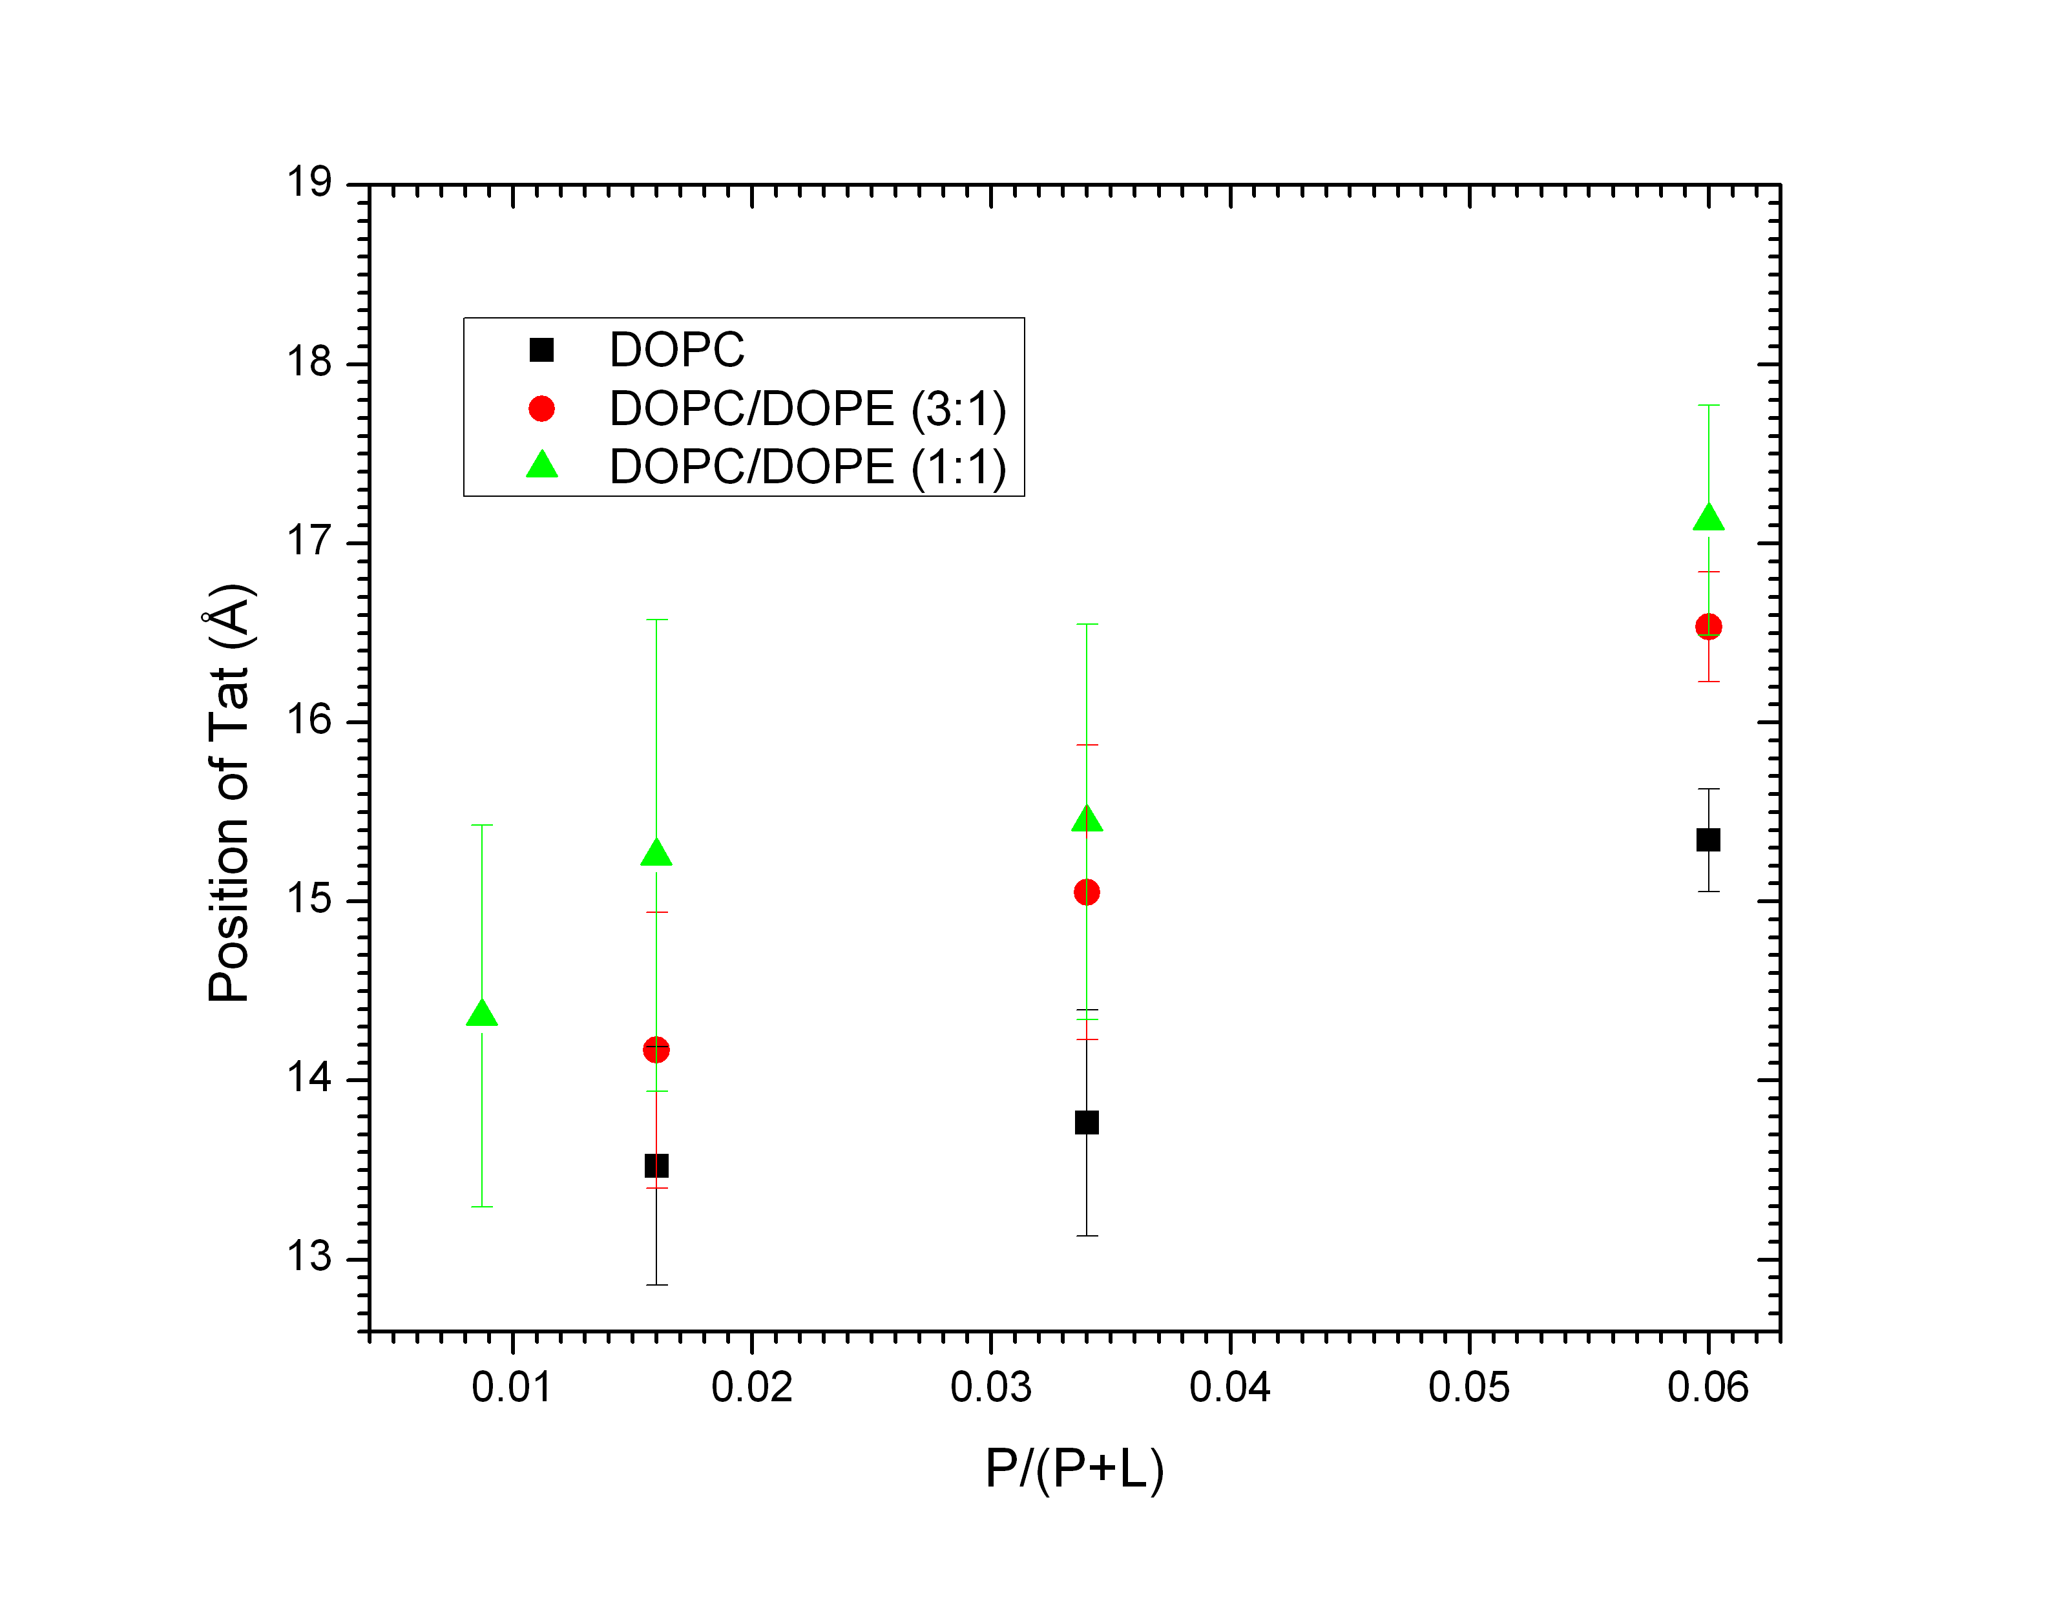
Fig. 6 Tat position as a function of increasing concentration. This shows clearly that Tat moves out as the concentration increases. I am not very confident of this result, but it is so far my best attempt at getting the Tat position.

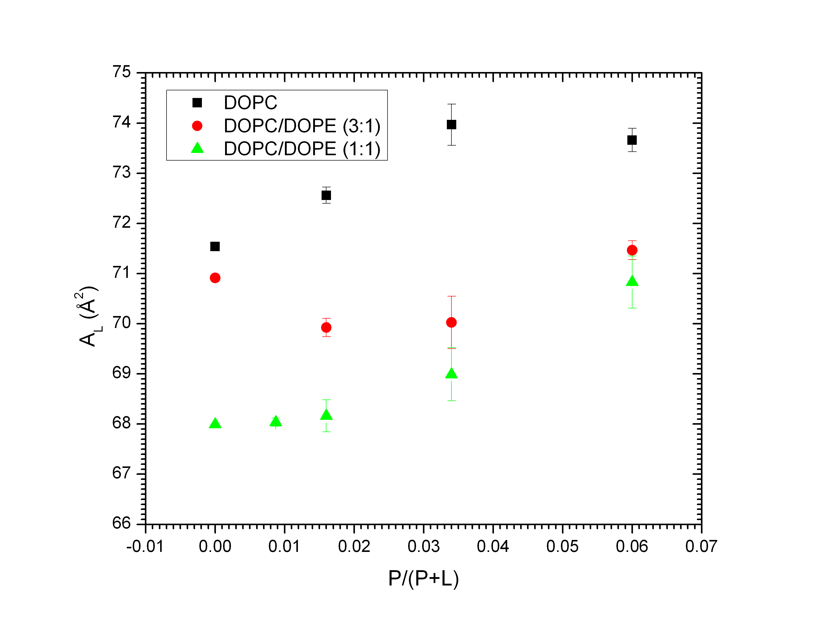
Fig. 7 Area per lipid as a function of increasing concentration. It ranges from 71.5 to 74. As pointed out already, the value for pure DOPC is larger than what was published in 2008, which combined x-ray and neutron data. We do not know yet the origin of this discrepancy.

Conclusion:
It is reasonable to suspect that different mechanism than pore formation is in effect at Tat translocation. I have a reason to believe that Tat induces micropinocytosis, which was suggested by the other simulation group including Marrink (biophys. j. 2009), but I don't have any concrete evidence so far.

