Kiyo Akabori 9/23/2013

In this document, I will compare the electron density profiles (EDP) derived from Kun's all-atom simulations using the SIMtoEXP program. Three systems that have been simulated so far are pure DOPC, DOPC/Tat (64:1 mole ratio), and DOPC/Tat (32:1 mole ratio).

**A point to note**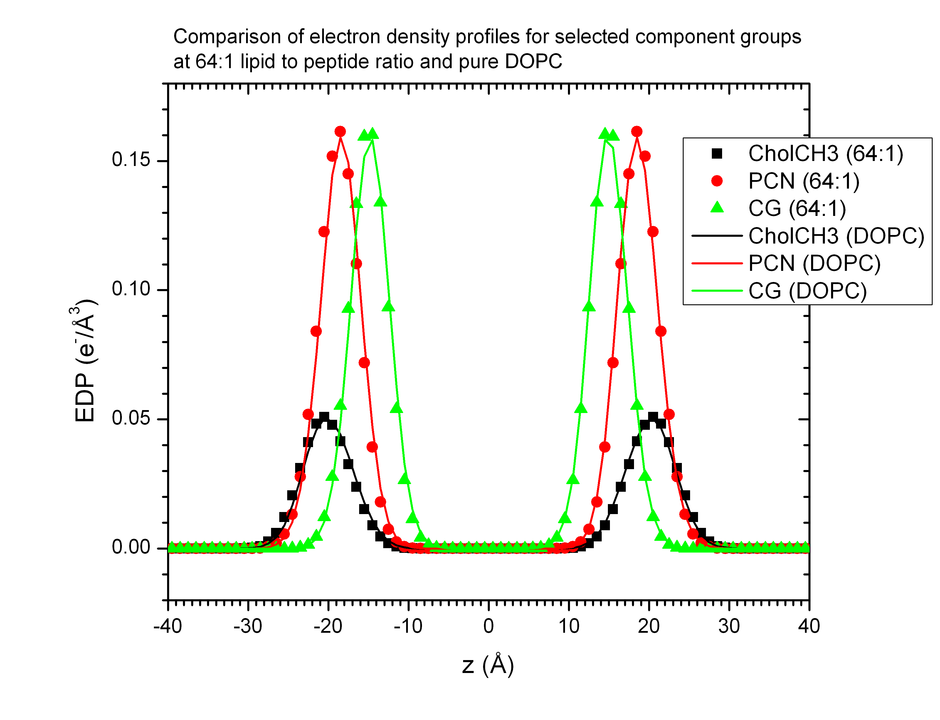

The program does not accept multiple occurrence of an atom name in the header line because that will cause a name conflict at the time when the component file called *.cmp is read. For parsing the atoms into the component groups, I had to create a proper header line for 64:1 and 32:1 sim files. This is a potential source of an error; however, given the EDP from these two sim files, I feel confident that this was done correctly.

This compares the head group EDPs for pure DOPC and DOPC/Tat (64:1). The positions of the component groups are almost the same with and without Tat. This suggests that the effect of Tat on the bilayer structure is very small. The result was similar for other component groups (data not shown).

This compares selected EDPs for DOPC/Tat (64:1) and (32:1). Although the concentration of Tat is twice as large, the EDPs of component groups for 32:1 system were very similar to those for 64:1 system. Other component groups are not shown here, but the results are the same as for the PCN group. Since the earlier graph shows that the difference in the EDPs between pure DOPC and 64:1 is negligible, this graph suggests that adding four Tat to 128 DOPC has no effect on the bilayer structure.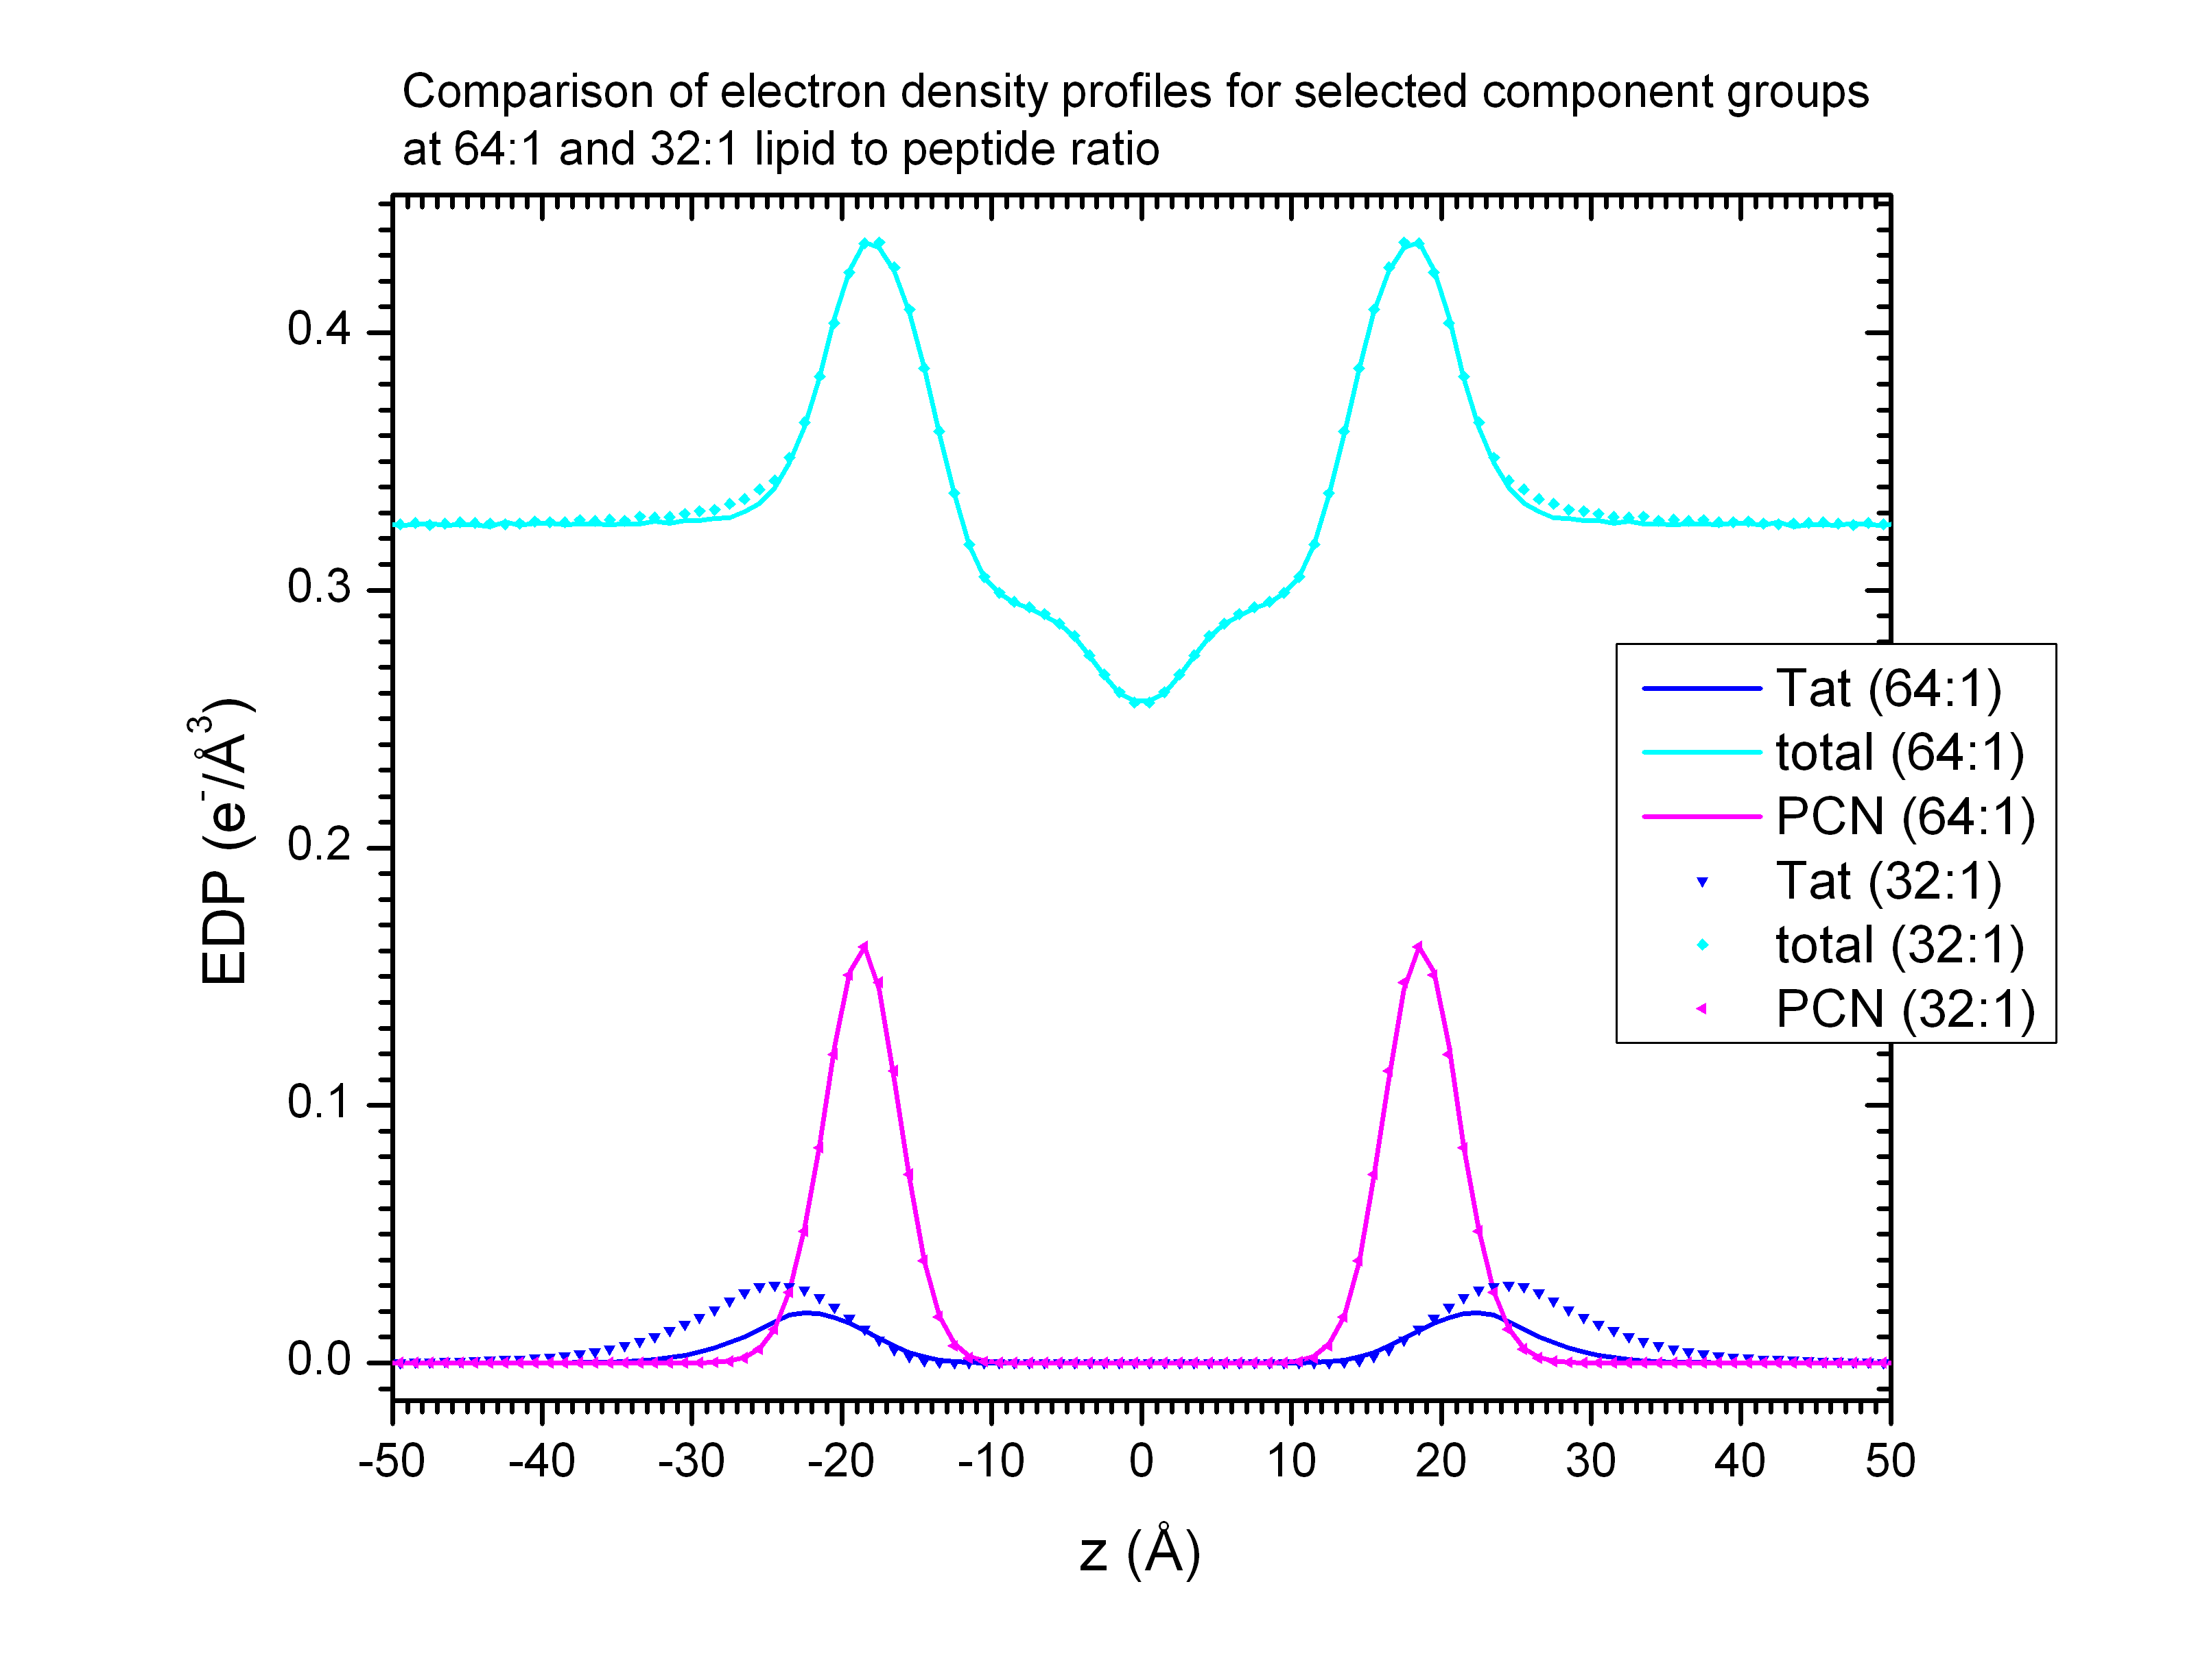

Two additionally added Tat seems to just stay at the interface of lipid head groups and water. They do not penetrate into the bilayer.

This compares x-ray form factors for pure DOPC obtained by two independent methods. If the SIMtoEXP program accurately calculates the form factor, then this graph suggests that Kun did not calculate correctly the form factor, or the sim file was not produced properly. 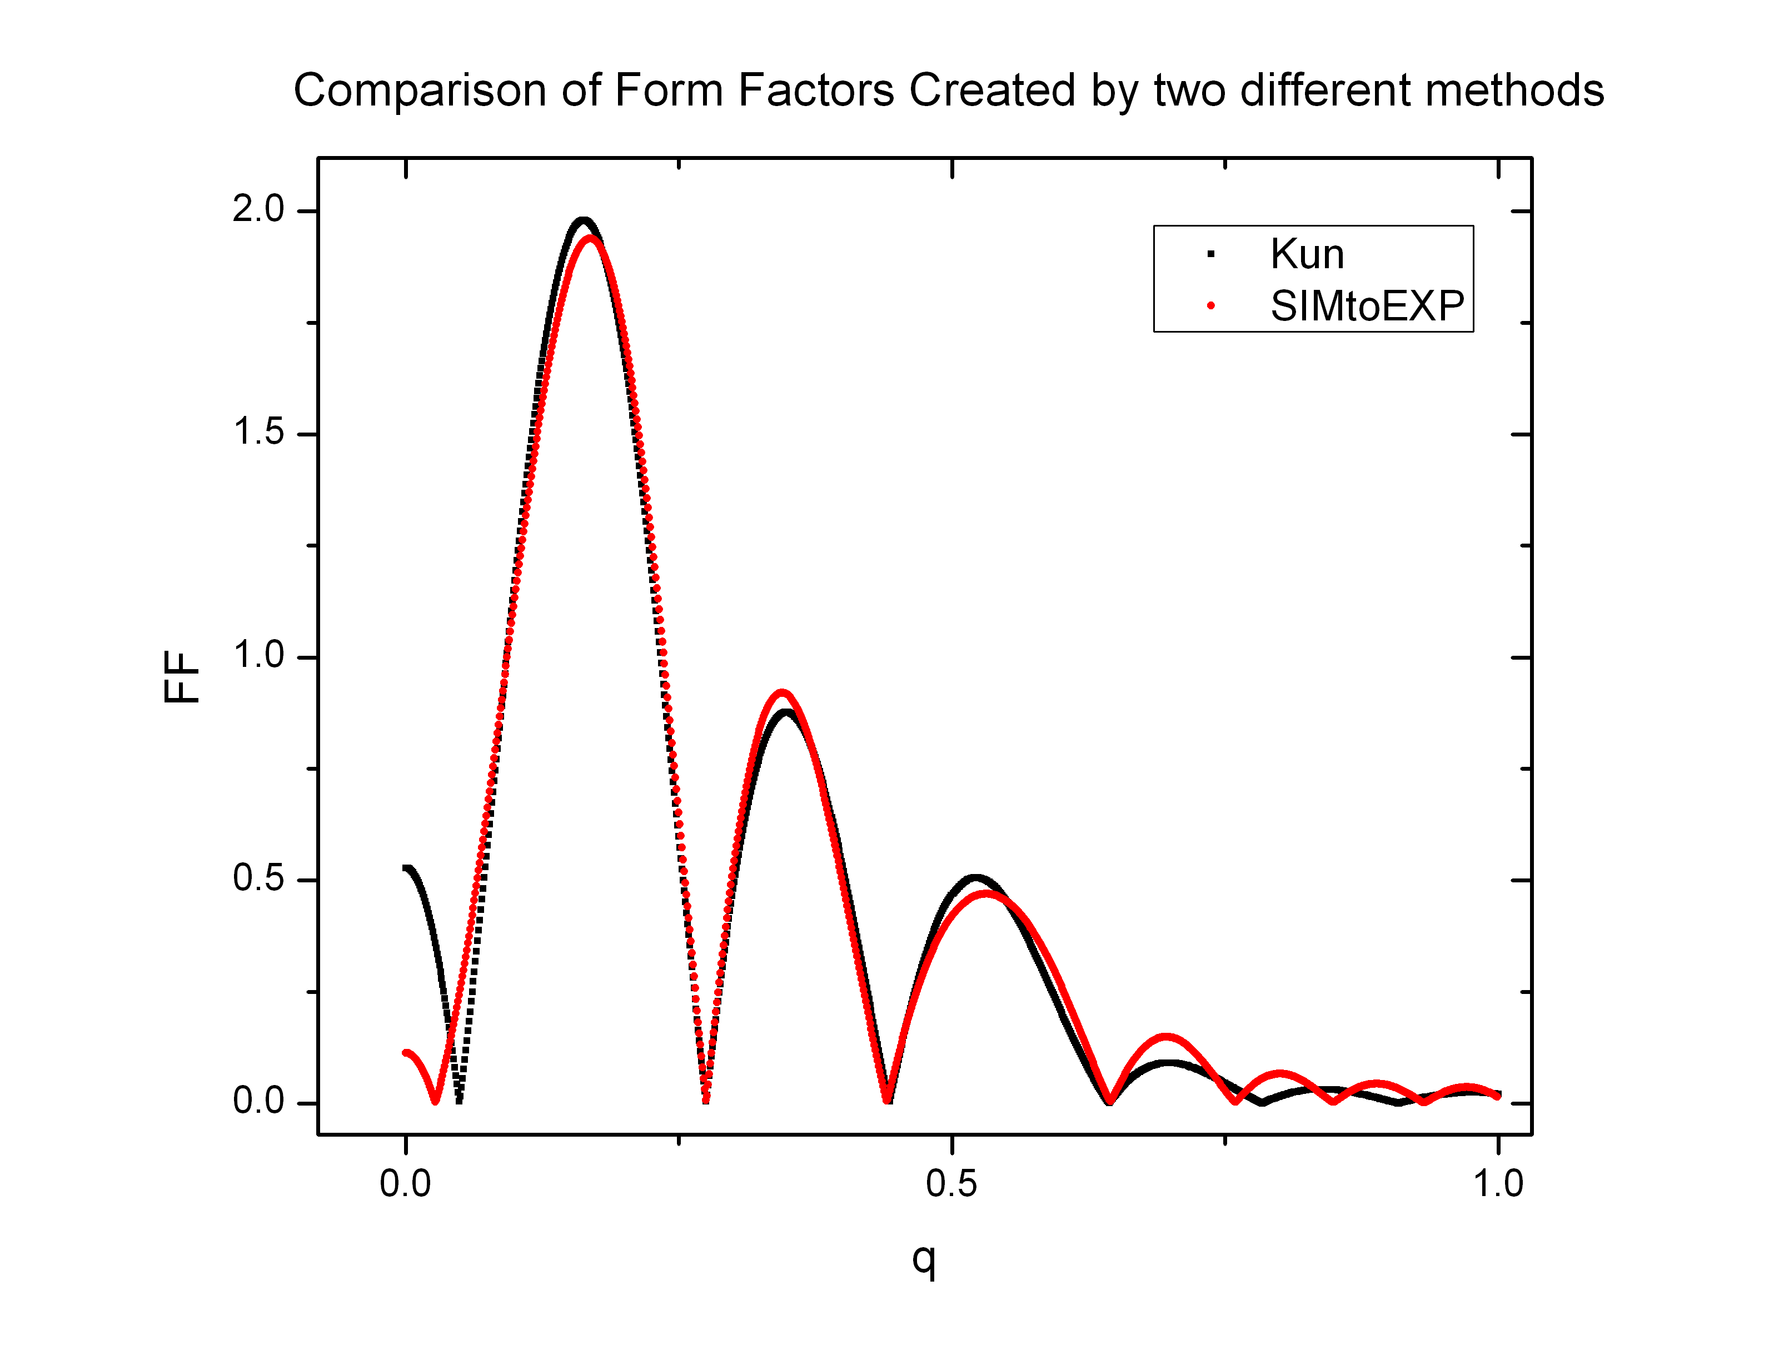

Finally, this compares the two test data available in the SIMtoEXP program test directory and the form factor calculated from Kun's sim file using the SIMtoEXP program. Since they were simulated in different conditions, the form factors do not agree with each other. However, note that at q = 0, the disagreement is not as bad as found in the earlier plot. This makes me believe that the DOPC sim file was created correctly. Recall that the experimental form factor for DOPC goes to zero at q = 0, which was predicted simply from a volumetric condition. Because MD simulations don't get the DOPC volume exactly right, the form factor predicted by simulations usually deviates from zero at q = 0. A description...

**Summary**

Four peptides on 128 DOPC had almost no effect on the bilayer structure, which contrasts with the results from experimental data. I will compare simulations and experiments directly on plots next, but note that the x-ray experiment suggests a larger effect of addition of Tat than suggested by the simulations. It seems like the sim files were produced correctly, but if possible, Kun may want to check that somehow. Once 16:1 simulation is finished, Kun may have to run some simulations with fixed area per lipid. Now that these results are obtained, I will have to plot them in a more meaningful way to compare simulation and experimental data.