10/7/2013 KA

In this report, experimental and simulation form factors are compared for three systems: pure DOPC, DOPC/Tat (62:1), and DOPC/Tat ((28:1). The ratios quoted here are for experimental data. For simulations, the ratios are 64:1 and 32:1. In general, if area per lipid increases, thickness decreases, which in turn shifts form factor to higher qz.

**Notation**

A: area per lipid

t: thickness

F: form factor

**Experimentally obtained area per lipid**

|  |  |
| --- | --- |
| Lipid : Peptide | A (Å2) |
| 0 | 71.5 |
| 62:1 | 72.6 |
| 28:1 | 74.0 |
| 16:1 | 73.7 |

Figure 1 compares F for pure DOPC. It implies that A obtained from the simulation is smaller than that from the experiment. We can try larger A in a step of 2 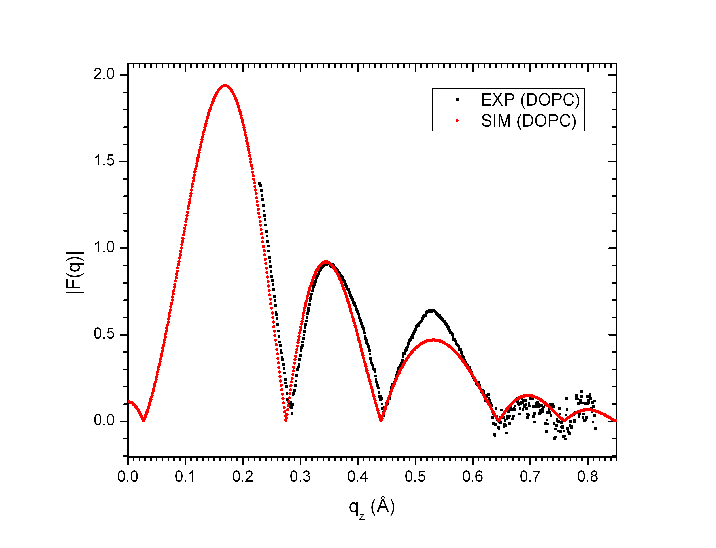Å2.

Figure 2 compares F for 62:1 (experiment) and 64:1 (simulation). The discrepancy between experimental and simulation F is larger compared to pure DOPC. Again, we can try to increase A in a step of 2 Å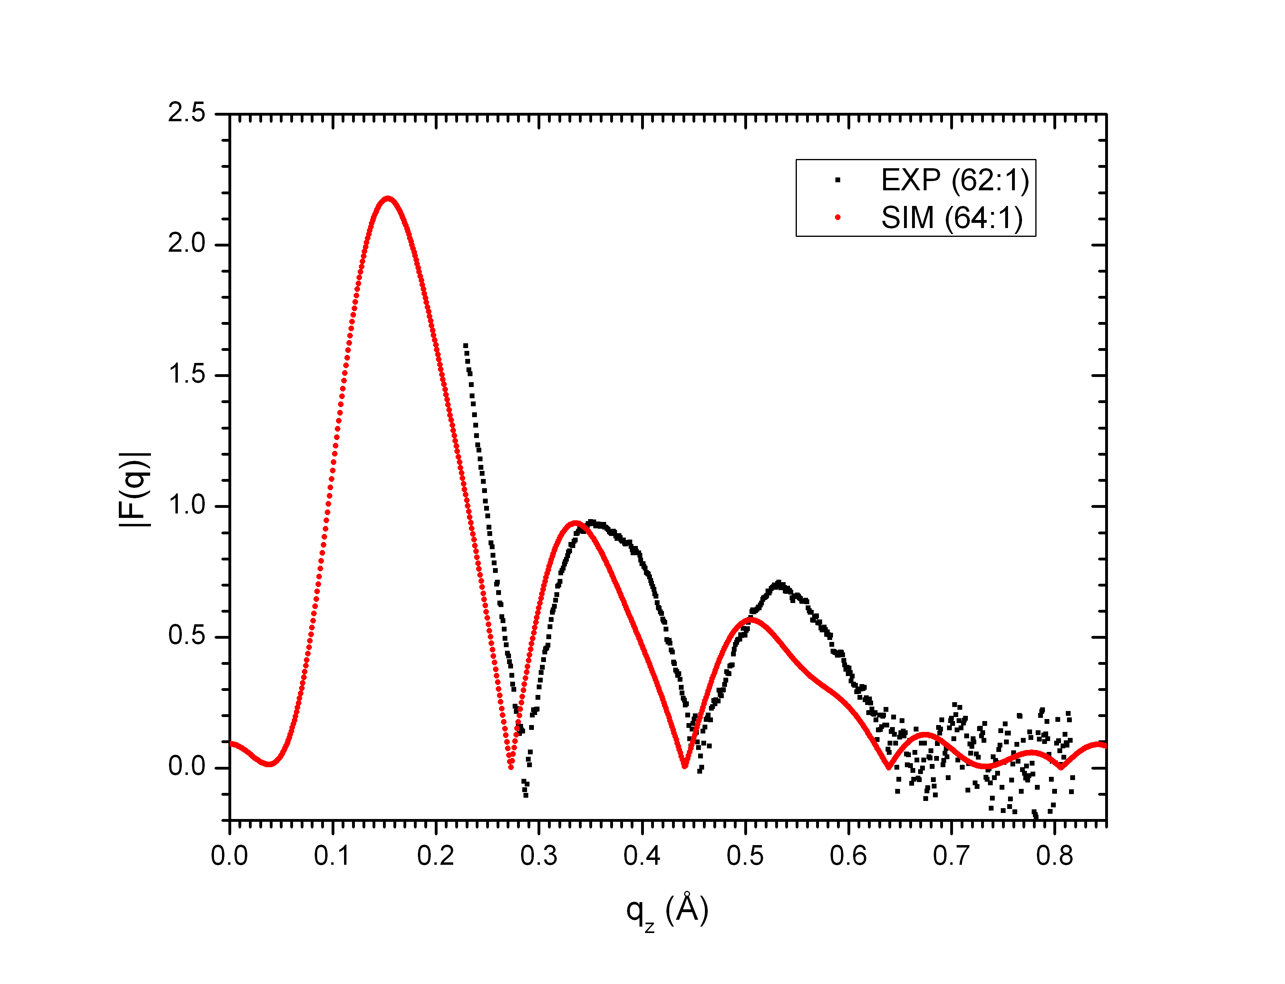2. It will be helpful to know the value of A from the simulation.

Figure 3 compares F for 28:1 (experiment) and 32:1 (simulation). The discrepancy between experimental and simulation F is even larger. We might want to try to increase A in a step of 3 Å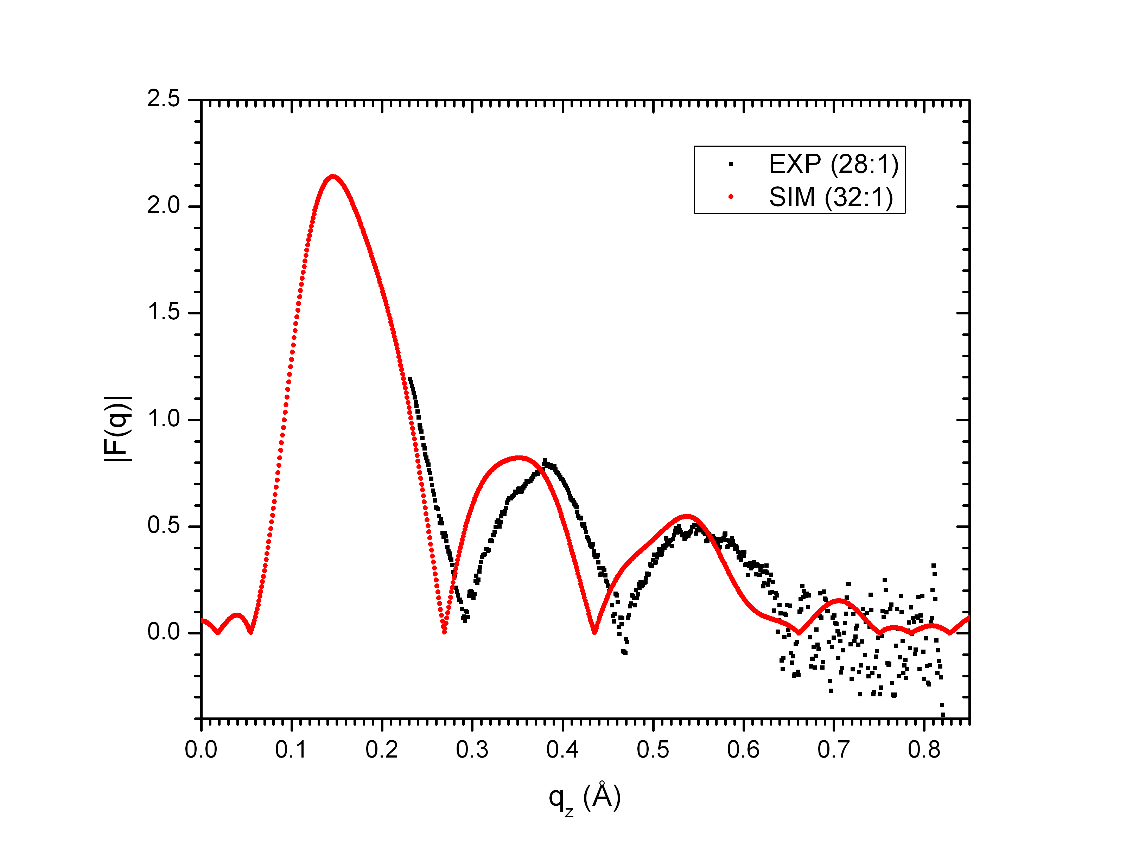2? It will be helpful to know the value of A from the simulation.