The presence of Tat may result in compression of lipid bilayer along z-direction. If so, the phosphorus-phosphorus distance of the bilayer near Tat (denoted by DPP’ in the figure below) may be different from that away from Tat (DPP); presumably, DPP is the same as that of pure DOPC, and DPP’ < DPP. We want to measure the true thickness change measured by DPP - DPP’.

First, let us define what we mean by lipids close to Tat. Assuming Tat is a cylinder with its height given by the FWHM of its electron density distribution, we can calculate its radius, R. The volume of Tat is 1876 A3. hTat = 7.6 was measured from one of the simulations. This gives RTat ≈ 9 A. Let us assume that lipids that are below and above this Tat cylinder are interacting with Tat, while others don’t (in the figure below, there is no lipid above Tat, but in reality, there might be some). We pick up those lipids and get Z position of their phosphorous atoms, and calculate the average DPP’.

To be more precise, assume that the arginine in the middle of the amino acid sequence is at the center of the cylinder. We imagine a cylinder around this molecule and pick up all the phosphorus atoms within it. We average over positive Zphos and over negative Zphos, and calculate DPP’ = Zphos (>0) - Zphos (<0).

It might also be of interest to measure DPP from lipids outside of Tat cylinders.

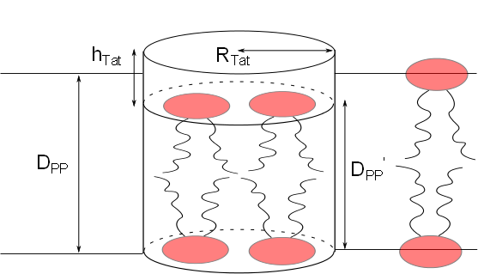

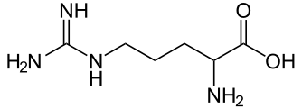

Use this carbon atom as the center