1/13/2014, K.A.

This report shows the two best simulations for each Tat concentration. The best simulation here is defined to be a simulation that yields the lowest chi squared value when the form factor derived from it is fitted to the experimental form factor.

K.A. went through all the sim files created by K.H. on 1/5/2014 and chose two simulation-derived form factors for each Tat concentration (2 Tat in 128 DOPC and 4 Tat in 128 DOPC) to display here.

The simulations were done by fixing the center of mass of Tat at various distances from the bilayer center and also fixing the area per lipid to various values. The distance used is 18, 16, 14, 12, 10, 8, or 5 Å. The area per lipid used is 70, 72, 74, or 76 Å2.

**DOPC:Tat 64:1**

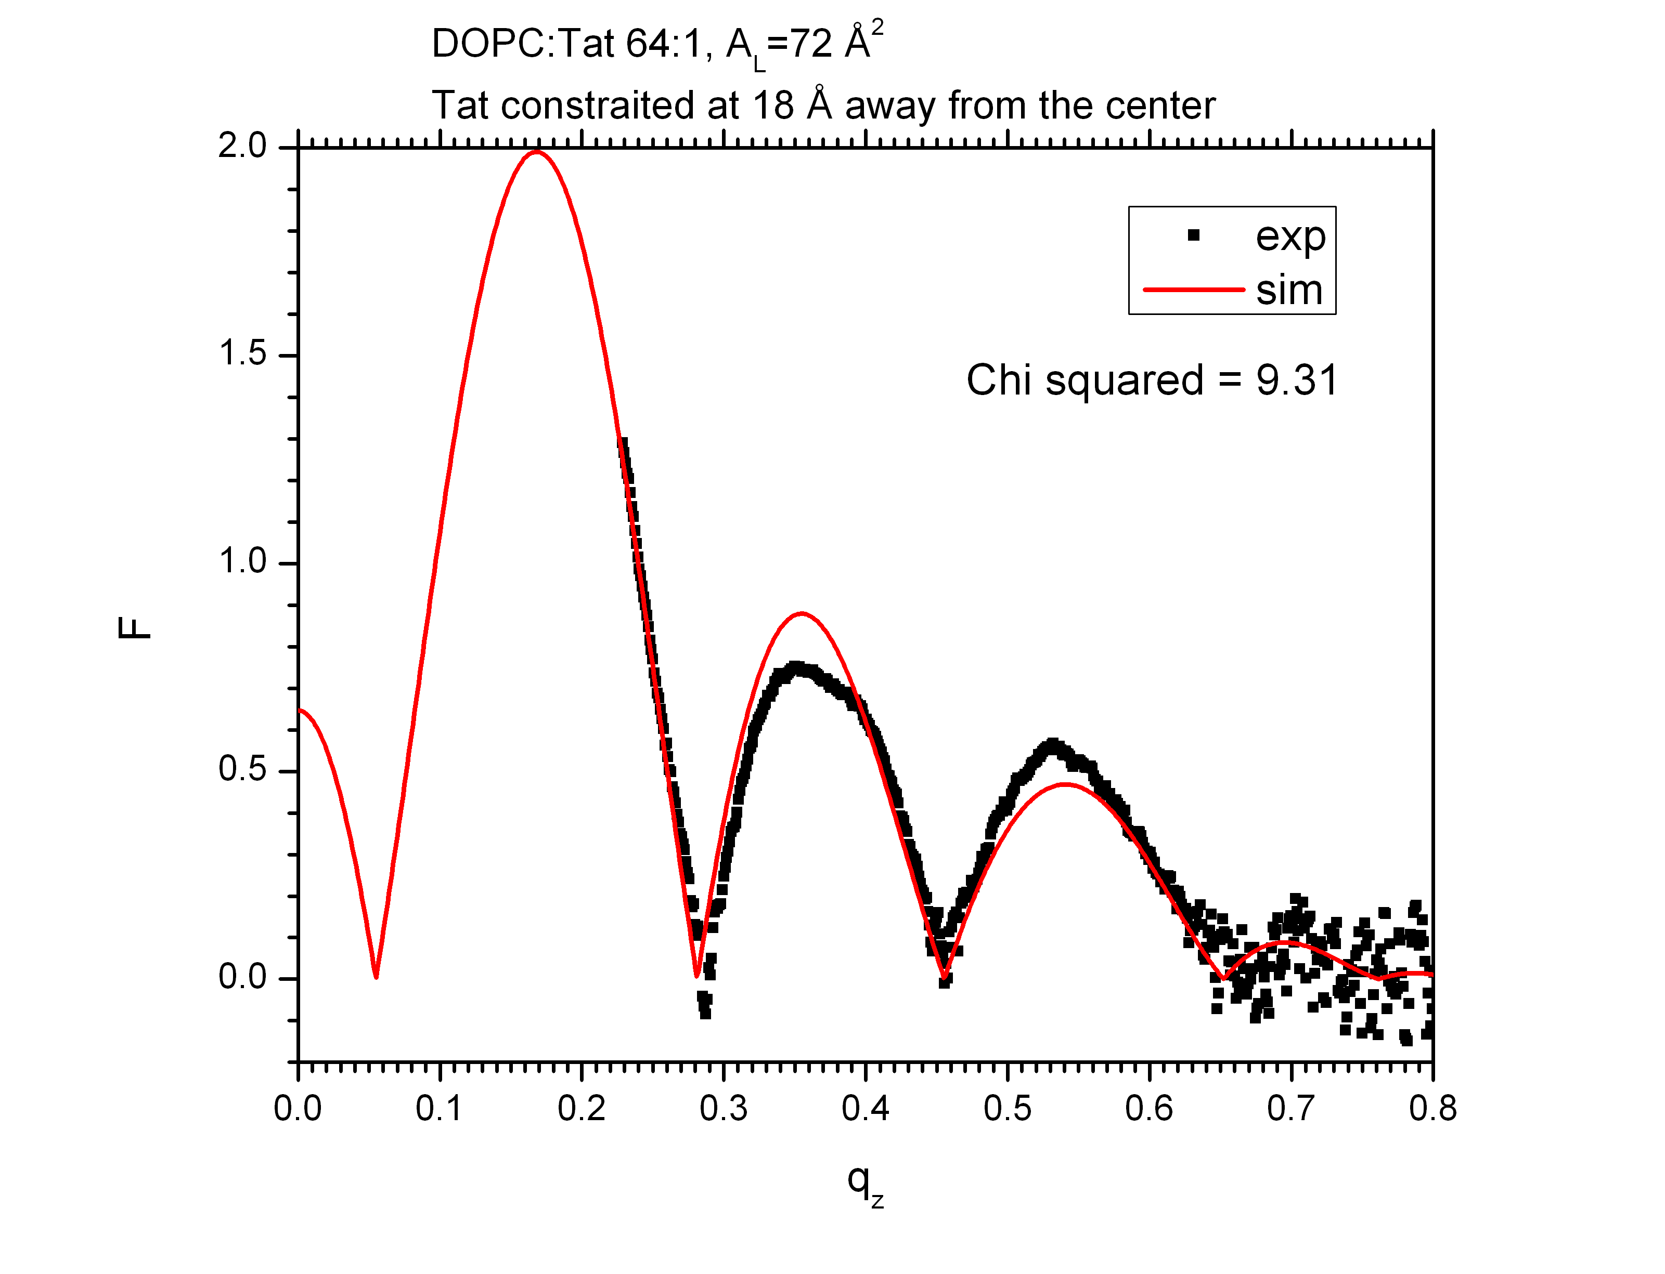

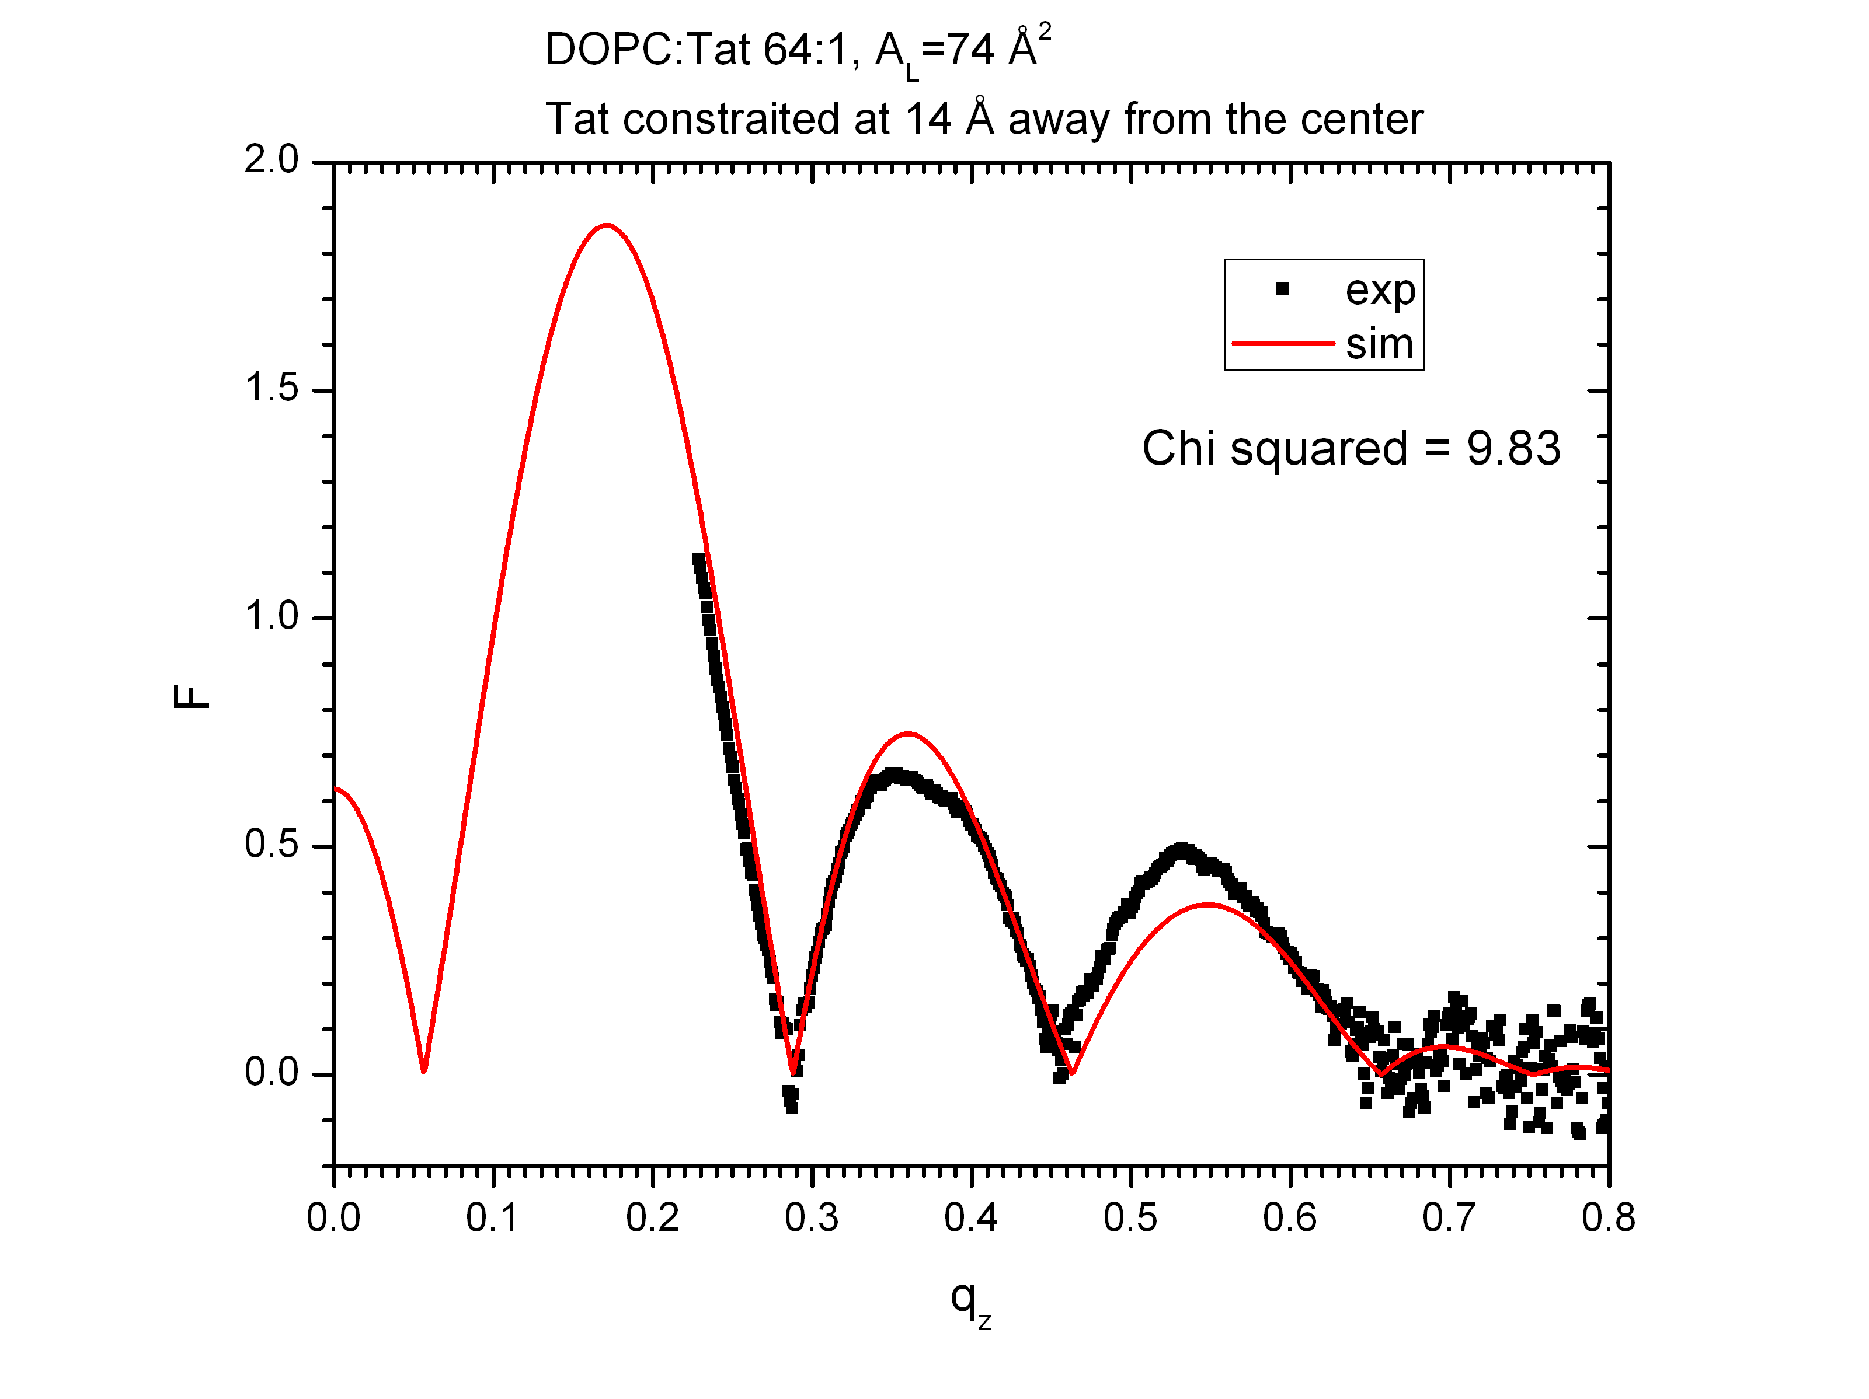

The above two graphs show simulations that yield the smallest and second smallest chi squared values. Tat at 18 Å away from the bilayer center means that Tat is located close to the phosphate group. Tat at 14 Å away from the bilayer center means that Tat is located close to the carbonyl-glycerol group.

Look at snapshots of both simulations to gain some insight?

dopc-tat2-a72-0.kiyo.sim

dopc-tat2-a74-2.kiyo.sim

**DOPC:Tat 32:1**

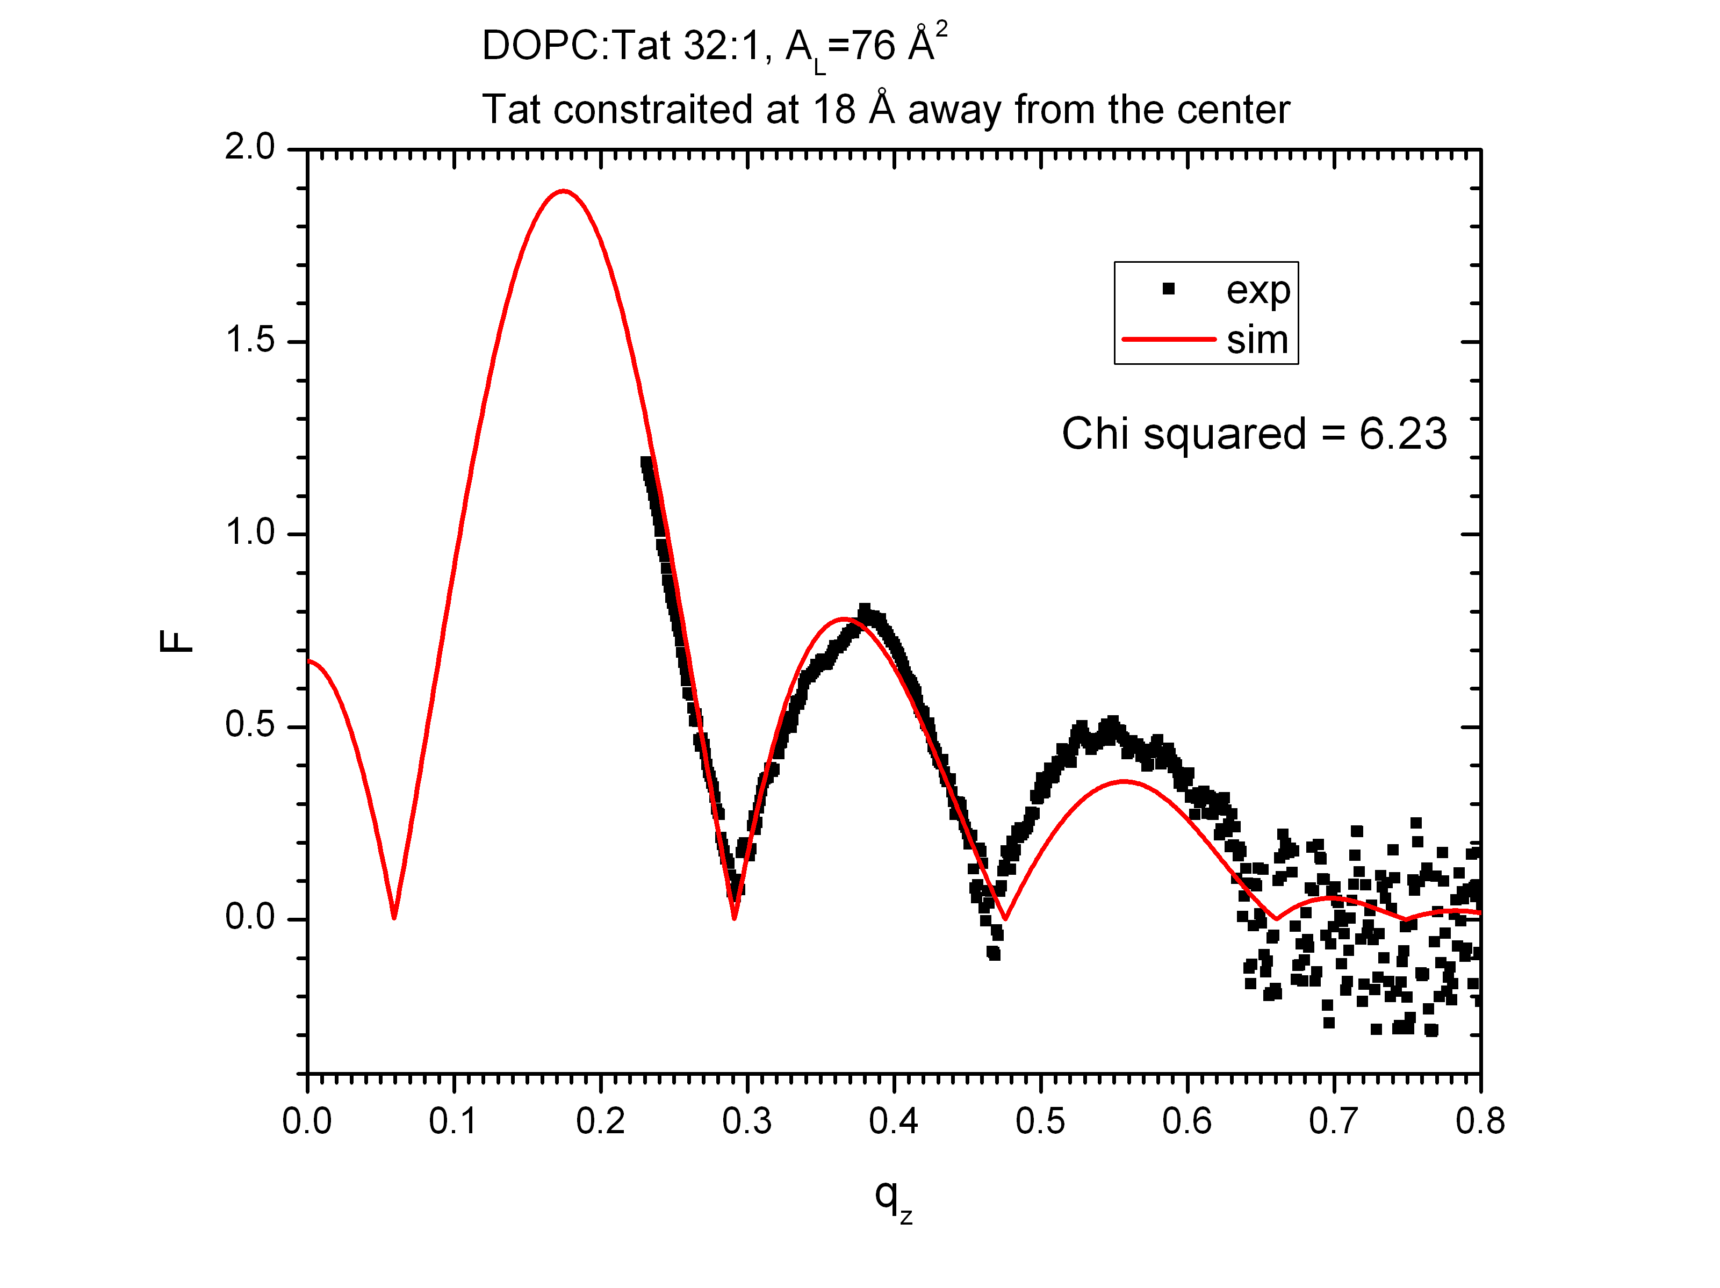

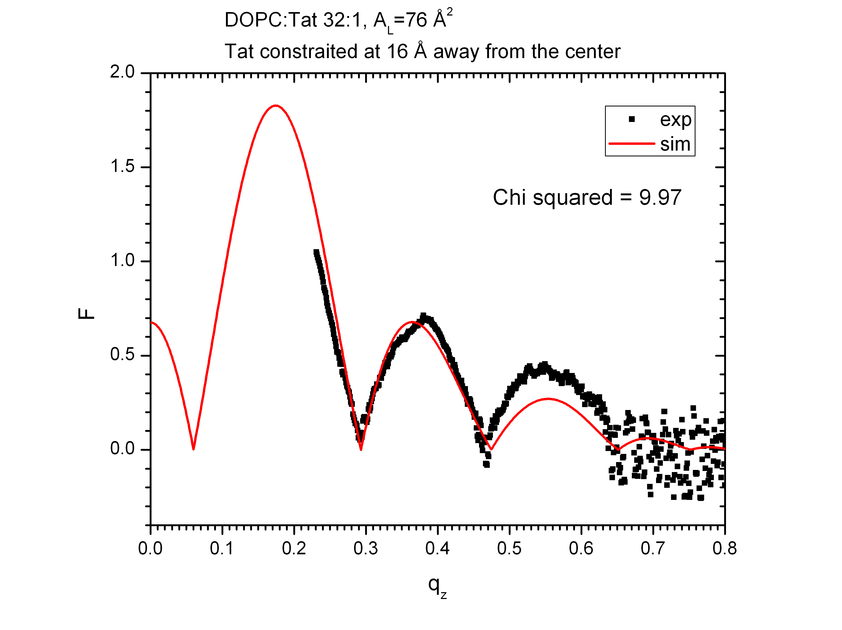

A simulation with Tat constrained at 1.8 nm yields a smaller chi squared value than one at 1.6 nm.

Look at snapshots of both simulations to gain some insight?

dopc-tat4-a76-0.kiyo.sim

dopc-tat4-a76-1.kiyo.sim