Summary of SIMtoEXP analysis on simulations

4/21/2014

Kun simulated DOPC/Tat systems where Tat center of mass was fixed at 0.5 nm from the bilayer center and the bilayer center was flat (as opposed to the distorted bilayer center simulated earlier). The area per lipid explored is summarized in the table below. In all cases, a pore (pores?) was formed.

|  |  |  |  |
| --- | --- | --- | --- |
| **File** | **AL (Å2)** | **Ztat (Å)** | **Chi2** |
| dopc-tat2-a70-6b.sim | 70 | 5 | 458 |
| dopc-tat2-a72-6b.sim | 72 | 5 | 459 |
| dopc-tat2-a74-6b.sim | 74 | 5 | 405 |
| dopc-tat4-a72-6b.sim | 72 | 5 | 349 |
| dopc-tat4-a74-6b.sim | 74 | 5 | 110 |
| dopc-tat4-a76-6b.sim | 76 | 5 | 1664 |

Overall, agreement between experimental and simulated form factors is bad. The chi-squared values of the best matching simulations (Tat fixed at 16 or 18 Å from the bilaye center) are between 18 and 40, far smaller than any chi-squared measured in the current set of simulations.

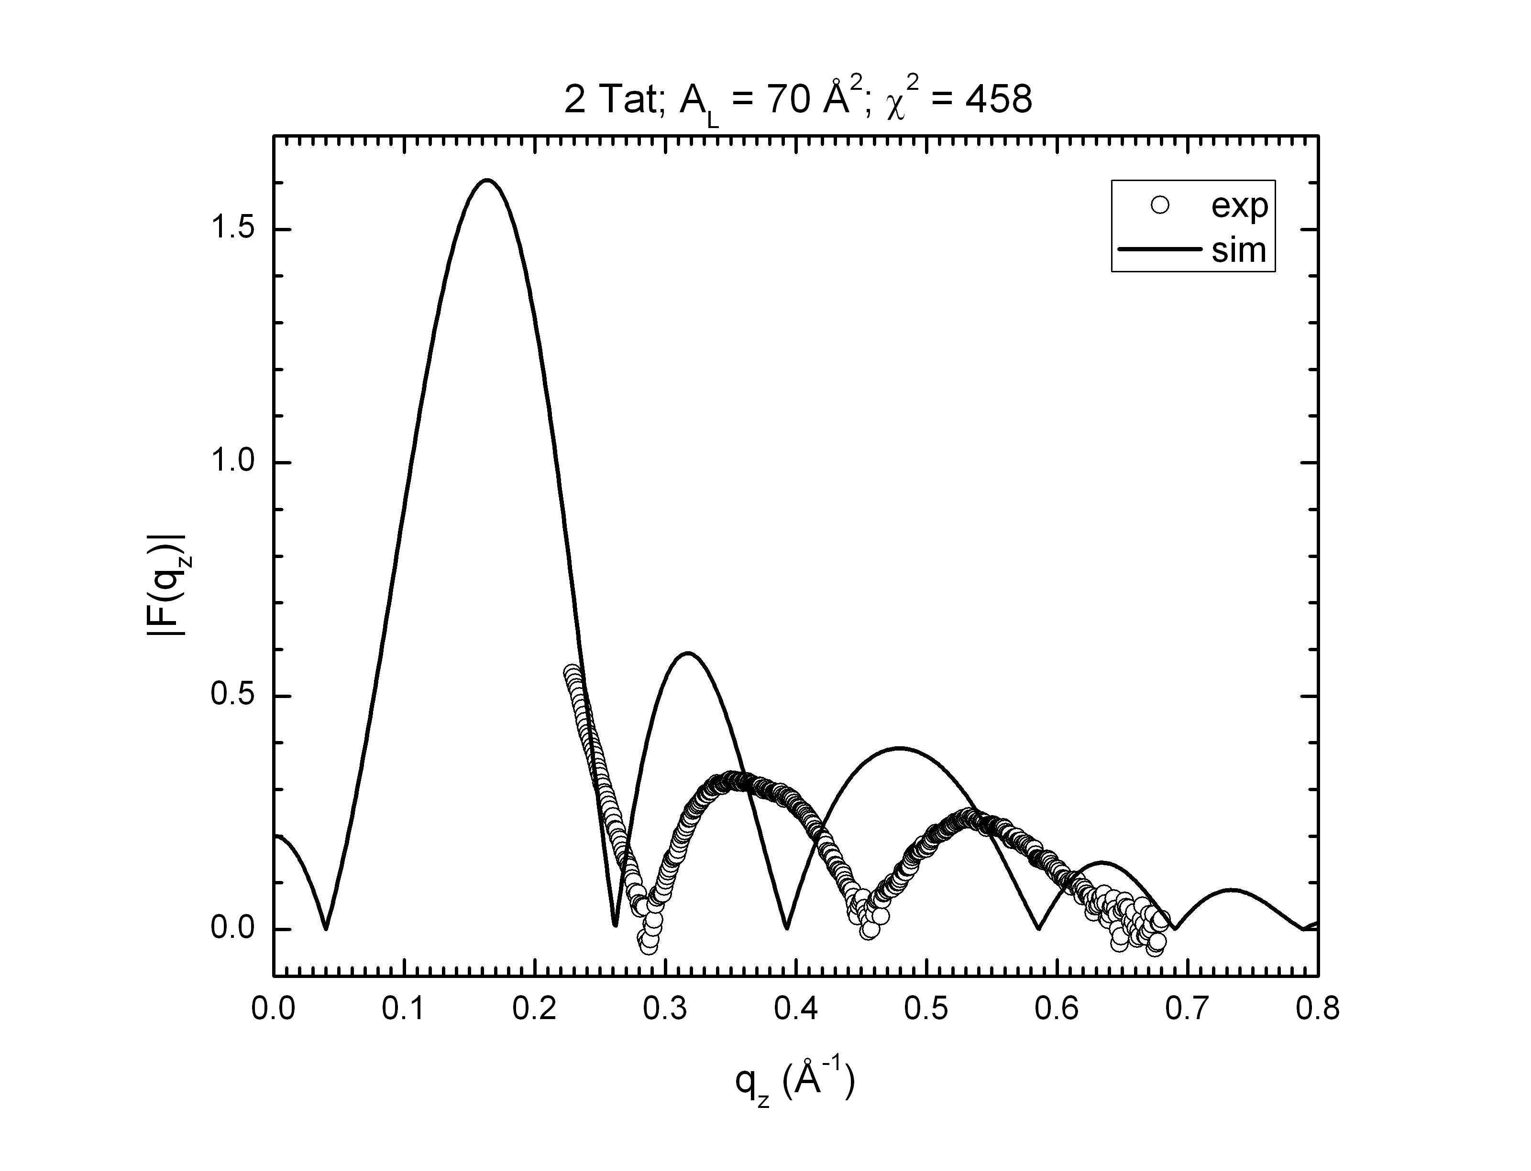

A description...

A description...

