**12/13/2013, KA**

**DOPC form factor**

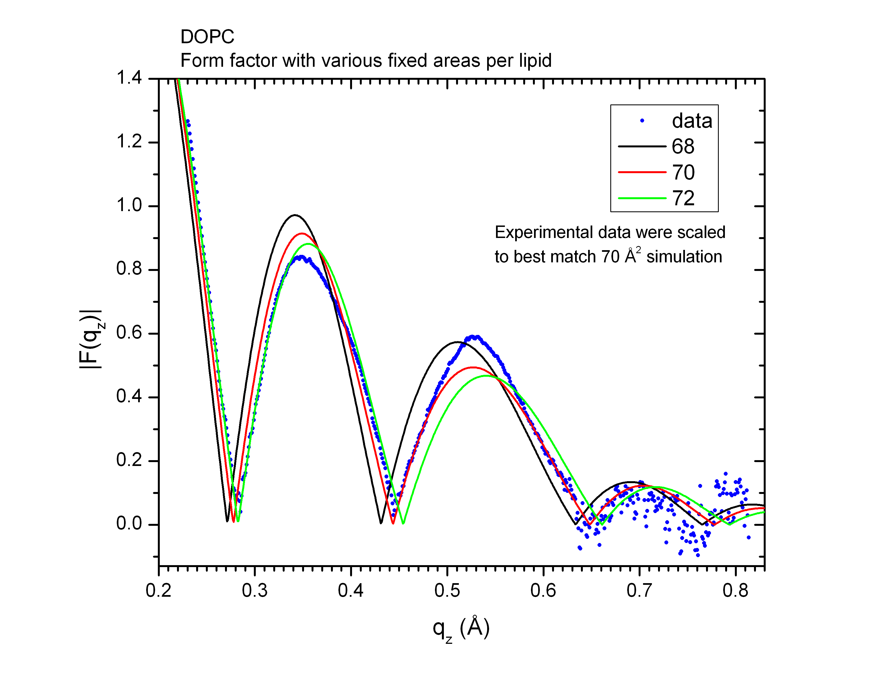

For DOPC, it looks like 70 Å2 is the best match.

**DOPC/Tat 64:1 form factor**

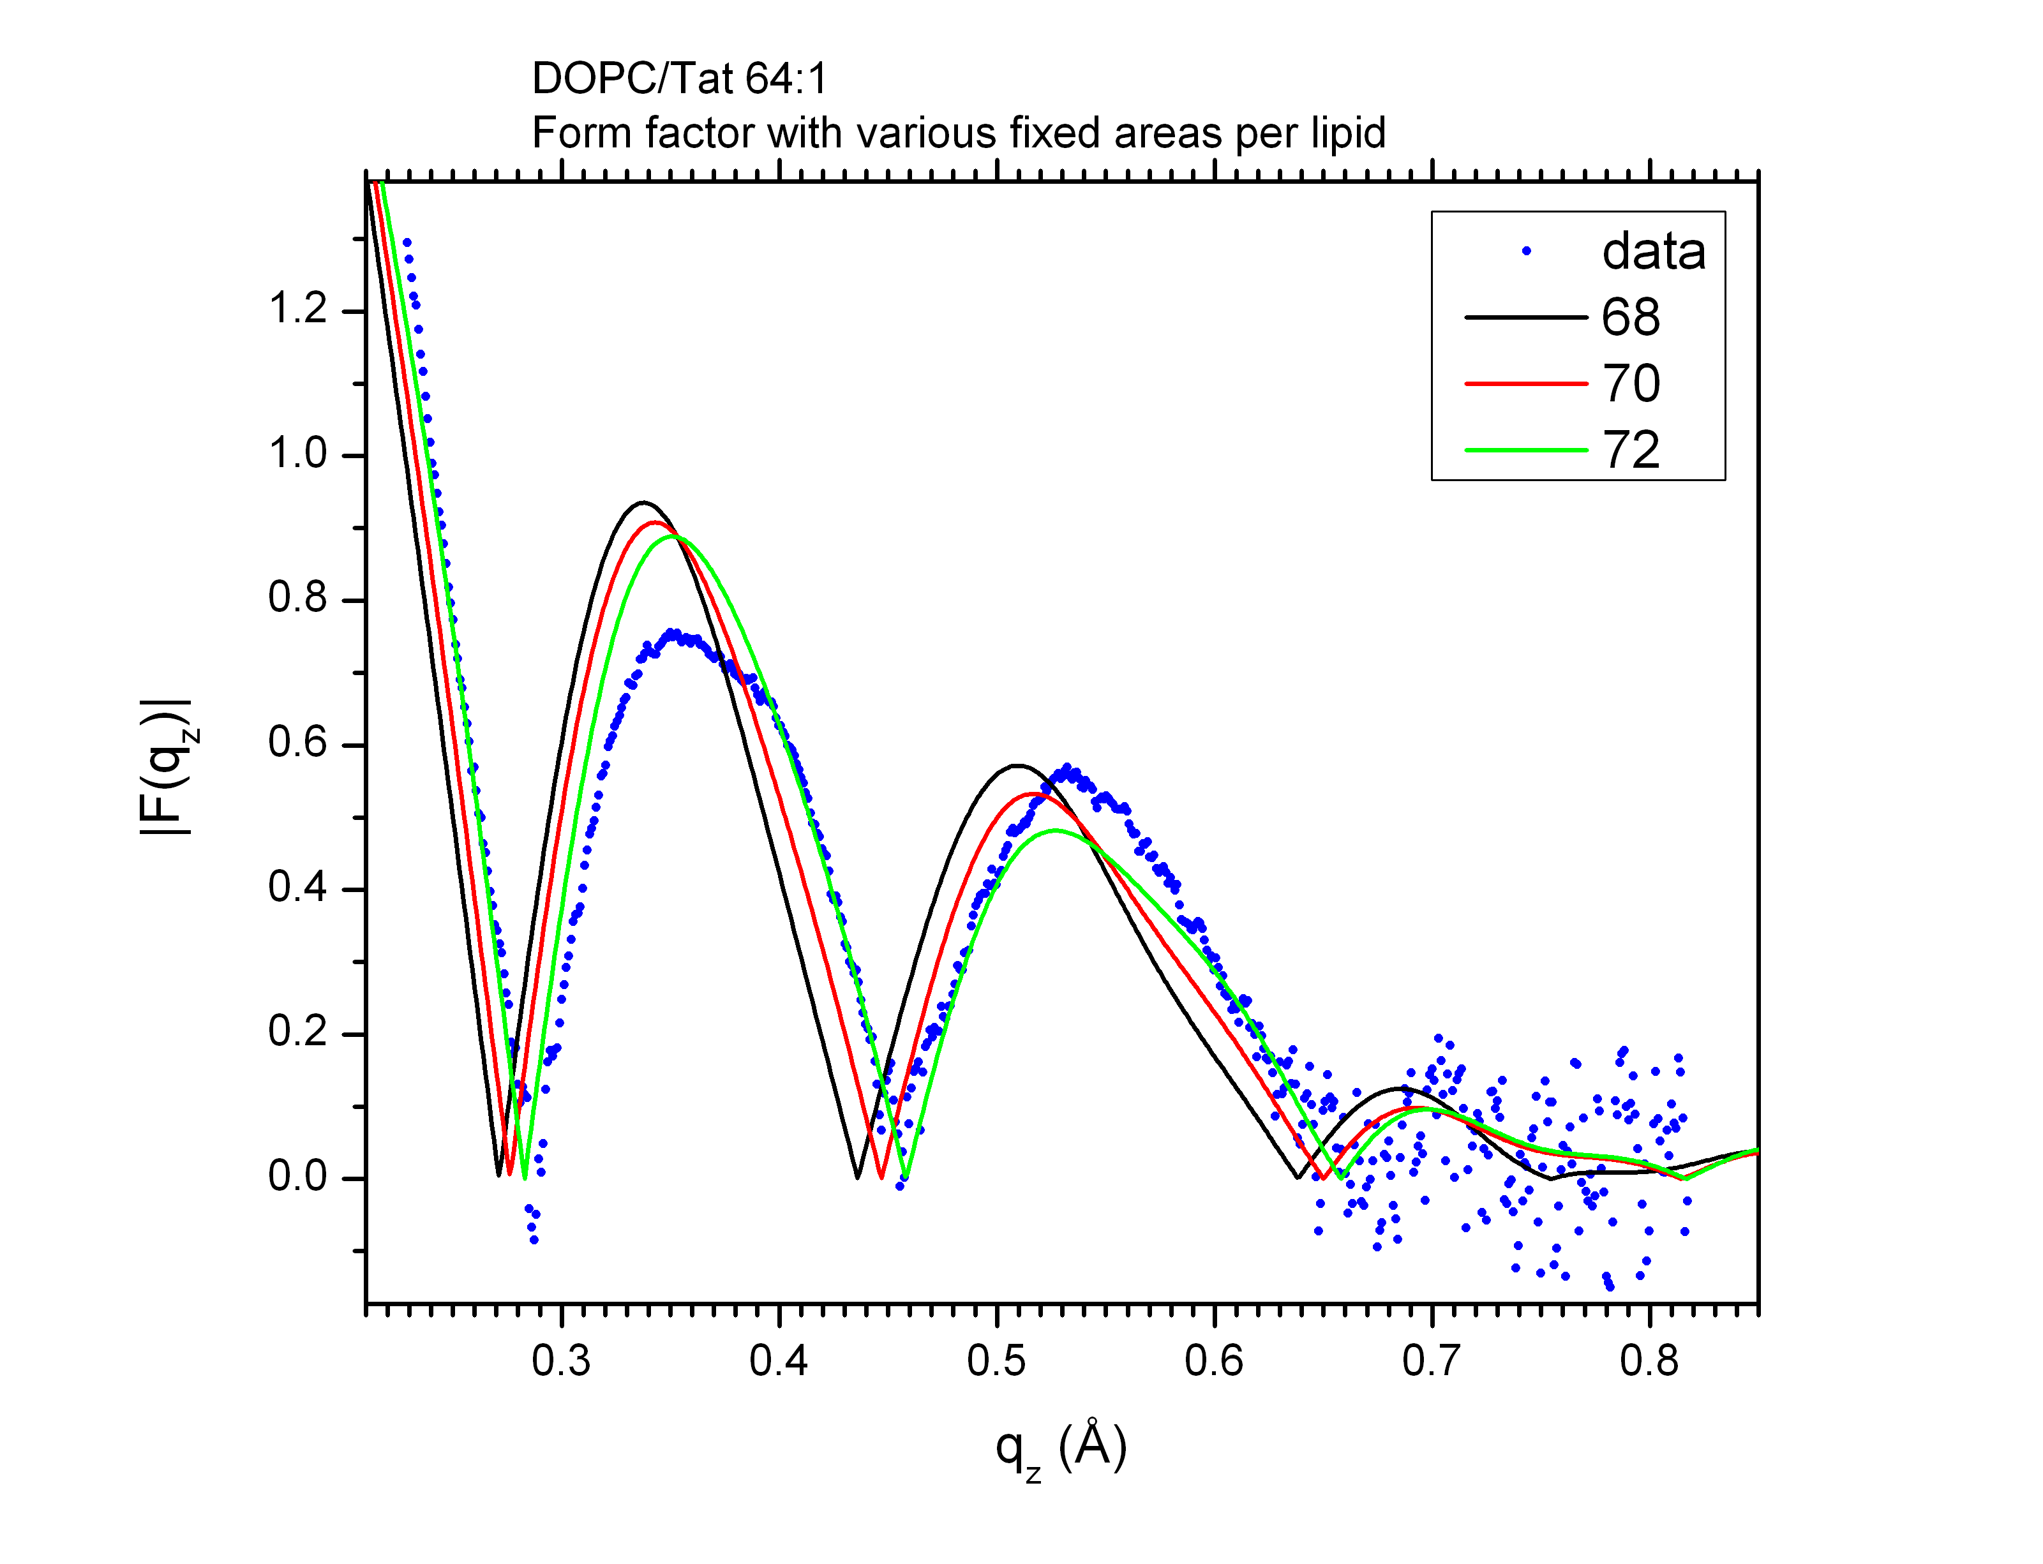

For DOPC/Tat 64:1, it looks like 72 Å2 is the best match.

* Try 74, 76 for completeness

**DOPC/Tat 32:1 form factor**

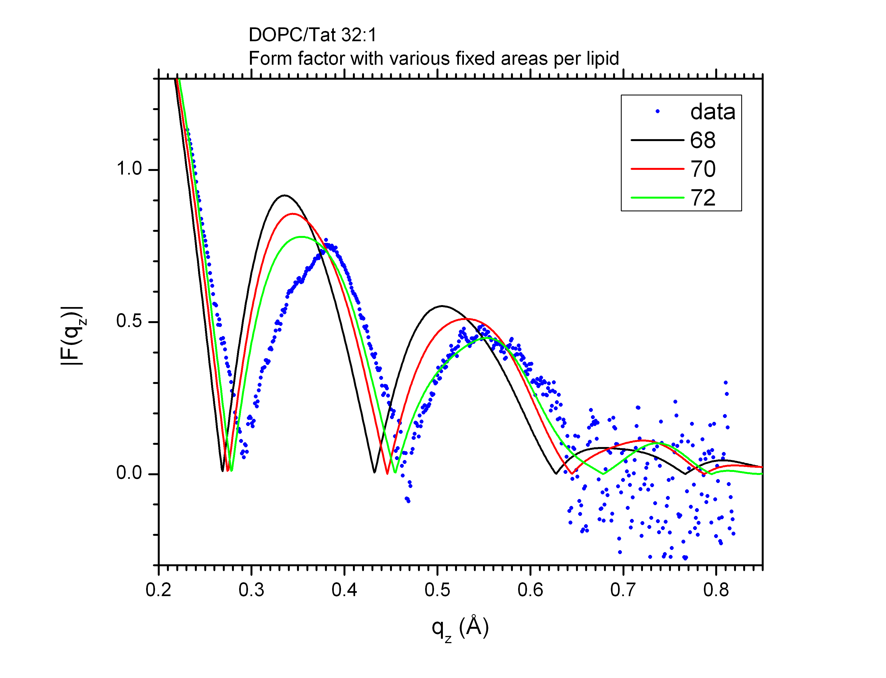

For DOPC/Tat 32:1, it looks like AL > 72 Å2 is better. 74 Å2 perhaps?

* Try 74, 76, 78 Å2

**Comparison of electron density profiles (EDP) obtained by SDP analysis and from simulations**

**Notation in SDP analysis:**

PC = Phosphate + Choline

CG = Carbonyl + Glycerol

CH2+CH = methlyene + methine

CH3 = terminal methyl

Note that in SDP analysis, CholCH3 and PCN are combined to make PC group.

For simulations, EDPs were calculated based on simulations at 70, 72, and 72 Å2 for DOPC, DOPC/Tat 64:1, and DOPC/Tat 32:1, respectively.

**DOPC**

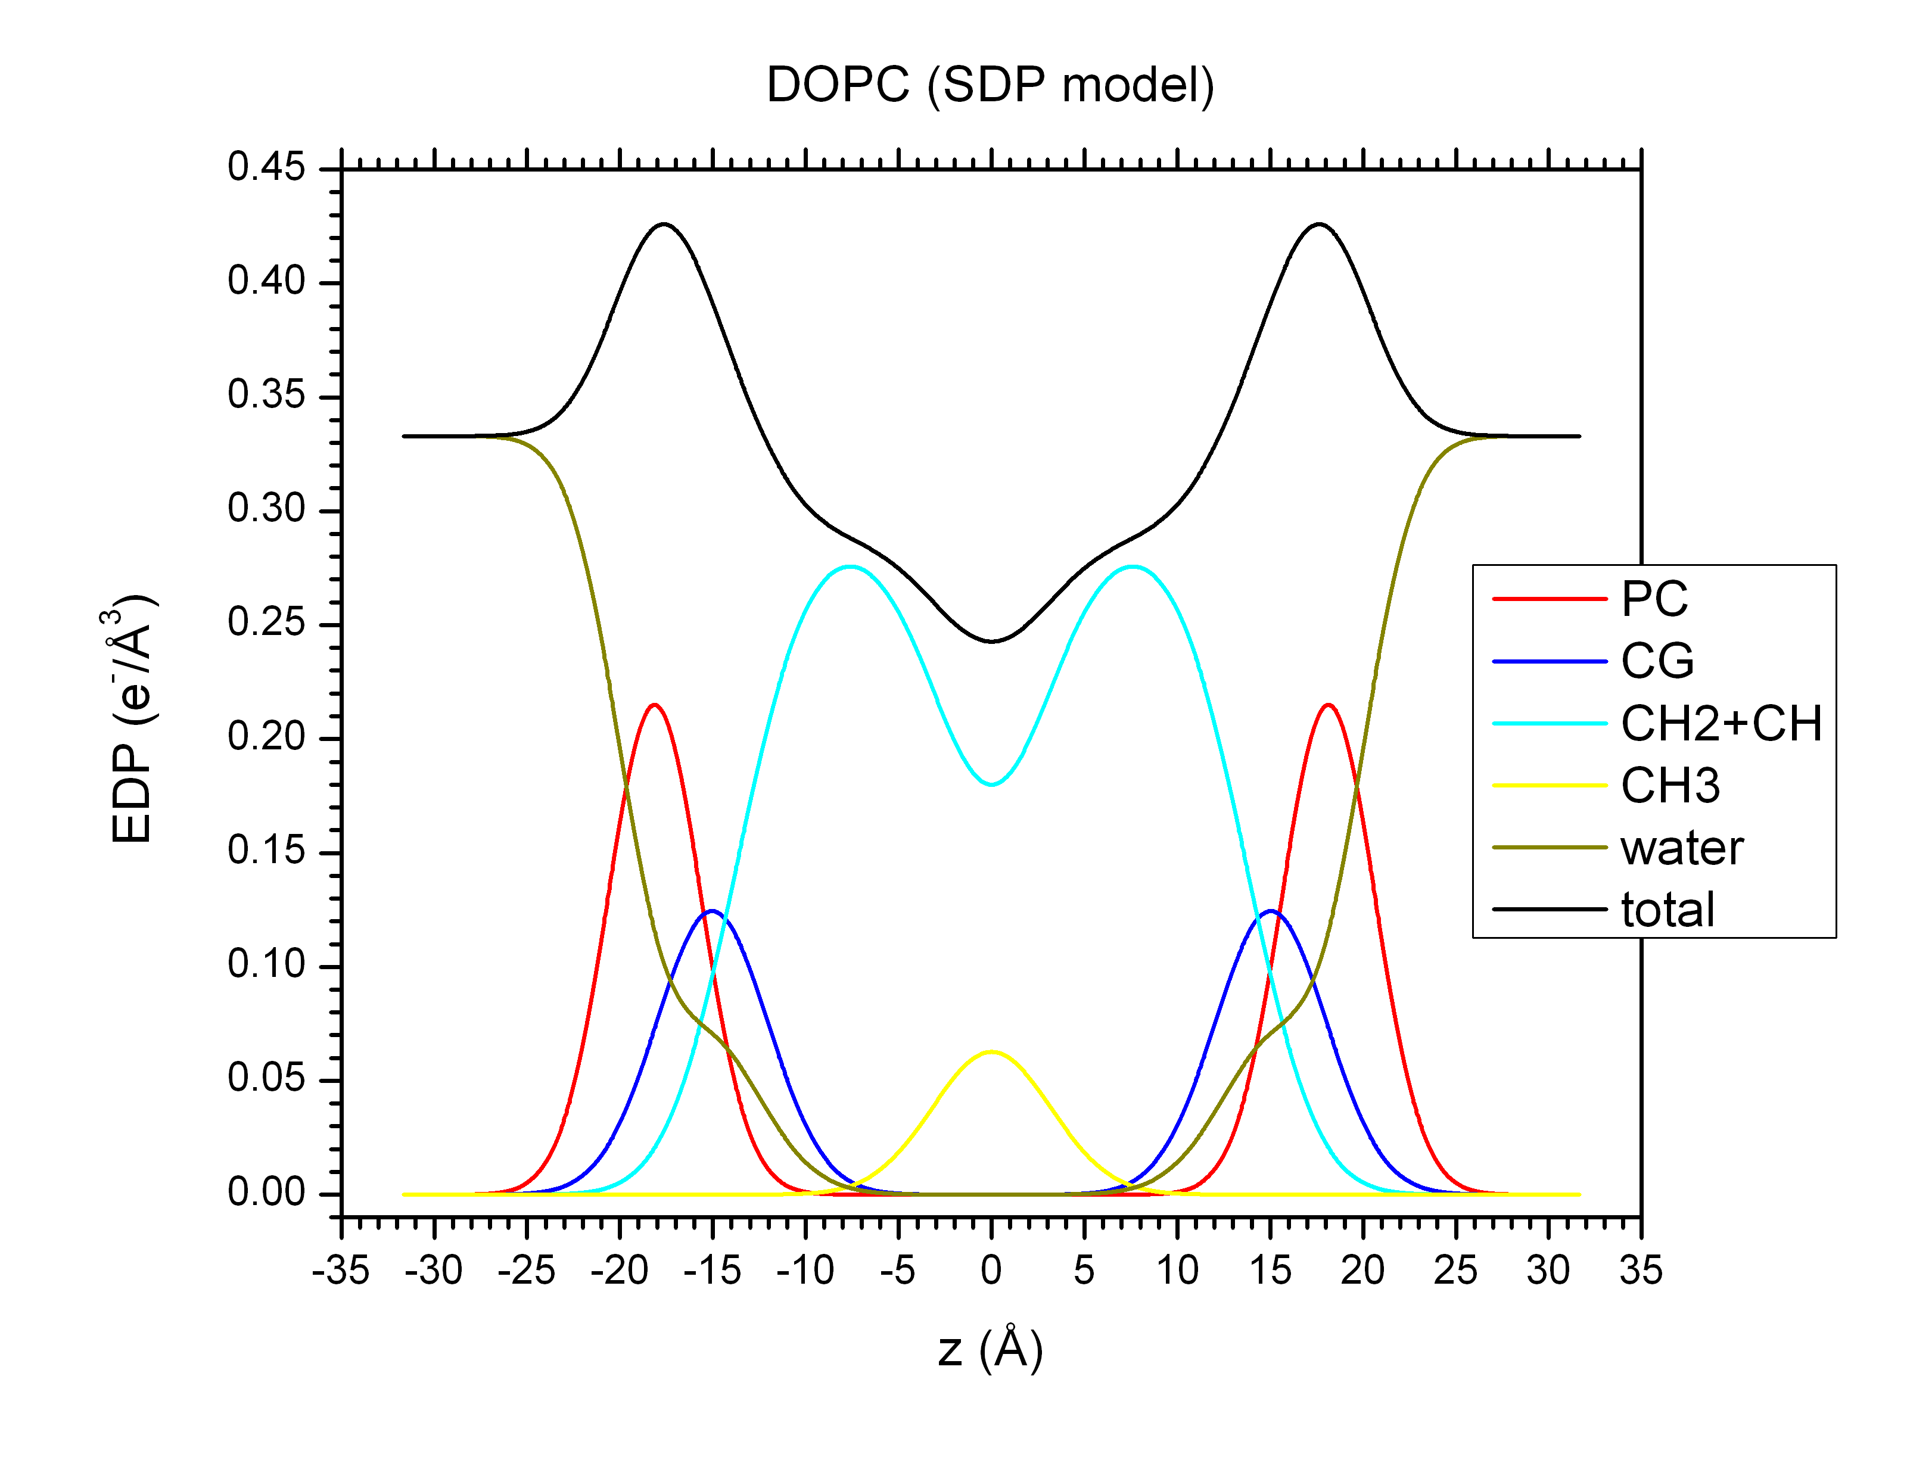

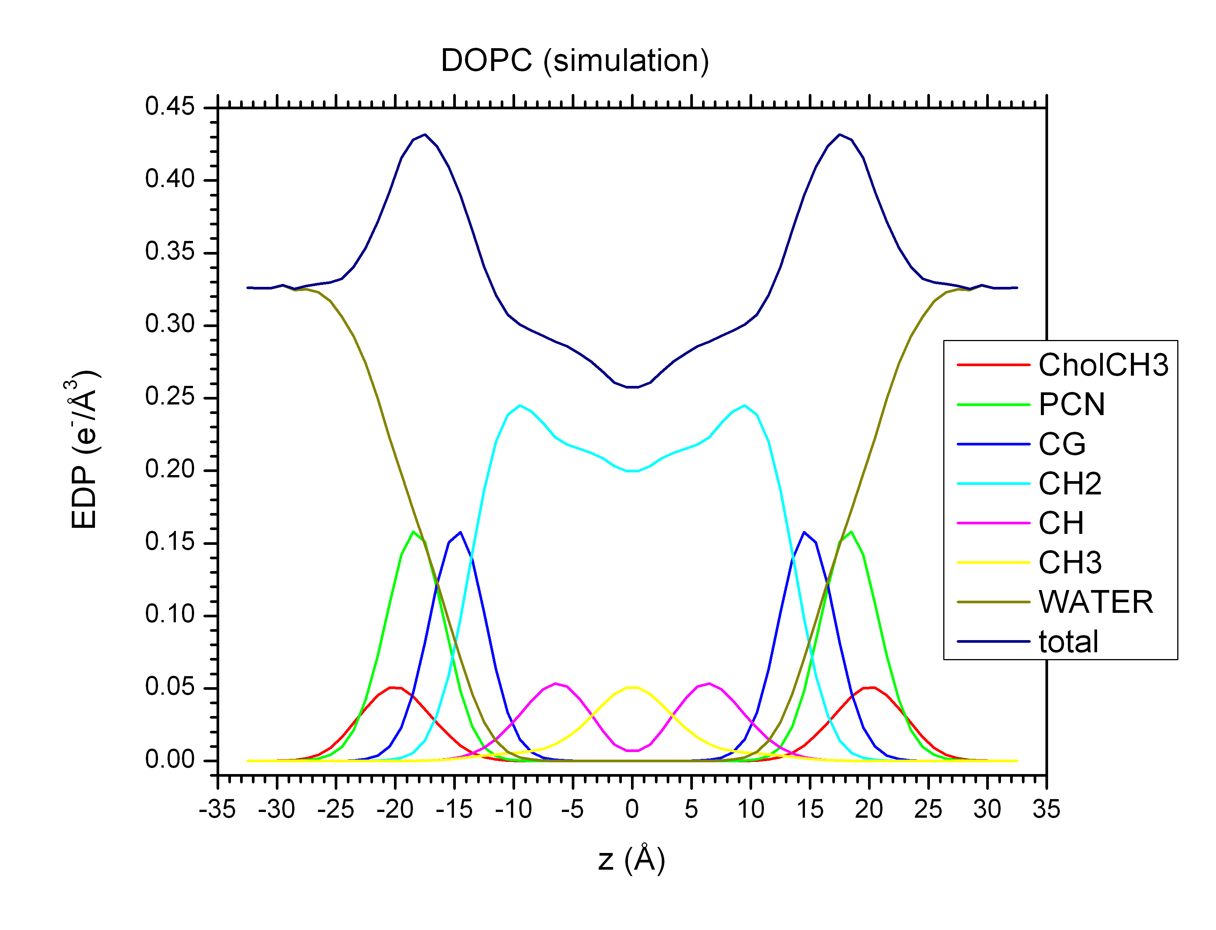

**62:1**

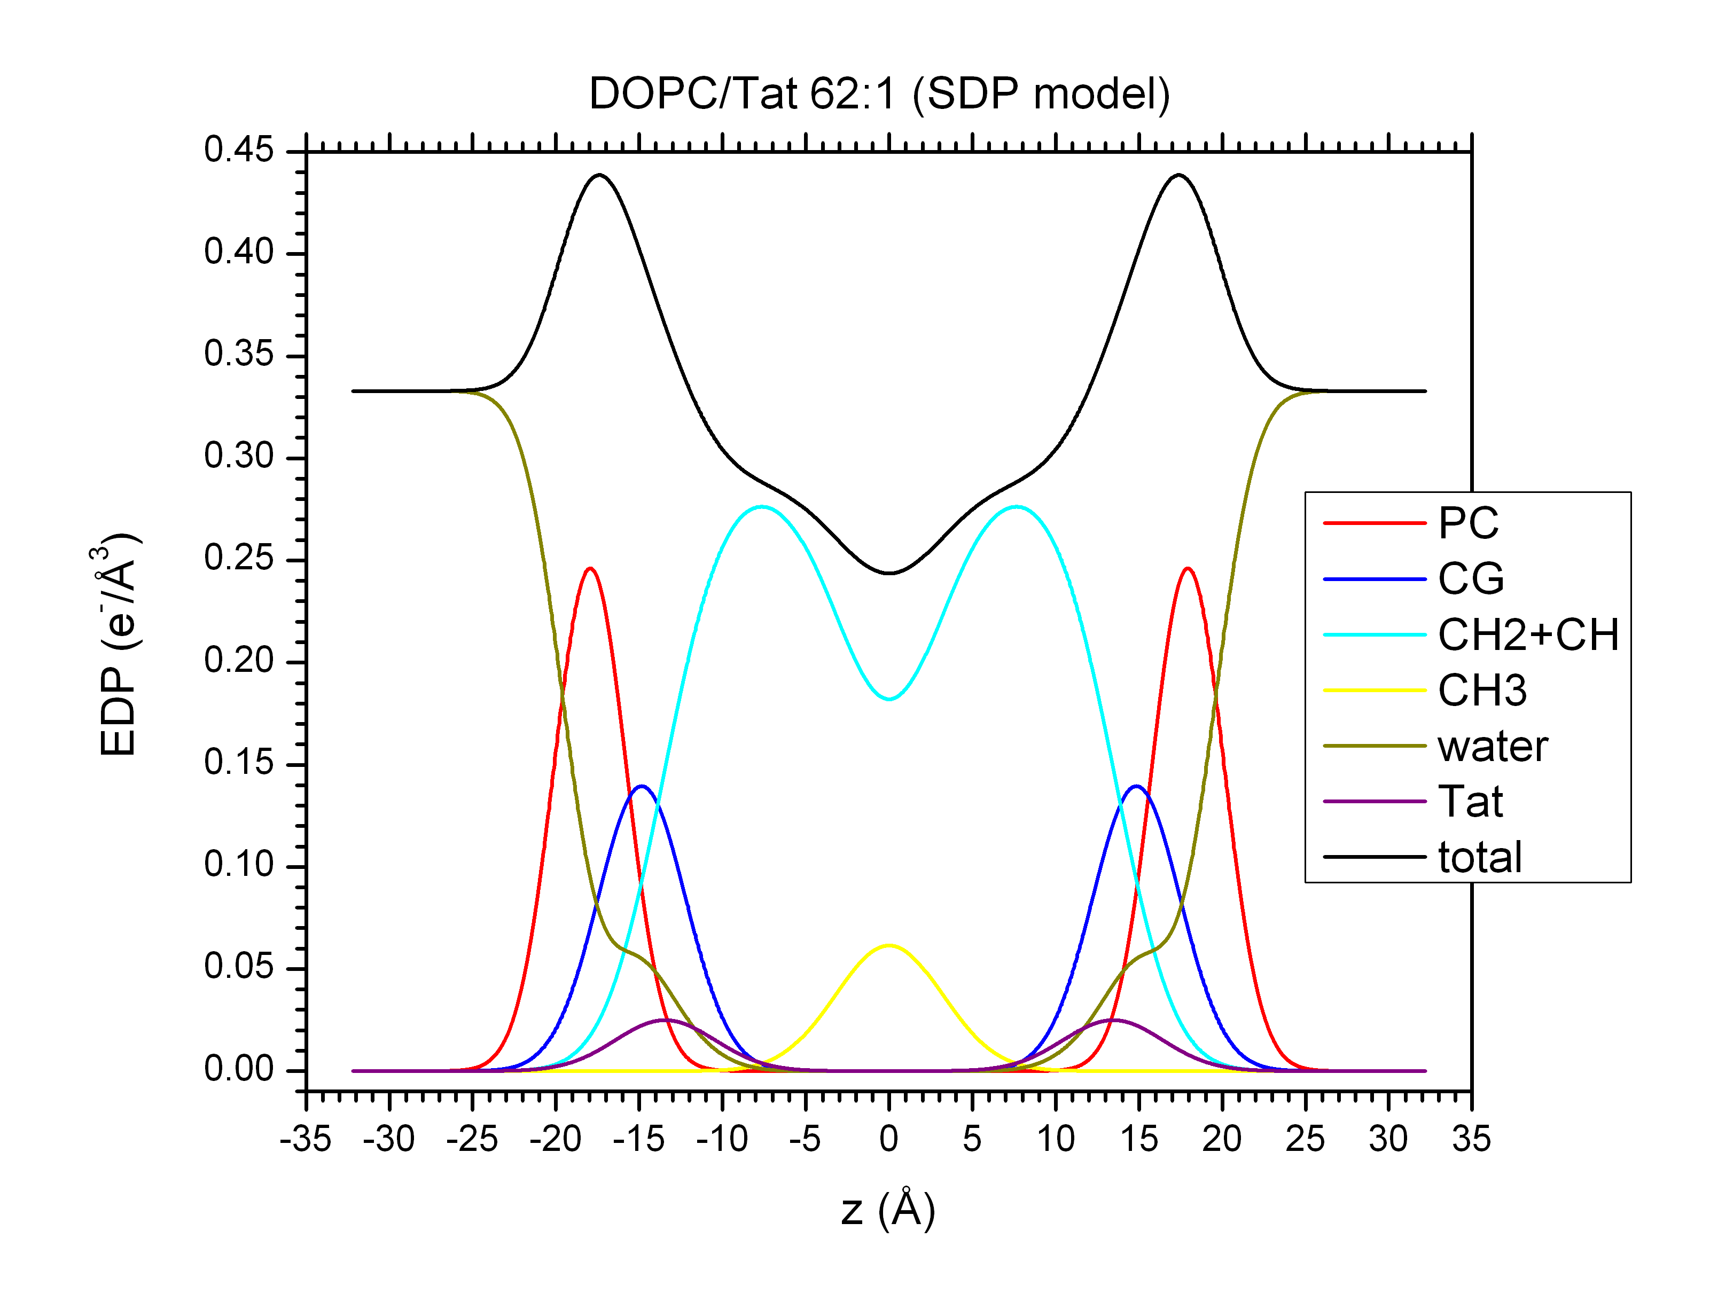

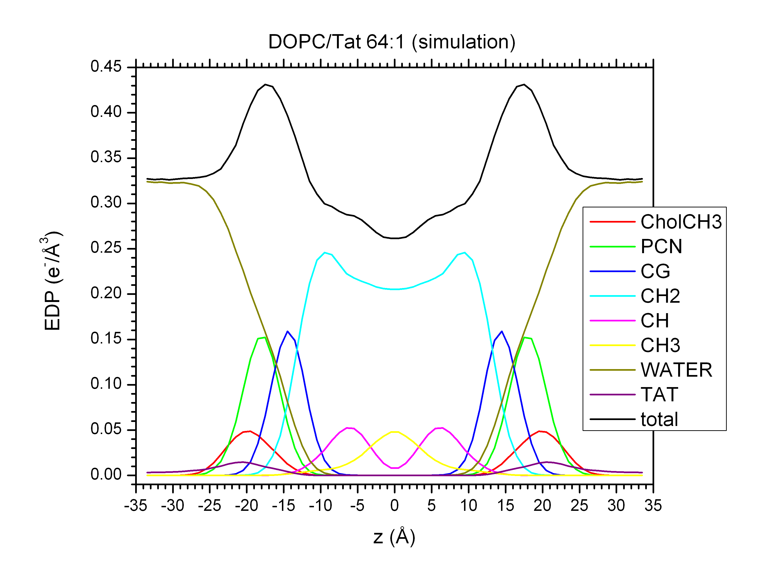

Tat’s position is quite different between experiment and simulation. We should start a simulation where Tat is already embedded in the bilayer.

**32:1**

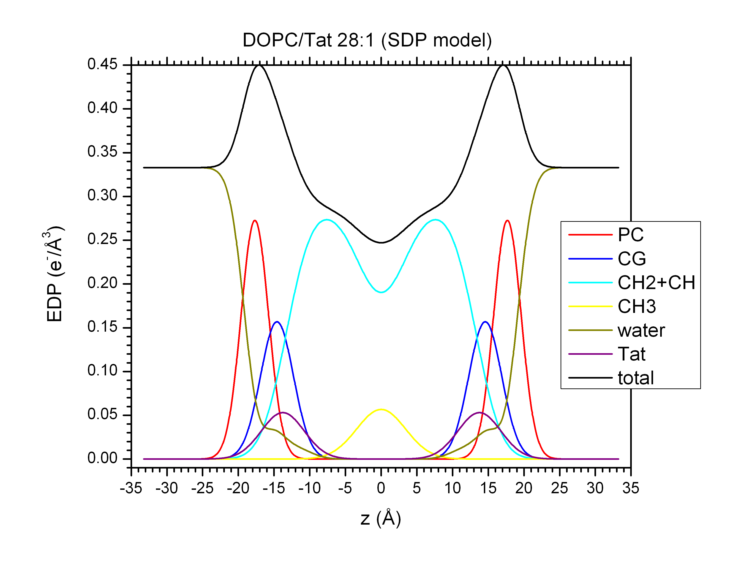

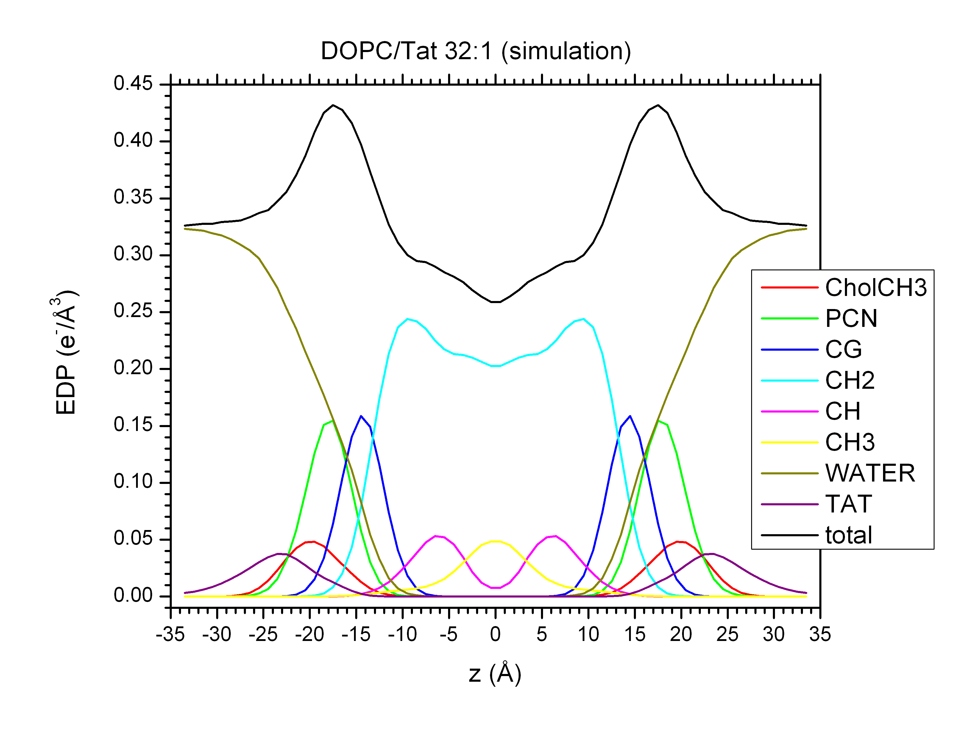

Tat’s position is quite different between experiment and simulation. We should start a simulation where Tat is already embedded in the bilayer.

**Summary of experimental results**

|  |  |  |  |  |
| --- | --- | --- | --- | --- |
| **Lipid:Tat**  **Ratio** | **Tat’s**  **Position (Å)** | **Bilayer**  **Thickness (Å)** | **Area per**  **Lipid (Å2)** | **CG**  **Position (Å)** |
| 0 | N/A | 36.3 | 71.5 | 15.0 |
| 62:1 | 13.5 | 35.9 | 72.6 | 14.8 |
| 28:1 | 13.8 | 35.4 | 74.0 | 14.6 |
| 16:1 | 15.3 | 35.5 | 73.7 | 14.7 |

**Conclusion**

For 32:1 system, we need to simulate at area per lipid of 74 and above. Once we know what area to use for each system, we will initially put Tat inside the bilayer and simulate with the fixed best area. Do this for various initial locations (i.e., depth of insertion).