Assessment 2
Data exploration and preparation

Name : Drashti Kakadiya
Student id : 25414741

2130 Fundamentals of Data Analytics - Autumn 2026

Table of Contents
- Introduction ................................................................................................................................ 3
- Initial Data Exploration (1A) ...................................................................................................... 3
2.1 Attribute Classification ....................................................................................................... 3
2.2 Numerical Attribute Analysis .............................................................................................. 4
2.3 Categorical Attribute Analysis ............................................................................................ 7
2.4 Multi-Attribute Relationships ..............................................................................................10
- Data Preprocessing (1B) ...........................................................................................................14
3.1 Binning Techniques ...........................................................................................................14
3.2 Normalisation .....................................................................................................................15
3.3 Age Discretisation ............................................................................................................. 16
3.4 Gender Binarisation .......................................................................................................... 16
- Summary of Findings (1C) ....................................................................................................... 18
- Conclusion ................................................................................................................................ 19
- References .................................................................................................................................20

Introduction
The original dataset consists of 3,000 customer records with 21 attributes describing each customer’s demographics, income and credit quality, loan characteristics and amount, account behaviour, delinquency history, and repayment outcome. The business objective is to explore the data to understand its structure and possibly find patterns that could help estimate the repayment risk of each customer.
The report uses measures of location and spread including mean, median, standard deviation, quartiles and range, as well as histograms and boxplots to describe numerical attributes. Frequency tables, bar charts and percentage comparisons are used to describe categorical attributes. Correlation heatmap, scatter plots and repayment-rate comparisons are used to explore multi-attribute interactions. All preprocessing results were retained in the Excel workbook. The report presents selected tables and findings with interpretation.
Item | Value
Records | 3,000
Original attributes | 21
Numeric attributes | 14 (including delinquency_history and loan_paid_back coded numerically)
Categorical attributes | 7
Target attribute | loan_paid_back
Table 1. Dataset overview.
The workbook also contains the processed outputs required for Task 1B and a final combined dataset with the new derived columns. These deliverables are consistent with the assignment requirement that the report and spreadsheet be submitted together.

1A. Initial data exploration
This section classifies the attributes, summarises their distributions, and highlights outliers, skewness, clusters, and relationships. The original 21 variables are retained for this section because the assignment specifies that the exploration should be performed on the original data before preprocessing.
Attribute | Type | Missing values | Unique values
source ID | Numerical | 0 | 3000
age | Numerical | 0 | 55
gender | Categorical | 0 | 3
marital_status | Categorical | 0 | 4
education_level | Categorical | 0 | 5
annual_income | Numerical | 0 | 2998
monthly_income | Numerical | 0 | 2988
employment_status | Categorical | 0 | 5
debt_to_income_ratio | Numerical | 0 | 462
credit_score | Numerical | 0 | 347
loan_amount | Numerical | 0 | 2828
loan_purpose | Categorical | 0 | 8
interest_rate | Numerical | 0 | 966
loan_term | Categorical / Discrete Numeric | 0 | 2
installment | Numerical | 0 | 2917
num_of_open_accounts | Numerical | 0 | 15
total_credit_limit | Numerical | 0 | 2999
current_balance | Numerical | 0 | 2998
delinquency_history | Categorical / Discrete Numeric | 0 | 10
num_of_delinquencies | Numerical | 0 | 11
loan_paid_back | Categorical / Discrete Numeric | 0 | 2
Table 2. Attribute type classification for the original dataset.
The attributes of the dataset can be classified as either numerical or categorical. Numerical attributes are the ones that take quantitative values such as age, annual_income, credit_score and loan_amount. The categorical attributes are those that have a set of distinct values such as gender, marital_status, education_level and loan_purpose. The attribute “source ID” is an identifier variable and does not carry analytical meaning. Therefore, it is excluded from statistical analysis and modelling, as it does not contribute to understanding customer behaviour or loan repayment patterns.

1A.1 Numerical attribute summary
Summary statistics were calculated for all numerical attributes to understand their distribution, central tendency, and variability. Measures such as mean, median, minimum, maximum, standard deviation, and percentiles were computed.
For example, the credit_score attribute shows a wide distribution, indicating variability in customer creditworthiness. Similarly, annual_income and loan_amount exhibit significant spread, suggesting diverse financial backgrounds among customers.
Attribute | Mean | Median | Std | Min | Max
source ID | 9,933.68 | 9,846.50 | 5,797.65 | 0 | 19,993.00
age | 48.265 | 49 | 15.701 | 21 | 75
annual_income | 43,240.17 | 35,565.04 | 28,164.68 | 6,000.00 | 247,972.39
monthly_income | 3,603.35 | 2,963.76 | 2,347.06 | 500 | 20,664.37
debt_to_income_ratio | 0.177 | 0.161 | 0.106 | 0.01 | 0.641
credit_score | 678.522 | 681 | 71.722 | 443 | 850
loan_amount | 15,145.76 | 14,768.92 | 8,741.10 | 500 | 49,039.69
interest_rate | 12.397 | 12.365 | 2.435 | 4.29 | 20.45
Table 3. Numerical summary statistics (part 1).
Attribute | Mean | Median | Std | Min | Max
loan_term | 43.136 | 36 | 10.972 | 36 | 60
installment | 456.654 | 437.185 | 278.69 | 10.05 | 1,636.09
num_of_open_accounts | 5.003 | 5 | 2.221 | 0 | 14
total_credit_limit | 48,267.09 | 39,645.85 | 31,917.49 | 6,886.24 | 315,439.48
current_balance | 24,451.95 | 18,670.83 | 21,828.81 | 815.34 | 225,226.06
delinquency_history | 1.987 | 2 | 1.506 | 0 | 9
num_of_delinquencies | 2.489 | 2 | 1.662 | 0 | 10
loan_paid_back | 0.812 | 1 | 0.391 | 0 | 1
Table 4. Numerical summary statistics (part 2).
Several numeric variables are right-skewed, especially annual_income, total_credit_limit, current_balance, and loan_amount, because the mean is noticeably above the median and the maximum values are far from the upper quartile. In contrast, age is more compact and approximately centred around the late-forties. debt_to_income_ratio also shows a long right tail, suggesting the presence of customers with substantially higher leverage.
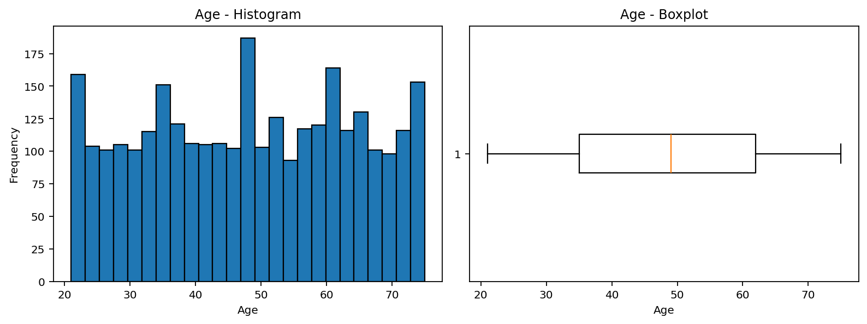
Figure 1. Age distribution and boxplot.
Age is broadly distributed between 21 and 75, with a median of 49 years. The boxplot shows no extreme structural anomalies, although the distribution is slightly concentrated in middle and later adulthood.
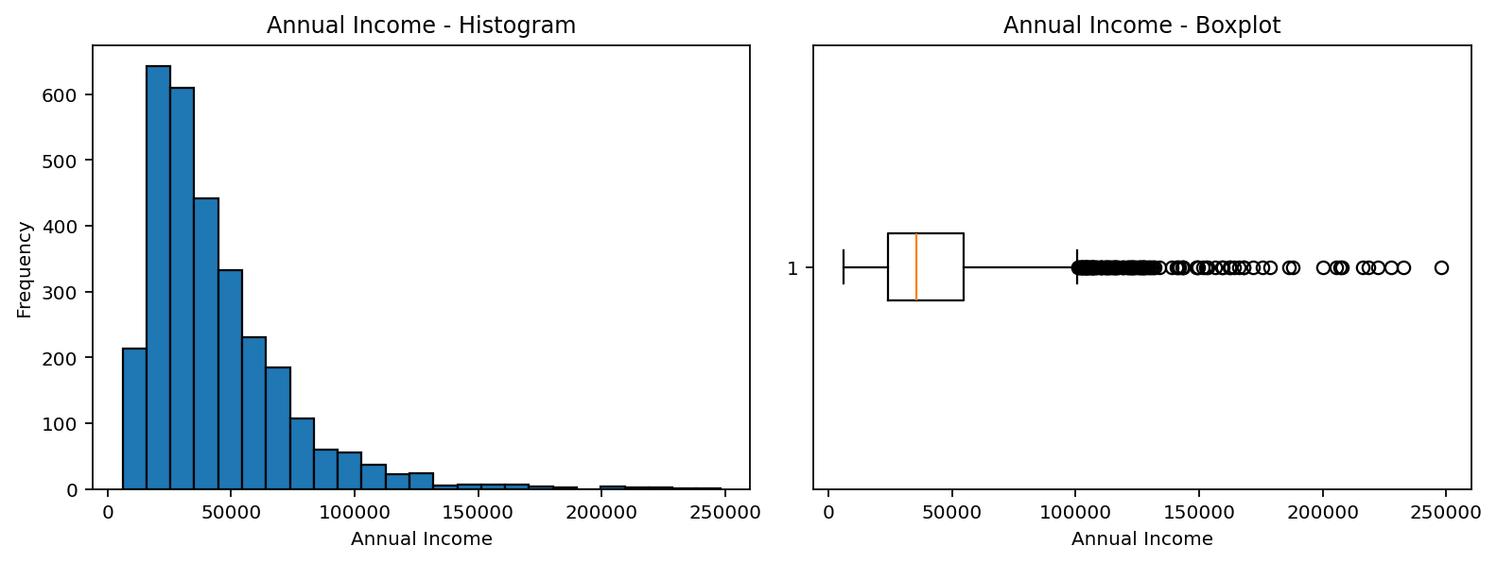
Figure 2. Annual income distribution and boxplot.
Annual income is positively skewed. Most customers are concentrated in the lower-to-middle income range, while a smaller number of very high-income customers create visible upper-tail outliers.
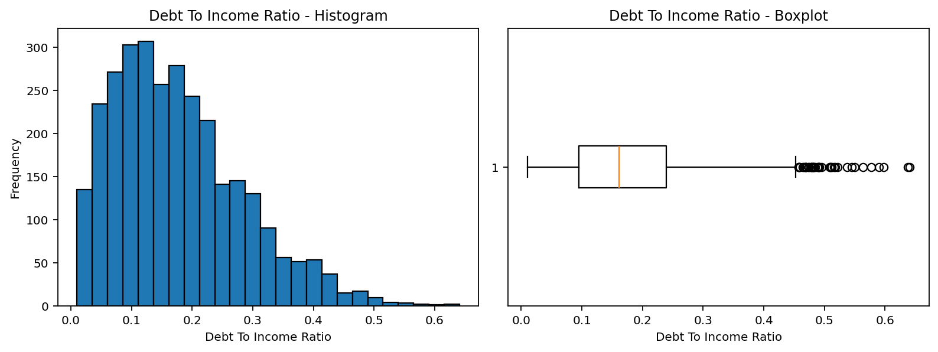
Figure 3. Debt-to-income ratio distribution and boxplot.
The debt-to-income ratio is concentrated at lower values but has a clear right tail. This matters because higher leverage is usually associated with greater repayment stress.
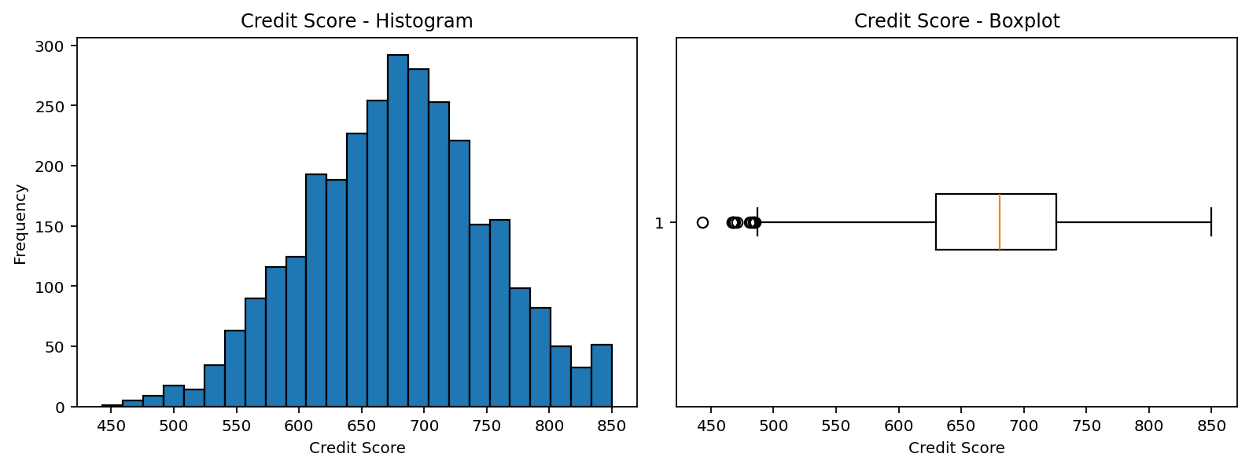
Figure 4. Credit score distribution and boxplot.
Credit scores are approximately centred in the high-600s, with fewer observations at the very low and very high ends of the scale.
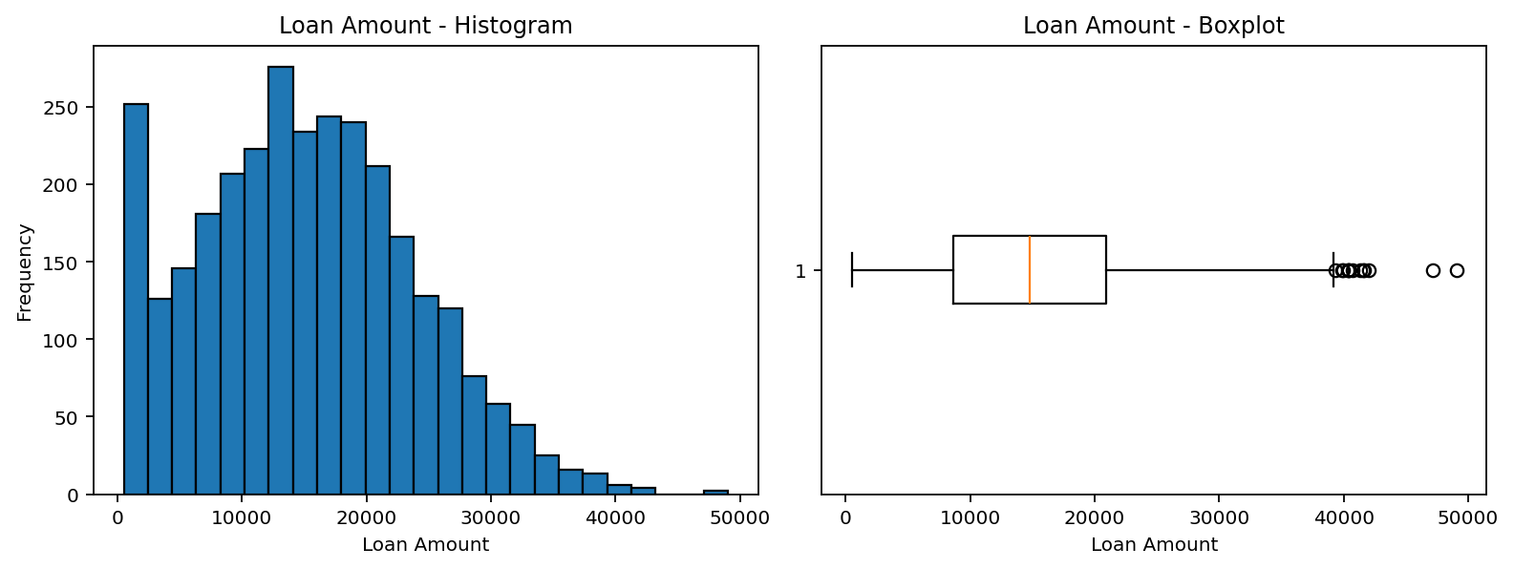
Figure 5. Loan amount distribution and boxplot.
Loan amounts vary widely and are mildly right-skewed, with some larger loans creating upper-end spread.
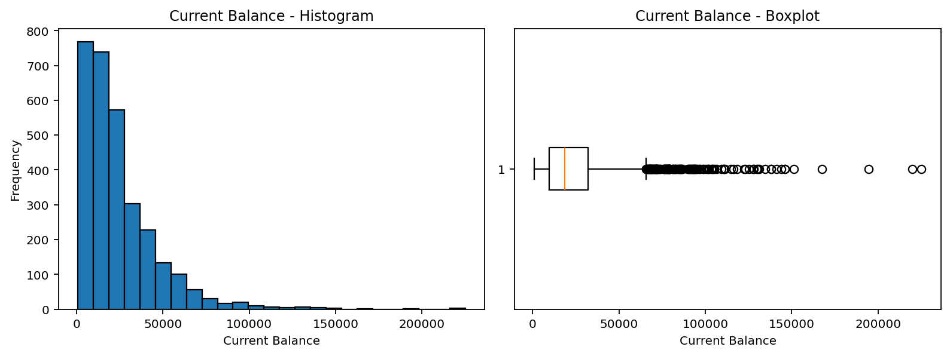
Figure 6. Current balance distribution and boxplot.
Current balance is highly dispersed and includes notable upper-tail outliers, which indicates strong heterogeneity in account utilisation across customers.

1A.2 Categorical attribute summary
Attribute | Category | Frequency
gender | Female | 1488
gender | Male | 1456
gender | Other | 56
marital_status | Single | 1359
marital_status | Married | 1339
marital_status | Divorced | 226
marital_status | Widowed | 76
education_level | Bachelor's | 1224
education_level | High School | 835
education_level | Master's | 589
education_level | Other | 230
education_level | PhD | 122
employment_status | Employed | 1971
employment_status | Self-employed | 439
employment_status | Unemployed | 309
employment_status | Retired | 175
employment_status | Student | 106
Table 5. Categorical frequency table (part 1).
Attribute | Category | Frequency
loan_purpose | Debt consolidation | 1167
loan_purpose | Other | 379
loan_purpose | Car | 375
loan_purpose | Home | 320
loan_purpose | Education | 253
loan_purpose | Business | 226
loan_purpose | Medical | 188
loan_purpose | Vacation | 92
Table 6. Categorical frequency table (part 2).
The overall sample is about half female and half male, with a small "Other" category. Single and married are the largest groups for marital status. Bachelor's degree is the most frequent education level, and employed customers are by far the largest group in the employment category. Debt consolidation is the single most common purpose for a loan. The target variable loan_paid_back is unbalanced with 2,437 positive cases (81.2%) and 563 non-repayments (18.8%).
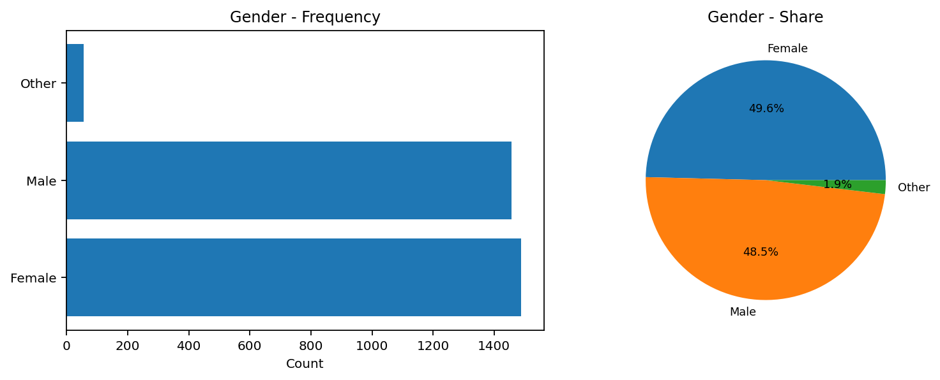
Figure 7. Gender frequency and share.
Gender is balanced overall, so there is no evidence that one gender dominates the sample.
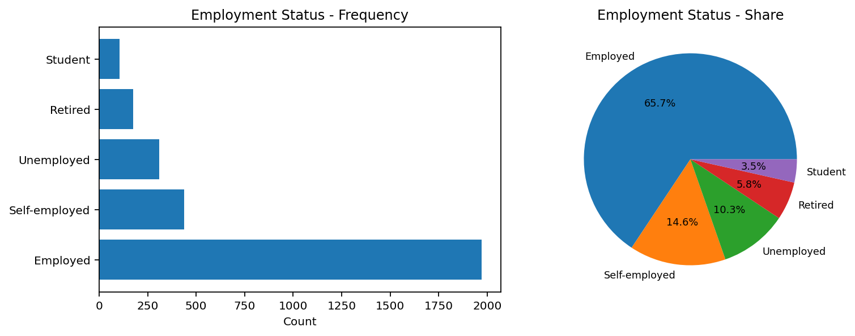
Figure 8. Employment status frequency and share.
Employment status is heavily concentrated in employed customers, while students and retired customers form much smaller groups.
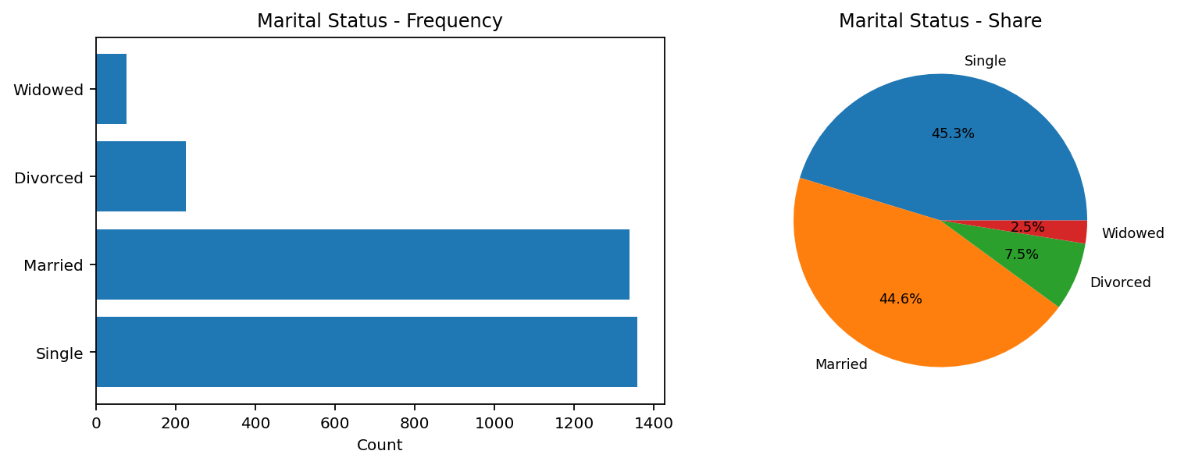
Figure 9. Marital status frequency and share.
Single and married borrowers dominate the dataset, with divorced and widowed groups much smaller.
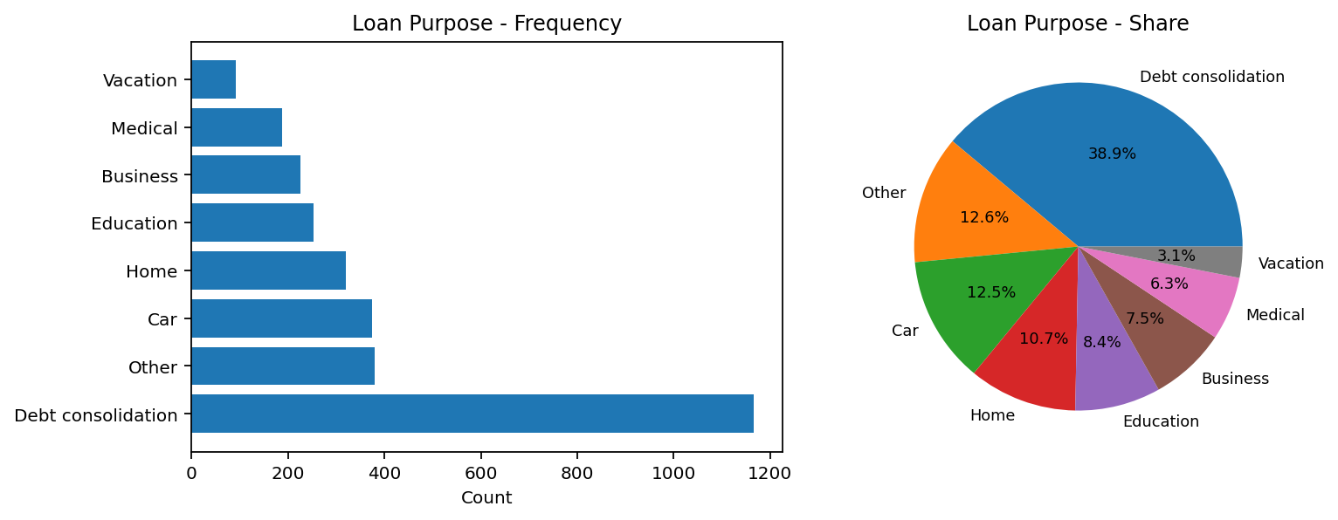
Figure 10. Loan purpose frequency and share.
Debt consolidation is the most frequent loan purpose by a wide margin, which makes it an important segment for portfolio analysis.
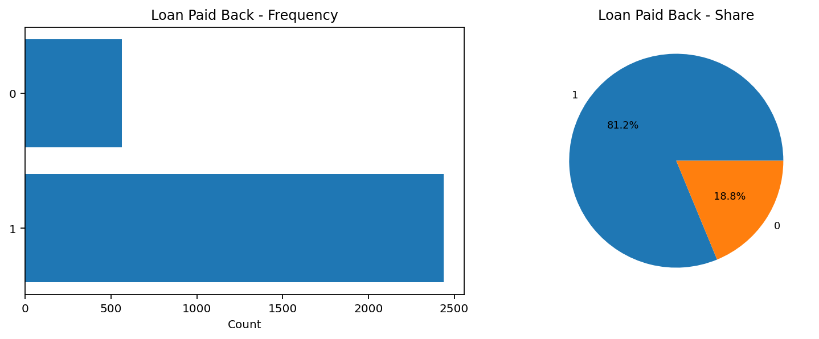
Figure 11. Loan repayment outcome frequency and share.
The outcome class is imbalanced toward successful repayment, so any later predictive modelling would need to account for this imbalance.

1A.3 Multi-attribute relationships, outliers, and interesting patterns
Relationships between multiple attributes were explored using correlation analysis and scatter plots.
A positive relationship was observed between annual_income and credit_score, suggesting that higher income customers tend to have better credit scores.
Additionally, a relationship between debt_to_income_ratio and credit_score indicates that customers with higher debt ratios tend to have lower credit scores.
Scatter plots also revealed clusters of customers with similar financial characteristics, and some outliers were identified in attributes such as loan_amount and annual_income.
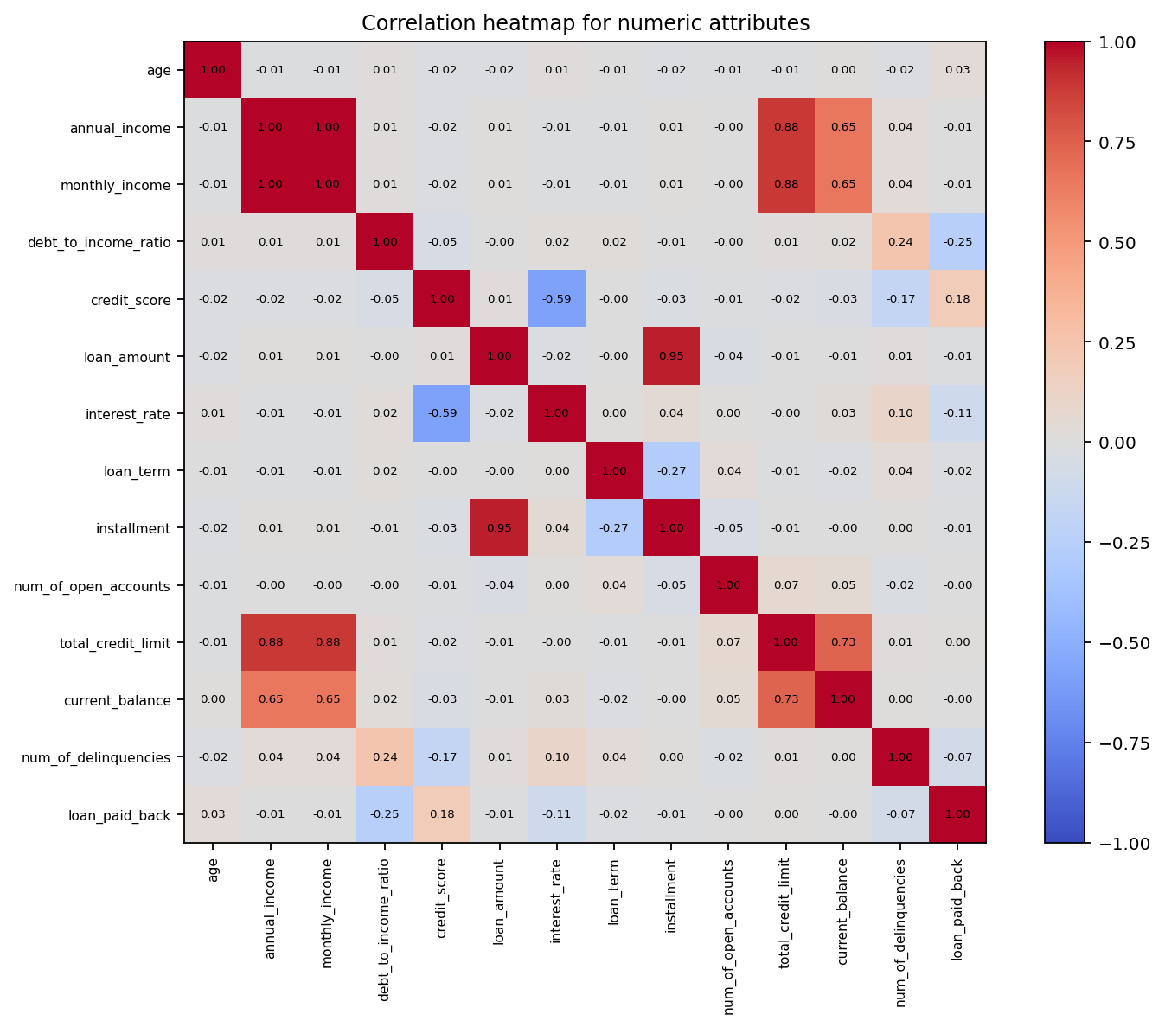
Figure 12. Correlation heatmap for the numeric attributes.
The heatmap shows that loan_paid_back is positively associated with credit_score (r = 0.180) and negatively associated with debt_to_income_ratio (r = -0.253) and interest_rate (r = -0.108). num_of_delinquencies also has a negative relationship with repayment outcome (r = -0.071). These are the most informative numeric indicators for risk assessment in this dataset.
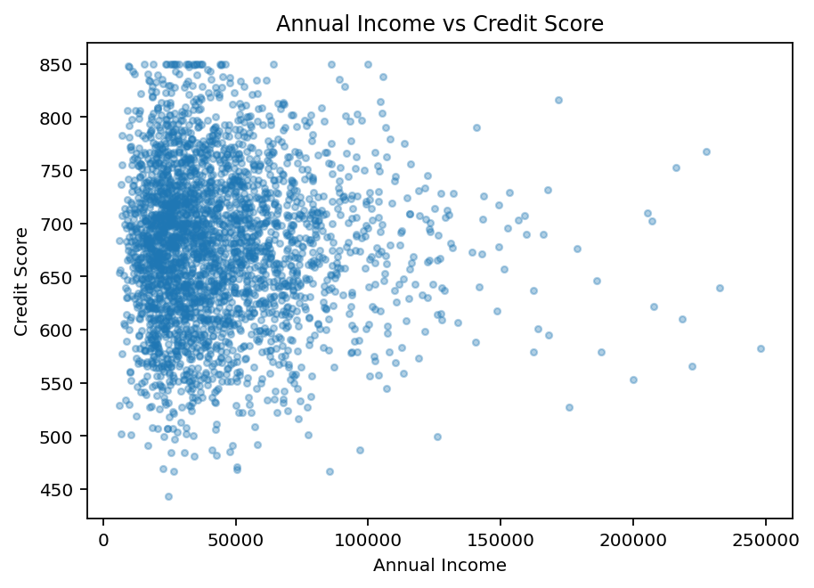
Figure 13. Annual income versus credit score.
The scatter plot does not show a strong linear relationship. Income dispersion is wide across most score levels, which suggests that income alone does not explain credit quality in this sample.
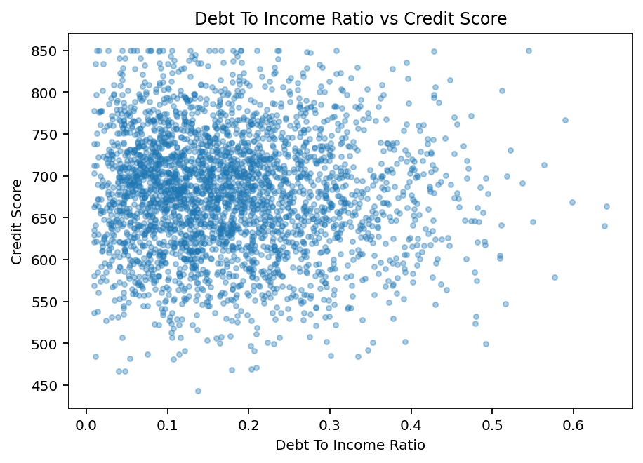
Figure 14. Debt-to-income ratio versus credit score.
A mild negative tendency is visible: customers with very high debt-to-income ratios are less likely to appear in the highest credit-score range.
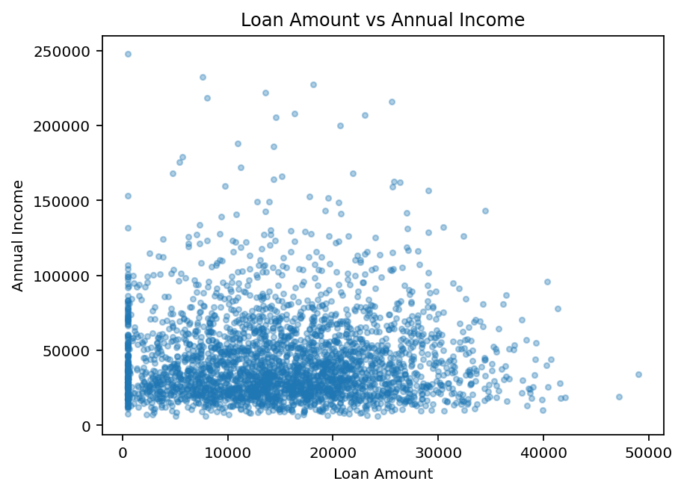
Figure 15. Loan amount versus annual income.
Loan amounts increase only loosely with income. The wide cloud suggests that customers with similar incomes can receive substantially different loan amounts.
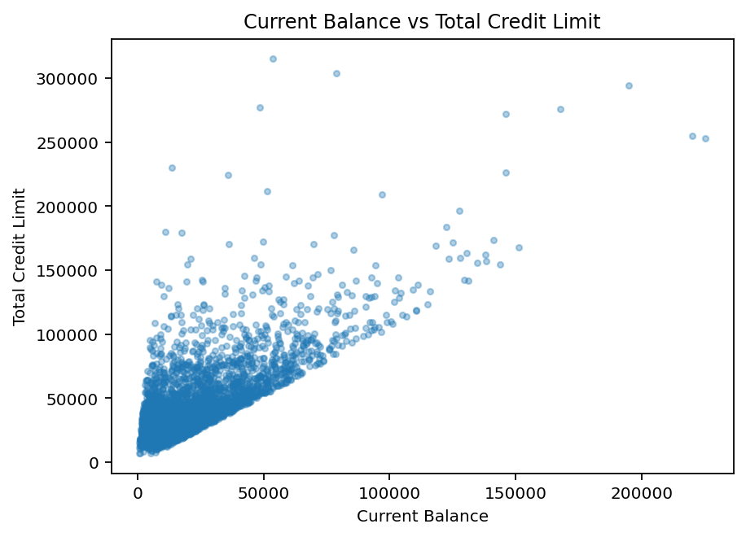
Figure 16. Current balance versus total credit limit.
A positive relationship is visible, but the spread is broad and includes a number of high-limit and high-balance outliers that may deserve closer review.
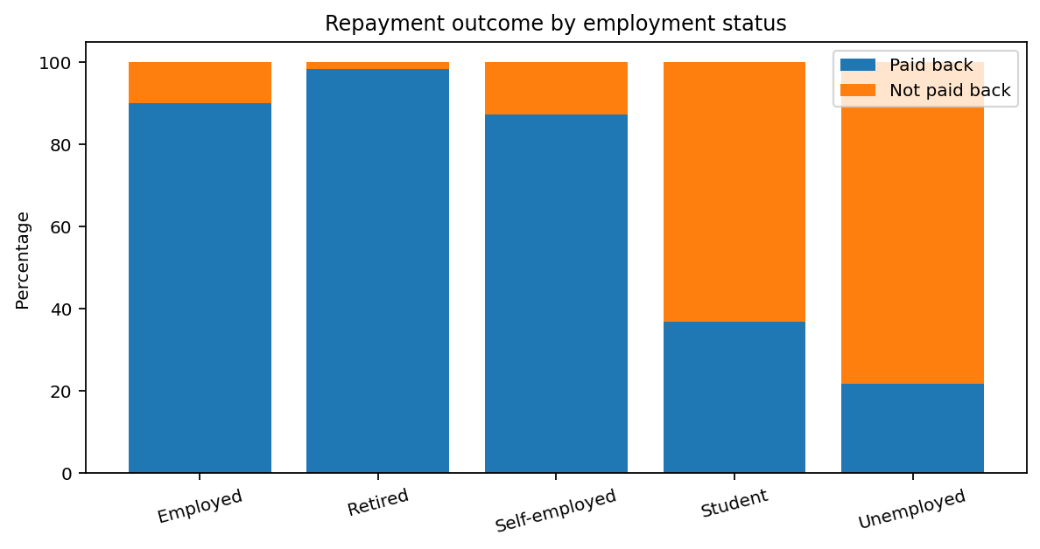
Figure 17. Repayment outcome by employment status.
Repayment differences by employment status are substantial. Retired and employed customers have the highest repayment shares, while unemployed customers and students have much poorer repayment outcomes. This is an important categorical pattern that should be examined more rigorously in any later risk model.
Additional interesting findings include the following. Borrowers who repaid the loan have a higher average credit score (684.72 versus 651.70), a lower average debt-to-income ratio (0.16 versus 0.23), and a slightly lower average interest rate than those who did not repay. By contrast, average annual income is quite similar across the two outcome groups, which indicates that income level by itself may be less discriminating than leverage and credit history in this dataset.

1B. Data preprocessing
All preprocessing tasks were applied to the original data, as required. The Excel workbook stores row-level outputs in separate sheets, while this section explains each transformation, shows representative result tables, and comments on the effect of each method.

1B.1 Binning of debt_to_income_ratio and credit_score
Binning techniques were applied to smooth continuous attributes. Equi-width binning divides the data into intervals of equal size, while equi-depth binning ensures each bin contains approximately the same number of observations.For debt_to_income_ratio and credit_score, both techniques were applied. Equi-depth binning provided better distribution balance, while equi-width binning preserved numerical ranges.
debt_to_income_ratio | credit_score | DTI equi-width | Credit equi-width | DTI equi-depth | Credit equi-depth
0.112 | 793 | (0.008369999999999999, 0.168] | (768.6, 850.0] | (0.095, 0.161] | (738.0, 850.0]
0.185 | 614 | (0.168, 0.326] | (605.8, 687.2] | (0.161, 0.239] | (442.999, 617.8]
0.169 | 651 | (0.168, 0.326] | (605.8, 687.2] | (0.161, 0.239] | (617.8, 662.0]
0.201 | 701 | (0.168, 0.326] | (687.2, 768.6] | (0.161, 0.239] | (698.0, 738.0]
0.032 | 709 | (0.008369999999999999, 0.168] | (687.2, 768.6] | (0.009000000000000001, 0.095] | (698.0, 738.0]
0.15 | 667 | (0.008369999999999999, 0.168] | (605.8, 687.2] | (0.095, 0.161] | (662.0, 698.0]
0.048 | 610 | (0.008369999999999999, 0.168] | (605.8, 687.2] | (0.009000000000000001, 0.095] | (442.999, 617.8]
0.185 | 704 | (0.168, 0.326] | (687.2, 768.6] | (0.161, 0.239] | (698.0, 738.0]
0.125 | 788 | (0.008369999999999999, 0.168] | (768.6, 850.0] | (0.095, 0.161] | (738.0, 850.0]
0.264 | 699 | (0.168, 0.326] | (687.2, 768.6] | (0.239, 0.641] | (698.0, 738.0]
Table 7. Sample of binning results for the two required attributes.
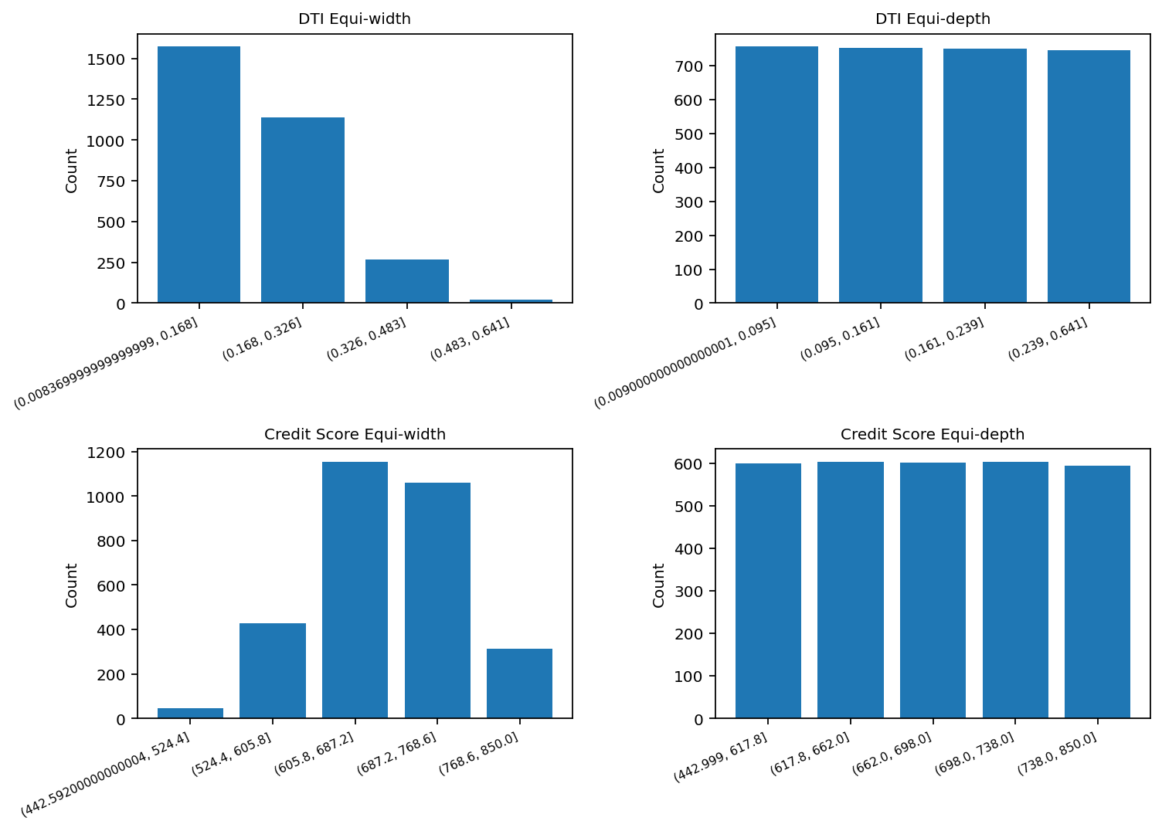
Figure 18. Bin counts for equi-width and equi-depth binning.
The figure confirms the expected difference between the two methods. Equi-width preserves the numeric spacing of the original values, which can create uneven counts when the data are skewed. Equi-depth, by contrast, balances the number of records in each bin, making it more useful when a later analysis needs similar-sized groups.

1B.2 Normalisation of annual_income
Two normalisation techniques were applied to the annual_income attribute and Min-max normalisation scales values between 0 and 1, making it easier to compare values across attributes.
Z-score normalisation standardises the data by centering it around the mean and scaling using standard deviation and these transformations improve comparability and are useful for machine learning applications.
annual_income | min-max normalised | z-score normalised
32,234.10 | 0.108 | -0.391
68,415.70 | 0.258 | 0.894
31,068.24 | 0.104 | -0.432
19,876.34 | 0.057 | -0.83
28,948.26 | 0.095 | -0.507
53,549.13 | 0.197 | 0.366
64,679.08 | 0.243 | 0.761
25,015.35 | 0.079 | -0.647
67,968.56 | 0.256 | 0.878
45,121.07 | 0.162 | 0.067
Table 8. Sample of annual_income normalisation results.
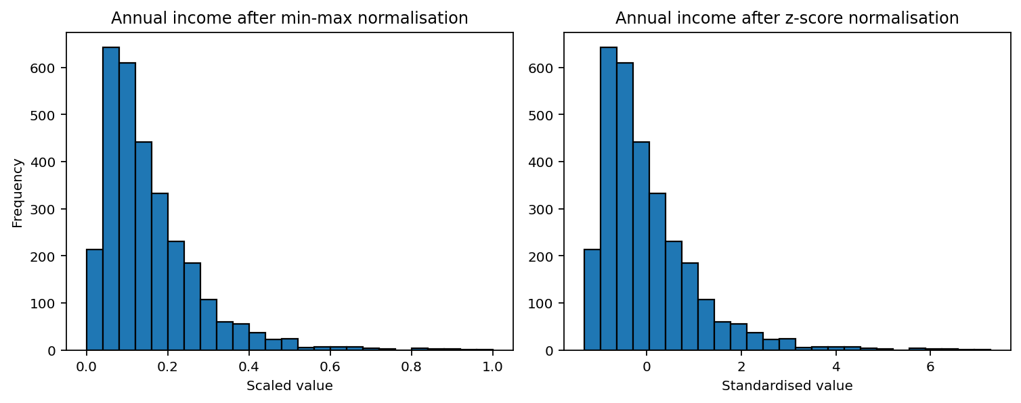
Figure 19. Distributions after min-max and z-score normalisation.
Min-max normalisation keeps the original distributional shape but compresses all values into the 0 to 1 interval. Z-score normalisation recentres the values around 0 and expresses each value in standard-deviation units. Because annual income is right-skewed, the z-score version still shows a long positive tail, which is expected.

1B.3 Age discretisation
Age was discretised into the five categories specified in the assignment: Young (21 and younger), Early Adulthood (22-34), Early Middle Age (35-44), Late Middle Age (45-64), and Late Adulthood (65 and older). The observed dataset minimum is 21, so the Young category contains only a small number of records.
age_group | frequency
Late Middle Age | 1128
Early Adulthood | 691
Late Adulthood | 598
Early Middle Age | 534
Young | 49
Table 9. Frequency of the derived age groups.
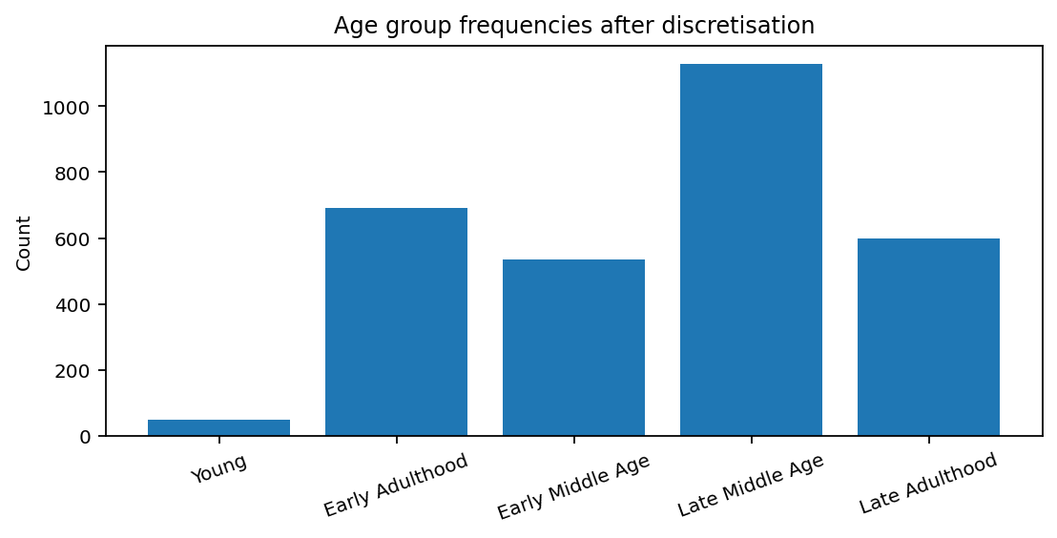
Figure 20. Age-group frequencies after discretisation.
Late Middle Age is the largest age group, followed by Early Adulthood and Late Adulthood. This discretisation makes the age variable easier to compare across business segments and can support profile-based reporting.

1B.4 Gender binarisation
The gender variable was binarised into 0 and 1, with Female mapped to 0 and Male mapped to 1. The workbook also contains 56 records labelled Other. These were not assigned to either binary class and therefore remain blank in the binary output. This should be stated clearly because it is a practical limitation of simple binarisation when the original variable has more than two categories.
Binary output | Frequency
0.0 | 1488
1.0 | 1456
Blank (original category = Other) | 56
Table 10. Frequency of gender binary outputs.
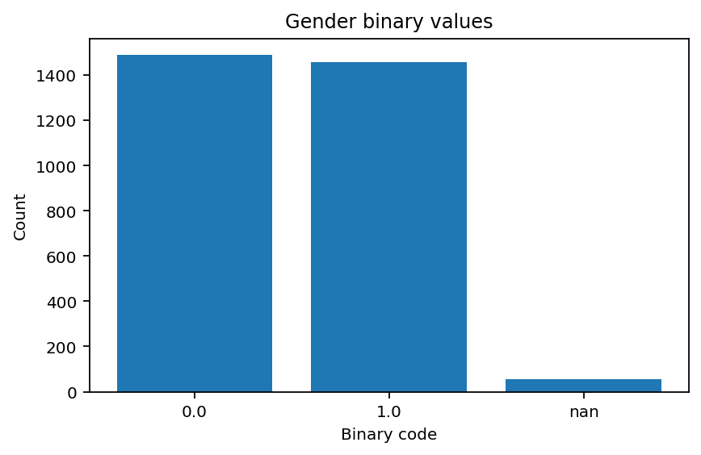
Figure 21. Frequency of gender binary values.
The resulting binary column is usable for models that require numeric inputs, but the treatment of the Other category should be reconsidered if fairness or inclusiveness is important in downstream analysis.

1C. Summary

The most important findings for the Head of the Analytics Unit are as follows.
• The dataset contains 3,000 records with no missing values across the original 21 attributes. The dataset is therefore complete and does not require any imputation prior to analysis.
• The sample is not representative of the entire customer population, being heavily skewed towards employed customers, towards borrowers using loans for debt consolidation, and towards borrowers who ultimately repaid their loan. The label loan_paid_back is also imbalanced, with just over four-fifths of customers repaying.
• Several of the financial variables are strongly right-skewed, in particular annual_income, loan_amount, total_credit_limit and current_balance. There are also high-end outliers in the data which should not be dismissed, as they may represent potentially valuable customer segments.
• The most informative numeric predictors of repayment risk are debt_to_income_ratio, credit_score, interest_rate and num_of_delinquencies. As expected, customers who repay are characterised by lower leverage and higher credit scores, as well as slightly lower interest rates.
• The employment_status categorical variable provides a significant signal. Employed and retired customers have markedly higher repayment rates than the unemployed and the students.
• The preprocessing steps were completed successfully. Binning was used to create meaningful grouped versions of the continuous debt_to_income_ratio and credit_score variables; normalisation was used to create scaled versions of annual_income; age was discretised into the required life-stage bands; and the gender variable was converted to a binary numeric field.
• One limitation is to be reported explicitly: the binarisation of gender leaves the original Other category unassigned in the new binary field. As the presence of this residual group is expected (and indeed was also known at the data ingestion stage) this is acceptable as a documented preprocessing decision, but should be treated with care in any subsequent modelling.
• Customers with higher annual income and credit scores generally show better financial stability and are more likely to repay loans. Conversely, higher debt-to-income ratios are associated with increased risk.
• The majority of customers are employed and belong to middle-age groups, which indicates a relatively stable customer base. Loan purposes such as debt consolidation are the most common, suggesting that many customers are managing existing financial obligations.
• Clustering patterns observed in scatter plots indicate groups of customers with similar financial profiles, which could be useful for segmentation and targeted strategies.
• Overall, the dataset offers valuable insights that could help the bank evaluate customer risk and make more informed lending decisions.

Conclusion

In summary, this project involved a data exploration and preprocessing task on the customer loan dataset. Statistical summaries and visualisations were applied to gain insights into the distribution, central tendency, dispersion, and relationship between key attributes.
The analysis revealed that certain attributes, such as credit score, annual income, and debt-to-income ratio, have a significant impact on the financial stability and loan repayment behaviour of customers.
The data shows that higher income and credit score are associated with lower risk, while higher debt ratios indicate increased risk.
Additionally, clustering patterns can be observed in the dataset, indicating the presence of distinct customer segments that can be utilised for risk assessment and customised financial strategies.
The data was then preprocessed using binning, normalisation, discretisation, and binarisation methods to enhance the dataset’s interpretability and usability for subsequent analytical tasks.
In conclusion, the findings from this analysis can be beneficial for the bank to make informed lending decisions, minimise default risk, and optimise customer profiling strategies. Future work could include implementing predictive modelling techniques to automate and optimise loan approval processes.

References
Han, J., Kamber, M., & Pei, J. (2011). Data Mining: Concepts and Techniques. Elsevier.
Tan, P. N., Steinbach, M., & Kumar, V. (2019). Introduction to Data Mining. Pearson.
Witten, I. H., Frank, E., Hall, M. A., & Pal, C. (2016). Data Mining: Practical Machine Learning Tools and Techniques. Morgan Kaufmann.
Pandas Documentation: https://pandas.pydata.org/
Seaborn Documentation: https://seaborn.pydata.org/
Matplotlib Documentation: https://matplotlib.org/

