# Practical No. 02

## 1. Write a java program to implement a Server calculator using RPC concept. (Make use of datagram)

**Program:**

## Server.java

package rpc;

import java.net.DatagramPacket; import java.net.DatagramSocket; import java.net.InetAddress; import java.util.StringTokenizer;

public class Server {

private DatagramSocket udpSocket; private int port;

public Server(int port) { this.port = port;

}

public static int addition(int num1,int num2)

{

return num1+num2;

}

public static int substraction(int num1,int num2)

{

return num1-num2;

}

public static int multiplication(int num1,int num2)

{

return num1*num2;

}

public static int division(int num1,int num2)

{

return num1/num2;

}

private void listen() { try {

DatagramSocket udpSocket = new DatagramSocket(port); System.out.println("Server started at " + InetAddress.getLocalHost()); String msg;

byte[] buf = new byte[1024];

DatagramPacket packet = new DatagramPacket(buf, buf.length);

// blocks until a packet is received udpSocket.receive(packet);

msg = new String(packet.getData()).trim();

StringTokenizer str=new StringTokenizer(msg,"-"); int mthNo=Integer.parseInt(str.nextToken());

int num1=Integer.parseInt(str.nextToken()); int num2=Integer.parseInt(str.nextToken()); int result;

if(mthNo==1)

{

result=addition(num1,num2); msg="Addition:"+result;

}

if(mthNo==2)

{

result=substraction(num1,num2); msg="substraction:"+result;

}

if(mthNo==3)

{

result=multiplication(num1,num2); msg="multiplication:"+result;

}

if(mthNo==4)

{

result=division(num1,num2); msg="division:"+result;

}

System.out.println("Message from " + packet.getAddress().getHostAddress() + ": " + msg);

}

catch(Exception e) {

System.out.println(e.getMessage());

}

finally {

//udpSocket.close();

}

}

public static void main(String[] args) { Server client = new Server(5000); client.listen();

}

}

## Client.java

package rpc;

import java.io.BufferedReader; import java.io.InputStreamReader;

import java.net.DatagramPacket; import java.net.DatagramSocket; import java.net.InetAddress; import java.util.Scanner;

public class Client {

DatagramSocket udpSocket; InetAddress serverAddress;

int port;

Scanner scanner;

public Client(int port) { this.port = port;

}

public void sendReq() { String in;

try {

udpSocket = new DatagramSocket(); InetAddress host = InetAddress.getLocalHost();

serverAddress = InetAddress.getByName(host.getHostName());

BufferedReader keyRead = new BufferedReader(new InputStreamReader(System.in)); System.out.println("UDP Client started at " + InetAddress.getLocalHost());

String paramlist="";

System.out.println("Enter Method:\n1.Addition:\n2.Subtraction\n3.Multiplication\n4.Devision");

in = keyRead.readLine(); paramlist=paramlist+in+"-"; System.out.println("Enter Number 1:"); in = keyRead.readLine();

paramlist=paramlist+in+"-"; System.out.println("Enter Number 2:"); in = keyRead.readLine(); paramlist=paramlist+in;

DatagramPacket p = new DatagramPacket(paramlist.getBytes(), paramlist.getBytes().length, serverAddress, port);

udpSocket.send(p);

}

catch(Exception e) { System.out.println(e.getMessage());

}

}

public static void main(String[] args) { Client sender = new Client(5000); sender.sendReq();

}

}

**Output:**

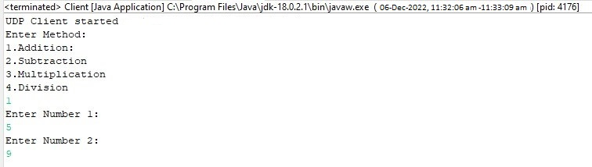

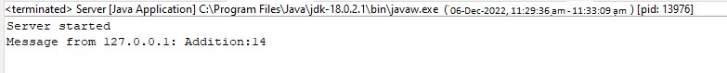

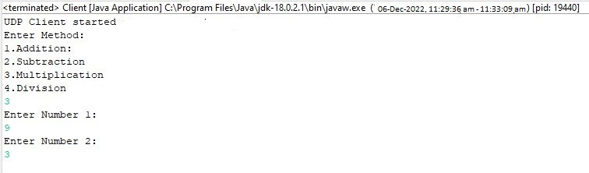



# 2) Write a java to implement a Date Time Server using RPC concept. (Make use of datagram)

## Program:

**Server.java**

package rpcdatetime;

import java.net.DatagramPacket; import java.net.DatagramSocket; import java.net.InetAddress; import java.time.LocalDateTime;

public class Server {

private DatagramSocket udpSocket; private int port;

public Server(int port) { this.port = port;

}

public static LocalDateTime date()

{

return java.time.LocalDateTime.now();

}

private void listen() { try {

DatagramSocket udpSocket = new DatagramSocket(port); System.out.println("Server started at " + InetAddress.getLocalHost()); LocalDateTime msg;

byte[] buf = new byte[1024];

DatagramPacket packet = new DatagramPacket(buf, buf.length);

// blocks until a packet is received udpSocket.receive(packet);

": " + msg);

msg=date();

System.out.println("Message from " + packet.getAddress().getHostAddress() +

}

catch(Exception e) { System.out.println(e.getMessage());

}

finally {

//udpSocket.close();

}

}

public static void main(String[] args) { Server client = new Server(5000); client.listen();

}

}

## Client.java

package rpcdatetime;

import java.io.BufferedReader; import java.io.InputStreamReader; import java.net.DatagramPacket; import java.net.DatagramSocket; import java.net.InetAddress; import java.time.LocalDateTime; import java.util.Scanner;

public class Client {

DatagramSocket udpSocket; InetAddress serverAddress;

int port;

Scanner scanner;

public Client(int port) { this.port = port;

}

public void sendReq() { String in;

try {

udpSocket = new DatagramSocket(); InetAddress host = InetAddress.getLocalHost();

serverAddress = InetAddress.getByName(host.getHostName());

BufferedReader keyRead = new BufferedReader(new InputStreamReader(System.in));

System.out.println("UDP Client started at " + InetAddress.getLocalHost()); String paramlist="";

DatagramPacket p = new DatagramPacket(paramlist.getBytes(), paramlist.getBytes().length, serverAddress, port);

udpSocket.send(p);

}

catch(Exception e) { System.out.println(e.getMessage());

}

}

public static void main(String[] args) { Client sender = new Client(5000); sender.sendReq();

}

}

## Output:



