C2
Input Information
Input file(s): | C_2.assembled.fastq
Input format(s): | FASTQ
# Sequences: | 29,138,228
Total bases: | 4,502,138,107

Length Distribution
Mean sequence length: | 154.51 ± 48.54 bp
Minimum length: | 50 bp
Maximum length: | 240 bp
Length range: | 191 bp
Mode length: | 126 bp with 198,348 sequences
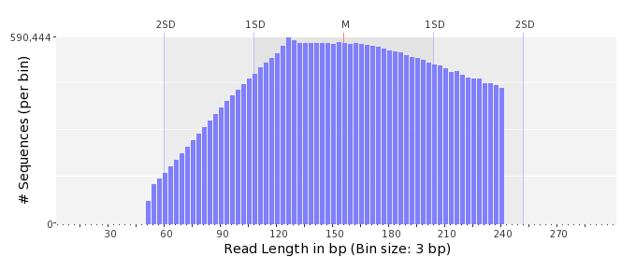

GC Content Distribution
Mean GC content: | 51.83 ± 12.70 %
Minimum GC content: | 0 %
Maximum GC content: | 100 %
GC content range: | 101 %
Mode GC content: | 50 % with 1,033,218 sequences
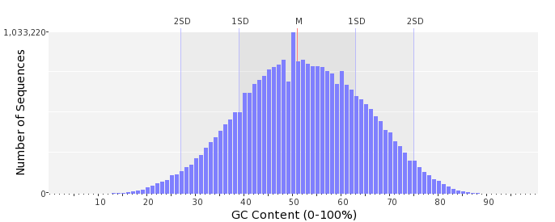

Base Quality Distribution
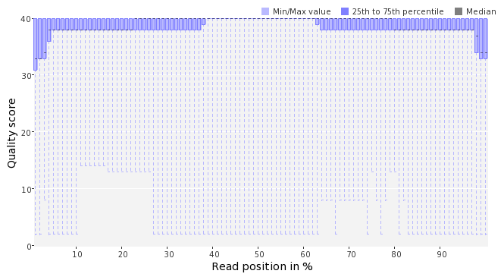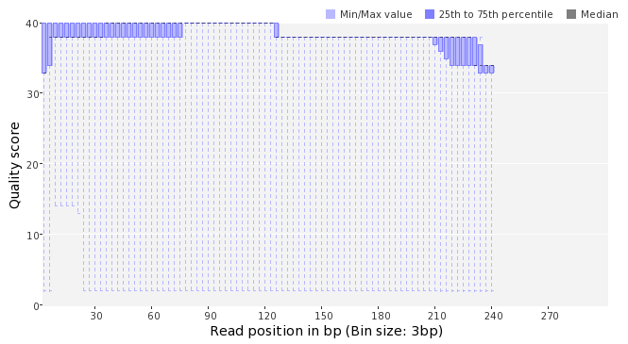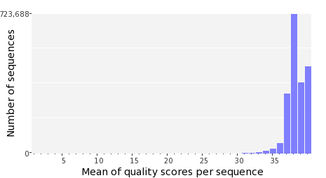

Occurence of N
Sequences with N: | 525,980 (1.81 %)
Max percentage of Ns per sequence: | 9 %
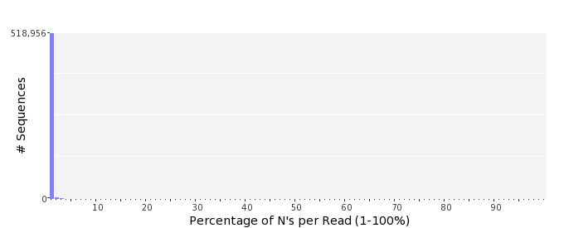

Poly-A/T Tails
 | 5'-end | 3'-end
Sequences with tail: | 99,251 (0.34 %) | 103,882 (0.36 %)
Maximum tail length: | 115 | 125
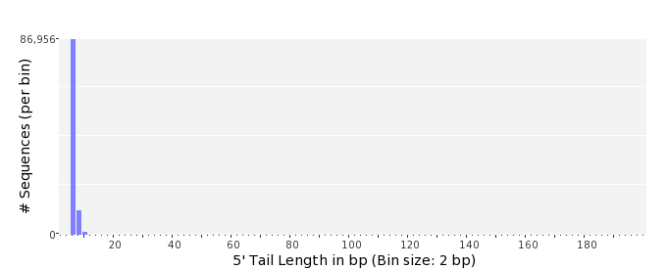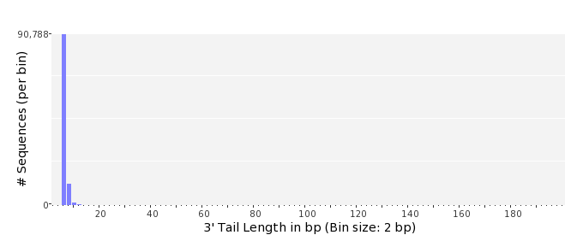

Tag Sequence Check
 | 5'-end | 3'-end
Probability of tag sequence: | 0 % | 0 %
GSMIDs or RLMIDs: | none

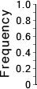 |  |  |  |  |  |  |  |  |  |  |  |  |  |  |  |  |  |  |  |  | ...
 | 1 |  |  |  | 5 |  |  |  |  | 10 |  |  |  |  | 15 |  |  |  |  | 20 |  | 20 |  |  |  |  | 15 |  |  |  |  | 10 |  |  |  |  | 5 |  |  |  | 1
 | Position from Sequence Ends

Sequence Duplication
 | # Sequences | Max duplicates
Exact duplicates: | 2,824,530 (9.69 %) | 698
Exact duplicates with reverse complements: | 2,322 (0.01 %) | 2
5' duplicates | 866,524 (2.97 %) | 26
3' duplicates | 452,168 (1.55 %) | 37
5'/3' duplicates with reverse complements | 637,730 (2.19 %) | 4
Total: | 4,783,274 (16.42 %) | -
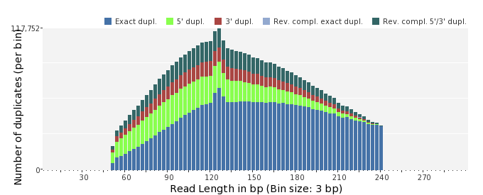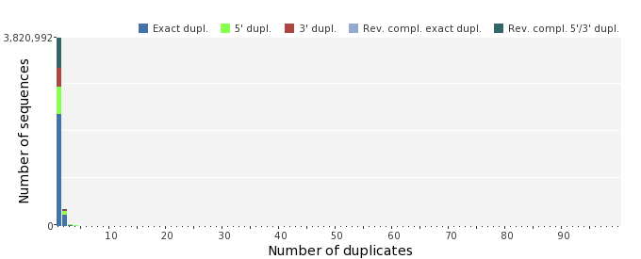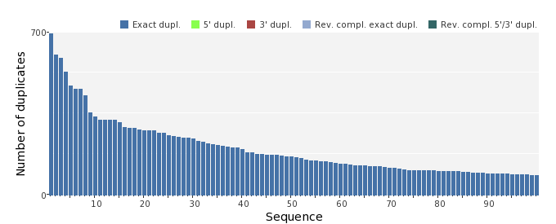

Sequence Complexity
 | Value | Sequence
Minimum DUST score: | 0 | CTTAGCCCAAGTTTGTGAATCAACGTATTCGGATTGCGCTAAATAGGTTCCAATGAGGCC  CTCTAGTTTTGCACAGAAAGCTTC
Maximum DUST score: | 99 | TTTTTTTTTTTTTTTTTTTTTTTTTTTTTTTTTTTTTTTTTTTTTTTTTTTTTTTTTTTT  TTTTTTTTTTTTTTTTTTTTTTTTTTTTTT
Minimum Entropy value: | 0 | TTTTTTTTTTTTTTTTTTTTTTTTTTTTTTTTTTTTTTTTTTTTTTTTTTTTTTTTTTTT  TTTTTTTTTTTTTTTTTTTTTTTTTTTTTTTTTTTTTTTT
Maximum Entropy value: | 97 | CTTGGGCTGCCGTGTTTCCACACCATCTCGCAGAACGAGGATTATCAAGA
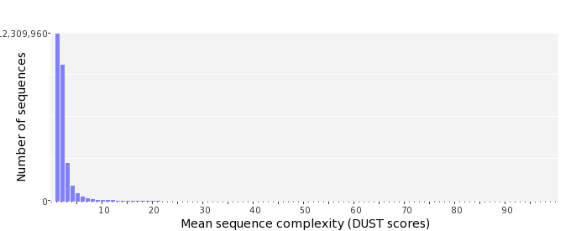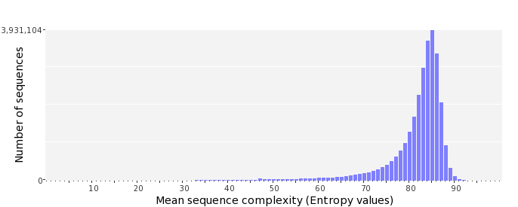

Dinucleotide Odds Ratios
 | AA/TT | AC/GT | AG/CT | AT | CA/TG | CC/GG | CG | GA/TC | GC | TA
Odds ratio | 1.0505 | 0.8832 | 1.0573 | 1.0026 | 1.1354 | 0.9362 | 0.8774 | 1.1051 | 1.0955 | 0.6478
