C3
Input Information
Input file(s): | C_3.assembled.fastq
Input format(s): | FASTQ
# Sequences: | 18,902,108
Total bases: | 2,858,322,399

Length Distribution
Mean sequence length: | 151.22 ± 49.10 bp
Minimum length: | 50 bp
Maximum length: | 240 bp
Length range: | 191 bp
Mode length: | 125 bp with 132,775 sequences
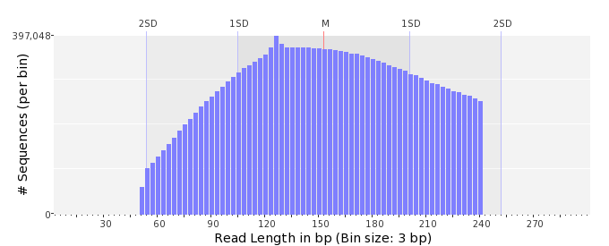

GC Content Distribution
Mean GC content: | 51.63 ± 12.62 %
Minimum GC content: | 0 %
Maximum GC content: | 100 %
GC content range: | 101 %
Mode GC content: | 50 % with 653,616 sequences
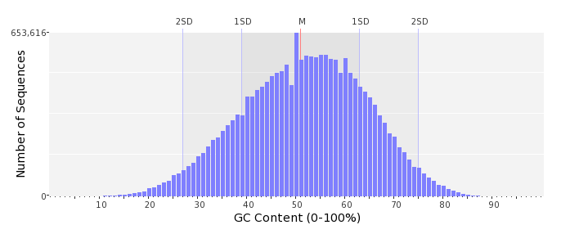

Base Quality Distribution
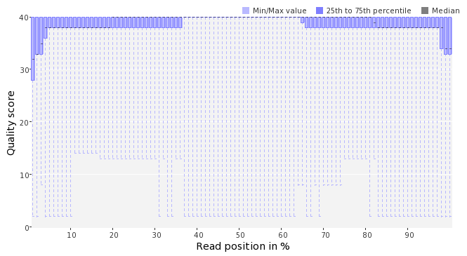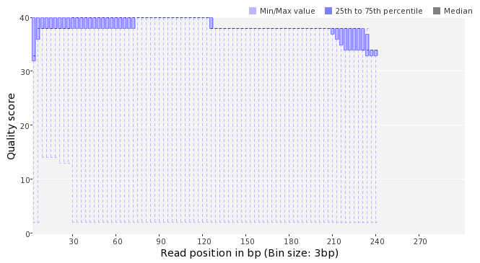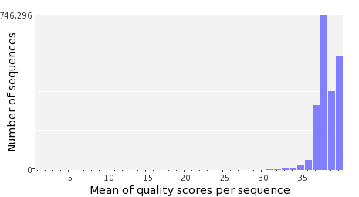

Occurence of N
Sequences with N: | 331,151 (1.75 %)
Max percentage of Ns per sequence: | 9 %
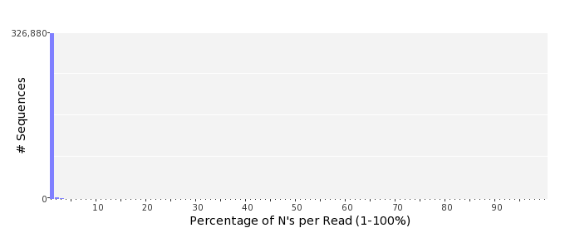

Poly-A/T Tails
 | 5'-end | 3'-end
Sequences with tail: | 66,141 (0.35 %) | 67,983 (0.36 %)
Maximum tail length: | 125 | 125
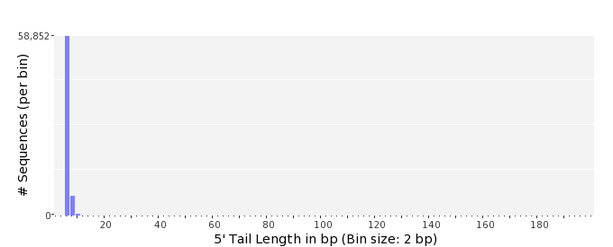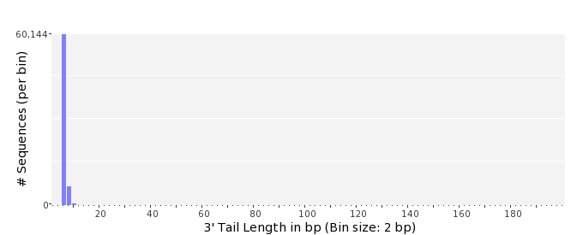

Tag Sequence Check
 | 5'-end | 3'-end
Probability of tag sequence: | 0 % | 0 %
GSMIDs or RLMIDs: | none

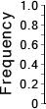 |  |  |  |  |  |  |  |  |  |  |  |  |  |  |  |  |  |  |  |  | ...
 | 1 |  |  |  | 5 |  |  |  |  | 10 |  |  |  |  | 15 |  |  |  |  | 20 |  | 20 |  |  |  |  | 15 |  |  |  |  | 10 |  |  |  |  | 5 |  |  |  | 1
 | Position from Sequence Ends

Sequence Duplication
 | # Sequences | Max duplicates
Exact duplicates: | 770,923 (4.08 %) | 429
Exact duplicates with reverse complements: | 777 (0.00 %) | 1
5' duplicates | 207,886 (1.10 %) | 20
3' duplicates | 126,915 (0.67 %) | 21
5'/3' duplicates with reverse complements | 194,748 (1.03 %) | 4
Total: | 1,301,249 (6.88 %) | -
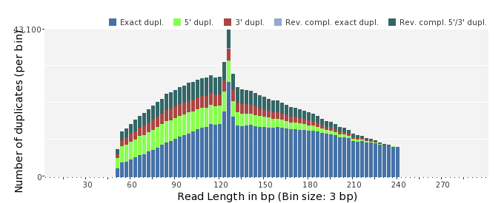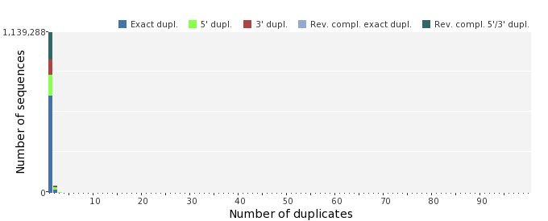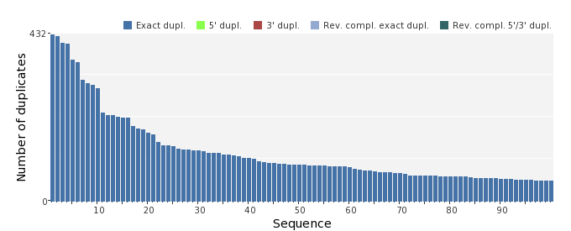

Sequence Complexity
 | Value | Sequence
Minimum DUST score: | 0 | GTCTGTTGTCTACAACAACAGCCTGCTTCCAGCGCTCAGCCAATTTGGGTTGAATTATTC  GAGCTACGATATCGCTTCCAGAGCCTGCGGTAAAGGGG
Maximum DUST score: | 100 | TTTTTTTTTTTTTTTTTTTTTTTTTTTTTTTTTTTTTTTTTTTTTTTTTTTTTTTTTTTT  TTTT
Minimum Entropy value: | 0 | TTTTTTTTTTTTTTTTTTTTTTTTTTTTTTTTTTTTTTTTTTTTTTTTTTTTTTTTTTTT  TTTTTTTTTTTTTTTTTTTTTTTTTT
Maximum Entropy value: | 96 | CGGTGACCAGATACTCGGTCTGCTAGCGCACCAAAGGCCCTATTTGTTCAT
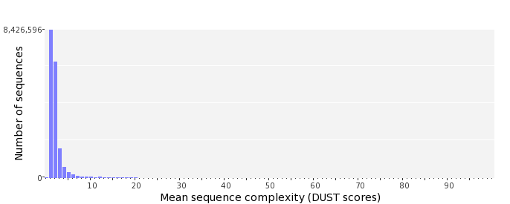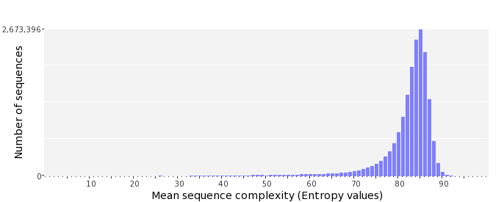

Dinucleotide Odds Ratios
 | AA/TT | AC/GT | AG/CT | AT | CA/TG | CC/GG | CG | GA/TC | GC | TA
Odds ratio | 1.0828 | 0.8858 | 1.0230 | 1.0129 | 1.1419 | 0.9429 | 0.9053 | 1.0612 | 1.1234 | 0.6522
