A1
Input Information
Input file(s): | A_1.assembled.fastq
Input format(s): | FASTQ
# Sequences: | 16,222,732
Total bases: | 2,523,516,459

Length Distribution
Mean sequence length: | 155.55 ± 49.22 bp
Minimum length: | 50 bp
Maximum length: | 240 bp
Length range: | 191 bp
Mode length: | 156 bp with 105,580 sequences
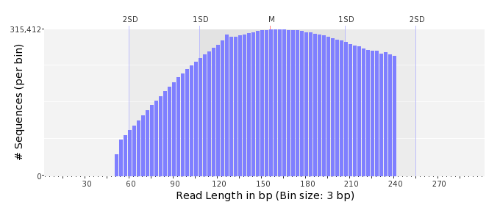

GC Content Distribution
Mean GC content: | 47.42 ± 11.36 %
Minimum GC content: | 0 %
Maximum GC content: | 100 %
GC content range: | 101 %
Mode GC content: | 50 % with 622,756 sequences
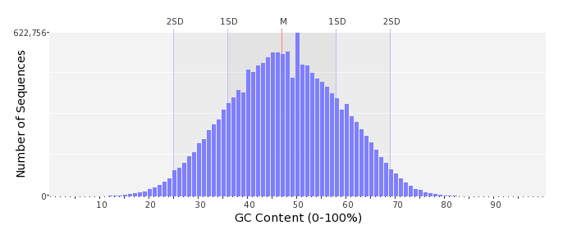

Base Quality Distribution
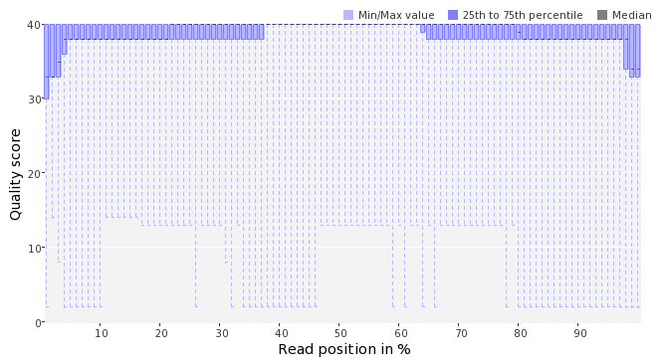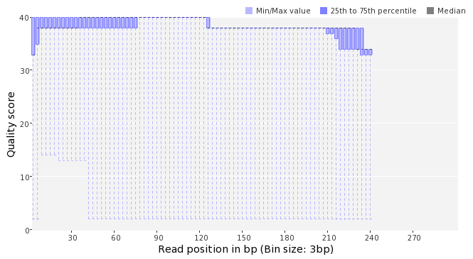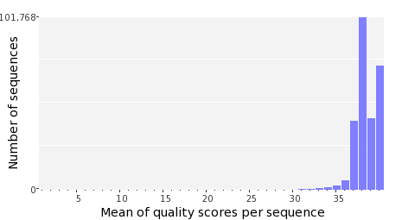

Occurence of N
Sequences with N: | 118,240 (0.73 %)
Max percentage of Ns per sequence: | 5 %
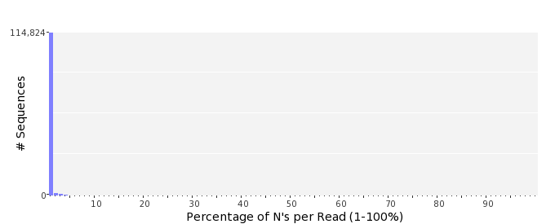

Poly-A/T Tails
 | 5'-end | 3'-end
Sequences with tail: | 78,225 (0.48 %) | 78,861 (0.49 %)
Maximum tail length: | 125 | 125
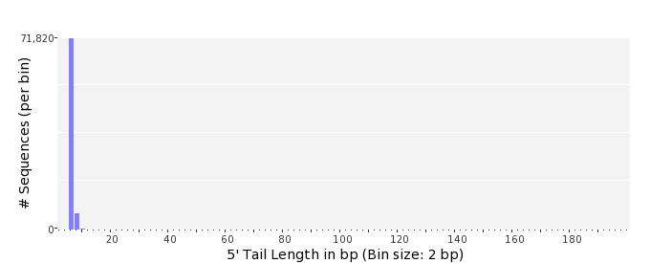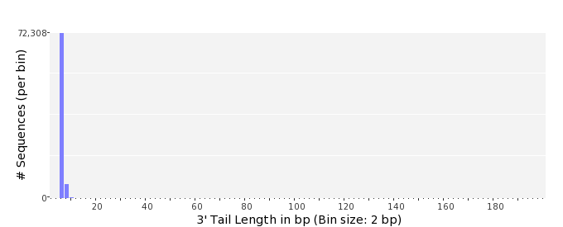

Tag Sequence Check
 | 5'-end | 3'-end
Probability of tag sequence: | 0 % | 0 %
GSMIDs or RLMIDs: | none

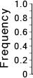 |  |  |  |  |  |  |  |  |  |  |  |  |  |  |  |  |  |  |  |  | ...
 | 1 |  |  |  | 5 |  |  |  |  | 10 |  |  |  |  | 15 |  |  |  |  | 20 |  | 20 |  |  |  |  | 15 |  |  |  |  | 10 |  |  |  |  | 5 |  |  |  | 1
 | Position from Sequence Ends

Sequence Duplication
 | # Sequences | Max duplicates
Exact duplicates: | 302,258 (1.86 %) | 143
Exact duplicates with reverse complements: | 702 (0.00 %) | 2
5' duplicates | 98,045 (0.60 %) | 25
3' duplicates | 77,376 (0.48 %) | 30
5'/3' duplicates with reverse complements | 132,492 (0.82 %) | 3
Total: | 610,873 (3.77 %) | -
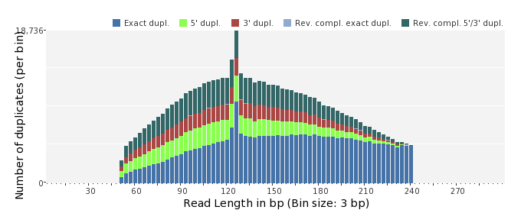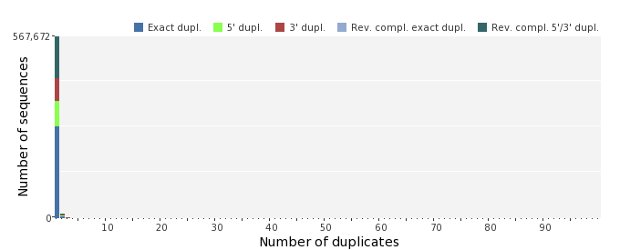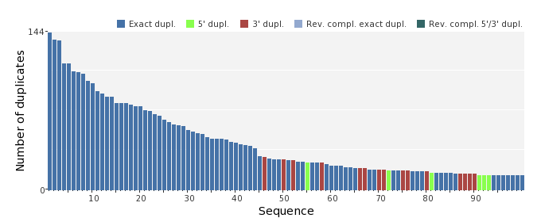

Sequence Complexity
 | Value | Sequence
Minimum DUST score: | 0 | ATGGCCGTTAAAACCGTTAATGCTATGATCGACGGCCAGTCAAGCTATAGGGAAGACTGG  CGCGTATTAAACAGCATAGAT
Maximum DUST score: | 98 | TTTTTTTTTTTTTTTTTTTTTTTTTTTTTTTTTTTTTTTTTTTTTTTTTTTTTTTTTTTT  TTTTTTTTTTTTTTTTTTTTTTTTTTTTTTTTTTTTTTTTTTTTTTTTTTTTTTTT
Minimum Entropy value: | 0 | TTTTTTTTTTTTTTTTTTTTTTTTTTTTTTTTTTTTTTTTTTTTTTTTTTTTTTTTTTTT  TTTTTTTTTTTTTTTTTTTTTTTTTTTTTTTTTTTTTTTTTTTTTTTTTTTTTTTT
Maximum Entropy value: | 96 | TCTGGCATACCCCACAGATTAGGAATGTCTCGCGCTTTGCCGTTATCAAT
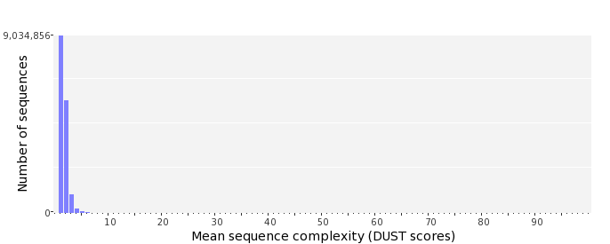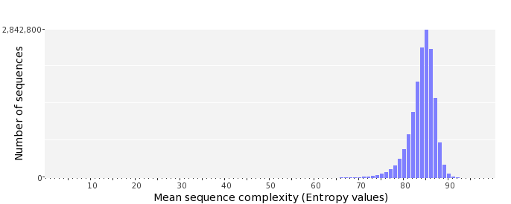

Dinucleotide Odds Ratios
 | AA/TT | AC/GT | AG/CT | AT | CA/TG | CC/GG | CG | GA/TC | GC | TA
Odds ratio | 1.1479 | 0.8782 | 0.9425 | 1.0355 | 1.1183 | 0.9830 | 0.9368 | 1.0269 | 1.1464 | 0.6856
