B4
Input Information
Input file(s): | B_4.assembled.fastq
Input format(s): | FASTQ
# Sequences: | 18,336,024
Total bases: | 2,827,931,914

Length Distribution
Mean sequence length: | 154.23 ± 48.73 bp
Minimum length: | 50 bp
Maximum length: | 240 bp
Length range: | 191 bp
Mode length: | 160 bp with 121,326 sequences
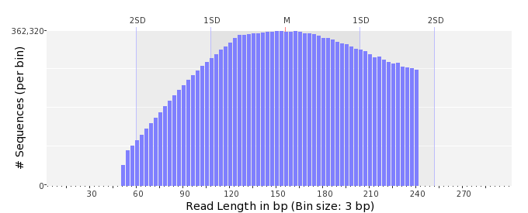

GC Content Distribution
Mean GC content: | 53.64 ± 12.02 %
Minimum GC content: | 0 %
Maximum GC content: | 98 %
GC content range: | 99 %
Mode GC content: | 60 % with 712,504 sequences
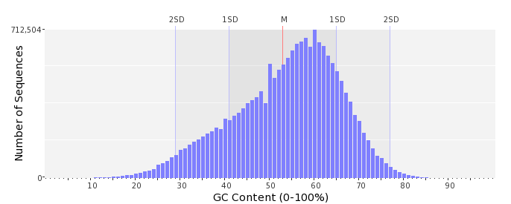

Base Quality Distribution
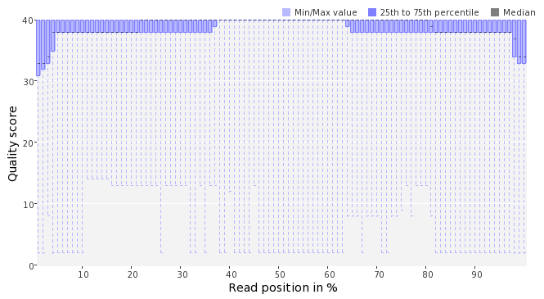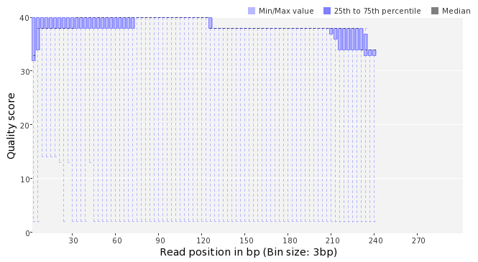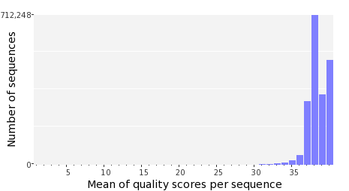

Occurence of N
Sequences with N: | 325,625 (1.78 %)
Max percentage of Ns per sequence: | 6 %
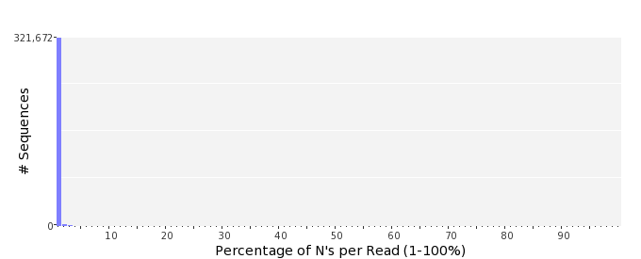

Poly-A/T Tails
 | 5'-end | 3'-end
Sequences with tail: | 47,196 (0.26 %) | 49,147 (0.27 %)
Maximum tail length: | 125 | 125
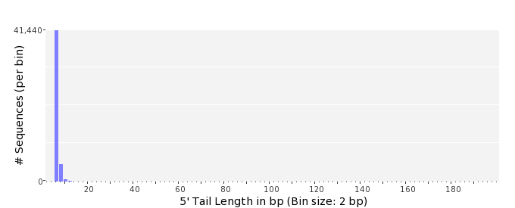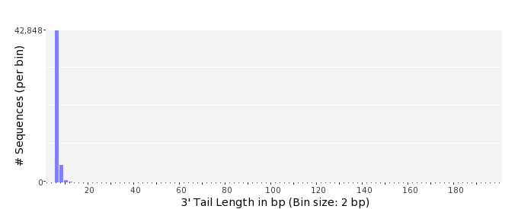

Tag Sequence Check
 | 5'-end | 3'-end
Probability of tag sequence: | 0 % | 0 %
GSMIDs or RLMIDs: | none

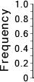 |  |  |  |  |  |  |  |  |  |  |  |  |  |  |  |  |  |  |  |  | ...
 | 1 |  |  |  | 5 |  |  |  |  | 10 |  |  |  |  | 15 |  |  |  |  | 20 |  | 20 |  |  |  |  | 15 |  |  |  |  | 10 |  |  |  |  | 5 |  |  |  | 1
 | Position from Sequence Ends

Sequence Duplication
 | # Sequences | Max duplicates
Exact duplicates: | 812,501 (4.43 %) | 73
Exact duplicates with reverse complements: | 891 (0.00 %) | 1
5' duplicates | 186,370 (1.02 %) | 14
3' duplicates | 138,048 (0.75 %) | 25
5'/3' duplicates with reverse complements | 218,972 (1.19 %) | 4
Total: | 1,356,782 (7.40 %) | -
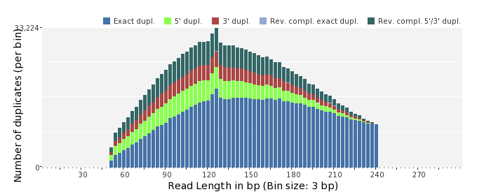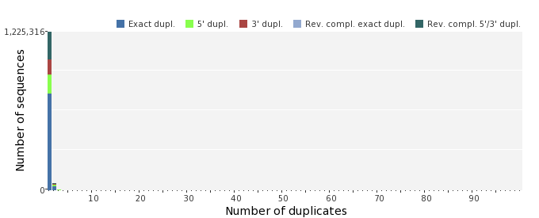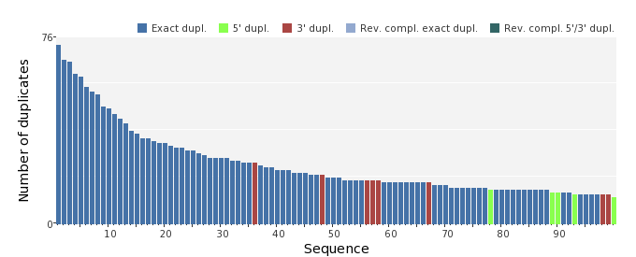

Sequence Complexity
 | Value | Sequence
Minimum DUST score: | 0 | CGGCCGCAACTACCGCCTGGGCGTCGCGGACACCAGCAAAGGAATACTGCTCGATGCTTT  CGGTGAAACCC
Maximum DUST score: | 98 | TTTTTTTTTTTTTTTTTTTTTTTTTTTTTTTTTTTTTTTTTTTTTTTTTTTTTTTTTTTT  TTTTTTTTTTTTTTTTTTTTTTTTTTTTTTTTTTTTTTTTTTTTTTTTTTTTTTTTTTTT  TTTTT
Minimum Entropy value: | 0 | GTTTTTTTTTTTTTTTTTTTTTTTTTTTTTTTTTTTTTTTTTTTTTTTTTTTTTTTTTTT  TTTTTTTTTTTTTTTTTTTTTTTTTTTTTTTTTTTTTTTTTTTTTTTTTTTTTTTTTTTT  TTTTTT
Maximum Entropy value: | 96 | ACGGTCAGGCCGTAAGTCGCGTTCTCCACATTGCAGCCTGTATGAATACC
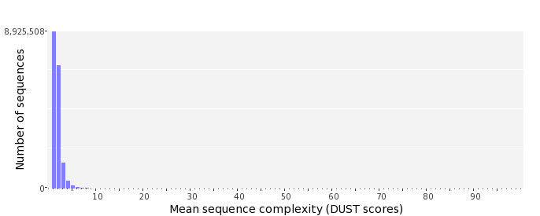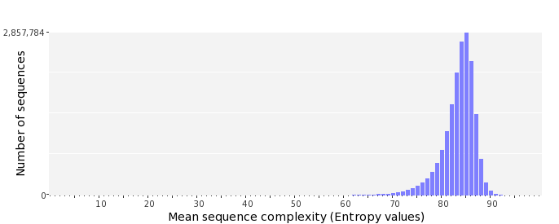

Dinucleotide Odds Ratios
 | AA/TT | AC/GT | AG/CT | AT | CA/TG | CC/GG | CG | GA/TC | GC | TA
Odds ratio | 1.1395 | 0.8748 | 0.9590 | 1.0757 | 1.1313 | 0.9522 | 0.9679 | 1.0537 | 1.1204 | 0.5974
