B1
Input Information
Input file(s): | B_1.assembled.fastq
Input format(s): | FASTQ
# Sequences: | 17,921,662
Total bases: | 2,717,944,754

Length Distribution
Mean sequence length: | 151.66 ± 49.37 bp
Minimum length: | 50 bp
Maximum length: | 240 bp
Length range: | 191 bp
Mode length: | 125 bp with 118,437 sequences
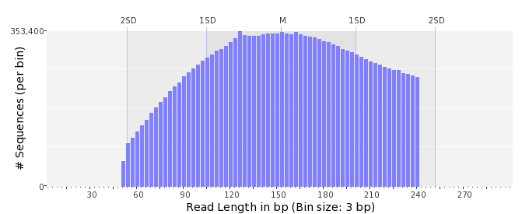

GC Content Distribution
Mean GC content: | 49.74 ± 12.43 %
Minimum GC content: | 0 %
Maximum GC content: | 100 %
GC content range: | 101 %
Mode GC content: | 50 % with 576,689 sequences
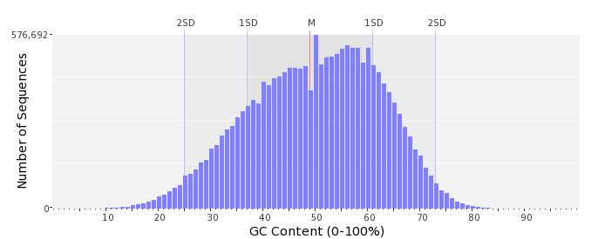

Base Quality Distribution
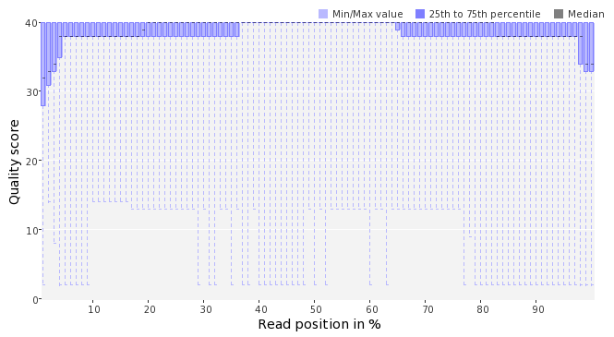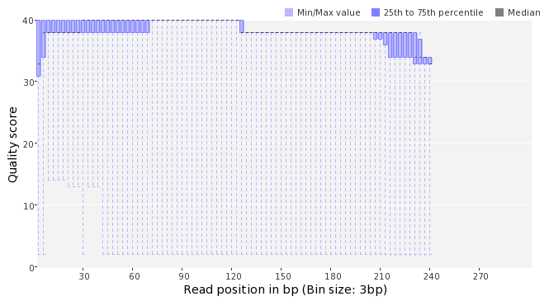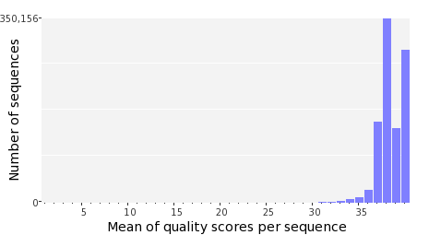

Occurence of N
Sequences with N: | 123,321 (0.69 %)
Max percentage of Ns per sequence: | 7 %
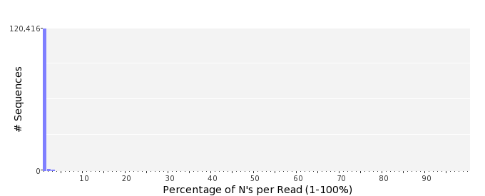

Poly-A/T Tails
 | 5'-end | 3'-end
Sequences with tail: | 76,786 (0.43 %) | 77,690 (0.43 %)
Maximum tail length: | 125 | 125
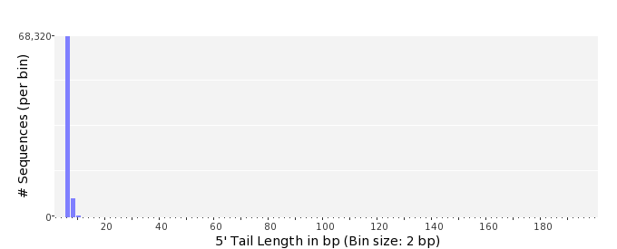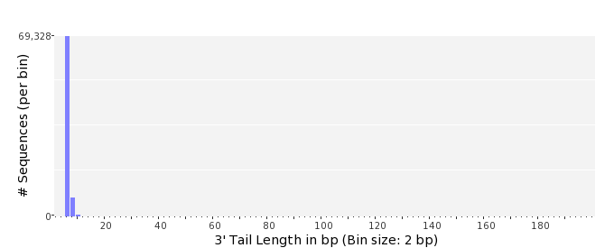

Tag Sequence Check
 | 5'-end | 3'-end
Probability of tag sequence: | 0 % | 0 %
GSMIDs or RLMIDs: | none

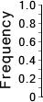 |  |  |  |  |  |  |  |  |  |  |  |  |  |  |  |  |  |  |  |  | ...
 | 1 |  |  |  | 5 |  |  |  |  | 10 |  |  |  |  | 15 |  |  |  |  | 20 |  | 20 |  |  |  |  | 15 |  |  |  |  | 10 |  |  |  |  | 5 |  |  |  | 1
 | Position from Sequence Ends

Sequence Duplication
 | # Sequences | Max duplicates
Exact duplicates: | 1,243,955 (6.94 %) | 310
Exact duplicates with reverse complements: | 665 (0.00 %) | 2
5' duplicates | 223,020 (1.24 %) | 19
3' duplicates | 111,588 (0.62 %) | 77
5'/3' duplicates with reverse complements | 152,947 (0.85 %) | 3
Total: | 1,732,175 (9.67 %) | -
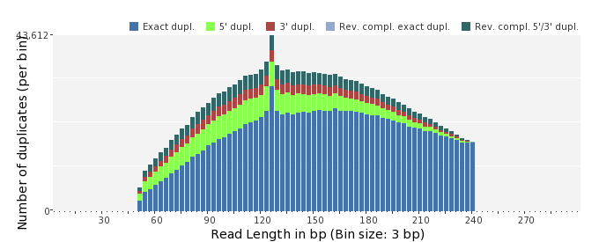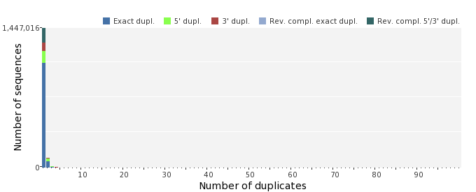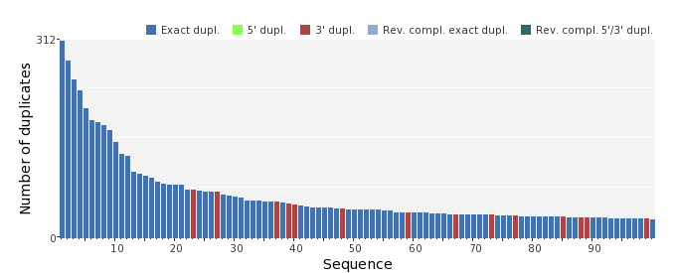

Sequence Complexity
 | Value | Sequence
Minimum DUST score: | 0 | CGTCTTTATCACTGCCAATGGTGATGAGAACGTCCGCCCGCGGCTCATGGAACGAGGGGC  TGTCGAGTGCCTGTTCAAACCTTTTAGCGATACAGCACTGAT
Maximum DUST score: | 99 | TTTTTTTTTTTTTTTTTTTTTTTTTTTTTTTTTTTTTTTTTTTTTTTTTTTTTTTTTTTT  TTTTTTTT
Minimum Entropy value: | 0 | TTTTTTTTTTTTTTTTTTTTTTTTTTTTTTTTTTTTTTTTTTTTTTTTTTTTTTTTTTTT  TTTTTTTT
Maximum Entropy value: | 96 | TTCGGCTACTGTGCCCTAGGGAGCAGTCGCGACGGACTCCCAGAAAGGGTCTGATTTATG  GCAAC
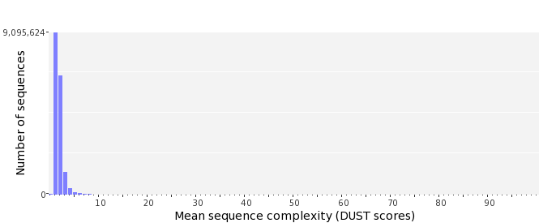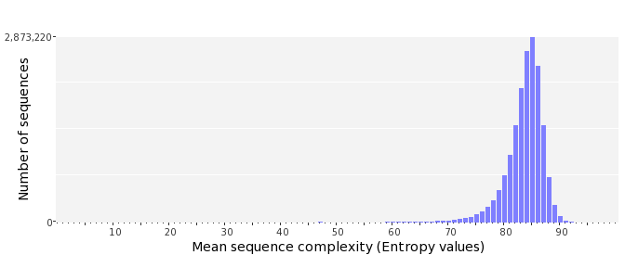

Dinucleotide Odds Ratios
 | AA/TT | AC/GT | AG/CT | AT | CA/TG | CC/GG | CG | GA/TC | GC | TA
Odds ratio | 1.1399 | 0.8906 | 0.9486 | 1.0512 | 1.1179 | 0.9736 | 0.9474 | 1.0465 | 1.1100 | 0.6493
