E3
Input Information
Input file(s): | E_3.assembled.fastq
Input format(s): | FASTQ
# Sequences: | 16,588,878
Total bases: | 2,468,650,316

Length Distribution
Mean sequence length: | 148.81 ± 48.78 bp
Minimum length: | 50 bp
Maximum length: | 240 bp
Length range: | 191 bp
Mode length: | 134 bp with 112,457 sequences
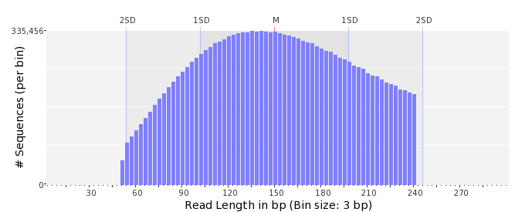

GC Content Distribution
Mean GC content: | 50.29 ± 10.69 %
Minimum GC content: | 0 %
Maximum GC content: | 95 %
GC content range: | 96 %
Mode GC content: | 50 % with 720,739 sequences
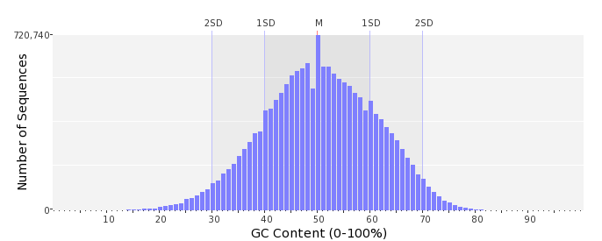

Base Quality Distribution
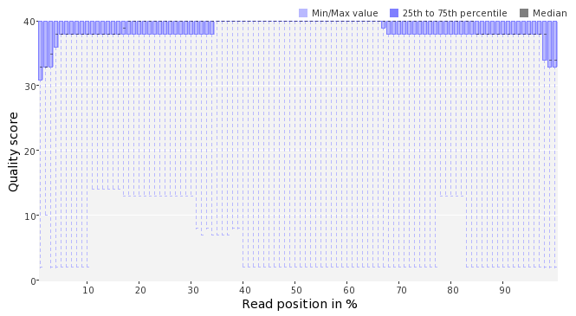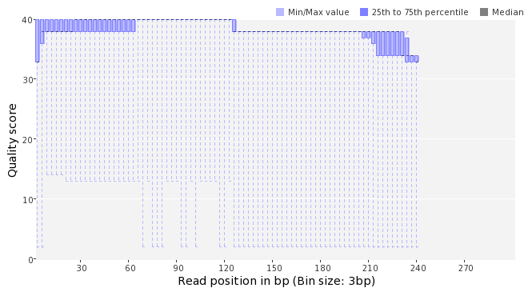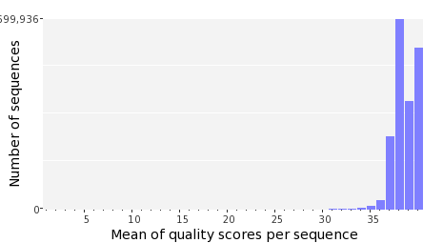

Occurence of N
Sequences with N: | 86,993 (0.52 %)
Max percentage of Ns per sequence: | 4 %
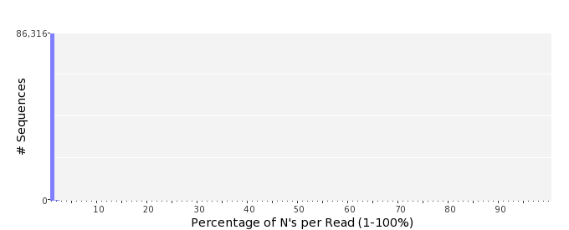

Poly-A/T Tails
 | 5'-end | 3'-end
Sequences with tail: | 65,301 (0.39 %) | 66,761 (0.40 %)
Maximum tail length: | 125 | 125
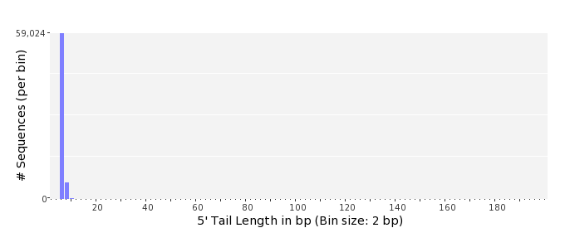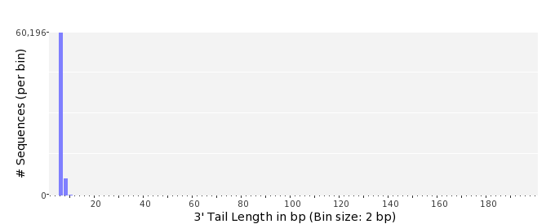

Tag Sequence Check
 | 5'-end | 3'-end
Probability of tag sequence: | 0 % | 0 %
GSMIDs or RLMIDs: | none

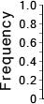 |  |  |  |  |  |  |  |  |  |  |  |  |  |  |  |  |  |  |  |  | ...
 | 1 |  |  |  | 5 |  |  |  |  | 10 |  |  |  |  | 15 |  |  |  |  | 20 |  | 20 |  |  |  |  | 15 |  |  |  |  | 10 |  |  |  |  | 5 |  |  |  | 1
 | Position from Sequence Ends

Sequence Duplication
 | # Sequences | Max duplicates
Exact duplicates: | 394,211 (2.38 %) | 9
Exact duplicates with reverse complements: | 2,276 (0.01 %) | 1
5' duplicates | 364,194 (2.20 %) | 18
3' duplicates | 222,154 (1.34 %) | 21
5'/3' duplicates with reverse complements | 187,907 (1.13 %) | 3
Total: | 1,170,742 (7.06 %) | -
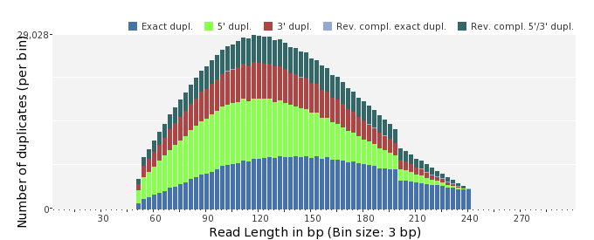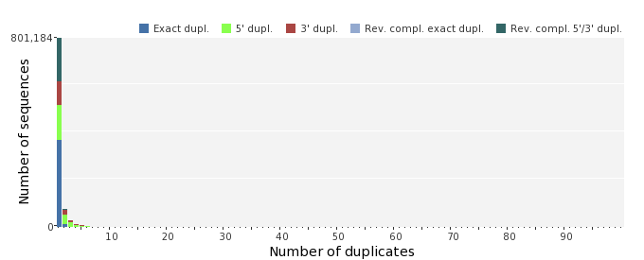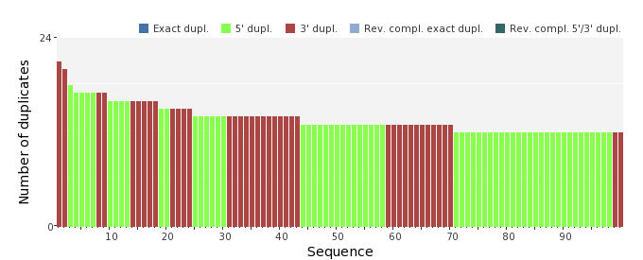

Sequence Complexity
 | Value | Sequence
Minimum DUST score: | 0 | ACCTCCATTGCTCCGGCACGCACTTTCTGCCTGGAGACTGAAGCTAGCCAGTTACAAAAT  CAA
Maximum DUST score: | 100 | TTTTTTTTTTTTTTTTTTTTTTTTTTTTTTTTTTTTTTTTTTTTTTTTTTTTTTTTTT
Minimum Entropy value: | 0 | TTTTTTTTTTTTTTTTTTTTTTTTTTTTTTTTTTTTTTTTTTTTTTTTTTTTTTTTTT
Maximum Entropy value: | 97 | GCCCGGTCTGGCGACAGCAAGATCCTTGCCCATATTAATGAAACCGTACTGTTC
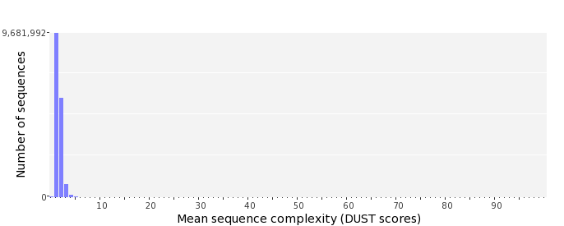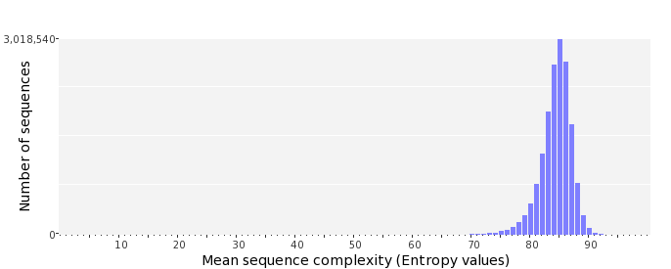

Dinucleotide Odds Ratios
 | AA/TT | AC/GT | AG/CT | AT | CA/TG | CC/GG | CG | GA/TC | GC | TA
Odds ratio | 1.1920 | 0.8271 | 0.9112 | 1.0999 | 1.0625 | 1.0071 | 1.0123 | 1.0640 | 1.1295 | 0.6439
