G1
Input Information
Input file(s): | G_1.assembled.fastq
Input format(s): | FASTQ
# Sequences: | 17,346,500
Total bases: | 2,632,337,750

Length Distribution
Mean sequence length: | 151.75 ± 49.47 bp
Minimum length: | 50 bp
Maximum length: | 240 bp
Length range: | 191 bp
Mode length: | 125 bp with 115,102 sequences
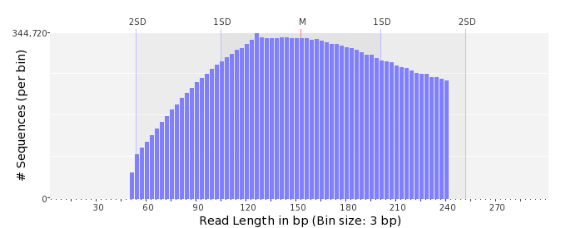

GC Content Distribution
Mean GC content: | 51.37 ± 12.63 %
Minimum GC content: | 0 %
Maximum GC content: | 100 %
GC content range: | 101 %
Mode GC content: | 50 % with 550,063 sequences
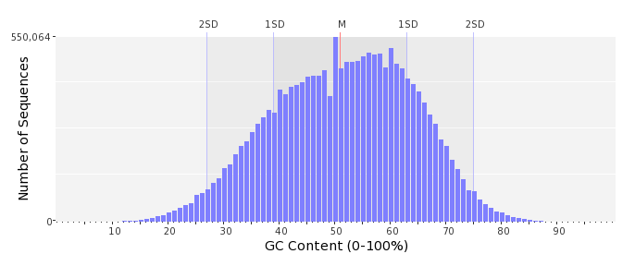

Base Quality Distribution
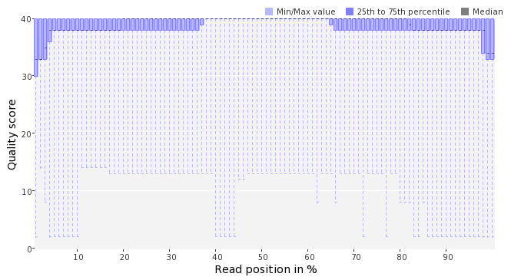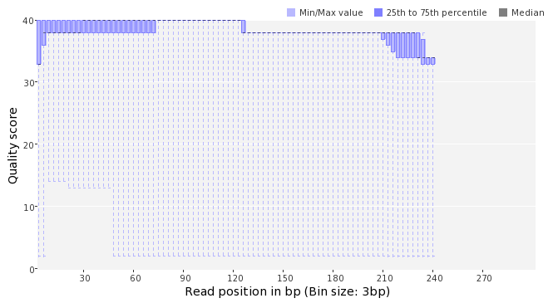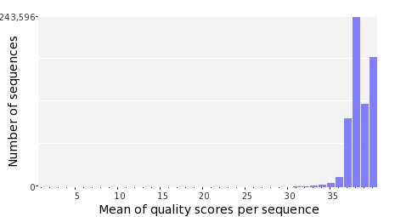

Occurence of N
Sequences with N: | 120,928 (0.70 %)
Max percentage of Ns per sequence: | 9 %
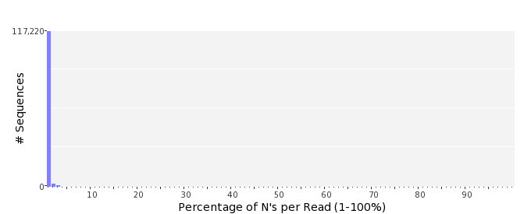

Poly-A/T Tails
 | 5'-end | 3'-end
Sequences with tail: | 59,930 (0.35 %) | 61,691 (0.36 %)
Maximum tail length: | 95 | 120
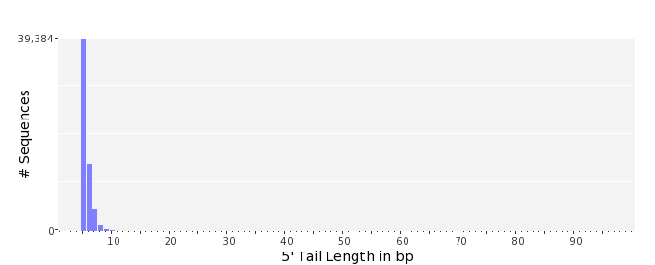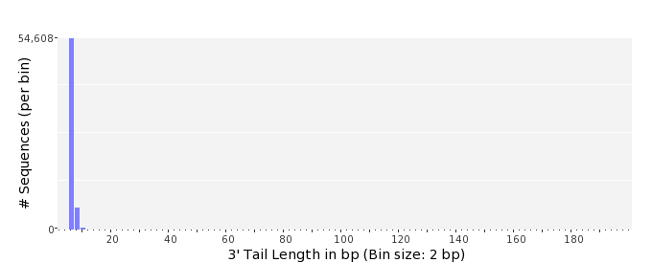

Tag Sequence Check
 | 5'-end | 3'-end
Probability of tag sequence: | 0 % | 0 %
GSMIDs or RLMIDs: | none

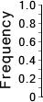 |  |  |  |  |  |  |  |  |  |  |  |  |  |  |  |  |  |  |  |  | ...
 | 1 |  |  |  | 5 |  |  |  |  | 10 |  |  |  |  | 15 |  |  |  |  | 20 |  | 20 |  |  |  |  | 15 |  |  |  |  | 10 |  |  |  |  | 5 |  |  |  | 1
 | Position from Sequence Ends

Sequence Duplication
 | # Sequences | Max duplicates
Exact duplicates: | 512,365 (2.95 %) | 359
Exact duplicates with reverse complements: | 674 (0.00 %) | 1
5' duplicates | 156,353 (0.90 %) | 21
3' duplicates | 106,596 (0.61 %) | 33
5'/3' duplicates with reverse complements | 172,442 (0.99 %) | 4
Total: | 948,430 (5.47 %) | -
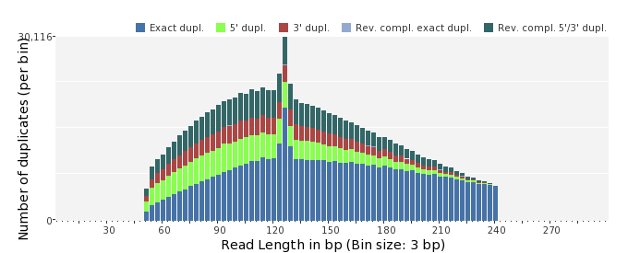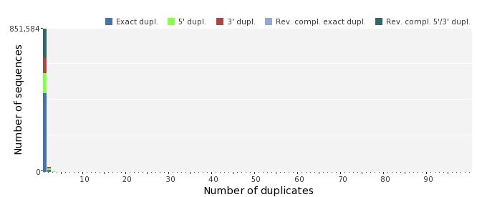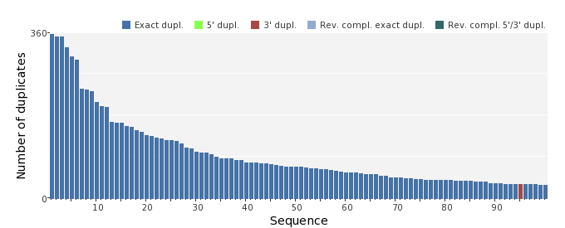

Sequence Complexity
 | Value | Sequence
Minimum DUST score: | 0 | CAGAACAACTTGTTTTCGTGCCGCTGGCATTCACATAGCTCCAGGTGTACGCAGGAATCG  AGATCACATTCCCGGAGATCGTGGGATACGCGCCAGT
Maximum DUST score: | 99 | TTTTTTTTTTTTTTTTTTTTTTTTTTTTTTTTTTTTTTTTTTTTTTTTTTTTTTTTTTTT  TTTTTTTTTTTTTTTTTTTTTTTTTTTTTTTTTTT
Minimum Entropy value: | 0 | TTTTTTTTTTTTTTTTTTTTTTTTTTTTTTTTTTTTTTTTTTTTTTTTTTTTTTTTTTTT  TTTTTTTTTTTTTTTTTTTTTTTTTTTTTTTTTTT
Maximum Entropy value: | 96 | CCAATGGGCTGGAGGCCTTCACAACTTTACCATTTATAGTCACCGACGGGTTGCAGGCGT  GAACA
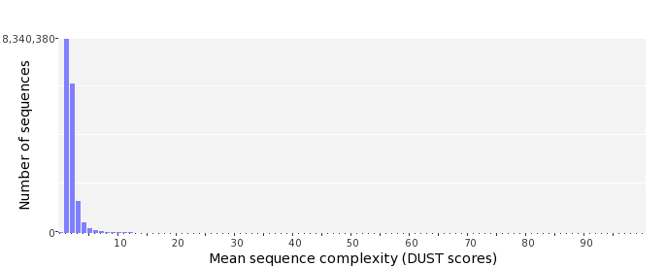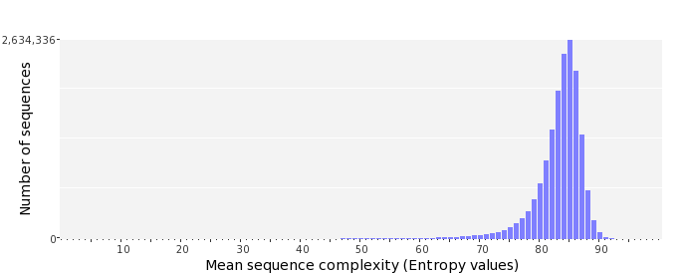

Dinucleotide Odds Ratios
 | AA/TT | AC/GT | AG/CT | AT | CA/TG | CC/GG | CG | GA/TC | GC | TA
Odds ratio | 1.1106 | 0.8871 | 0.9710 | 1.0617 | 1.1068 | 0.9574 | 0.9498 | 1.0766 | 1.1038 | 0.6520
