B2
Input Information
Input file(s): | B_2.assembled.fastq
Input format(s): | FASTQ
# Sequences: | 20,621,756
Total bases: | 3,151,443,468

Length Distribution
Mean sequence length: | 152.82 ± 49.11 bp
Minimum length: | 50 bp
Maximum length: | 240 bp
Length range: | 191 bp
Mode length: | 126 bp with 138,466 sequences
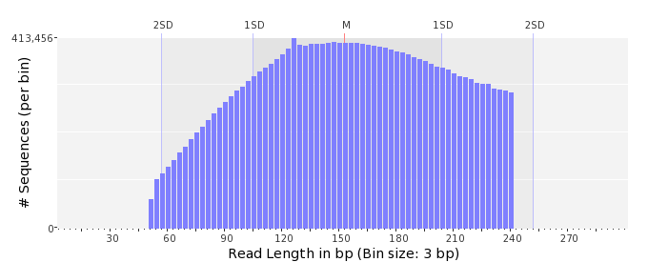

GC Content Distribution
Mean GC content: | 51.70 ± 12.52 %
Minimum GC content: | 0 %
Maximum GC content: | 100 %
GC content range: | 101 %
Mode GC content: | 60 % with 707,796 sequences
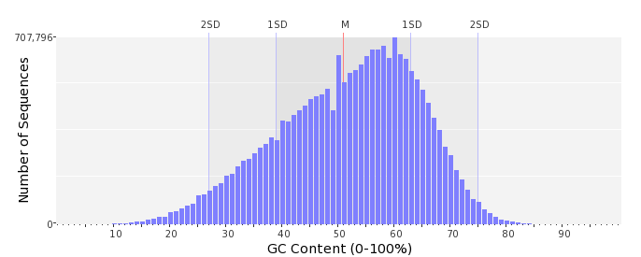

Base Quality Distribution
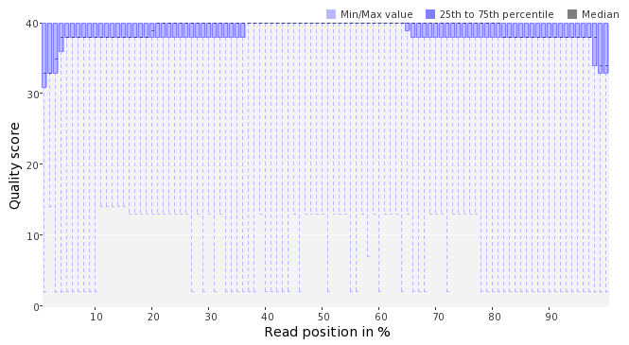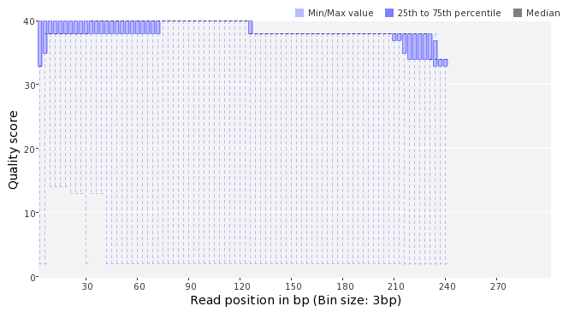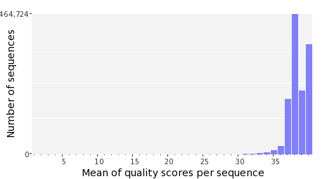

Occurence of N
Sequences with N: | 146,609 (0.71 %)
Max percentage of Ns per sequence: | 8 %
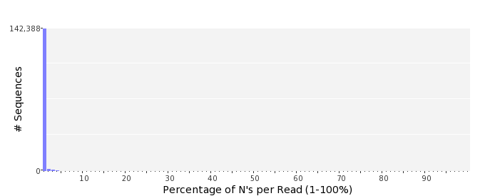

Poly-A/T Tails
 | 5'-end | 3'-end
Sequences with tail: | 91,784 (0.45 %) | 91,872 (0.45 %)
Maximum tail length: | 125 | 125
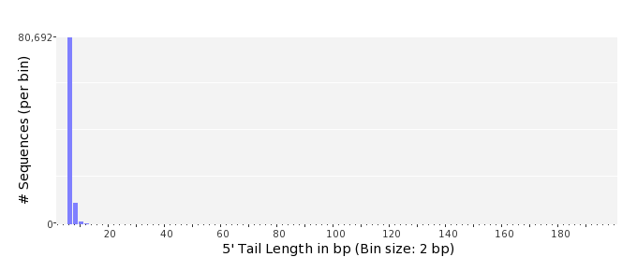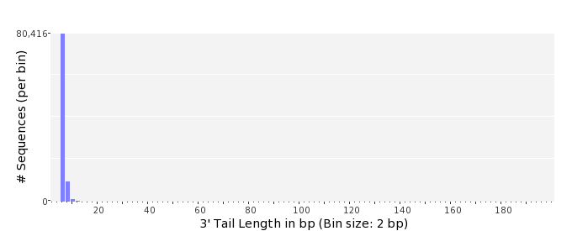

Tag Sequence Check
 | 5'-end | 3'-end
Probability of tag sequence: | 0 % | 0 %
GSMIDs or RLMIDs: | none

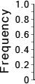 |  |  |  |  |  |  |  |  |  |  |  |  |  |  |  |  |  |  |  |  | ...
 | 1 |  |  |  | 5 |  |  |  |  | 10 |  |  |  |  | 15 |  |  |  |  | 20 |  | 20 |  |  |  |  | 15 |  |  |  |  | 10 |  |  |  |  | 5 |  |  |  | 1
 | Position from Sequence Ends

Sequence Duplication
 | # Sequences | Max duplicates
Exact duplicates: | 1,547,437 (7.50 %) | 567
Exact duplicates with reverse complements: | 676 (0.00 %) | 2
5' duplicates | 153,465 (0.74 %) | 25
3' duplicates | 98,703 (0.48 %) | 75
5'/3' duplicates with reverse complements | 150,245 (0.73 %) | 3
Total: | 1,950,526 (9.46 %) | -
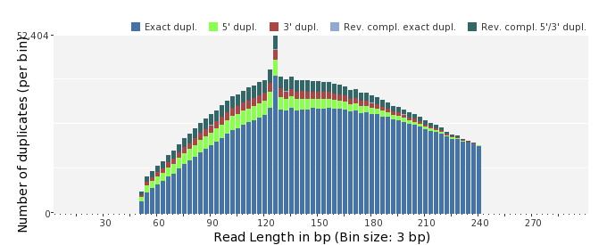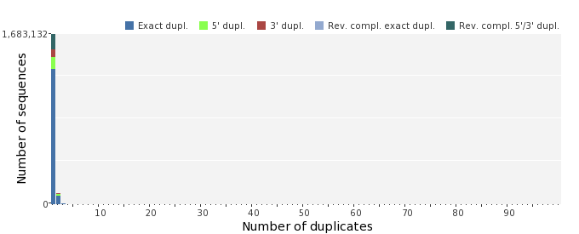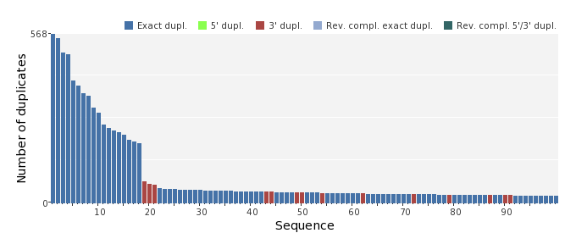

Sequence Complexity
 | Value | Sequence
Minimum DUST score: | 0 | CACTGCCTATAGGGCATACACAGATTTCAGCTTTAGATTGAGTTAAACTATCCCTTCGAC  CTTTGGGTCTC
Maximum DUST score: | 100 | TTTTTTTTTTTTTTTTTTTTTTTTTTTTTTTTTTTTTTTTTTTTTTTTTTTTTTTTTTTT  TT
Minimum Entropy value: | 0 | TTTTTTTTTTTTTTTTTTTTTTTTTTTTTTTTTTTTTTTTTTTTTTTTTTTTTTTTTTTT  TTTTTTTTTTTTTTTTTTTTTTTTTTTTTTTTTTTTTTTTTTTTTTTTTTTTTTTTTTTT  TTTTT
Maximum Entropy value: | 97 | CAATCGTGCCATGGTTGTCACGGATAGGGCTGAAGCTGTAACTTCCGACCCAG
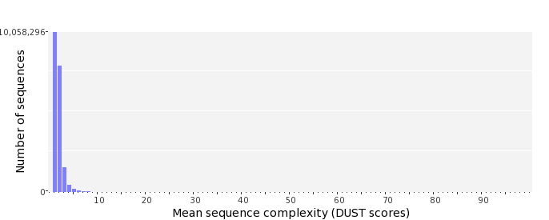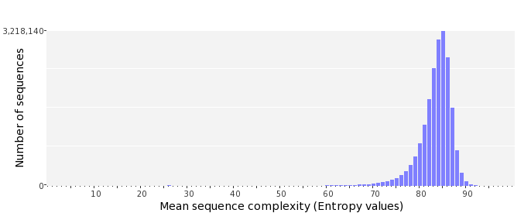

Dinucleotide Odds Ratios
 | AA/TT | AC/GT | AG/CT | AT | CA/TG | CC/GG | CG | GA/TC | GC | TA
Odds ratio | 1.1537 | 0.8842 | 0.9281 | 1.0840 | 1.1164 | 0.9619 | 0.9811 | 1.0533 | 1.1204 | 0.6168
