D3
Input Information
Input file(s): | D_3.assembled.fastq
Input format(s): | FASTQ
# Sequences: | 16,558,012
Total bases: | 2,425,369,875

Length Distribution
Mean sequence length: | 146.48 ± 48.92 bp
Minimum length: | 50 bp
Maximum length: | 240 bp
Length range: | 191 bp
Mode length: | 131 bp with 112,178 sequences
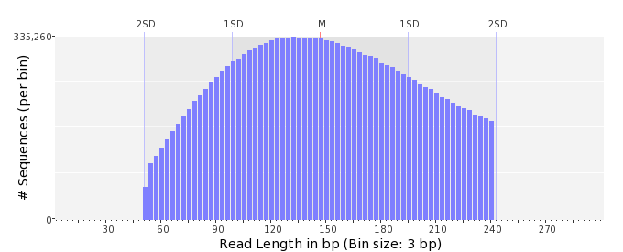

GC Content Distribution
Mean GC content: | 50.04 ± 10.84 %
Minimum GC content: | 1 %
Maximum GC content: | 95 %
GC content range: | 95 %
Mode GC content: | 50 % with 693,540 sequences
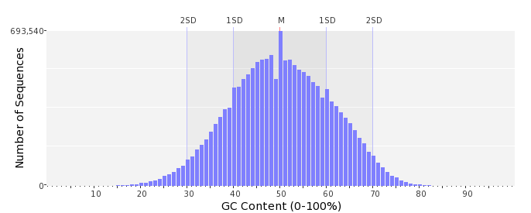

Base Quality Distribution
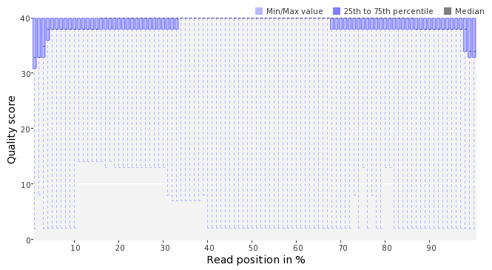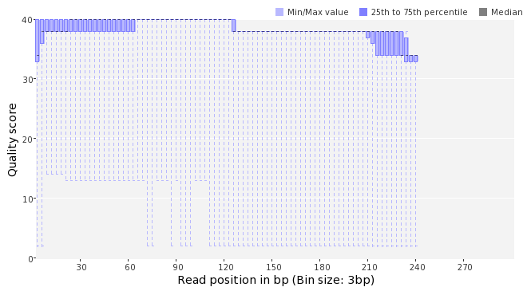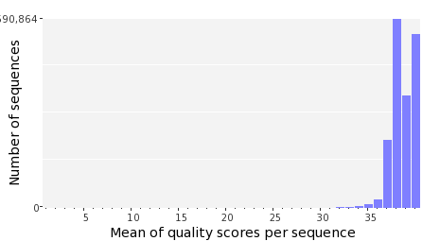

Occurence of N
Sequences with N: | 81,554 (0.49 %)
Max percentage of Ns per sequence: | 4 %
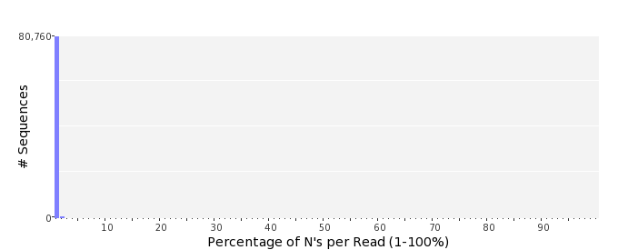

Poly-A/T Tails
 | 5'-end | 3'-end
Sequences with tail: | 67,459 (0.41 %) | 67,951 (0.41 %)
Maximum tail length: | 33 | 121
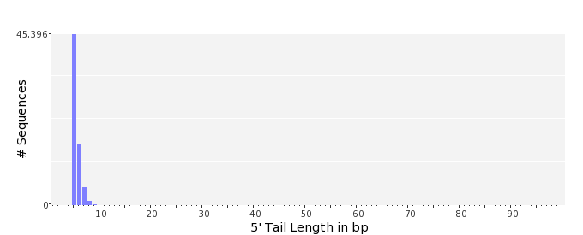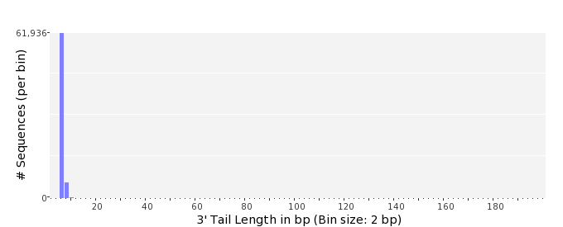

Tag Sequence Check
 | 5'-end | 3'-end
Probability of tag sequence: | 0 % | 0 %
GSMIDs or RLMIDs: | none

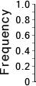 |  |  |  |  |  |  |  |  |  |  |  |  |  |  |  |  |  |  |  |  | ...
 | 1 |  |  |  | 5 |  |  |  |  | 10 |  |  |  |  | 15 |  |  |  |  | 20 |  | 20 |  |  |  |  | 15 |  |  |  |  | 10 |  |  |  |  | 5 |  |  |  | 1
 | Position from Sequence Ends

Sequence Duplication
 | # Sequences | Max duplicates
Exact duplicates: | 531,143 (3.21 %) | 9
Exact duplicates with reverse complements: | 255 (0.00 %) | 1
5' duplicates | 50,030 (0.30 %) | 21
3' duplicates | 38,075 (0.23 %) | 25
5'/3' duplicates with reverse complements | 60,557 (0.37 %) | 4
Total: | 680,060 (4.11 %) | -
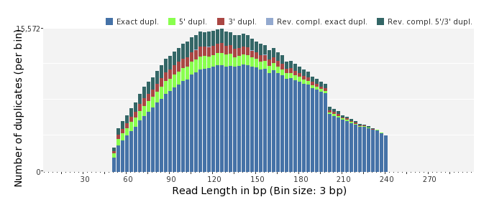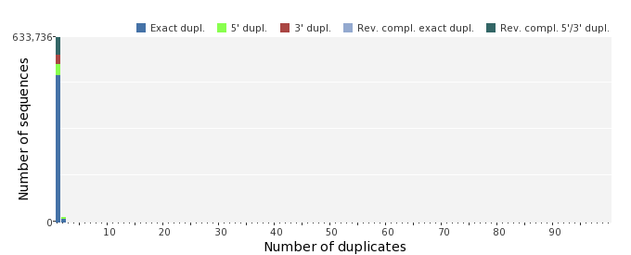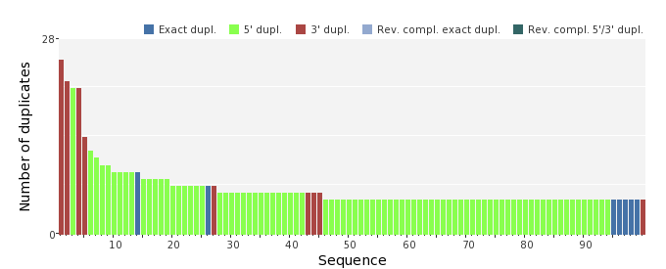

Sequence Complexity
 | Value | Sequence
Minimum DUST score: | 0 | AAAATTCCATGCGGACTAGGCAGTGCGATTCGAGTCCGGACGCCATCGCACAGCAGAAAA  TCTTCTCCGGACTAAGCATGTAGTCGCGGCTGGTTTG
Maximum DUST score: | 94 | GTTTCTTTTTTTTTTTTTTTTTTTTTTTTTTTTTTTTTTTTTTTTTTTTTTTTTTTTTTT  TTTTTTTTTTTTTTTTTTTTTTTTTTTTTTTTTTTTTTTTTTTTTTTTTTTTTTTTTTTT  TTTTTT
Minimum Entropy value: | 2 | GTTTCTTTTTTTTTTTTTTTTTTTTTTTTTTTTTTTTTTTTTTTTTTTTTTTTTTTTTTT  TTTTTTTTTTTTTTTTTTTTTTTTTTTTTTTTTTTTTTTTTTTTTTTTTTTTTTTTTTTT  TTTTTT
Maximum Entropy value: | 97 | GATCCATGTTGGCGGACAACTCAGTCTTCTACGCAAGGAGCTGATTAGAA
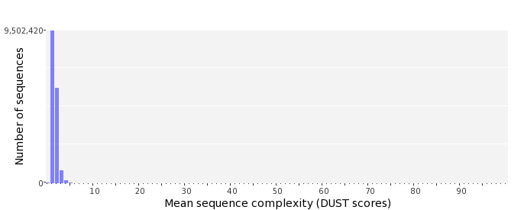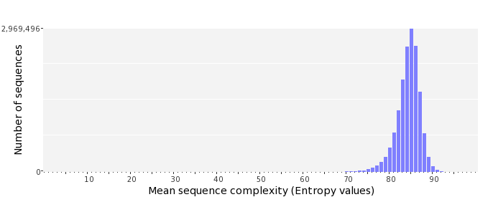

Dinucleotide Odds Ratios
 | AA/TT | AC/GT | AG/CT | AT | CA/TG | CC/GG | CG | GA/TC | GC | TA
Odds ratio | 1.1924 | 0.8157 | 0.9136 | 1.1037 | 1.0350 | 1.0143 | 1.0358 | 1.0692 | 1.1312 | 0.6664
