F5
Input Information
Input file(s): | F_5.assembled.fastq
Input format(s): | FASTQ
# Sequences: | 12,894,541
Total bases: | 1,936,183,195

Length Distribution
Mean sequence length: | 150.16 ± 48.25 bp
Minimum length: | 50 bp
Maximum length: | 240 bp
Length range: | 191 bp
Mode length: | 143 bp with 89,698 sequences
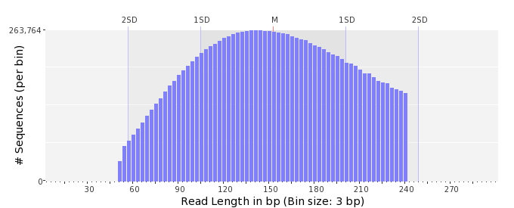

GC Content Distribution
Mean GC content: | 50.09 ± 9.66 %
Minimum GC content: | 0 %
Maximum GC content: | 95 %
GC content range: | 96 %
Mode GC content: | 50 % with 683,038 sequences
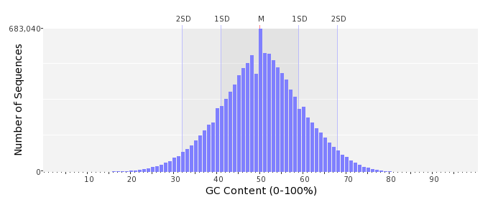

Base Quality Distribution
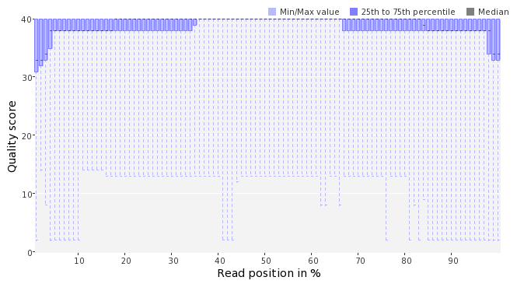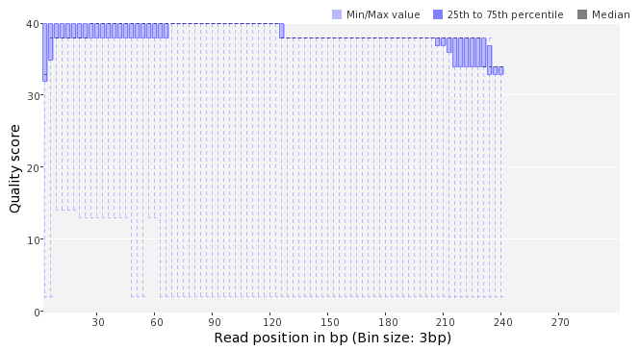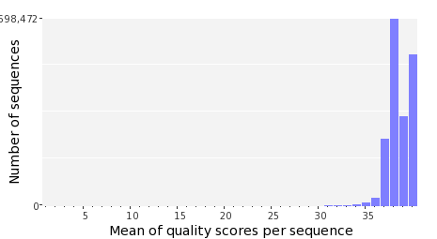

Occurence of N
Sequences with N: | 87,665 (0.68 %)
Max percentage of Ns per sequence: | 4 %
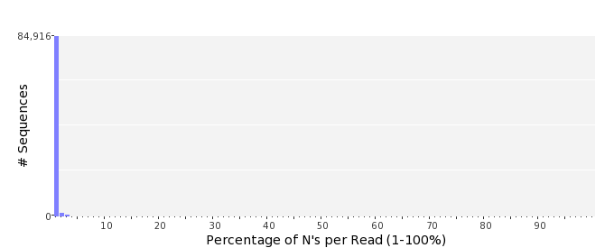

Poly-A/T Tails
 | 5'-end | 3'-end
Sequences with tail: | 38,361 (0.30 %) | 39,664 (0.31 %)
Maximum tail length: | 35 | 107
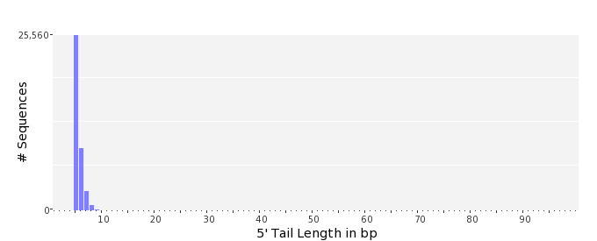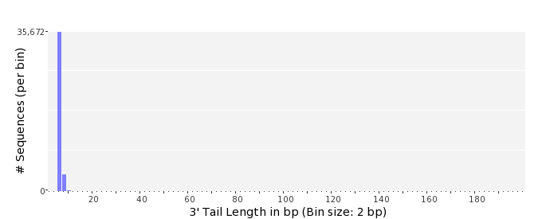

Tag Sequence Check
 | 5'-end | 3'-end
Probability of tag sequence: | 0 % | 0 %
GSMIDs or RLMIDs: | none

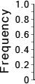 |  |  |  |  |  |  |  |  |  |  |  |  |  |  |  |  |  |  |  |  | ...
 | 1 |  |  |  | 5 |  |  |  |  | 10 |  |  |  |  | 15 |  |  |  |  | 20 |  | 20 |  |  |  |  | 15 |  |  |  |  | 10 |  |  |  |  | 5 |  |  |  | 1
 | Position from Sequence Ends

Sequence Duplication
 | # Sequences | Max duplicates
Exact duplicates: | 450,571 (3.49 %) | 28
Exact duplicates with reverse complements: | 6,130 (0.05 %) | 2
5' duplicates | 1,525,175 (11.83 %) | 26
3' duplicates | 764,425 (5.93 %) | 28
5'/3' duplicates with reverse complements | 551,058 (4.27 %) | 6
Total: | 3,297,359 (25.57 %) | -
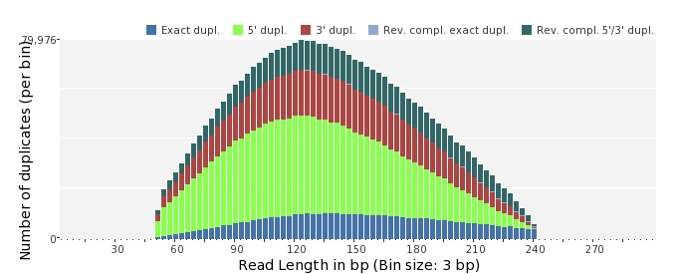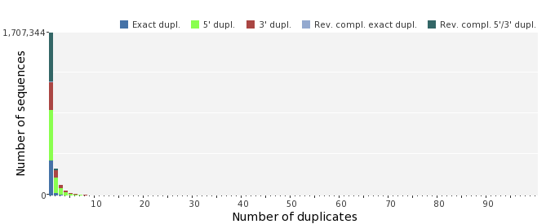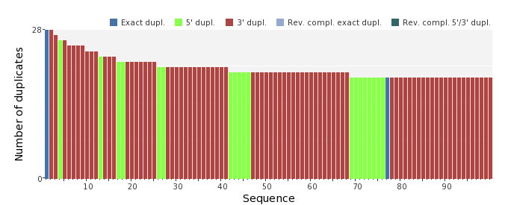

Sequence Complexity
 | Value | Sequence
Minimum DUST score: | 0 | TCCCCCGCGCGTTGTAGAGACTGCAAGCGGAATGCTTAACTCAATAGGCCTCGAGAACAA  AGGATTGG
Maximum DUST score: | 96 | AATTTTTTTTTTTTTTTTTTTTTTTTTTTTTTTTTTTTTTTTTTTTTTTTTTTTTTTTTT  TTTTTTTTTTTTTTTTTTTTTTTTTTTTTTTTTTTTTTTTT
Minimum Entropy value: | 1 | AATTTTTTTTTTTTTTTTTTTTTTTTTTTTTTTTTTTTTTTTTTTTTTTTTTTTTTTTTT  TTTTTTTTTTTTTTTTTTTTTTTTTTTTTTTTTTTTTTTTT
Maximum Entropy value: | 96 | GGCAACCAATCCTAGAAAAGTTTCCGAACGGGACATTGAGGTCGTGTATG
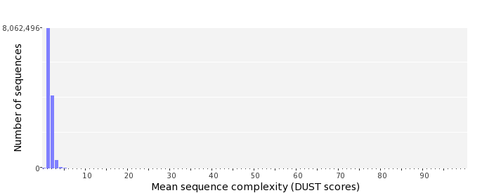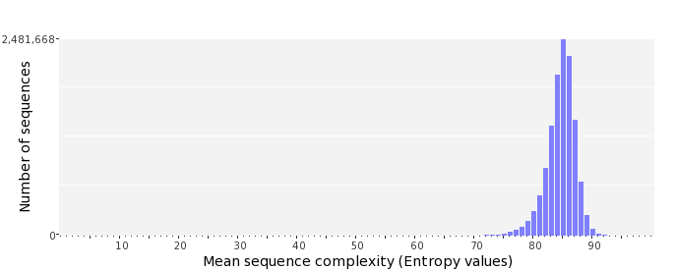

Dinucleotide Odds Ratios
 | AA/TT | AC/GT | AG/CT | AT | CA/TG | CC/GG | CG | GA/TC | GC | TA
Odds ratio | 1.2033 | 0.8133 | 0.9095 | 1.0999 | 1.0701 | 1.0146 | 1.0029 | 1.0631 | 1.1254 | 0.6376
