A4
Input Information
Input file(s): | A_4.assembled.fastq
Input format(s): | FASTQ
# Sequences: | 20,193,216
Total bases: | 3,089,981,012

Length Distribution
Mean sequence length: | 153.02 ± 49.75 bp
Minimum length: | 50 bp
Maximum length: | 240 bp
Length range: | 191 bp
Mode length: | 125 bp with 130,493 sequences
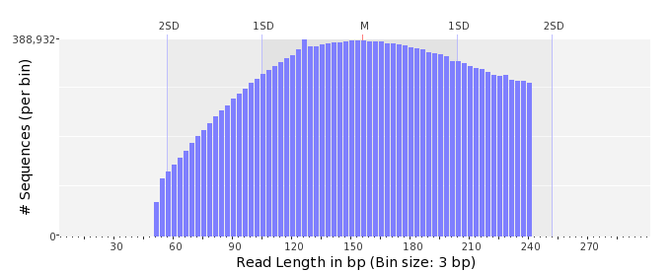

GC Content Distribution
Mean GC content: | 50.61 ± 10.83 %
Minimum GC content: | 0 %
Maximum GC content: | 97 %
GC content range: | 98 %
Mode GC content: | 50 % with 881,890 sequences
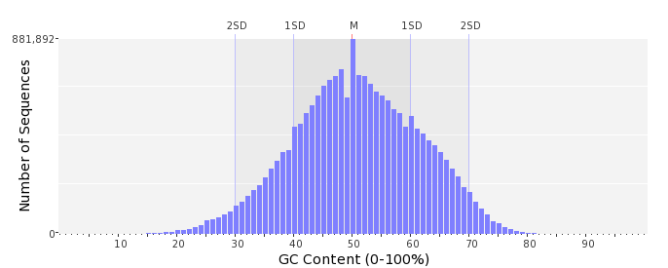

Base Quality Distribution
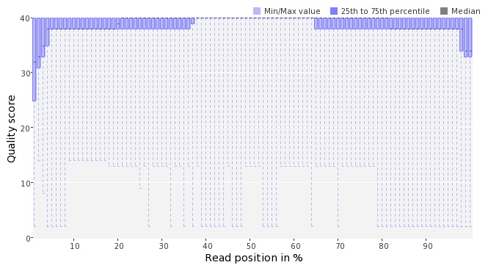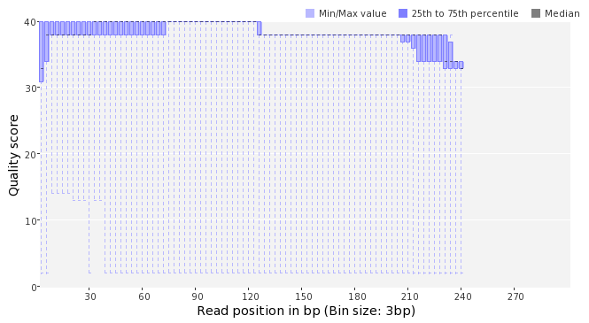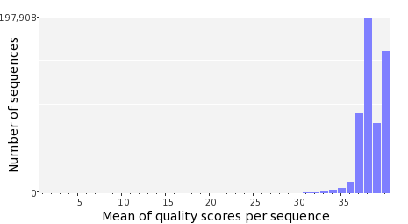

Occurence of N
Sequences with N: | 141,434 (0.70 %)
Max percentage of Ns per sequence: | 10 %
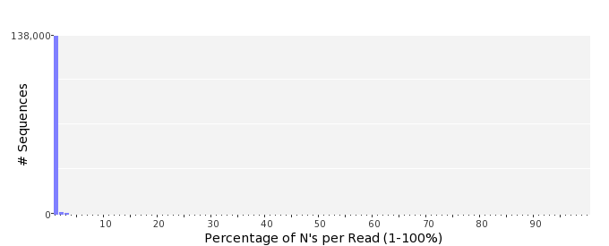

Poly-A/T Tails
 | 5'-end | 3'-end
Sequences with tail: | 76,013 (0.38 %) | 79,367 (0.39 %)
Maximum tail length: | 125 | 125
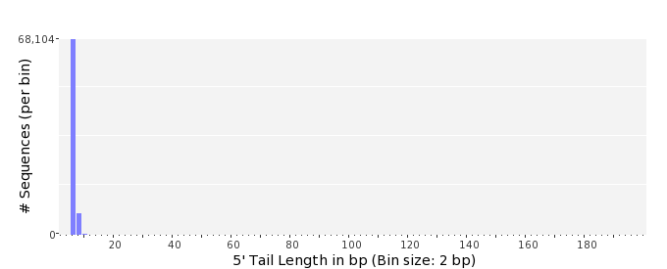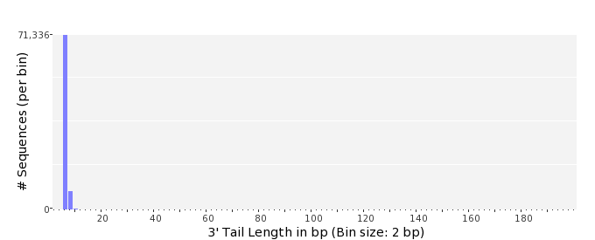

Tag Sequence Check
 | 5'-end | 3'-end
Probability of tag sequence: | 0 % | 0 %
GSMIDs or RLMIDs: | none

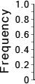 |  |  |  |  |  |  |  |  |  |  |  |  |  |  |  |  |  |  |  |  | ...
 | 1 |  |  |  | 5 |  |  |  |  | 10 |  |  |  |  | 15 |  |  |  |  | 20 |  | 20 |  |  |  |  | 15 |  |  |  |  | 10 |  |  |  |  | 5 |  |  |  | 1
 | Position from Sequence Ends

Sequence Duplication
 | # Sequences | Max duplicates
Exact duplicates: | 831,604 (4.12 %) | 332
Exact duplicates with reverse complements: | 4,168 (0.02 %) | 2
5' duplicates | 776,416 (3.84 %) | 18
3' duplicates | 411,337 (2.04 %) | 56
5'/3' duplicates with reverse complements | 336,807 (1.67 %) | 4
Total: | 2,360,332 (11.69 %) | -
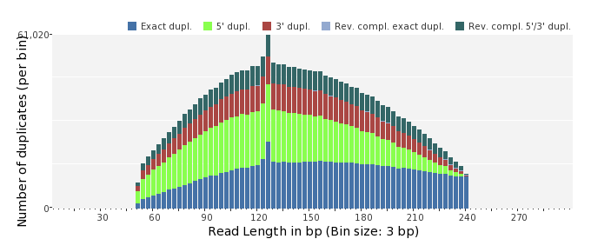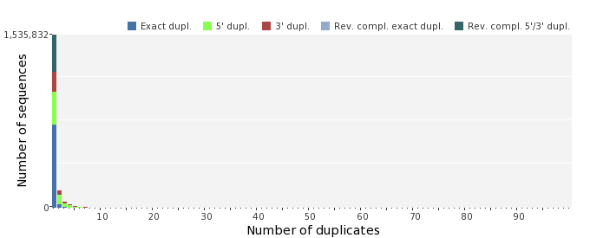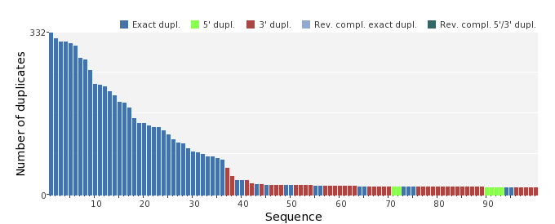

Sequence Complexity
 | Value | Sequence
Minimum DUST score: | 0 | GCATGCAGGGGCTTTTCAGGATTGTGATCACTACCTATGAGTCCCACTGAAACCACGATG  GTCGCTTCGGTAGGACCATAAACGTTCCAGAATGCAAGCCGGTGG
Maximum DUST score: | 98 | TTTTTTTTTTTTTTTTTTTTTTTTTTTTTTTTTTTTTTTTTTTTTTTTTTTTTTTTTTTT  TTTTTTTTTTTTTTTTTTTTTTTTTTTTTTTTTTTTTTTTTTTTTTTTTTTTTTTTTTTT  TTTTT
Minimum Entropy value: | 0 | TTTTTTTTTTTTTTTTTTTTTTTTTTTTTTTTTTTTTTTTTTTTTTTTTTTTTTTTTTTT  TTTTTTTTTTTTTTTTTTTTTTTTTTTTTTTTTTTTTTTTTTTTTTTTTTTTTTTTTTTT  TTTTT
Maximum Entropy value: | 97 | GGTGGCGTTAGGCGATGCCTTCTTGAGAAAGTCAGCTCCCACCCGCAACG
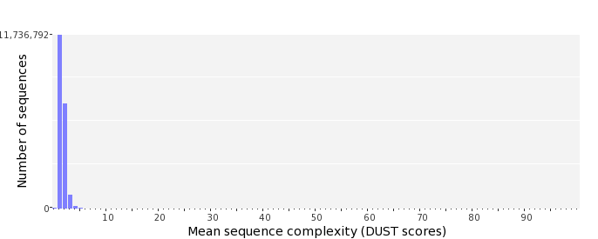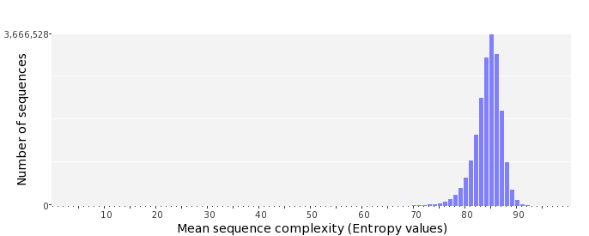

Dinucleotide Odds Ratios
 | AA/TT | AC/GT | AG/CT | AT | CA/TG | CC/GG | CG | GA/TC | GC | TA
Odds ratio | 1.1758 | 0.8351 | 0.9170 | 1.0995 | 1.0806 | 1.0051 | 0.9926 | 1.0686 | 1.1131 | 0.6337
